User by name srinivas created comment , he can edit, delete comments

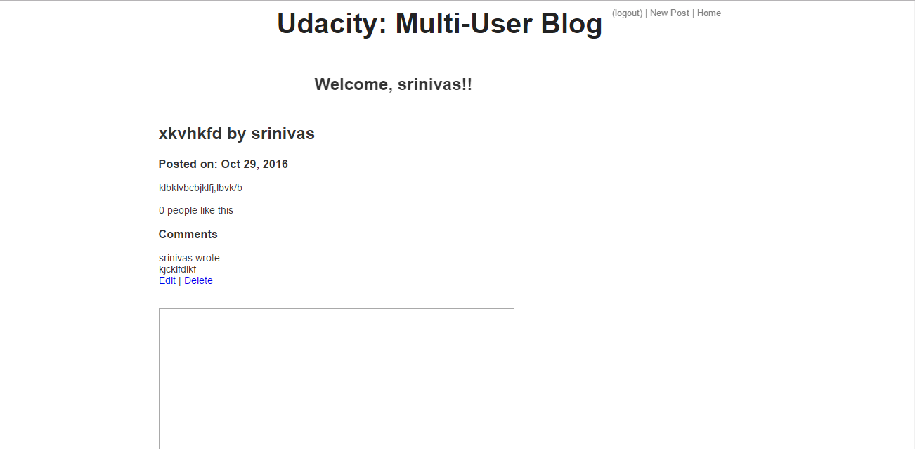

On logout the user can only see he cannot edit it comments

On login he has access to edit or delete comments .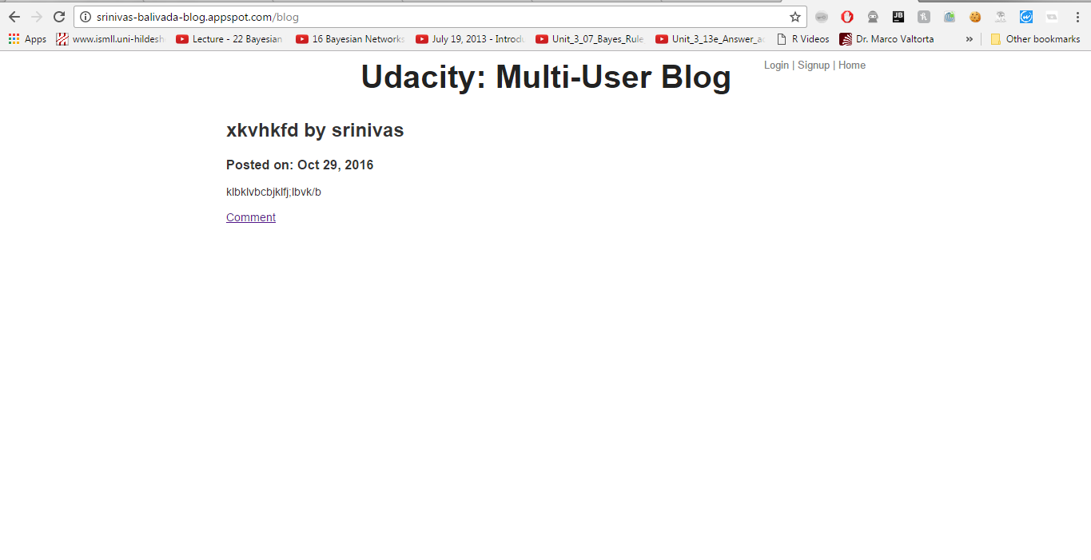

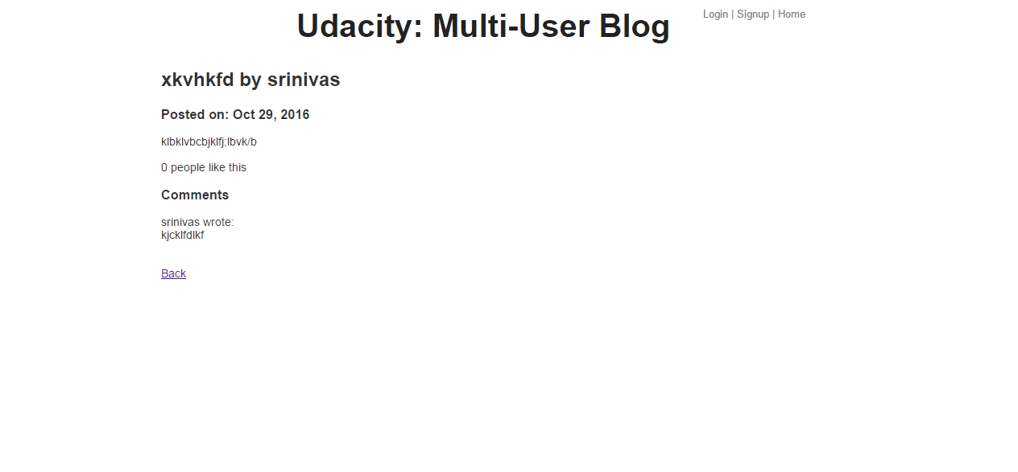

A new user with name abcde logged in now he has access to edit , delete his own comments he cannot delete user srinivas’s comments , user abcde he can like srinivas ‘s post but cannot delete srinivas’s post

Secondly abcde cannot edit posts of srinivas he can only create his own posts and edit his own posts and abcde cannot like his own post

Thirdly user abcde can like srinivas’s posts only once on click of again count will not increase rather like turns to unlike

