**Email Id Validation**

Introduction:

This is an Email Id Validation fully written in JAVA. User can check if the entered email id exist in the database or not

Installation Guide:

1. GitHub link: https://github.com/baljeet-singh97/Email-Id-Validation
2. Download the entire project as Zip in local system.
3. import the project in **Eclipse IDE**
4. Go to src/arithmaticCalculator/arithmeticCalc.java and run the code

How to use:

1. After running the code you will see the window like:

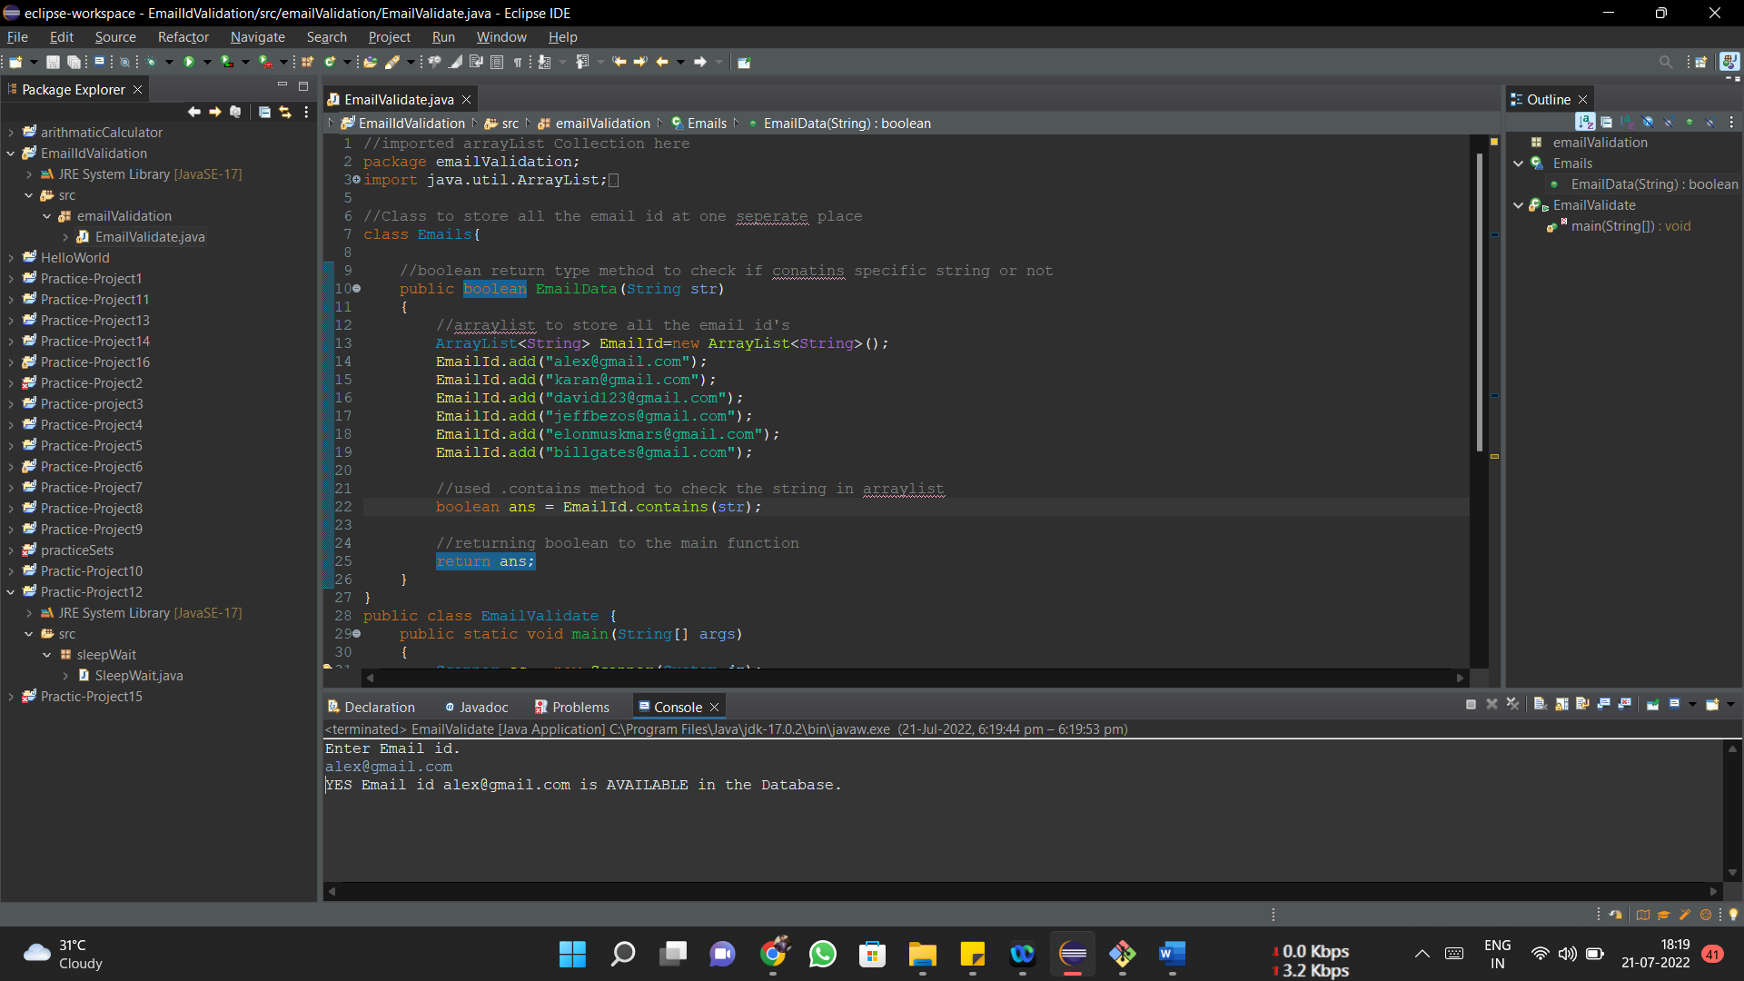

2. Enter the Email id you want to check.



1. After entering the email id program will give output if the email id is available in the database or not .

Code Description:

Main Function:

* Creates an object of Scanner class

Scanner sc = new Scanner(System.*in);* *.*

* taking input from the user as string

String email = sc.nextLine(); . .

* created object of class Emails

Emails obj = new Emails(); .

* **calling the class EmailData method that is Boolean return type.**

|  |  |
| --- | --- |
|  |  |
| if(obj.EmailData(email)==true) | |

Class

Class Emails

Defined this class to store all the email data at one place.

* Defined a Boolean type parameterized method “EmailData” taking string as a parameter from main function.

public boolean EmailData(String str) .

* Defined ArrayList to store all the email – id’s

ArrayList<String> EmailId=new ArrayList<String>(); .

* Returned Boolean value to the main function used contain to check if string present in the database or not

boolean ans = EmailId.contains(str); return ans; .