

**Dealer/Retailer Database**

**Prepared by**

Beytullah Eren Erdoğan – 010200035

Kerem Bal – 040210078

Mehmet Nortcu – 070210036

Erol Oray Eren – 070210286

Group 28

Bachelor of Industrial Engineering, Department of Management

Istanbul Technical University

END 213E: Data Management in Industrial Systems

Prof. Dr. Başar Öztayşi

January 12th, 2024

**CONTENTS**

1. Explanation of the System 3

1.1 Brief Information About the System 3

1.2 Processes 3

1.3 Aims of the System 7

1.4 Expected Benefits 8

2. DESIGN OF THE DATABASE 9

2.1 Data Types, Fields and Definitions 9

2.1.1 Supplier 9

2.1.2 Product 10

2.1.3 Category 11

2.1.4 Customer 11

2.1.5 Location 12

2.1.6 Country 13

2.1.7 Order 13

2.1.8 Inventory 14

2.1.9 Address 15

2.1.10 Shipping 16

2.1.11 OrderConfig 17

2.1.12 AddressConfig 17

2.1.13 Payment 18

2.2 ENTITY RELATIONSHIP DIAGRAM 23

2.3 RELATIONSHIPS: DIAGRAM AND DEFINITIONS 24

2.3.1 ADDRESS – SHIPPING (1:M) 24

2.3.2 ADDRESS – AddressConfig – CUSTOMER (M:M) 24

2.3.3 CUSTOMER – ORDER (1:M) 25

2.3.4 SHIPPING – ORDER (1:1) 25

2.3.5 ORDER – OrderConfig – PRODUCT (M:M) 25

2.3.6 PAYMENT – ORDER (1:M) 25

2.3.7 CATEGORY - PRODUCT (1:M) 26

2.3.8 PRODUCT - INVENTORY (1:M) 26

2.3.9 PRODUCT - SUPPLIER (1:M) 26

2.3.10 SUPPLIER - LOCATION (1:M) 27

2.3.11 LOCATION - COUNTRY (M:1) 27

2.3.12 LOCATION - ADDRESS (1:1) 27

3. QUERIES & REPORTS 27

3.1 QUERIES 27

3.1.1 CUSTOMER PROFILE QUERY 27

3.1.2 PRODUCT PROFILE QUERY 28

3.1.3 REVENUE BY COUNTRY QUERY 28

3.1.4 REVENUE BY CATEGORY QUERY 28

3.1.5 SUPPLIER PROFILE QUERY 29

3.2 REPORTS 29

3.2.1 CUSTOMER PROFILE REPORT 29

3.2.2 PRODUCT PROFILE REPORT 30

3.2.3 REVENUE BY COUNTRY REPORT 31

3.2.4 REVENUE BY CATEGORY REPORT 32

3.2.5 SUPPLIER PROFILE REPORT 33

# Explanation of the System

## Brief Information About the System

Retailers are the last link in the chain that allows products to be sold to actual customers at physical and online stores. Dealers, on the other hand, are typically middlemen who acquire different categories of products from manufacturers and sell them to retailers. Dealers operate the flow of goods by acting as a bridge to the retailers. Dealers are trusted by retailers to supply goods and this relationship makes the whole chain process smooth and effective.

While dealers perform their roles, there are some databases to be kept up to date and procedures to follow. Basically, dealers usually hold databases that include data about customers, orders and inventory. In general, dealers routinely maintain databases including information about orders, inventory, and customers. That way greatly reduces the probability of errors and enables their follow-up when they do occur. Following a guideline while going through a process can be crucial while dealing with lots of orders and shipping due to understanding and visualizing its steps clearly and staying on track. Roughly, all of the processes that must be followed are written down below.

## Processes

The dealer receives an order inquiry from a customer or a retailer. The dealer provides the key information about the products and the order. If the customer finds it appropriate, they will inform that they would like to proceed to the next step. If not, they would wish to find another solution. The next step is that the dealer verifies the customer authentication by gathering an ID validation. Dealer also further evaluates the reliability of the customer by some crucial tests, such as background checks, reputation checks, credibility checks etc. about their policies. If the customer successfully passes the tests, the dealer approves the order and sends them the agreement to be signed by them. If not, the process ends. After the agreement is signed the order is placed and the dealer receives the payment. The dealer checks the inventory and if there is a sufficient amount of the product ordered within the inventory, the dealer confirms the inventory availability. If not, the dealer purchases the amount needed, and a new purchase order is created, this leads to the arrival date of the products being delayed. After the inventory availability confirmation, the dealer decides on the shipment method. Products are being shipped and the records for shipping are registered. If a new product that is not currently included in the inventory is introduced, those products are registered with specific details like product name, product description, category of the product, quantity in stock and selling price. If not, then the remaining products should be checked to see if the stock needs to be reordered or not. If it is below the reorder point, then the process ends, but if it is not, then more quantities should be reordered and a new purchase order is created and sent to the relevant supplier. If a product that has already been registered is introduced, then the quantity in stock gets updated.

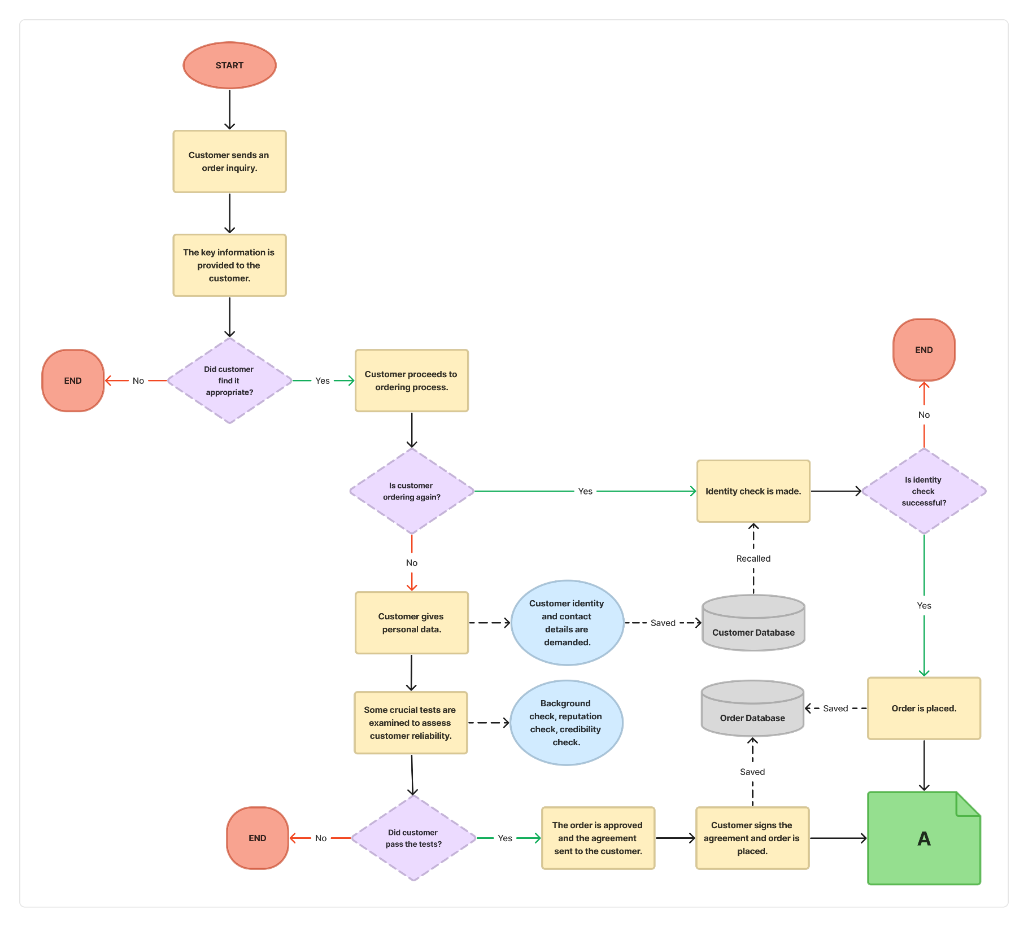**1.2.1 Flowchart of the System**

**Figure 1.1** Flowchart of the System (Part 1)

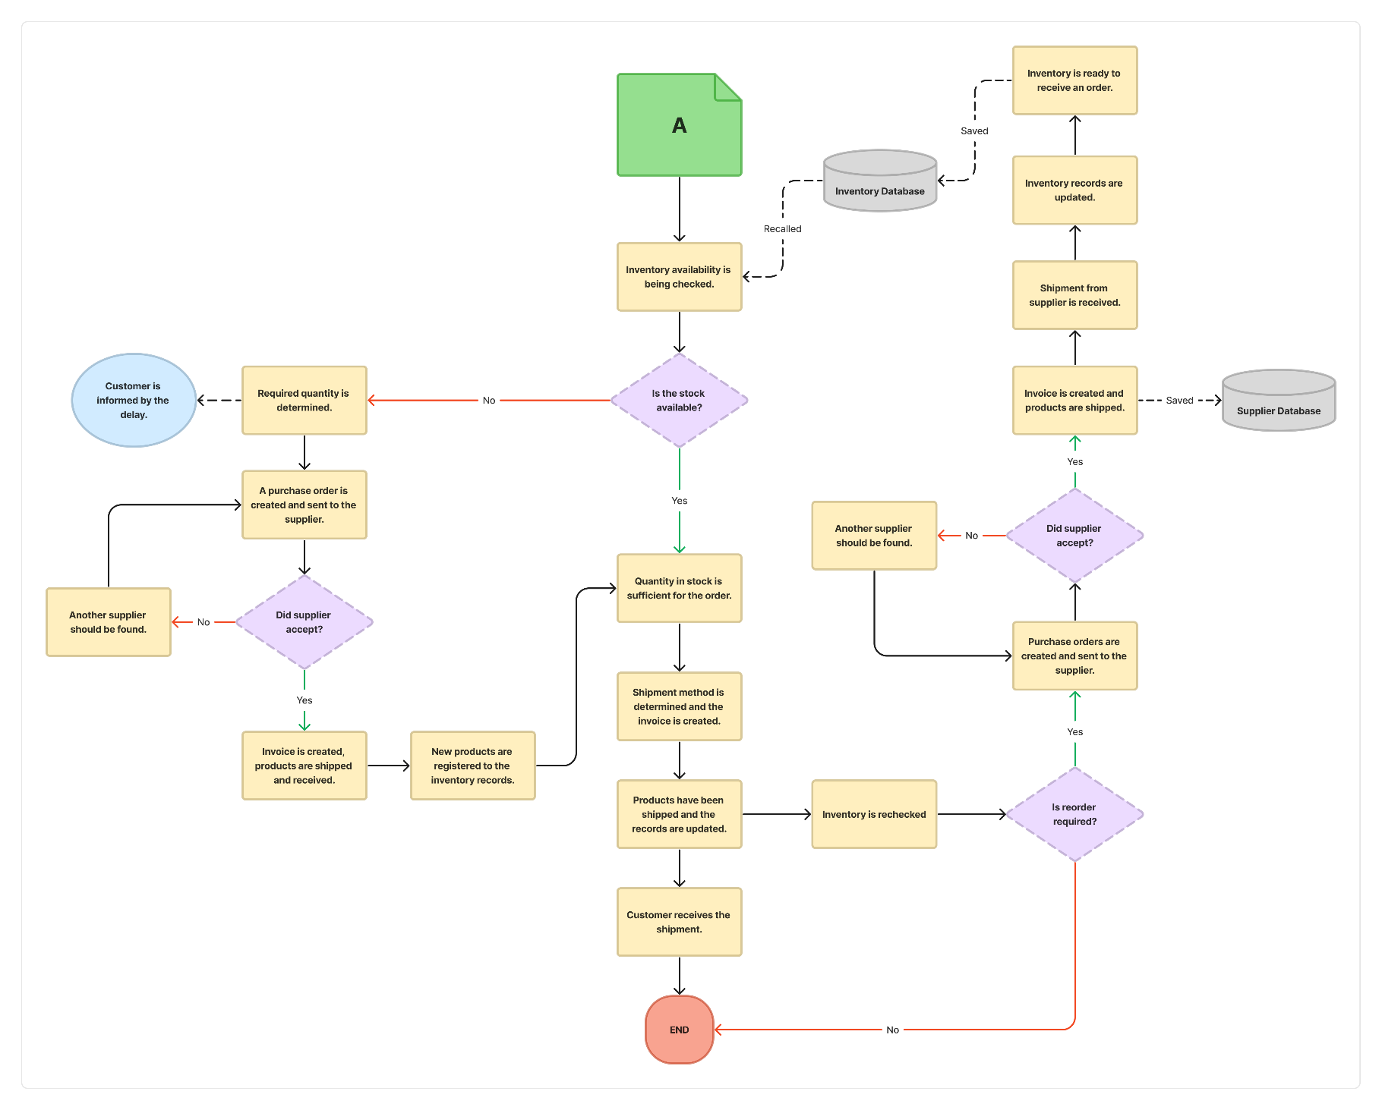

**Figure 1.2** Flowchart of the System (Part 2)

## Aims of the System

Retailer-dealer databases play a crucial role in contemporary commerce by aiming to streamline and optimize the interactions between retailers and their dealer networks. These systems are crafted to encourage efficient communication, simplify inventory management, and boost overall collaboration between retailers and their partners. By consolidating essential information like product catalogs, pricing structures, and order histories, these databases empower retailers and dealers to make more informed decisions, leading to enhanced customer service, improved stock management, and ultimately, greater profitability.

One key objective of these systems is to maintain consistency in pricing and product availability across all dealer locations. Offering real-time data on inventory levels and pricing updates, retailer-dealer databases contribute to a consistent customer experience, irrespective of the specific outlet chosen by a consumer. This consistency builds customer trust and loyalty, as shoppers can depend on the retailer to provide consistent quality across their dealer network.

Moreover, these databases aid in tracking and analyzing sales and inventory trends, enabling retailers and dealers to make decisions based on data. Through examining historical data and performance metrics, businesses can optimize their supply chain operations, identify top-selling products, and adjust strategies to respond to market changes. Essentially, these systems foster agility and responsiveness in the dynamic landscape of the market.

In conclusion, retailer-dealer databases act as a crucial link between retailers and their dealer networks, aiming to improve collaboration, ensure uniformity, and facilitate data-driven decision-making. As technology progresses, these systems are expected to play an increasingly vital role in the retail ecosystem, ensuring customers enjoy the best possible shopping experience while assisting businesses in adapting to the evolving demands of the marketplace.

## Expected Benefits

Retailer-dealer database software enables businesses to adapt more effectively to the dynamics of the business world by offering unique advantages. For instance, with its success in inventory management, these software solutions provide businesses with the ability to respond quickly to instantaneous changes in demand for a product. The automatic inventory tracking system detects unexpected increases in demand and optimizes strategic orders instantly by updating stock levels, thereby enhancing customer satisfaction and minimizing losses.

In terms of customer relationship management, businesses take a significant step forward in understanding and addressing each customer's unique needs through the powerful data management capabilities offered by the software. Immediate access to past shopping details of a customer, for example, provides customer representatives with unprecedented information, ultimately increasing customer satisfaction and contributing to the strengthening of long-term customer relationships.

Additionally, the analytical capabilities of the software allow businesses to delve deep into sales data, enabling them to analyze it comprehensively and shape their future strategies. For example, understanding sales trends during a specific period can assist businesses in optimizing inventory management and developing more precise demand forecasts.

In conclusion, retailer-dealer database software not only optimizes operational processes for businesses but also offers the potential to reshape business strategies and elevate customer satisfaction, providing a competitive advantage in a dynamic business environment. These software solutions provide businesses with a deeper insight into inventory management, customer relationship management, and analytical capabilities, while their customizable features ensure adaptability to the specific needs of each business, presenting a more effective approach to conducting business. Therefore, retailer-dealer database software helps businesses secure long-term success by not only addressing immediate needs but also guiding them in taking strategic steps toward the future.

# DESIGN OF THE DATABASE

## Data Types, Fields and Definitions

### Supplier

**SupplierID (PK):** A number that is automatically assigned by our system to each supplier and provides their unique identification. It can be associated with other fields in the table. Data type is auto number.

**SupplierName:** It is a field that identifies a supplier and can be used to create queries and reports about suppliers. Data type is short text.

**SupplierPhone:** A field that can be used to store the phone number to contact a supplier. Data type is integer.

**SupplierEmail:** It is a field used to store the email address required when contacting a supplier. Data type is short text.

**LocationID (FK):** This field can be used to determine the location of a supplier and to obtain reports and queries about them. This field is linked as a foreign key to the LocationID field in the Location table. Data type is auto number.

### Product

**ProductID (PK):** It is a field that uniquely identifies a product and can be used to create queries and reports about products. It can be associated with other fields in the table. Data type is auto number.

**ProductName:** It is a field that defines the name or title of a product and can be used to create queries and reports about products. Data type is short text.

**ProductDesc:** It is a field that provides a detailed description of a product that makes it attractive to potential customers. This area may include product features, benefits, uses, specifications, and other relevant information. It plays an important role in influencing customers' purchasing decisions. Data type is long text.

**Price:** It is a field used in sales and profit calculations that holds the sold price of a product. Additionally, pricing strategies and product comparisons can be determined using this area Data type is currency.

**CategoryID (FK):** A foreign key field that identifies the category to which a product belongs and can be used to create queries and reports on products. This field is linked as a foreign key to the CATEGORYID field in the Category table. Data type is auto number.

**InventoryID (FK):** It is a link that provides users access to inventory data associated with products and is crucial to product management operations. This field is linked as a foreign key to the INVENTORYID field in the Inventory table. Data type is auto number.

**SupplierID (FK):** It is a field that plays an important role in managing the supply chain of products and makes it easier to manage relationships with suppliers. This field is linked as a foreign key to the SUPPLIERID field in the Supplier table. Data type is auto number.

### Category

**CategoryID (PK):** It is a field that has a unique value for each record in the Category table and uniquely identifies the records in that table. It can be associated with other fields in the table. Data type is auto number.

**CategoryName:** It is an area that declares the names of the categories and is used for viewing and navigating categories in the user interface. Data type is short text.

**CategoryDesc:** It is a field that describes the scope and content of categories and highlights on similarities and distinctions among them. Data type is long text.

**Material:** It is an area used to access category information related to materials. Data type is short text

**Color:** It is a field used to access category information related to colors. Data type is short text

**Size:** It is a field used to access information related to the category's size. Data type is short text

### Customer

CustomerID (PK): A unique numerical identifier assigned to each customer, serving as the primary key for the Customer table. This identifier is crucial for ensuring the distinct identification of each customer record within the system. Data type is auto number.

**CustomerName:** The first name of the customer, expressed as a variable character string. This attribute holds the personal name by which the customer is formally addressed in the system. Data type is short text.

**CustomerSurname:** The last name or surname of the customer, providing additional specificity to the customer's identity. It completes the full name associated with a customer record. Data type is short text.

**CustomerEmail:** It stores the email address associated with the customer, serving as a unique identifier and facilitating communication. It is a critical contact point for various interactions such as order confirmations and promotional communications. Data type is short text.

**CustomerPhone:** It records the phone number of the customer, enabling direct contact and communication. It serves as an alternate means of reaching the customer and is valuable for order-related queries or updates. Data type is integer.

**Password:** An encrypted string serving as the customer's authentication key. The password is securely stored and used for accessing the customer's account, ensuring data security. Data type is short text.

**AddresID (FK):** A foreign key linking to the Address table, establishing a relationship between customer records and their corresponding addresses. It enables the retrieval of associated address details for a given customer. Data type is auto number.

### Location

**LocationID (PK):** A unique numerical identifier assigned to each location, serving as the primary key for the Location table. This identifier ensures the uniqueness of each location record within the system. Data type is auto number.

**CityName:** The name of the city where the location is situated. This attribute contributes to the geographical identification of the location, providing context to the user. Data type is short text.

**CountryID (FK):** A foreign key linking to the Country table, establishing a relationship between location records and their associated countries. It facilitates the retrieval of additional information about the country to which a location belongs. Data type is auto number.

### Country

**CountryID (PK):** A unique numerical identifier assigned to each country, serving as the primary key for the Country table. This identifier ensures the distinct identification of each country within the system. Data type is auto number.

**CountryName:** The name of the country, providing information about the geographical region it represents. This attribute is essential for contextualizing the country's identity. Data type is short text.

**CountryCode:** A code uniquely identifying the country, facilitating standardization and reference. This code serves as a concise and unique identifier for each country record. Data type is short text.

### Order

**OrderID (PK):** A unique numerical identifier assigned to each order, serving as the primary key for the Order table. This identifier ensures the uniqueness of each order record within the system. Data type is auto number.

**ShippingID (FK):** A foreign key linking to the Shipping table, establishing a relationship between orders and their associated shipping information. It facilitates retrieval of specific details related to the shipping process. Data type is auto number.

**CustomerID (FK):** A foreign key linking to the Customer table, establishing a relationship between orders and the customers who placed them. This key enables the association of orders with specific customers. Data type is auto number.

**ProductID (FK):** A numerical identifier assigned to the product included in the order. This identifier allows tracking of the specific product associated with an order. Data type is auto number.

**DepartureDate:** The date when the order departs for shipping. This attribute represents the initiation date of the shipping process for the associated order. Data type is date.

**ArrivalDate:** The expected or actual date of arrival for the shipped order. This attribute provides information about when the customer can anticipate receiving their order. Data type is date.

**OrderedAmount:** The quantity of the product ordered by the customer. This attribute indicates the number of units of the specified product included in the order. Data type is integer.

**TotalPrice:** The total price of the order, accounting for the quantity and unit price of the ordered items. This attribute represents the overall cost associated with the order. Data type is currency.

**PaymentID (FK):** A foreign key linking to the Payment table, establishing a relationship between orders and their associated payment information. This key allows retrieval of details about the payment made for a specific order. Data type is auto number.

### Inventory

**InventoryID (PK):** A unique numerical identifier serving as the primary key for each inventory record. This identifier ensures the exclusivity and individuality of each inventory entry within the system. Data type is auto number.

**QuantityInStock:** The current quantity of a product available in the inventory. This attribute provides real-time information about the stock level of a specific product, supporting effective inventory management. Data type is integer.

**ReorderPoint:** The threshold level of product quantity that, when reached, triggers a reorder. This attribute helps in managing inventory levels efficiently by indicating the need to replenish stock when it falls below the specified threshold. Data type is integer.

### Address

**AddressID (PK):** Serves as the primary key, uniquely identifying each record in the Address entity. It is a crucial identifier for maintaining the integrity and uniqueness of address information within the retailer/dealer relational database. Data type is auto number.

**UnitNumber:** UnitNumber represents the specific unit or apartment number associated with an address. It is instrumental in providing a more granular level of detail, especially in multi-unit buildings or complexes. Data type is short text.

**Street:** The Street attribute captures the name of the street where the address is located. This information is essential for geolocation and navigation purposes, as well as for providing a fundamental component of the address. Data type is short text.

**AddressLine1:** AddressLine1 encompasses the initial line of the address, typically containing the street number and the primary street name. This part of the address is fundamental for identifying the physical location within a given street. Data type is short text.

**AddressLine2:** AddressLine2 represents the secondary line of the address, offering additional space for details such as suite numbers, building names, or any supplementary address information. It allows for flexibility in accommodating various addressing conventions. Data type is short text.

**LocationID (FK):** LocationID is a foreign key establishing a relational link between the Address entity and the Location entity. This connection enables the association of a specific address with a geographic location, facilitating streamlined management of location-based data. Data type is auto number.

**PostalCode:** The PostalCode attribute records the postal code or ZIP code associated with the address. This information is crucial for postal services, shipping, and logistical purposes, ensuring accurate and efficient mail delivery. Data type is short text.

### Shipping

**ShippingID (PK)**: ShippingID serves as the primary key, acting as a unique identifier for each shipping record within the retailer/dealer relational database. This key plays a critical role in facilitating efficient tracking, management, and retrieval of specific shipping transactions. Data type is auto number.

**ShippingMethod:** ShippingMethod is a descriptive attribute that signifies the method or service employed for shipping products to customers. It provides valuable insights into the logistics and transportation aspects of order fulfillment. Data type is short text.

**ShippingPrice:** ShippingPrice denotes the cost associated with the chosen shipping method. This attribute holds a numerical value, typically in decimal or float format, providing financial information regarding the expenses incurred in delivering products to customers. Data type is currency.

**AdressID (FK):** AddressID, as a foreign key, establishes a relationship between the Shipping entity and the Address entity. This linkage is essential for associating each shipping record with a specific delivery address, contributing to accurate and organized order fulfillment. Data type is auto number.

### OrderConfig

**OrderConfigID (PK):** A number that is automatically assigned by the system to each correlated orders and products. It can be associated with other fields in the database. Data type is auto number.

**OrderID (FK):** A foreign key located on the table, which is indicating the order that is accompanied with. This is the linkage between Order table and OrderConfig table, which is also assembling Product table and Order table. OrderID is also the primary key of Order table. Data type is auto number.

**ProductID (FK):** A foreign key located on the table, which is indicating the product that is related with. This is the linkage between Product table and OrderConfig table, which is also colligating Product table and Order table. ProductID is also the primary key of Product table. Data type is auto number.

### AddressConfig

**AddressConfigID (PK):** A number that is automatically assigned by the system to each correlated addresses and customers. It can be associated with other fields in the database. Data type is auto number.

**CustomerID (FK):** A foreign key located on the table, which is indicating the customer that is concomitant with. This is the linkage between Customer table and AddressConfig table, which is also consolidating Customer table and Address table. CustomerID is also the primary key of Customer table. Data type is auto number.

**AddressID (FK):** A foreign key located on the table, which is indicating the address that is owned by customers. This is the linkage between Address table and AddressConfig table, which is also accompanying Customer table and Address table. AddressID is also the primary key of Address table. Data type is auto number.

**AddressDefaultStatus:** An attribute belonging to AddressConfig table which denotes whether the specific address is the default location that the customer resides or desires the order to be delivered. The data type is Yes/No.

### Payment

**PaymentID (PK):** A number that is automatically given by the system to each payment methods. It can be utilized in other fields in the database. The data type is auto number.

**PaymentMethod:** An attribute belonging to Payment table which implies a specific payment method that a customer wishes to use whilst ordering. The data type is short text.

|  |  |  |  |
| --- | --- | --- | --- |
| **TABLE NAME** | **TABLE NAME** | **TABLE NAME** | **DEFINITION** |
| CUSTOMER | CustomerID (PK) | AUTO NUMBER | Unique identifier for each customer. |
| CustomerName | SHORT TEXT | First name of the customer. |
| CustomerSurname | SHORT TEXT | Last name or surname of the customer. |
| CustomerEmail | SHORT TEXT | Email address associated with the customer. |
| CustomerPhone | SHORT TEXT | Phone number of the customer. |
| Password | SHORT TEXT | Encrypted password for customer authentication. |
| AddressID (FK) | AUTO NUMBER | Foreign key linking to the Address table. |
| LOCATION | LocationID (PK) | AUTO NUMBER | Unique identifier for each location. |
| CityName | SHORT TEXT | Name of the city where the location is situated. |
| CountryID (FK) | AUTO NUMBER | Foreign key linking to the Country table. |
| COUNTRY | CountryID (PK) | AUTO NUMBER | Unique identifier for each country. |
| CountryName | SHORT TEXT | Name of the country. |
| CountryCode | AUTO NUMBER | Code uniquely identifying the country. |
| ORDER | OrderID (PK) | AUTO NUMBER | Unique identifier for each order. |
| ShippingID (FK) | AUTO NUMBER | Foreign key linking to the Shipping table. |
| CustomerID (FK) | AUTO NUMBER | Foreign key linking to the Customer table. |
| ProductID (FK) | AUTO NUMBER | Numerical identifier for the product. |
| DepartureDate | DATE | Date when the order departs for shipping. |
| ArrivalDate | DATE | Expected or actual date of arrival for the order. |
| OrderedAmount | INTEGER | Quantity of the product ordered. |
| TotalPrice | CURRENCY | Total price of the order. |
| PaymentID (FK) | AUTO NUMBER | Foreign key linking to the Payment table. |
| INVENTORY | InventoryID (PK) | AUTO NUMBER | Unique identifier for each inventory record. |
| QuantityInStock | INTEGER | Quantity of a product currently available. |
| ReorderPoint | INTEGER | Threshold level triggering a reorder. |
| ADDRESS | AddressID (PK) | AUTO NUMBER | Unique identifier for each address record. |
| UnitNumber | SHORT TEXT | Represents the unit or apartment number within a building. |
| Street | SHORT TEXT | The name of the street where the address is located |
| AddressLine1 | SHORT TEXT | The first line of the address, typically indicating the street number and street name. |
| AddressLine2 | SHORT TEXT | The second line of the address, providing additional details if needed |
| LocationID (FK) | AUTO NUMBER | Foreign key linking the address to a specific location or geographic area. |
|  |
| PostalCode | SHORT TEXT | The postal code or ZIP code associated with the address, facilitating mail delivery. |  |
| SHIPPING | ShippingID (PK) | AUTO NUMBER | ShippingID serves as the primary key, uniquely identifying each shipping record in the retailer/dealer relational database. It is crucial for tracking and managing individual shipping transactions. |  |
| ShippingMethod | SHORT TEXT | ShippingMethod denotes the method or service used for shipping, providing information on how the products are delivered to the customer. |  |
| ShippingPrice | CURRENCY | ShippingPrice represents the cost associated with the shipping method. It provides financial information regarding the expenses related to delivering the products to the customer. |  |
| AddressID (FK): | AUTO NUMBER | AddressID is a foreign key establishing a connection between the Shipping entity and the Address entity. This linkage associates each shipping record with a specific delivery address. |  |
| SUPPLIER | SUPPLIERID (PK) | AUTO NUMBER | A unique identifier assigned by the system to each supplier. |  |
| SupplierName | SHORT TEXT | Short text field identifying the supplier. |  |
| SupplierPhone | INTEGER | A field that can be used to store the phone number to contact a supplier |  |
| SupplierEmail | SHORT TEXT | It is a field used to store the email address required when contacting a supplier |  |
| LOCATIONID (FK) | AUTO NUMBER | Foreign key linked to the LOCATIONID field in the LOCATION table, determining the supplier's location. |  |
| PRODUCT | PRODUCTID (PK) | AUTO NUMBER | Auto number field uniquely identifying each product. |  |
| ProductName | SHORT TEXT | Short text field defining the name or title of a product. |  |
| ProductDesc | LONG TEXT | Long text field providing a detailed description of the product. |  |
| Price | CURRENCY | Field used for sales and profit calculations, holding the sold price of a product. |  |
| CATEGORYID (FK) | AUTO NUMBER | Foreign key linked to the CATEGORYID field in the CATEGORY table, identifying the product's category. |  |
| INVENTORYID (FK) | AUTO NUMBER | Foreign key linked to the INVENTORYID field in the Inventory table, providing access to inventory data. |  |
| SUPPLIERID (FK) | AUTO NUMBER | Foreign key linked to the SUPPLIERID field in the Supplier table, managing the supply chain and supplier relationships. |  |
| CATEGORY | CATEGORYID (PK) | AUTO NUMBER | Auto number field with a unique value for each category record. |  |
| CategoryName | SHORT TEXT | Short text field declaring the names of categories. |  |
| CategoryDesc | LONG TEXT | It is a field that describes the scope and content of categories and highlights on similarities and distinctions among them. |  |
| Material | SHORT TEXT | It is an area used to access category information related to materials. |  |
| Color | SHORT TEXT | It is a field used to access category information related to colors. |  |
| Size | SHORT TEXT | It is a field used to access information related to the category's size. |  |
| PAYMENT | PaymentID (PK) | AUTO NUMBER | A number that is automatically given by the system to each payment methods. It can be utilized in other fields in the database. |  |
| PaymentMethod | SHORT TEXT | An attribute belonging to Payment table which implies a specific payment method that a customer wishes to use whilst ordering. |  |
| ADDRESSCONFIG | AddressConfigID (PK) | AUTO NUMBER | A number that is automatically assigned by the system to each correlated addresses and customers. It can be associated with other fields in the database. |  |
| CustomerID (FK) | AUTO NUMBER | A foreign key located on the table, which is indicating the customer that is concomitant with. This is the linkage between Customer table and AddressConfig table, which is also consolidating Customer table and Address table. CustomerID is also the primary key of Customer table. |  |
| AddressID (FK) | AUTO NUMBER | A foreign key located on the table, which is indicating the address that is owned by customers. This is the linkage between Address table and AddressConfig table, which is also accompanying Customer table and Address table. AddressID is also the primary key of Address table. |  |
| AddressDefaultStatus | YES/NO | An attribute belonging to AddressConfig table which denotes whether the specific address is the default location that the customer resides or desires the order to be delivered. |  |
| ORDERCONFIG | OrderConfigID (PK) | AUTO NUMBER | A number that is automatically assigned by the system to each correlated orders and products. It can be associated with other fields in the database. |  |
| OrderID (FK) | AUTO NUMBER | A foreign key located on the table, which is indicating the order that is accompanied with. This is the linkage between Order table and OrderConfig table, which is also assembling Product table and Order table. OrderID is also the primary key of Order table. |  |
| ProductID (FK) | AUTO NUMBER | A foreign key located on the table, which is indicating the product that is related with. This is the linkage between Product table and OrderConfig table, which is also colligating Product table and Order table. ProductID is also the primary key of Product table. |  |

## ENTITY RELATIONSHIP DIAGRAM

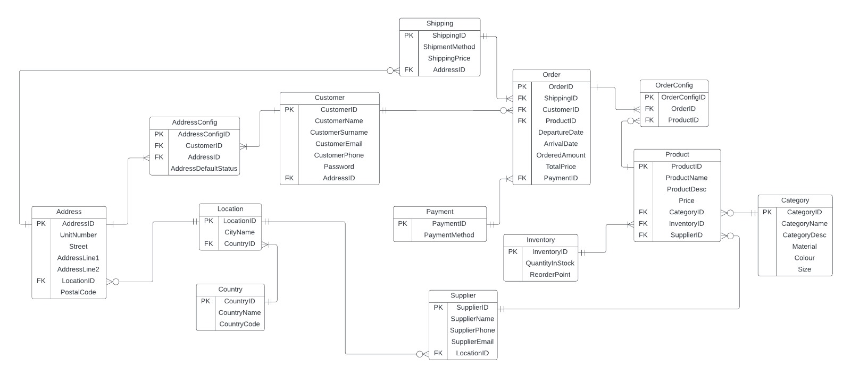

## RELATIONSHIPS: DIAGRAM AND DEFINITIONS

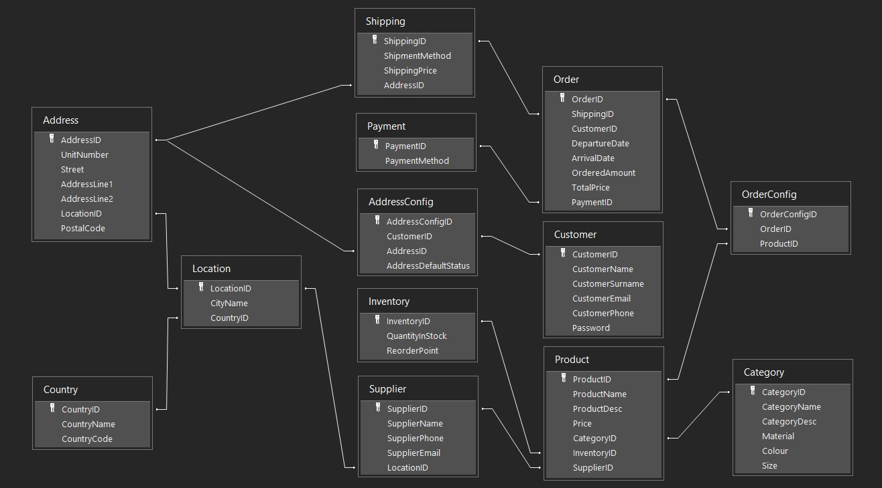

### ADDRESS – SHIPPING (1:M)

The relationship between Address table and Shipping table is one-to-many relationship, as many shippings can be made to one destination that is listed on the Address table, and reversely one destination can have many shippings. Moreover, in the extent of cardinality, one destination may not have a shipping incoming, but one shipping must be made to one destination.

### ADDRESS – AddressConfig – CUSTOMER (M:M)

The relationship between Address table and Customer table is many-to-many relationship, as many customers can have many addresses registered, and many addresses can belong to many customers. In addition to the scope of many-to-many relationship between Address table and Customer table, there is an additional table called AddressConfig which enables many-to-many relationship to occur by containing temporary information of both of the tables. Moreover, in the extent of cardinality, a customer must have at least one address to register to the system and at least one address should be owned by one customer.

### CUSTOMER – ORDER (1:M)

The relationship between Customer table and Order table is one-to-many relationship, as one customer can have many orders, but one order is given by only one customer. Moreover, in the extent of cardinality, one customer may not give an order, so the minimum cardinality becomes zero, but one order should be given by at least one customer, so the minimum cardinality is one.

### SHIPPING – ORDER (1:1)

The relationship between Shipping table and Order table is one-to-one relationship, as one shipping can deliver only one order, and one order can be delivered by only one shipping. Moreover, in the extent of cardinality, one shipping should have to carry one order, so the minimum cardinality becomes one, and one order should be carried by one shipping, so the minimum cardinality becomes one again.

### ORDER – OrderConfig – PRODUCT (M:M)

The relationship between Order table and Product table is many-to-many relationship, as one order can include many products, and one product can be demanded by many orders. Moreover, in the extent of cardinality, one order must have one product in order to be valid, so the minimum cardinality is one, but one product does not have to be ordered by someone, so the minimum cardinality is zero.

### PAYMENT – ORDER (1:M)

The relationship between Payment table and Order table is one-to-may relationship, as one payment can be made to many orders, and one order can only be given by one payment. Moreover, in the extent of cardinality, one payment needs to be made to at least one order, so the minimum cardinality is one, and one order also requires to be paid by one payment, so the minimum cardinality method is again one.

### CATEGORY - PRODUCT (1:M)

The relationship between the Category table and the Product table is a one-to-many relationship. A category can encompass multiple products, but each product belongs to only one category. Therefore, a category may have zero or more associated products, while each product must be linked to exactly one category.

### PRODUCT - INVENTORY (1:M)

The relationship between the Product table and the Inventory table is a one-to-many relationship. Each product can have multiple inventory entries, indicating its presence in different locations or with varying quantities. However, each inventory entry is associated with only one product. This setup allows for effective tracking of product stock levels in various locations, ensuring a detailed inventory management system.

### PRODUCT - SUPPLIER (1:M)

The relationship between the Product table and the Supplier table is a one-to-many relationship. Each product is exclusively associated with one supplier, indicating a direct link between the product and its source. However, a supplier can provide multiple products, allowing for a diverse product catalog from a single supplier. This setup enables efficient tracking of the products offered by each supplier while ensuring that each product originates from a specific supplier.

### SUPPLIER - LOCATION (1:M)

The relationship between the Supplier table and the Location table is a one-to-many relationship. A supplier can be associated with multiple locations, indicating that they operate in different geographical areas. However, each location is linked to only one supplier. This setup allows for the representation of suppliers with diverse operational bases.

### LOCATION - COUNTRY (M:1)

The relationship between the Location table and the Country table is a many-to-one relationship. Multiple locations can be situated within a single country, but each location is specifically associated with one country. This relationship provides a hierarchy where multiple locations share a common country.

### LOCATION - ADDRESS (1:1)

The relationship between the Location table and the Address table is a one-to-one relationship. Each location has a unique address, and conversely, each address corresponds to one specific location. This exclusive association ensures a direct mapping between location entities and their respective addresses, facilitating precise location identification and management within the retailer/dealer relational database.

# QUERIES & REPORTS

# QUERIES

### CUSTOMER PROFILE QUERY

This section allows users to create a new identity and input their address information into the system. Once users input their basic details, it is saved securely in the system. Users can also enhance account security by creating a password. All performed actions undergo an approval process and are stored in the system, ensuring accurate and secure data storage. These functions aim to enable users to integrate quickly into the system and experience a secure shopping environment.

### PRODUCT PROFILE QUERY

This is much more than just a mechanism to check the product data for completeness and accuracy. This system is an essential source of data that establishes a product's identity in the digital world and serves as the base for all other processes. That query serves as not only a way to for data verification; it is a key tool that supports all procedures linked to products and offers lots of benefits to companies.

### REVENUE BY COUNTRY QUERY

The "Revenue by Country" form is a vital component of our retailer-dealer database system. This form serves as a tool to analyze and track revenue generation across different countries. Users can input revenue data from each country, providing insights into global financial performance. The "Country Revenue" field allows analysis of income from specific geographic locations, enabling strategic decision-making and optimizing marketing efforts. This form is valuable for businesses to understand regional financial trends, enhance sales strategies, and make informed decisions to improve overall revenue performance.

### REVENUE BY CATEGORY QUERY

The "Revenue by Category" form is a crucial tool for organizing and analyzing revenue data based on product categories. Users can categorize products and analyze revenue streams in detail using this form. It includes key metrics such as sales volume, total ordered amount, and total revenue. This form empowers businesses to make strategic decisions, optimize product offerings, and improve overall revenue performance by understanding category-specific sales dynamics.

### SUPPLIER PROFILE QUERY

This is a method that validates the accuracy and completeness of the information that suppliers enter into the system. This query provided access to up-to-date and solid supplier data. Better supplier connections, more compliance, and lower operating expenses are all a result of this.

## REPORTS

### CUSTOMER PROFILE REPORT

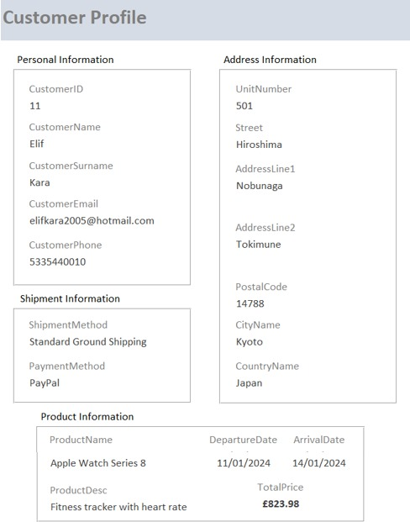

This form is designed to systematically capture and manage essential customer information. The "Personal Information" section includes fields for the customer's name, email address, phone number, and a unique customer ID for identification purposes. The "Address Information" section ensures accurate delivery and communication by collecting the customer's residential or business address. In the "Shipment Information" section, customers can specify their preferred shipping methods and delivery details, providing critical data for successful order deliveries. The "Product Information" section allows customers to detail purchased or relevant products, aiding in understanding their preferences. This comprehensive form, with emphasis on contact details and unique identifiers, aims to enhance customer relationships and satisfaction by capturing key information accurately.

### PRODUCT PROFILE REPORT

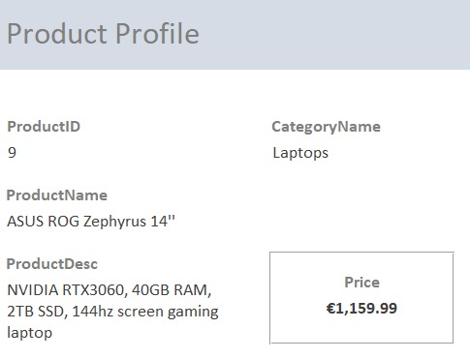

The "Product Profile" form within our retailer-dealer database system is a crucial tool for systematically managing product information. Each product is assigned a unique identifier through the "Product ID" field, facilitating efficient cataloging. The "Product Name" field allows for easy recognition, while the "Product Description" section provides a detailed overview of features and specifications. Categorization is streamlined with the "Category Name" field, aiding in inventory management, and the "Price" field enables precise financial tracking and supports pricing strategies. This comprehensive form empowers users to make informed decisions, track inventory effectively, and tailor marketing strategies based on product categories and specifications.

### REVENUE BY COUNTRY REPORT

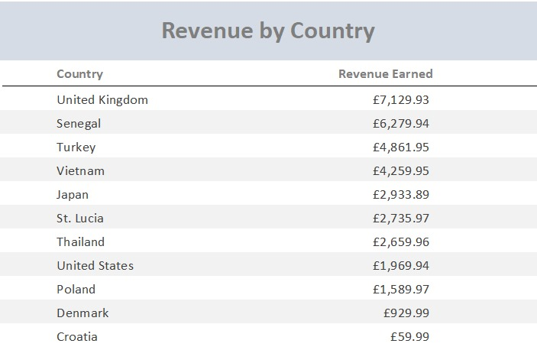

The "Revenue by Country" form is an essential component of our retailer-dealer database system, providing a systematic means to analyze and track revenue generation across different countries. The form includes a comprehensive breakdown of revenue earned from each country, facilitating a clear understanding of the financial performance on a global scale. The "Country Revenue" field allows users to input and analyze the income generated from specific geographic locations, enabling strategic decision-making and targeted marketing efforts. This form serves as a valuable tool for businesses to gain insights into regional financial trends, optimize sales strategies, and make informed decisions to enhance overall revenue performance.

### REVENUE BY CATEGORY REPORT

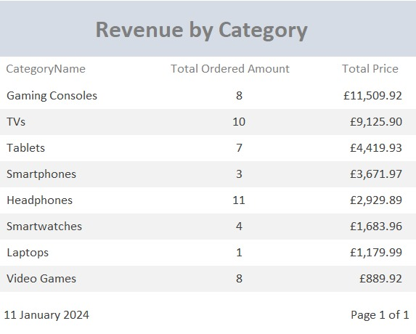

The "Revenue by Category" form is a pivotal component of our retailer-dealer database system, designed to systematically organize and analyze revenue data based on product categories. This form encompasses key metrics essential for insightful decision-making. The "Category Name" field allows users to categorize products, facilitating a granular analysis of revenue streams. The "Total Ordered Amount" field quantifies the quantity of products ordered within each category, providing valuable insights into demand patterns. The "Total Price" field reflects the cumulative monetary value generated from the sales within a specific category, aiding in assessing the financial performance of different product types. This form is instrumental in empowering businesses to strategize effectively, optimize product offerings, and enhance overall revenue performance by understanding and leveraging category-specific sales dynamics.

### SUPPLIER PROFILE REPORT

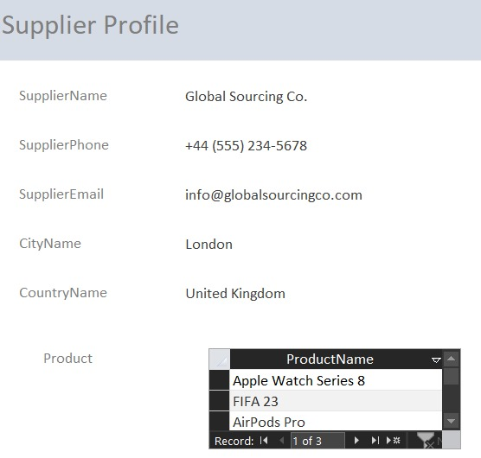

The "Supplier Profile" form is a fundamental element of our retailer-dealer database system, designed to systematically capture and manage crucial information related to our suppliers. This comprehensive form includes key fields such as "Supplier Name," providing a clear identification of the supplier entity. The "Supplier Phone" and "Supplier Email" fields ensure effective communication channels are established. Additionally, the "City Name" and "Country Name" fields offer a geographic perspective, aiding in logistics and relationship management. The inclusion of the "Product" field allows for the association of specific products with each supplier, streamlining inventory tracking and order fulfillment. This form is instrumental in fostering transparency and efficiency in supplier relations, enabling businesses to maintain accurate records, facilitate communication, and optimize the supply chain by aligning products with their respective suppliers.