Instructions for ISO metadata XML implementation Subversion workspace
Stephen M Richard

The folder for the workspace is in the jrc ISOTC211 subversion/drafts/trunk folder, named ‘implementation-XML’ (https://inspire-twg.jrc.ec.europa.eu/svn/iso/isotc211/Drafts/trunk/implementation-XML)
This folder is not currently part of the isoTC211 version control configuration, so it shouldn't show up in the Drafts folder in a normal ISO TC211 checkout in Enterprise Architect (EA)

The ‘model’ subfolder in the workspace contains an XMI file for each ISO project that is linked with ISO 19115 through some kind of dependency. All of these XMI files were generated by XMI export from the harmonized model, and then imported to the XML workspace with ‘strip GUIDs’ to decouple the implementation model from the conceptual model for EA management. An XMI file named 'implementation-XML.xml' in the root of the workspace loads all the project directories in the workspace.

Projects included:
19103:2005
19107:2003
19108:2006
19110 (CD Rev1)
19111:2009 (includes 2009 referencing by coordinates Leaf)
19115-3 (CD) (includes extensions defined in ISO19139)
19135:2005
19157:2013

Each model package is under separate version control, with the root package using the ISO project number and name. Within that are one or more ‘Application Schema’-stereotyped packages that define implementation of an XML namespace. Each Application Schema contains one or more ‘Leaf’-stereotyped packages that will be implemented as separate XML schema documents. Some Project packages also contain informative packages that have no stereotype and should not affect the XML generated by ShapeChange. These could be removed from the implementation model, but I have left them for now.

To load the model in EA, do a subversion check out from
https://inspire-twg.jrc.ec.europa.eu/svn/iso/isotc211/Drafts/trunk/implementation-XML
In a new EA project, create a version control configuration named ‘implementation-XML’, and point it at the path where you checked out the workspace. Right click on the root model, and do ‘Package Control/get package…’, select the ‘implementation-XML’ configuration, and then the file 'implementation-XML.xml'.
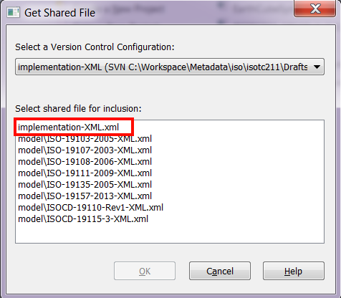
The directory structure for the workspace should appear in your EA project (I put it beneath the 'Model' root that EA generates for new projects, by clicking 'No' in the dialog that opens before loading the configuration). Right click on the root of the model 'implementation-XML'
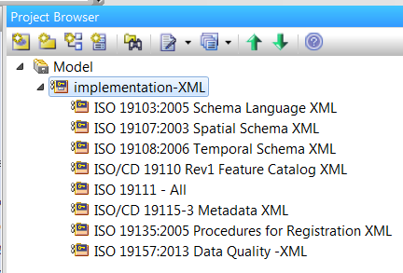

and select 'Package Control/get all latest', and accepting 'import changed files only' is fine in the following dialog. All the actual model content will now load into the EA project. You can check out individual ISO projects (right click on project, 'Package Control/Check out'), or the whole workspace (right click on root, 'Package Control/Check out branch').

As per discussions in Berlin, in this model, the ISO19115-2 elements have been integrated into the 19115-3 and ISO 19157 implementation models. The 19115-2 elements brought into the 19115-3 and 19157 implementation packages are in their own leaf packages in those Application Schema.
Each model also has an application schema package named ‘[model name] External’ that contains a ‘Leaf’ package for the abstract classes from the model that are used by other application schema.

Links to model elements that are in other models have been changed to point to the abstract class in the Externals package for that model.

I have used the Solid Ground EA extension to run conformance tests on all packages and make sure that all references to elements are correctly linked in the model. Tagged values for Rational Rose have been removed. Dependency diagrams generated by Solid Ground are added for all application schema.

