JEE Accent Feature

Functionality Intro
The objective of this feature was to elevate a student gradually to be able to solve JEE Main problems. We start their journey from a typical NCERT book problems and concept, and take them through levels of difficulty to JEE Main problems.
We ask the students in 11th or 12th to start with a chapter, ask them to do exercise problem (we help them with solutions, how to do, feedback on their approach). Then we extend by providing targeted problems in that chapter which are increasing in difficulty level (provide solutions, feedback etc. in the same way) and eventually ask them to solve actual past JEE Main questions (same solution help).
Problems from an NCERT Chapter based
Step up problems
JEE Main problems
More JEE Practice Problems
The actual screen shot of the feature as it is presented today is shared as a pick in this doc. Note that we will improve the UX, introduce chat based etc. eventually. But this should illustrate how we envisage.
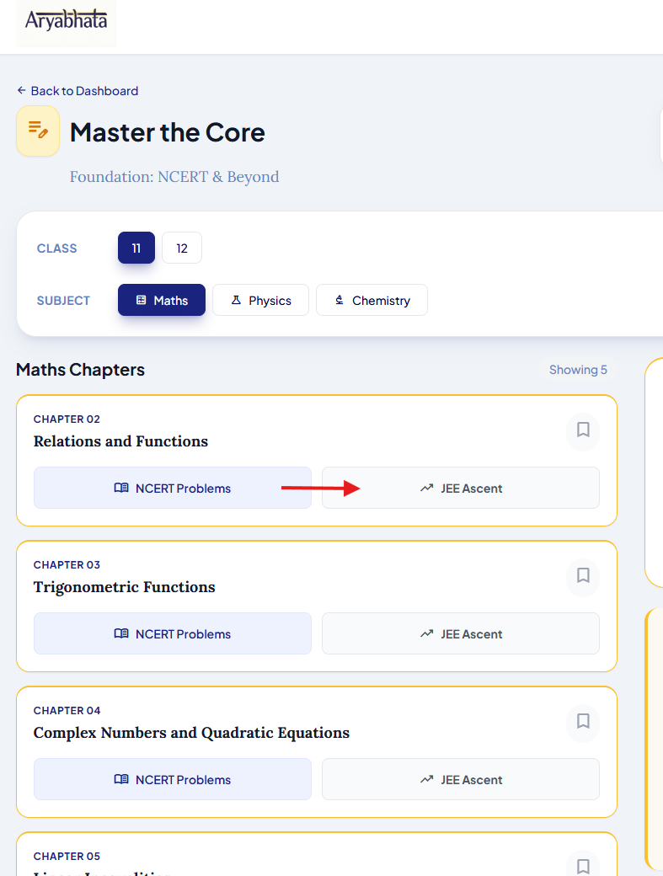

Functionality Details

How does it manifest for the user?
The straight forward way is by using the JEE Ascent feature.
We should also allow user to transition from NCERT Exercise to JEE Ascent problems. This can be achieved in few ways:
- When they are done with that chapter’s exercise, we nudge the user to pick problems which will gradually take them to JEE Main level problems. This will also take them to JEE Ascent.
- This option needn’t be strictly JEE Ascent, but of the NCERT exercise problems, we identify those which have close proximity to JEE Main problems. When user encounters those problems, we tell them that this is close to a JEE Main problem and users can jump to the relevant JEE Main problems. In this case it shouldn’t disrupt the exercise flow and user can clearly dismiss and return back to the NCERT workflow.

Experience
Similar to NCERT Exercise, this will be one question at a time kind of browsing feature. This will present problems in increasing level of difficulty and pattern.
We cannot have all problems in our Question bank thrown at the user. We should have a way in which if we feel the user is confident of a difficult level and they have covered all patterns at that difficulty level, then we suggest them to go to next level. We should allow users to skip their way into subsequent patterns and level.
We provide indicators to the user that they are at a certain difficulty level (maybe color coding and/or nomenclature). We show the difficulty levels prominently like a progress bar.
In subsequent iterations, we will allow users inline real-time feedback facility. However, in the 1st version, we will park this feature as this requires exclusive attention.
We will also introduce spot quizzes in subsequent versions.
In the absence of such evaluations, how do we know user’s confidence that we move them from one-level to another? Should we make educated guesses based on their navigation pattern or we ask them explicitly? A combination of both might be good. We ask them when we feel the educated guess crosses a confidence threshold.

Solution
The overall solution could potentially involve multiple independent modules. This might likely be a mix of offline and online components. Few things are quite key:
- We have to create a question bank from which the questions will be drawn and rendered
- The solutions for them also should be cached, so that users get a snappy feature

Key Modules
- Content – Question Bank Creation with meta information
- Concept Index and Topic Hierarchy for NCERT
- Tagging Questions to Concepts and Topics
- Question Generation Model
- Solution Model

Content – Question Bank Creation with Meta information
While having good content is ideal for this work, in the initial phases we are not going to have published content. Hence, we will rely on open sources to build the feature in the initial versions. We can imagine three sources:
- JEE Main official questions scraping with answer key - https://jeemain.nta.nic.in/ . We should tag them with the meta information – source, date, id etc.
- Open sets in the net
- If there are sites with open questions, we scrape them
Note that we are interested in JEE Main.
We create a Question Bank of these questions with source and meta information tagging.
We also need to create a proper structure for this – for eg. JEE Main site provides them as Question Papers with proper IDs and meta information. We need to hence have QuestionPaper as Entity with Questions as sub-entities. This may appear like a RDBMS structure. But we can adopt a structure which helps rendering online easily/snappily.

Concept Index and Topic Hierarchy for NCERT
The JEE Ascent feature is about taking a student from a Chapter in NCERT to JEE Main problems. The solutions themselves might involve highlighting the key concepts, formulas, examples etc. So, tagging questions back to the relevant topic/chapter from NCERT book is key.
- Hence, we need to create an index of concepts from NCERT. Should this be done hierarchically? Class->Chapter->concepts->Examples?
- Should the index be Vector?
- How can this be hierarchical if hierarchy is needed?

Tagging Questions to Concepts and Topics
We tag every question in the Question bank with:
- Meta information – properties from the source and that identifies the source itself
- Indexes to the Concept from NCERT. This could be:
  - Subject
  - Class->Chapter-Concept (this can be multiple tags to accommodate for multi-discipline)
  - Difficulty level (enum)
  - It would be interesting to know if we can identify patterns amongst questions and tag them

Question Generation Model
We expect the sources to provide some questions. But we would need substantially a greater number of questions to be able to provide this feature. The data collected may also be sparse. Hence, we need to be able to Generate Questions. However, this might be prohibitive to do it real-time. Hence, we generate and store it as part of Question Bank – but with the ability to distinguish them.
The model should be able to generate questions for a given subject, class->chapter->concept hierarchy, difficulty level (and potentially pattern going forward, in subsequent iterations)
We can initially rely on LLM like Gemini or GPT or Claude. But we need fine grained control over quality and also have scale. Hence, we can consider fine tuning and optimizing the model. The other main reason for considering fine tuning is that the output should be as if a teacher has come up with the questions. We can potentially use RLHF type of mechanism to make it realistic

Solution Model
We need solution for every question in the Question bank. We can consider pre-generation of solutions for every problem (like we do for NCERT problems) and store, for snappy application.
Today Solution is presented in two other places as well– practice session (NCERT Exercise) and in Student Feedback functionalities. In both the places we have two different prompts which are functional. We need to standardize across all 3 surfaces. However we can do in phase II of iteration of this feature. For now, we can possibly copy the implementation from the Practice session one, which is in the pipeline for School data extraction (multi-step) - pipelines\ExtractionPipeline\SchoolDataExtraction\MultiStep

Schematic representation
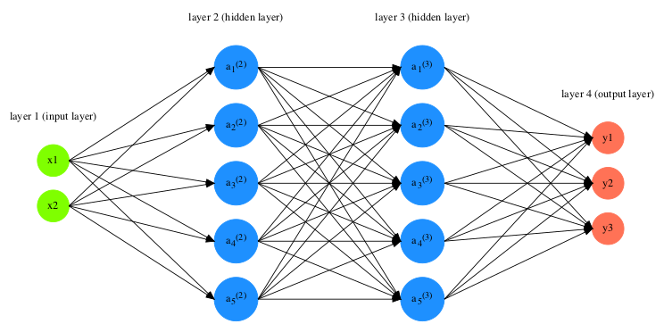
NCERT

Azure Storage and Postgresql
NCERT Exercises, Questions & Chapter PDFs
Vector Index of NCERT Chapters, Topics
Question Bank
Crawl & Scrape from Net
Tagging
Question Generation & Solution Model

