PREDICTING AIR QUALITY INDEX (AQI) IN SHANGHAI THROUGH USE OF WEATHER DATA
Introduction
Much of the recent attention paid to climate change has been in regard to either the role of human behavior in increased greenhouse gas emissions, or to the effects of this change on the environment, for instance, in the form of increased wildfires or coastal erosion. Less consideration has been given to potential environmental causes potentially amplifying the effect of human pollution sources, as represented in the Air Quality Index (AQI) metric.
This project explores that topic through the use of weather data collected in the city of Shanghai over the period of time between January 1, 2014, and January 31, 2021. The dataset, “Shanghai air pollution and weather 2014-2021”, is analyzed through three regression techniques: Principal Components Analysis/Regression (PCA/PCR), Robust Regression (RR, aka Iteratively Reweighted Least Squares) and Partial Least Squares (PLS) in search of answers to the following research questions:
- Which weather variables are most important in predicting air quality?
- How well do these variables predict air quality?
Answers to these questions are meant to inform meteorologists, as well as the Environmental Protection Agency (EPA) responsible for calculating the AQI, on the (presumably negative) role of daily weather phenomena in changing levels of air pollution. This information could lead to an improvement in computation of the AQI, and potentially additional ways to mitigate climate damage.
Data Preparation
Cleaning
The data set consists of 3 separate .csv files joined to provide 2,587 observations of 25 different variables broken down as follows: 19 quantitative weather related variables (temperature, wind speed, etc.), 3 date/time variables, 2 character variables involving time of day, and the response variable, the daily value of AQI reported. Observations reflect calendar days from 1/1/2014-1/31/2021. Date was converted to a quantitative variable representing number of days since 1/1/1970 (default value in R). The four times variables – sunrise/sunset and moonrise/moonset – were also converted number of minutes since 12:00 AM. Variables ‘location’ – constant value of ‘Shanghai’ – and ‘totalSnow_cm’ – all but 100 or so of the values of which were 0 – were dropped. 85 rows had missing data from either ‘AQI’, ‘AQI_Explained’ (not used here), ‘moonrise’, or ‘moonset’. NA values were imputed using, for simplicity’s sake, the Last One Carried Forward (LOCF) method.
Exploration and Transformation
High correlations were expected among many of these variables. For example, many variables were valued in degrees Celsius, and to an extent were all derived from the same daily temperature measurement. Two negative correlations stood out: ‘pressure’ and ‘sunrise’ varying inversely with temperature. Correlations are shown below in Figure 1. Additionally, significant non-normality was seen in all variables – all gave p < 0.05 values when subject to a Shapiro-Wilk test. Two right-skewed variables, ‘WindGustKmph’, and ‘precipMM’, were log-transformed. Many other, though not all, variables were transformed using a BoxCox optimized lambda exponent. Finally via Variance Inflation Factor values, the variable ‘maxtempC’ was dropped as it was found to be an alias of ‘mintempC’.
Principal Components Analysis (PCA)
Use of PCA was motivated by heavy multicollinearity as well as for dimension reduction for ease of interpretation and identification of a small subset of variables which serve to explain most of the variability. The scree plot in Figure 2 reveals that the first 8 PCs served to explain PVE = 90% of the variability. However, this is perhaps not quite at the elbow of the plot, which seems to occur more at 12 or 13 PCs. This will to an extent correspond to optimal hyperparameters in the next section.
Figure 3 is a biplot in PC1-PC2 space highlighting those variables with higher loadings in the two components. Perhaps the most prominent patterns are 1) the highest loadings in PC1 (top 6 in fact) all correspond to Celsius/temperature measurements, with similar coefficients; and 2) there is a sharper difference among the highest loadings in PC2. The top 4 – ‘cloudcove’, ‘humidity’, ‘log_precipMM’, and ‘visibility’ – all relate, either directly or indirectly, to some idea of rain or moisture in the atmosphere. Intuitively, this makes sense: heat and sunlight are what cause the chemical reactions that produce, most notably, ozone (O₃); contrarywise, rain and atmospheric water vapor can dissolve or wash away particulate matter. These two – ozone and particulate matter – are deemed the most common factors affecting air quality.
Modeling – PCR, PLS, RR
Cross Validation for Selection and Assessment
Initially, only RR was the only supervised method chosen for analysis. Once the difficulty of manually eliminating multicollinearity became clear, however, the two principal component regression methods were added, as principal components by definition remove multicollinearity among predictors/components.
Four models in total were fitted: two RR models, one using all predictors and one using all predictor variables, and one using PC1 and PC2 from above as predictors; one PCR model; and one PLS model. Tuning parameters included ‘INTERCEPT’ (TRUE/FALSE) and ‘psi’ (huber/tukey/hampel weights) for the RR models, and ‘ncomp’ (number of PCs from 1-23) for the PCR and PLS models. 10-fold cross validation was conducted on all models with the full range of all tuning parameters used. Variable importance in the PCR and PLS models is shown in Figures 4-5. It is interesting to compare the important variables here with what we concluded about important variables in the PCA. PCR variable importance seems to resemble that of PC1, in that the most important variables are all temperature/Celsius measurements, followed by a gradual decline in importance. PLS, on the other hand, has most important variables roughly corresponding to those with higher loadings in PC2 – namely, the “moisture” related variables such as ‘log_precipMM’, ‘humidity’, and ‘cloudcover’. A more visible drop in importance then occurs for most of the temperature-related variables. ‘mintempC’, the lowest temperature recorded on a given day, seems to be the only important variable in every case.
Fitting the Best Model
The lowest RMSE occurred in the RR model using all predictor variables in the final, cleaned dataset. Optimal tuning parameters were ‘INTERCEPT = TRUE’ and ‘psi = psi.hampel’. This model was subsequently fit on the entire data set, and resulted in an R² value of 0.31. This was within about 0.01 of values for both the PCR and PLS models, and about twice the R² for the PC1 + PC2 model.
An additional outer layer of 10-fold cross validation was performed to assess performance of the selection process. This produced an R² value of about 0.30. Thus, we have not found a model well-suited for predicting AQI using the given weather metrics.
Conclusions and Recommendations
It is difficult to make decisive recommendations based on the present results. Our best models were without exception the least interpretable. Perhaps it is enough to have recognized some signal here, based off of which improvements could be made through either subset selection or new metrics.
It should be noted that ‘date-time’, the date of every observation, only served as the most important variable in the case of the PLS model. However, it is clear this plays a role, if only indirectly, in AQI levels, to the extent that the temperature changes seasonally in a given location. This seasonality was not addressed in the present analysis. Nor was any accounting done for effects of the COVID pandemic on AQI levels, which effects may have resulted in lower/better air quality via reduction in human produced air pollution. Predictive ability might be improved by accounting for both of these.
Further, included in the data were also individual measurements of the molecules most responsible for air pollution, including ozone and particulate matter, along with carbon monoxide, nitrogen dioxide, and sulfur dioxide. The effects of weather on air quality might be seen in a different light were we to choose these as response variables. Moreover, a categorical variable, ‘AQI_Explained’, divides AQI measurements into five categories ranging from ‘Moderate’ to ‘Hazardous’. Prediction might improve if we looked at this as a classification problem using different supervised methods. A third way we might improve the model is by separately looking at the ‘temperature’ vs ‘moisture’ related variables as we have roughly defined them.
A final caveat in interpreting our model has to deal with evidence of non-normality in the data. We are not burdened by this with unsupervised methods which make no statistical inference, but we do have to account for it when doing regression. The majority of the variables exhibited non-normal distribution, and this in rather different ways, and we can’t be certain that Box Cox transformations entirely solved this issue for us.
Overall, we seem not to have found a way to accurately predict air quality with weather data. An R² of 0.30 does not suggest a strong correlation. However, perhaps this is not as useless as it seems. We might look at weather phenomena less as a determinant of air quality and more as an amplification of the human effect on air quality. Sunlight and heat are not directly responsible for producing greenhouse gases; rather, it is the nitrogen oxides and hydrocarbons present in the air that react to form ozone in the presence of sunlight and heat. Thus, as long as we know that increasing temperature leads to increased air pollution, we can take action. And there really is only one action here, which is to eliminate hazardous gas emissions. This seems obvious, but it remains the principal course of action to break the cycle of air pollution leading to higher temperatures which lead to greater air pollution, and the present study reinforces the need for that action.
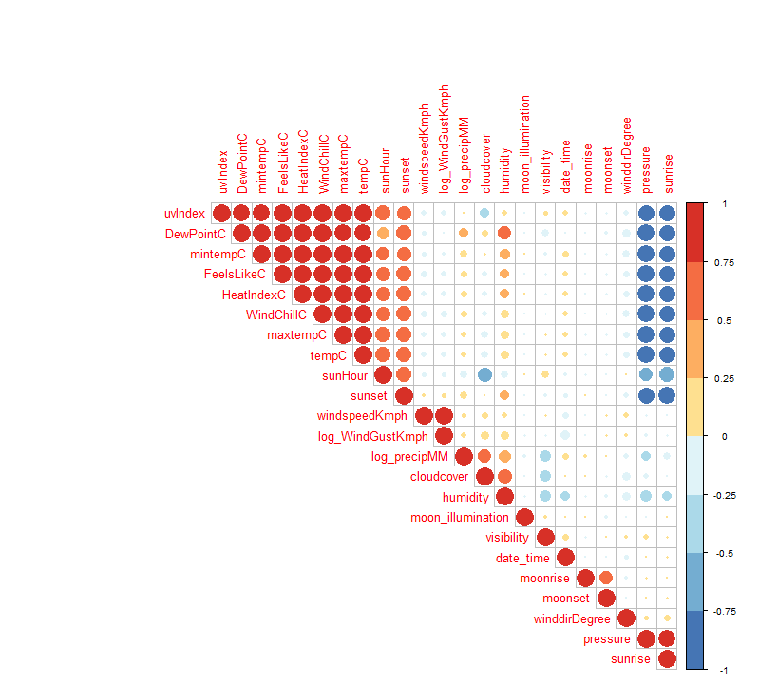
Figure 1 - Correlation plot of all predictors (red = positive cor., blue = neg.
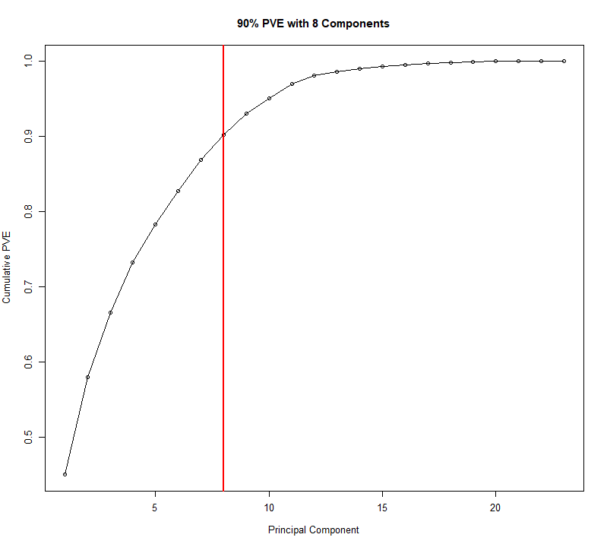

Figure 2 - PVE by number of PCs. 8 PCs covers 90% of variability.
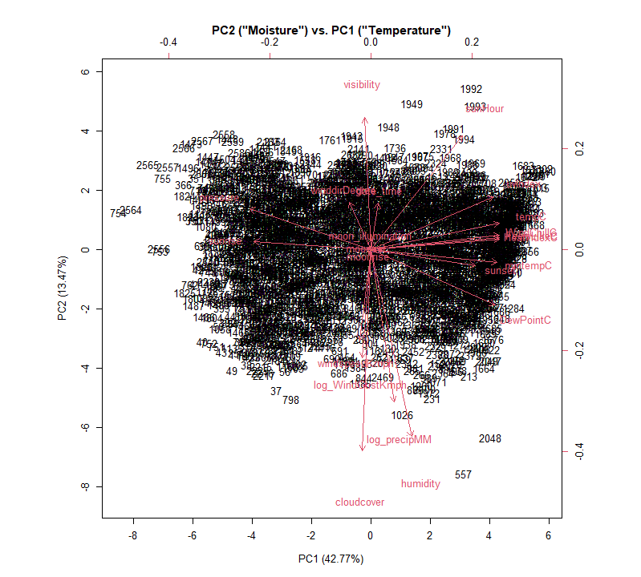 Figure 3 - Biplot of first two PCs. Rightward = higher PC1 loading. Upward = higher PC2 loading. Percentages are PVEs.
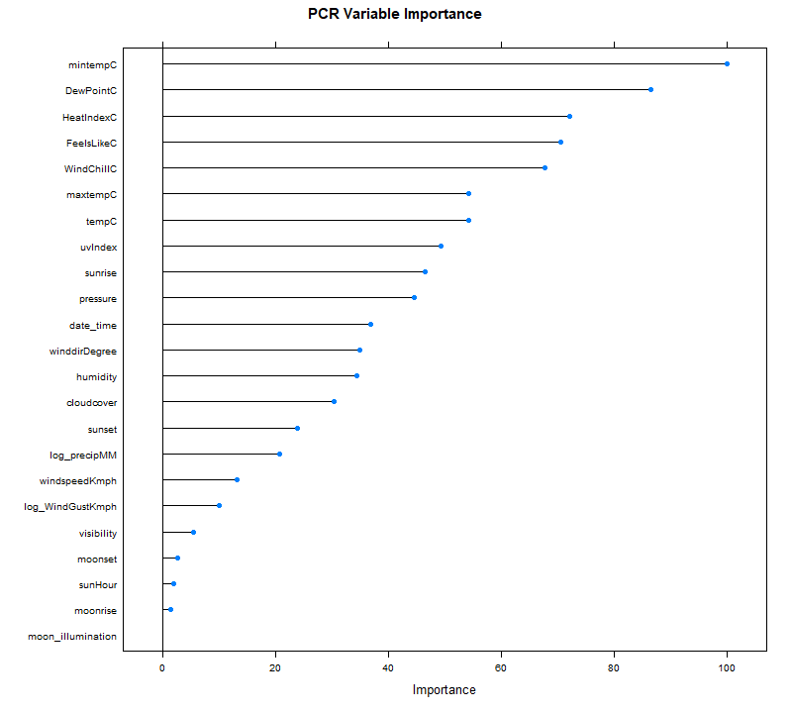 Figure 4 - Variable importance in PC regression.
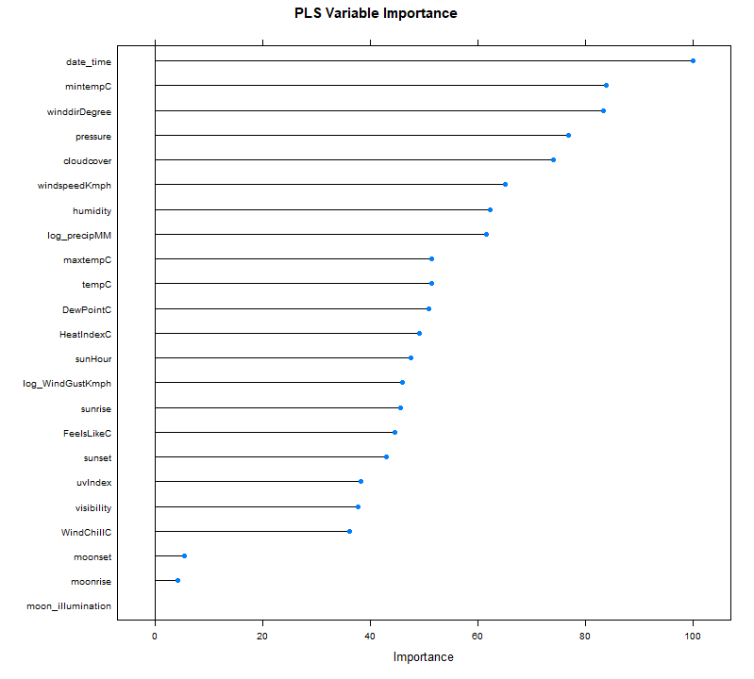
Figure 5 - Variable importance in Partial Least Squares regression.

https://www.weather.gov/wrn/summer-article-clearing-the-air

