# SEO On-Page Recommendation

**For**

**[www.newmika.co.in](http://www.newmika.co.in)**

**Prepared By:**

**SEO TEAM**



**Dated**

**24-Nov-2017**

**Remove 301 Redirection**

**Issue -** The page <https://www.newmika.co.in/blog/> is 301 redirect to the home page which is not good.

**PFB screenshot for ref.**

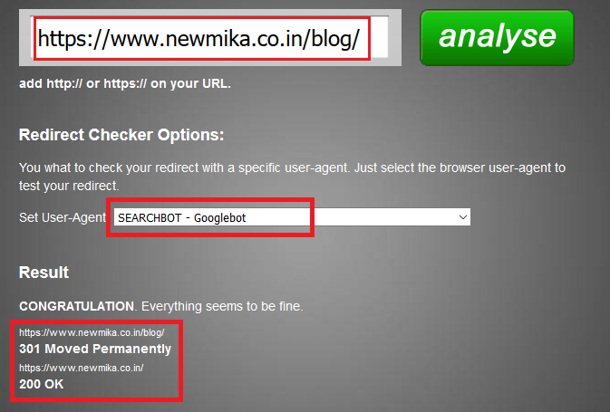

**Plan of action -** Please remove the redirection of the blog page from the home page of the website.

**Un- Relevant Page found**

**Issue -** While analysis the website we have found some unrelated web pages which are mention below:

**Webpages:**

<https://www.newmika.co.in/facebook/>

<https://www.newmika.co.in/twitter/>

<https://www.newmika.co.in/pinterest/>

<https://www.newmika.co.in/mail/>

Above page is not related to the website.

**For ex.-** <https://www.newmika.co.in/facebook/>

**PFB screenshot for ref.:**

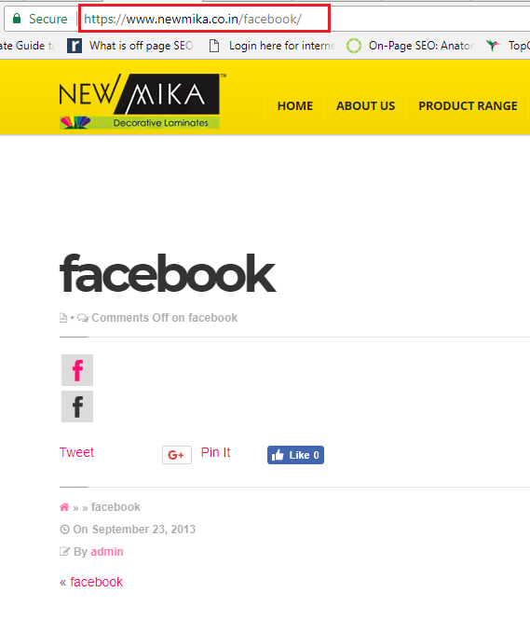

**Plan of Action:** Please remove the above mentioned pages from the server.

**Social Links Error**

**Issue:** We found social icons are added in the body section of the web pages with wrong URL.

Which is not good as per SEO purpose.

**Ex.** When we open the webpage: <https://www.newmika.co.in/bedroom/>

We can see in below screenshot the social icon are added in content part which are linked with the wrong URL.

PFB screenshot for ref.

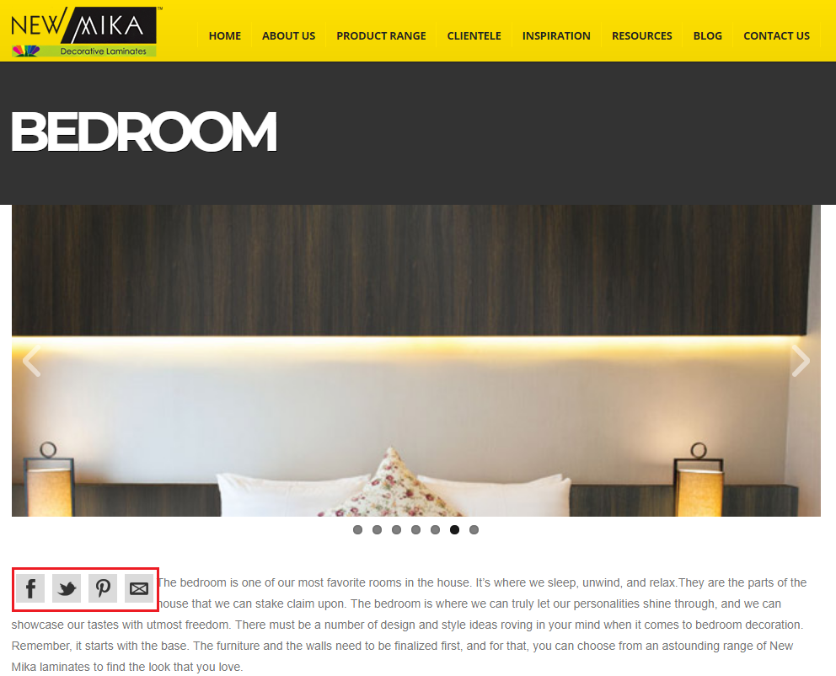

**Plan of action:** Please remove the social icons from the body section of the whole website.

We recommend to add social icons in the Header/Footer of the website.

Also, add the respective social profile link in their relevant social icons.

**i.e.**

Facebook: <https://www.facebook.com/GreenlamLaminate>

Twitter: <https://twitter.com/greenlam01>

You tube: <https://www.youtube.com/user/greenlamlaminates>

Google+: <https://plus.google.com/+GreenlamLaminatesIndia>

**Note:** As we know above social links are external links so please apply “**Nofollow**” attribute for all respective links.