**Docker: / comes into picture at deployment stage.**

* Docker is tool designed to make it easier to create, deploy and run applications by using containers.
* Containers allow a developer to package up an application with all parts it needs, such as libraries and its other dependencies and ship it all out as one package.
* Docker containers are lightweight alternatives to Virtual Machines, and it uses the host Operating System.
* Docker has client-server architecture. (command line is client and Docker daemon is server which contains containers together is called Docker Engine).
* Docker daemon (server) receives commands from docker client through CLI or REST API’s.

**Dockerfile:** is used to create a docker image(contains actual code, libraries, binaries and dependencies).

**Dockerfile** builds a **Docker image** and **Docker image** are run-time instance of the docker image. (contains actual code, libraries, binaries and its dependencies).

We can run **Docker image** to create as many **Docker containers** we want**,** then this docker images can be uploaded on **Docker Hub (**is like Git repository)from **Docker hub** any one can pull the **Docker images** and **build a Docker container.**

* **\*Docker can build images automatically by reading the instructions from Dockerfile.**
* **\*Docker containers are running instances of Dockers images.**
* **\*A Single Docker image can be used to create multiple containers.**

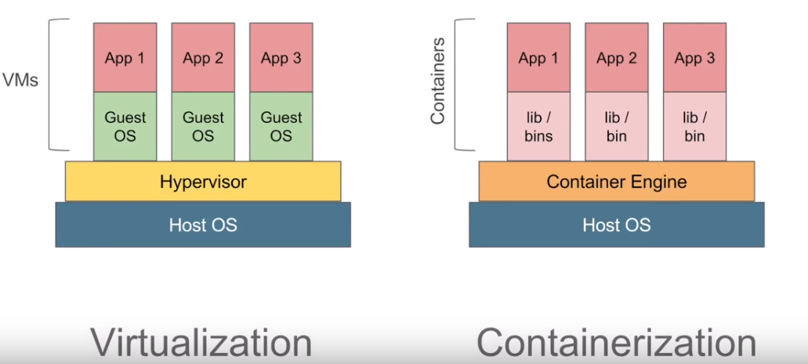

**Install the Docker on windows:**

If we install the Docker Toolbox on a Windows machine, the installer automatically installs Oracle VirtualBox to run Docker virtual machine.

* download from **docker toolbox** for Windows > Click “Get Docker for Windows“ to download
* go to **Docker Quickstart** -- (command line).

**How to create docker file:** is a simple test file with instruction to build image.

Steps:

* Create a file named Dockerfile without any extension.

FROM

MAINTAINER chakra <[ballachakri@yahoo.com](mailto:ballachakri@yahoo.com)>

RUN apt-get update

CMD [“echo”, “hello world”]

* To build docker image

docker build -t myimage:1.0.0 .

Then we will get a docker image ID

* To run docker image

docker run <image ID>

**How to pull image:** images are templates used to create docker containers. container is an running instance of image. Images are stored in registries.

* docker image -v
* docker image – help
* docker pull <imagename>

**How to run a container using an image:**

* docker run <dockerimagename>

**Docker commands:**

**Basic**

Docker –version ---- to get docker version info

Docker ---- to view all the docker commands

Docker -v ---- to get docker version

Docker info ---- to get more detailed info about docker

Docker - - help ---- info about commands

Docker login ----

**Images**

Docker images ---- to get list of images

Docker pull <image name> ---- to pull the image from the repository

Docker rmi <image name> ---- to remove image

**dockerContainers**

Docker ps ---- to get the list of containers

Docker run ---- to run the image

Docker start ---- to run one or more stopped containers

Docker stop ---- to stop one or more stopped containers

**System**

Docker stats ---- display a live stream of containers (s) resource usage stats.

Docker system df ---- shows the disk usage

Docker system prune ---- remove unused data

**How to create Dockerfile ?**

Dockerfile is a text file where give instructions to create images.

Step 1 :

we need to create a file named Dockerfile( file name can be any).

We do to desktop and create folder by DockerFiles

>mkdir DockerFiles

> then go into that folder.