Monty Sourjah

CPE 301 Spring 2018

Assignment01

February 20th, 2018

|  |  |  |  |  |  |
| --- | --- | --- | --- | --- | --- |
| |  |  | | --- | --- | |  |  | |  | NOTDIVBY5  RAM | | START  Prepare transfer of  data from Flash to  STARTADDS  STARTADDS  RAM  Flash  memory  Copy 300 bytes from Flash  memory to STARTADDS  Initialize the  Parsing Stage  Read byte from STARTADDS  Is divisible By  5  ?  DIVBY5  RAM  Store in  DIVBY5  Store in  NOTDIVBY5  YES  NO  ReadBytes=ReadBytes‐1  Have we parsed  all 300 bytes?  NO  Initializethe SUMS  stage. Set that both  types of Sums need to be  done.  Readbyte from  DIVBY5 Ram.  Sum its value to sum  of multiples of 5.  Sumsof multiples  of 5 to do?  YES  Sumsof non‐  multiples of 5 to do?  NO  Readbyte from  NOTDIVBY5 Ram.  Sum its value to sum of  non‐multiples of 5.  YES  Have we summed  all 300 bytes?  NO  NO  END  YES |

Task 1

YouTube:

<http://www.youtube.com/watch?v=Ct_UrOCpdOA>

1. Store 300 numbers starting from the STARTADDS=0x0222 location. Populate the value

of the memory location by adding high(STARTADDS) and low(STARTADDS) . Use the X/

Y/Z registers as pointers to fill up 300 numbers.

Start:

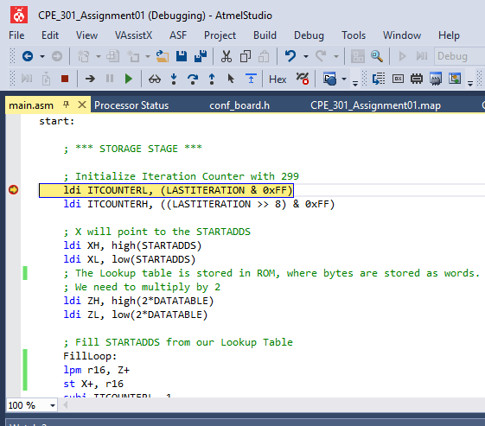

End Task1:

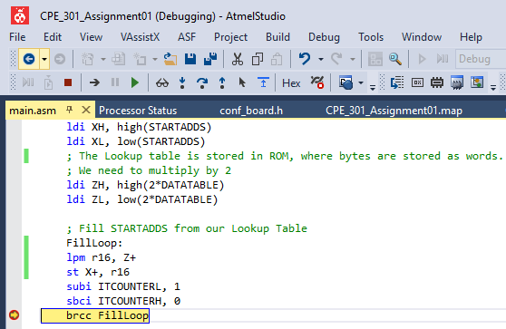

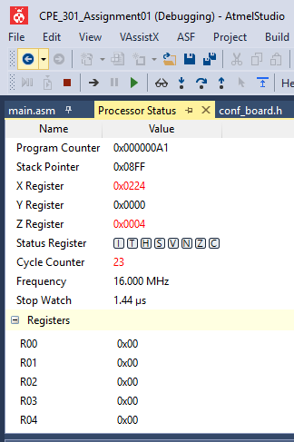

Task 2

YouTube:

<http://www.youtube.com/watch?v=h0SaDDK3-ZE>

2. Use X/Y/Z register addressing to parse through the 300 numbers, if the number is

divisible by 5 store the number starting from memory location 0x0400, else store at

location starting at 0x0600.

Start:

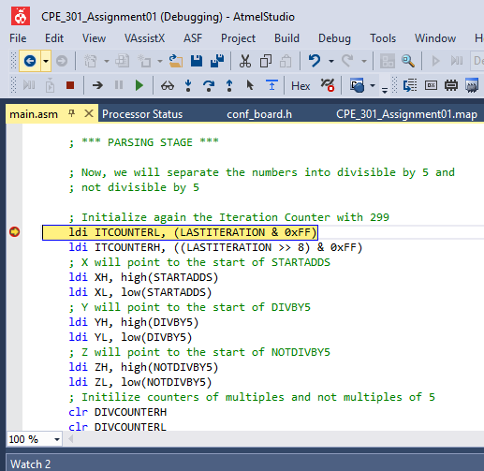

End:

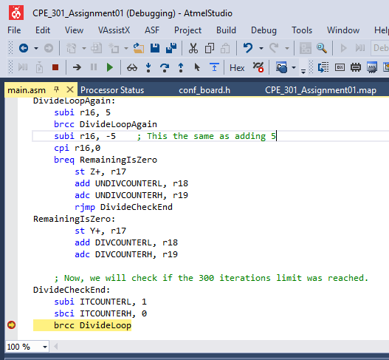

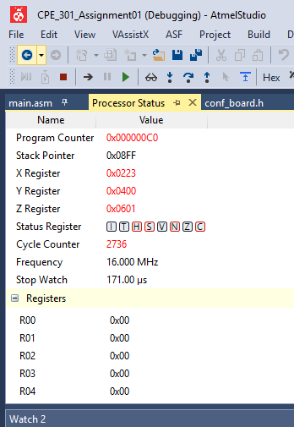

Task 3

YouTube:

<http://www.youtube.com/watch?v=6zldWbikCCs>

3. Use X/Y/Z register addressing to simultaneously add numbers from memory location

0x0400 and 0x0600 and store the sums at R16:R17 and R18:R19 respectively. Do not

worry about the overflow.

Start

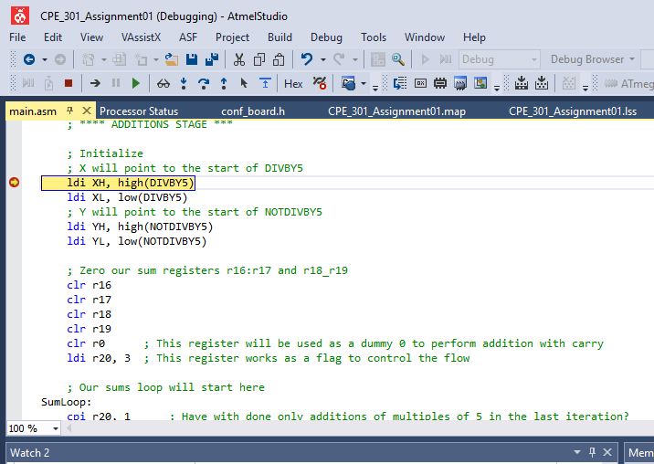

End

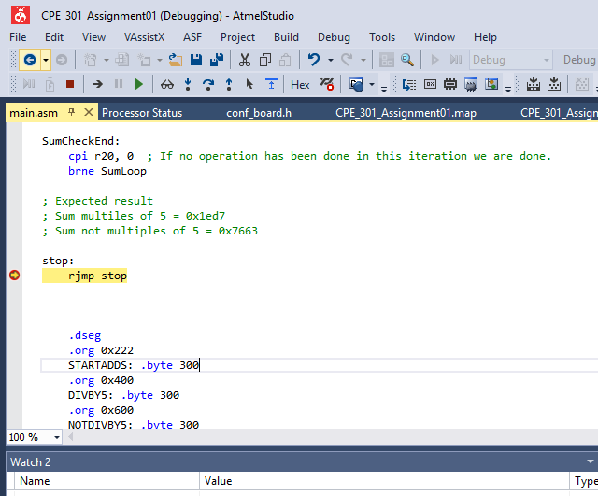

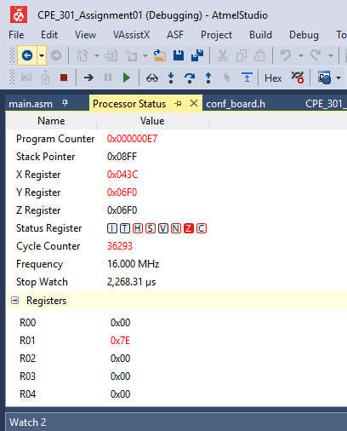

4. Verify your algorithm and answers using C programming.

YouTube:

<http://www.youtube.com/watch?v=bOPfRgrXpfA>

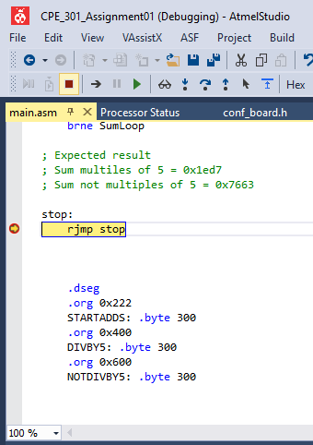

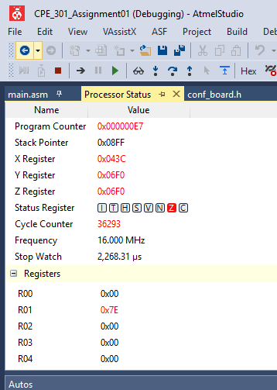

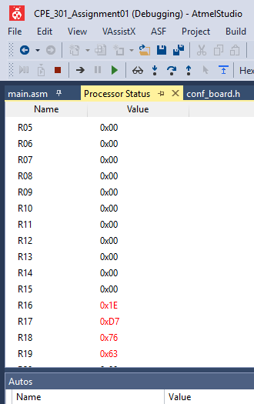

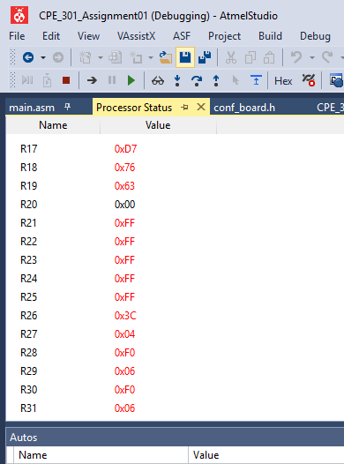

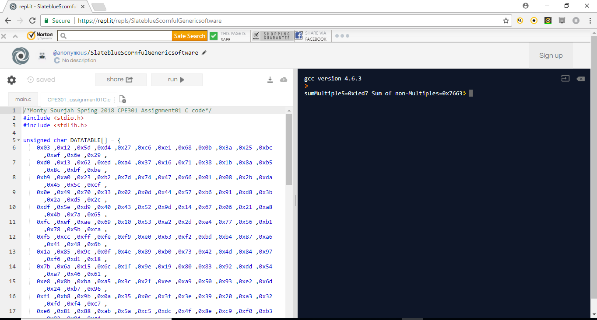

5. Determine the execution time @ 16MHz/#cycles of your algorithm using the simulation.

Execution time=2268.31 micro seconds.

YouTube:

<http://www.youtube.com/watch?v=lFr_WaelxB8>

