Program 1: Write a program that prints the message "Hello, World!

Flow Chart

Declare Variable: message

print message

Assign value: message=”Hello, World”

**Algorithm:**

1. **Start**
2. **Define** a variable named message and assign the string value "Hello, World!" to it.
3. **Print** the value of the message variable to the console.
4. **End**

Output of Program:



|  |  |
| --- | --- |
|  | Program 1: Write a program that prints the message "Hello, World! |
|  |  |
|  | def main():  message="Hello, world"  print(message)  if __name__ == "__main__":  main() |
|  |  |
|  |  |
|  |  |
|  |  |
|  |  |
|  |  |
|  |  |
|  |  |
|  |  |
|  |  |
|  |  |
|  |  |
|  |  |
|  |  |
|  |  |
|  |  |
|  |  |
|  |  |
|  |  |
|  |  |
|  |  |
|  |  |
|  |  |
|  |  |
|  |  |
|  |  |
|  |  |
|  |  |
|  |  |
|  |  |
|  |  |
|  |  |
|  |  |
|  |  |
|  |  |

Program 2: Write a statement in Python IDLE to view the list of Python keywords.

Flow Chart

**Import the keyword module:**

print kwlist

**Access the kwlist attribute:**

Algorithm:

1. **Start**
2. Import the keyword module:
3. Access the kwlist attribute:
4. Print the kwlist:
5. **End**

**Output of Program:**

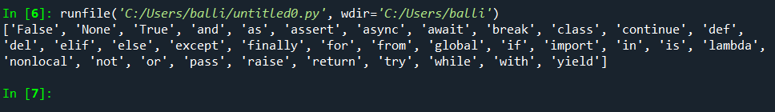

|  |  |
| --- | --- |
|  | Program 2: Write a statement in Python IDLE to view the list of Python keywords. |
|  | import keyword # Importing the keyword module to access Python's reserved keywords  def main(): # Defining the main function  print(keyword.kwlist) # Printing the list of all Python keywords  if __name__ == "__main__": # Checking if this script is being run directly  main() # Calling the main function |
|  |  |
|  |  |
|  |  |
|  |  |
|  |  |
|  |  |
|  |  |
|  |  |
|  |  |
|  |  |
|  |  |
|  |  |
|  |  |
|  |  |
|  |  |
|  |  |
|  |  |
|  |  |
|  |  |
|  |  |
|  |  |
|  |  |
|  |  |
|  |  |
|  |  |
|  |  |
|  |  |
|  |  |
|  |  |
|  |  |
|  |  |
|  |  |
|  |  |
|  |  |
|  |  |
|  |  |

Date

Page No.

Program 3: Write a code that prints your full name and your birthday as separate strings in Python.

Flow Chart

Call main Function

Print the full name: "Balwinder Singh Balli" Print the birthday: "Birthday: April 8, 1980"

**Define the main function**

Algorithm:

1. Start
2. Define a function named main.
3. Inside the main function:

Print the full name: "Balwinder Singh Balli"

Print the birthday: "Birthday: April 8, 1980"

1. call the main function.
2. End

**Output of Program:**

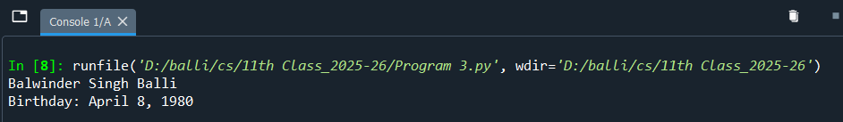

|  |  |
| --- | --- |
|  | Program3: Write a code that prints your full name and your birthday as separate strings in Python.  def main(): # Defining the main function  print("Balwinder Singh Balli") # name as Separate string  print("Birthday: April 8, 1980") # Birthday as Separate String  if __name__ == "__main__": # Checking if this script is being run directly  main() # Calling the main function  Date  Page No. |
|  |  |
|  |  |
|  |  |
|  |  |
|  |  |
|  |  |
|  |  |
|  |  |
|  |  |
|  |  |
|  |  |
|  |  |
|  |  |
|  |  |
|  |  |
|  |  |
|  |  |
|  |  |
|  |  |
|  |  |
|  |  |
|  |  |
|  |  |
|  |  |
|  |  |
|  |  |
|  |  |
|  |  |
|  |  |
|  |  |
|  |  |
|  |  |
|  |  |
|  |  |
|  |  |
|  |  |
|  |  |

Program 4: Write a program that asks two people for their names, stores the names in variables name1 and name2, and says hello to both of them.

**Input:** The first-person name.

**Input:** The second-person name.

**Store** the first person's name

in variable name1.

**Store** the Second person's name in variable name2.

**Output:** print variable name1

the greeting message: "Hello, name1!"

**Output:** print variable name2 with the greeting message: "Hello, name2!"

**Algorithm: Say 'hello' to greet two people**

1. **Start**
2. **Input:** The first-person name.
3. **Store** the first person's name in variable name1.
4. **Input:** The second-person name.
5. **Store** the second person's name in variable name2.
6. **Output:** **print Variable name1 with**

the greeting message: "Hello, name1!"

1. **Output:** **print Variable name2 with**

the greeting message: "Hello, name2!"

1. **End**

Output of Program :

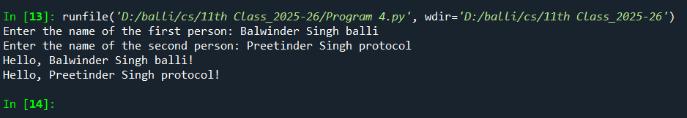

|  |  |
| --- | --- |
|  | Program 4: Write a program that asks two people for their names, stores the names in  variables name1 and name2, and says hello to both of them.  Date  Page No. |
|  |  |
|  |  |
|  | def main(): # Defining the main function  # name1 variable declaration  # Asking for the first person's name  **name1** = input( "Enter the name of the first person: " )  # name2 variable declaration  # Asking for the second person's name  **name2** = input("Enter the name of the second person: ")  # Saying hello to both people  print("Hello, " + name1 + "!")  print("Hello, " + name2 + "!")  if __name__ == "__main__": # Checking if this script is being run directly  main() # Calling the main function |
|  |  |
|  |  |
|  |  |
|  |  |
|  |  |
|  |  |
|  |  |
|  |  |
|  |  |
|  |  |
|  |  |
|  |  |
|  |  |
|  |  |
|  |  |
|  |  |
|  |  |
|  |  |
|  |  |
|  |  |
|  |  |
|  |  |
|  |  |
|  |  |
|  |  |
|  |  |
|  |  |
|  |  |
|  |  |
|  |  |
|  |  |
|  |  |
|  |  |
|  |  |

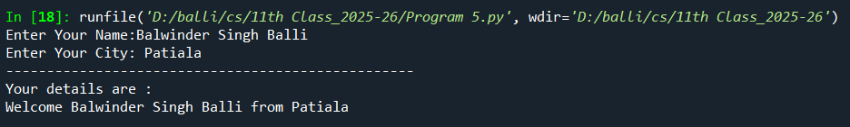

**Algorithm:**

1. **Start**: Begin the program.
2. **Prompt for Name**: Ask the user to input their name and store the input in the name1 variable.
3. **Prompt for City**: Ask the user to input their city and store the input in the name2 variable.
4. **Print Dotted Line**: Print a series of dashed lines for separation using the print() function.
5. **Print "Your details are:"**: Print the message "Your details are:" to introduce the user's information.
6. **Display Personalized Welcome Message**: Concatenate the name1 and name2 variables into a welcome message and print it in the format: "Welcome [name1] from [name2]".
7. **End**: End the program.

Program 5: Write a Python program prompts the user for their name and city, then displays a

personalized welcome message.

**Input:** The person’s name.

**Input:** Enter the City:

**Store** the person’s name

in variable name1.

**Store** the city in variable name2.

**Output:** print dotted line

**Output:** print greeting message: "Welcome” and name1 and from and name 2

**Output:** print “Your Details are:”

|  |  |
| --- | --- |
|  | Program 5: Write a Python program prompts the user for their name and city, then displays a  personalized welcome message.  Date  Page No. |
|  |  |
|  | def main(): # Defining the main function  # name1 variable declaration  **name1 =** input**("Enter Your Name:")** # Asking for the person's name  # name2 variable declaration  **name2 =** input**("Enter Your City: ")** # Asking for the person's City  print("--------------------------------------------------") # add doted line to console  print("Your details are:") # print message  print("Welcome " + name1 + " from "+ name2) # print final Message with detail  if __name__ == "__main__": # Checking if this script is being run directly  main() # Calling the main function |
|  |  |
|  |  |
|  |  |
|  |  |
|  |  |
|  |  |
|  |  |
|  |  |
|  |  |
|  |  |
|  |  |
|  |  |
|  |  |
|  |  |
|  |  |
|  |  |
|  |  |
|  |  |
|  |  |
|  |  |
|  |  |
|  |  |
|  |  |
|  |  |
|  |  |
|  |  |
|  |  |
|  |  |
|  |  |
|  |  |
|  |  |
|  |  |
|  |  |
|  |  |
|  |  |

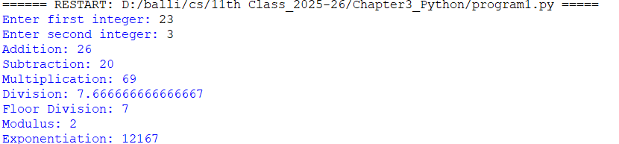

**Input:** enter the first integer.

**Input:** enter the Second integer.

**Store** first integer in variable num1.

**Store** the Second Integer in variable num1.

**Perform the following arithmetic operations: Addition, Subtraction, Multiplication, Division, Floor Division, Modulus and Exponentiation**

**Output:** print arithmetic operations Result

**Algorithm: Perform Arithmetic Operations on Two Integers**

1. **Start**
2. **Prompt the user** to enter the first integer → Store it in num1
3. **Prompt the user** to enter the second integer → Store it in num2
4. **Perform the following arithmetic operations and display the results**:
   * Add num1 and num2, display the result ("Addition")
   * Subtract num2 from num1, display the result ("Subtraction")
   * Multiply num1 and num2, display the result ("Multiplication")
   * Divide num1 by num2, display the result ("Division")
   * Perform floor division (num1 // num2), display the result ("Floor Division")
   * Find modulus (num1 % num2), display the result ("Modulus")
   * Perform exponentiation (num1 ** num2), display the result ("Exponentiation")
5. **End**

Chapter-3 Data Types, Operators & Expressions in Python

|  |  |
| --- | --- |
|  | Program 1: Write a program to enter two integers and perform all Arithmetic Operations on them.  Date  Page No. |
|  |  |
|  | *def main():*  *# Input from the user*  *num1 = int(input("Enter first integer: "))*  *num2 = int(input("Enter second integer: "))*  *# Performing arithmetic operations*  *print("Addition:", num1 + num2)*  *print("Subtraction:", num1 - num2)*  *print("Multiplication:", num1 * num2)*  *print("Division:", num1 / num2)*  *print("Floor Division:", num1 // num2)*  *print("Modulus:", num1 % num2)*  *print("Exponentiation:", num1 ** num2)*  # Call the main function  if __name__ == "__main__":  main() |
|  |  |
|  |  |
|  |  |
|  |  |
|  |  |
|  |  |
|  |  |
|  |  |
|  |  |
|  |  |
|  |  |
|  |  |
|  |  |
|  |  |
|  |  |
|  |  |
|  |  |
|  |  |
|  |  |
|  |  |
|  |  |
|  |  |
|  |  |
|  |  |
|  |  |
|  |  |
|  |  |
|  |  |
|  |  |
|  |  |
|  |  |
|  |  |
|  |  |
|  |  |
|  |  |

Chapter-3 Data Types, Operators & Expressions in Python

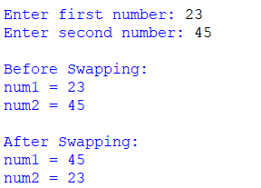

**Output:** print num1 and num2 after swapping

**Swap the values** of num1 and num2 using tuple unpacking: num1, num2 = num2, num1

**Output:** print num1 and num2 before swapping

**Store** the Second Integer in variable num2.

**Store** first integer in variable num1.

**Input:** enter the Second integer.

**Input:** enter the first integer.

**Input:** enter the first integer.

**Input:** enter the Second integer.

**Store** first integer in variable num1.

**Store** the Second Integer in variable num1.

**Perform the following arithmetic operations: Addition, Subtraction, Multiplication, Division, Floor Division, Modulus and Exponentiation**

**Output:** print arithmetic operations Result

**Algorithm: Swap Two Numbers Without Using a Temporary Variable**

1. **Start**
2. **Prompt the user** to enter the first number  
   → Store the value in variable num1
3. **Prompt the user** to enter the second number  
   → Store the value in variable num2
4. **Display the values** of num1 and num2 before swapping
5. **Swap the values** of num1 and num2 using tuple unpacking:  
   num1, num2 = num2, num1
6. **Display the values** of num1 and num2 after swapping
7. **End**

Program 2: Write a Python program to Swap two numbers.

Chapter-3 Data Types, Operators & Expressions in Python

|  |  |
| --- | --- |
|  | Program 2: Write a Python program to Swap two numbers.  Date  Page No. |
|  |  |
|  | def main():  num1 = int(input("Enter first number: "))  num2 = int(input( "Enter second number: "))  print( "\nBefore Swapping:" )  print( "num1 =", num1)  print( "num2 =", num2)  # Swapping without temporary variable  num1, **num2** = num2, **num1**  print( "\nAfter Swapping:" )  print( "num1 =", num1)  print( "num2 =", num2)  if __name__ == "__main__":  main() |
|  |  |
|  |  |
|  |  |
|  |  |
|  |  |
|  |  |
|  |  |
|  |  |
|  |  |
|  |  |
|  |  |
|  |  |
|  |  |
|  |  |
|  |  |
|  |  |
|  |  |
|  |  |
|  |  |
|  |  |
|  |  |
|  |  |
|  |  |
|  |  |
|  |  |
|  |  |
|  |  |
|  |  |
|  |  |
|  |  |
|  |  |
|  |  |
|  |  |
|  |  |
|  |  |

Chapter-3 Data Types, Operators & Expressions in Python

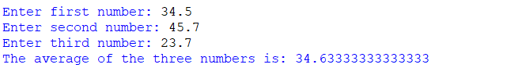

**Algorithm: Find the Average of Three Numbers**

1. **Start**
2. **Prompt the user** to enter the first number  
   → Store the value in num1
3. **Prompt the user** to enter the second number  
   → Store the value in num2
4. **Prompt the user** to enter the third number  
   → Store the value in num3
5. **Calculate the average** using the formula:  
   average = (num1 + num2 + num3) / 3
6. **Display** the result:  
   "The average of the three numbers is: average"
7. **End**

**Output:** print result of average of three number

arithmetic operations Result

**Calculate the average** using the formula:  
average = (num1 + num2 + num3) / 3

**Store** the Third Integer in variable num3.

**Input:** enter the Third integer.

**Store** the Second Integer in variable num2.

**Input:** enter the Second integer.

**Store** first integer in variable num1.

**Input:** enter the first integer.

Program 3: Write a Python program that asks three values to find average of three numbers.

Chapter-3 Data Types, Operators & Expressions in Python

|  |  |
| --- | --- |
|  | Program 3: Write a Python program that asks three values to find average of three numbers.  Date  Page No. |
|  |  |
|  | def main():  # Input three numbers from the user  num1 = float(input( "Enter first number: " ))  num2 = float(input( "Enter second number: " ))  num3 = float(input( "Enter third number: " ))  # Calculate average  average = (num1 + num2 + num3) / 3  # Display the result  print( "The average of the three numbers is:" , average)  # Call the main function  if __name__ == "__main__":  main() |
|  |  |
|  |  |
|  |  |
|  |  |
|  |  |
|  |  |
|  |  |
|  |  |
|  |  |
|  |  |
|  |  |
|  |  |
|  |  |
|  |  |
|  |  |
|  |  |
|  |  |
|  |  |
|  |  |
|  |  |
|  |  |
|  |  |
|  |  |
|  |  |
|  |  |
|  |  |
|  |  |
|  |  |
|  |  |
|  |  |
|  |  |
|  |  |
|  |  |
|  |  |
|  |  |

Chapter-3 Data Types, Operators & Expressions in Python



Program 4: Write a Program that asks radius (r) to find the area of circle.

**Calculate the area** of the circle using the formula: area = π × r × r

Import the Math package

**🔷 Algorithm: Find the Area of a Circle**

1. **Start**
2. **Prompt the user** to enter the radius of the circle  
   → Store the value in variable r
3. **Calculate the area** of the circle using the formula:  
   area = π × r × r  
   (Use π ≈ 3.14159 or use the math.pi constant)
4. **Display** the result:  
   "The area of the circle is: area"
5. **End**

**Output:** print The area of the circle is: area

**Input:** enter the radius.

**Store** the value in variable2

Chapter-3 Data Types, Operators & Expressions in Python

|  |  |
| --- | --- |
|  | Program 4: Write a Program that asks radius (r) to find the area of circle.  Date  Page No. |
|  |  |
| import math  def main():  # Input: Ask user to enter the radius  r = float(input( "Enter the radius of the circle: " ))  # Process: Calculate area using the formula: πr²  area = **math.pi** * r * r  # Output: Display the area  print("The area of the circle is:", area)  # Call the main function  if __name__ == "__main__":  main() |  |
|  |  |
|  |  |
|  |  |
|  |  |
|  |  |
|  |  |
|  |  |
|  |  |
|  |  |
|  |  |
|  |  |
|  |  |
|  |  |
|  |  |
|  |  |
|  |  |
|  |  |
|  |  |
|  |  |
|  |  |
|  |  |
|  |  |
|  |  |
|  |  |
|  |  |
|  |  |
|  |  |
|  |  |
|  |  |
|  |  |
|  |  |
|  |  |
|  |  |
|  |  |
|  |  |

Chapter-3 Data Types, Operators & Expressions in Python

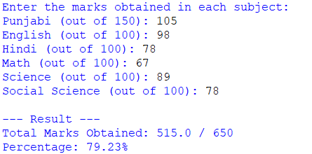

**Output:** print Total marks obtained &

Percentage

**Set total Max marks to 650 and calculate the Percentage**

Calculate percentage = (total_marks_obtained / total_max_marks) × 100

**Store** the input marks in Variables and Calculate the total marks and store in variable

Input**: "Input marks for Punjabi, English, Hindi, Math, Science & Social Science"**

Output**: "Enter marks..."**

**Algorithm**

1. **Start**
2. Display "Enter the marks obtained in each subject:"
3. Input marks for:
   * Punjabi (out of 150)
   * English (out of 100)
   * Hindi (out of 100)
   * Math (out of 100)
   * Science (out of 100)
   * Social Science (out of 100)
4. Calculate total_marks_obtained = sum of all marks
5. Set total_max_marks = 650
6. Calculate percentage = (total_marks_obtained / total_max_marks) × 100
7. Display:
   * Total marks obtained
   * Percentage
8. **End**

Program 5: Write a Program that asks the individual marks of subjects to calculate the percentage of marks of your 10th class result.

Chapter-3 Data Types, Operators & Expressions in Python

|  |  |
| --- | --- |
|  | Program 5: Write a Program that asks the individual marks of subjects to calculate the percentage of marks of your 10th class result.  Date  Page No. |
|  |  |
|  | def main():  print( "Enter the marks obtained in each subject:" )  # Input marks for each subject  punjabi = float(input("Punjabi (out of 150): "))  english = float(input( "English (out of 100): " ))  hindi = float(input( "Hindi (out of 100): " ))  math = float(input( "Math (out of 100): " ))  science = float(input( "Science (out of 100): " ))  social_science = float(input( "Social Science (out of 100): " ))  # Total and percentage calculation  total_marks_obtained = punjabi + english + hindi + math + science + social_science  total_max_marks = 650  percentage = (total_marks_obtained / total_max_marks) * 100  # Display result  print( "\n--- Result ---" )  print( f"Total Marks Obtained: {total_marks_obtained} / {total_max_marks}" )  print( f"Percentage: {percentage:.2f}%")  # Call the main function  If __name__ == "__main__":  main() |
|  |  |
|  |  |
|  |  |
|  |  |
|  |  |
|  |  |
|  |  |
|  |  |
|  |  |
|  |  |
|  |  |
|  |  |
|  |  |
|  |  |
|  |  |
|  |  |
|  |  |
|  |  |
|  |  |
|  |  |
|  |  |
|  |  |
|  |  |
|  |  |
|  |  |
|  |  |
|  |  |
|  |  |
|  |  |
|  |  |
|  |  |
|  |  |
|  |  |
|  |  |
|  |  |

Chapter-3 Data Types, Operators & Expressions in Python



Program 6: Write a program that asks for the temperature in degrees Celsius and converts it into Fahrenheit using the formula: F = C × 9/5 + 32.

Chapter-3 Data Types, Operators & Expressions in Python

**Output:** print **"<Celsius>°C is equal to <Fahrenheit>°F"**

Apply the conversion formula:  
**Fahrenheit = (Celsius × 9/5) + 32**

**Store** the input temperature in Variables Celsius

Input**: " enter temperature in degrees Celsius "**

Output**:** *"Temperature Converter: Celsius to Fahrenheit"*

**📋 Algorithm: Convert Celsius to Fahrenheit**

1. **Start**
2. Display the message: *"Temperature Converter: Celsius to Fahrenheit"*
3. Prompt the user to **enter temperature in degrees Celsius**
4. Read and store the input in variable Celsius
5. Apply the conversion formula:  
   **Fahrenheit = (Celsius × 9/5) + 32**
6. Display the result:  
   **"<Celsius>°C is equal to <Fahrenheit>°F"**
7. **End**

|  |  |
| --- | --- |
|  | Program 6: Write a program that asks for the temperature in degrees Celsius and converts it into Fahrenheit using the formula: F = C × 9/5 + 32.  Date  Page No. |
|  |  |
|  | def main():  print( "Temperature Converter: Celsius to Fahrenheit" )  # Ask the user to enter temperature in degrees Celsius  celsius = float(input( "Enter temperature in degrees Celsius: " ))  # Convert to Fahrenheit using the formula  fahrenheit = (celsius * 9/5) + 32  # Display the result  print( f"{celsius}°C is equal to {fahrenheit:.2f}°F" )  # Run the main function  if __name__ == "__main__":  main() |
|  |  |
|  |  |
|  |  |
|  |  |
|  |  |
|  |  |
|  |  |
|  |  |
|  |  |
|  |  |
|  |  |
|  |  |
|  |  |
|  |  |
|  |  |
|  |  |
|  |  |
|  |  |
|  |  |
|  |  |
|  |  |
|  |  |
|  |  |
|  |  |
|  |  |
|  |  |
|  |  |
|  |  |
|  |  |
|  |  |
|  |  |
|  |  |
|  |  |
|  |  |
|  |  |

Chapter-3 Data Types, Operators & Expressions in Python

Chapter-3 Data Types, Operators & Expressions in Python

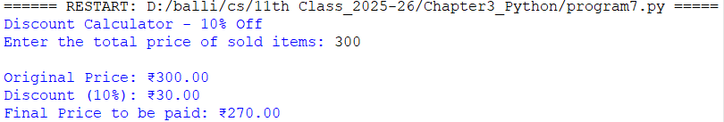

**Output:** print *Original Price, Discount Amount , Final Price to be paid*

Calculate the discount using the formula:  
*discount = total_price × 10 / 100*

Calculate the final price after discount:  
*final_price = total_price - discount*

**Store** the input total price in Variables Celsius

Input**:** *enter the total price of sold items*

Output**:** *"Discount Calculator - 10% Off"*

**Algorithm: Calculate 10% Discount on Total Price**

1. **Start**
2. Display the message: *"Discount Calculator - 10% Off"*
3. Prompt the user to **enter the total price of sold items**
4. Read and store the input in a variable called total_price
5. Calculate the discount using the formula:  
   **discount = total_price × 10 / 100**
6. Calculate the final price after discount:  
   **final_price = total_price - discount**
7. Display:
   * Original Price
   * Discount Amount
   * Final Price to be paid
8. **End**

Program 7: Write a program to calculate 10% discount on the total price of sold items.

Chapter-3 Data Types, Operators & Expressions in Python

|  |  |
| --- | --- |
|  | Program 7: Write a program to calculate 10% discount on the total price of sold items.  Date  Page No. |
|  |  |
|  | def main():  print( "Discount Calculator - 10% Off" )  # Ask the user to enter the total price of sold items  total_price = float(input( "Enter the total price of sold items: " ))  # Calculate 10% discount  discount = total_price * 10 / 100  # Calculate final price after discount  final_price = total_price - discount  # Display results  print( f"\nOriginal Price: ₹{total_price:.2f}" )  print( f"Discount (10%): ₹{discount:.2f}" )  print( f"Final Price to be paid: ₹{final_price:.2f}" )  # Run the main function  if __name__ == "__main__":  main() |
|  |  |
|  |  |
|  |  |
|  |  |
|  |  |
|  |  |
|  |  |
|  |  |
|  |  |
|  |  |
|  |  |
|  |  |
|  |  |
|  |  |
|  |  |
|  |  |
|  |  |
|  |  |
|  |  |
|  |  |
|  |  |
|  |  |
|  |  |
|  |  |
|  |  |
|  |  |
|  |  |
|  |  |
|  |  |
|  |  |
|  |  |
|  |  |
|  |  |
|  |  |
|  |  |

Chapter-3 Data Types, Operators & Expressions in Python

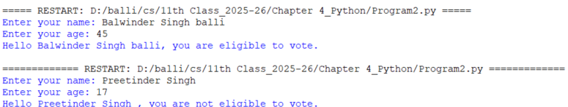

**Algorithm: Check Voting Eligibility**

1. **Start**
2. Prompt the user to **enter their name** and store it in the variable name.
3. Prompt the user to **enter their age** and store it in the variable age (convert it to integer)
4. **Check if** age is **greater than or equal to 18**
   * + **If True**, display: *"Hello [name], you are eligible to vote."*
     + **Else**, display: *"Hello [name], you are not eligible to vote."*
5. **End**

Program 1: Write a program that takes the name and age of the user as input and displays a message whether the user is eligible to vote. ( The eligible age is 18 years ).

**No**

**YES**

Output**:** *"Hello [name], you are eligible to vote."*

**Store** the input name and age in Variables. .Celsius

If age is >=18

**Output:** *"Hello [name], you are not eligible to vote."*

Input**:** *enter Name and Age*

Chapter-4 Control Statements

|  |  |
| --- | --- |
|  | Program 1: Write a program that takes the name and age of the user as input and displays a message whether the user is eligible to vote. ( The eligible age is 18 years ).  Date  Page No. |
|  |  |
|  | def main():  # Take user's name and age as input  name = input( "Enter your name: " )  age = int(input( "Enter your age: " ))  # Check voting eligibility  if age >= 18:  print( f"Hello {name}, you are eligible to vote." )  else:  print( f"Hello {name}, you are not eligible to vote." )  # Call the main function  if __name__ == "__main__":  main() |
|  |  |
|  |  |
|  |  |
|  |  |
|  |  |
|  |  |
|  |  |
|  |  |
|  |  |
|  |  |
|  |  |
|  |  |
|  |  |
|  |  |
|  |  |
|  |  |
|  |  |
|  |  |
|  |  |
|  |  |
|  |  |
|  |  |
|  |  |
|  |  |
|  |  |
|  |  |
|  |  |
|  |  |
|  |  |
|  |  |
|  |  |
|  |  |
|  |  |
|  |  |
|  |  |

Chapter-4 Control Statements