Screenshot 1
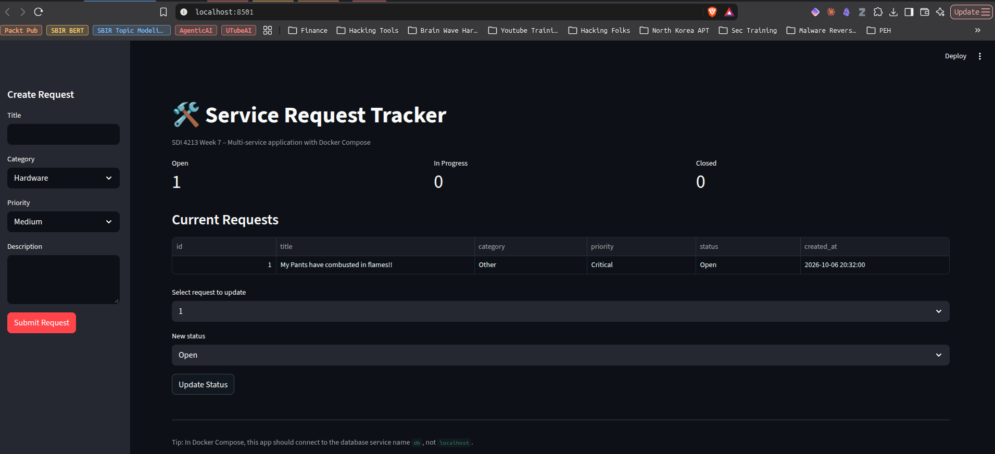

Screenshot 2

Screenshot 3
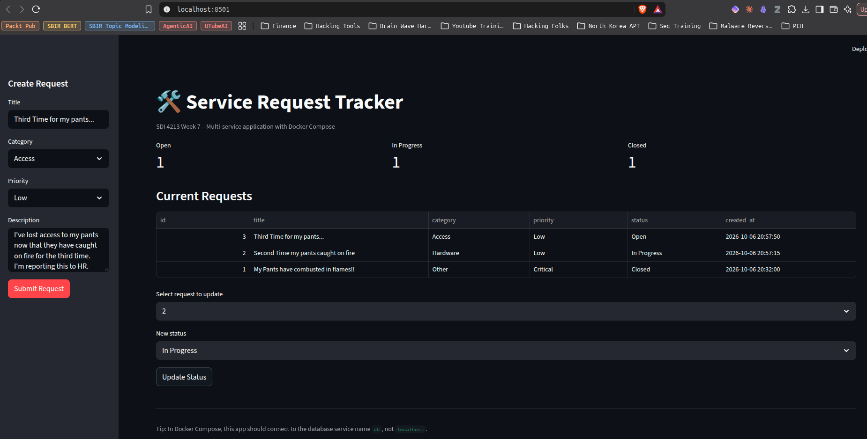

Screenshot 4

Screenshot 5
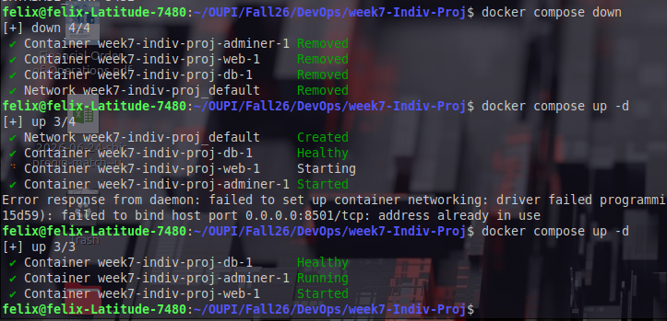
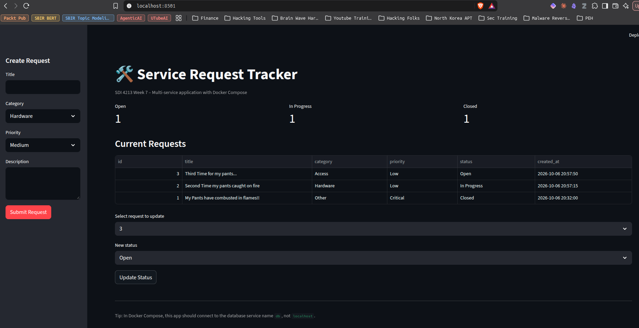

Screenshot 6
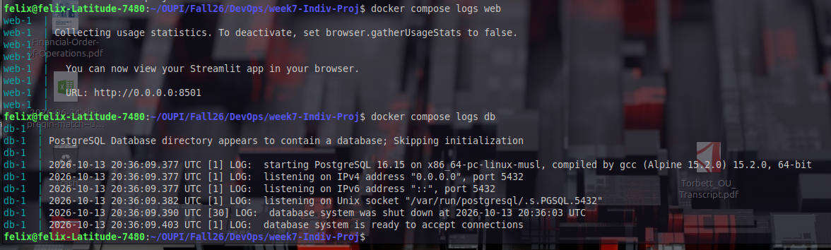

Screenshot 7
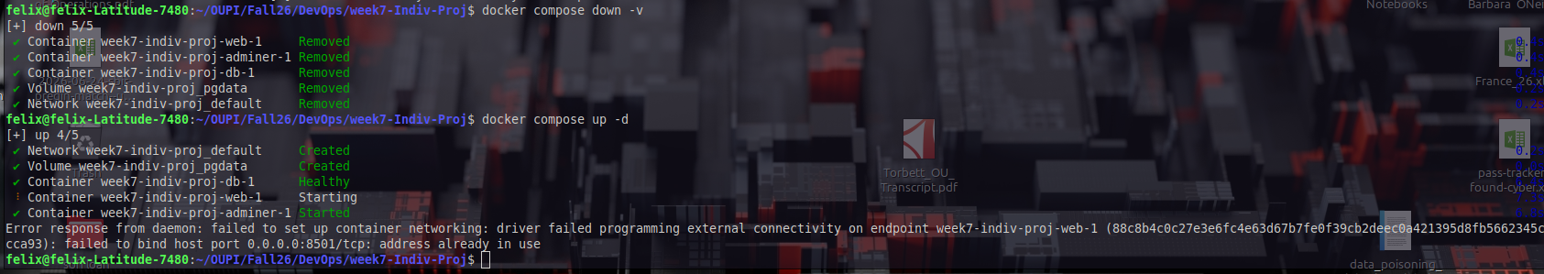

Screenshot 8

