1. **Purpose Statement**
   1. Describe the project you'd like to work on in a couple of paragraphs
      1. **I would like to create a website that will act as my portfolio for design and other development projects. I am considering making a gallery for pictures of drawings that I have done over the years, though I’m not sure if anyone would care or how that would help my job search/ career. I would also include my github and linkedIn information, so they could visit those. I also have the idea of including an image or something for a quick view of my resume and references.**
   2. Audience, Scope, Purpose, etc..
      1. **The audience would be anyone who wants to look me up, mostly potential employers. The scope would be a 2 to 3 pages where the resume and reference images would be on one page, gallery on another, and project information/ about on another. Although I think a gallery for the projects would be cool too.**
2. **Sitemap / Navigation**
   1. Flow chart or bulleted list outline of the navigation / page structure
      1. **Resume**
         1. Resume
         2. References
      2. **Work**
         1. Web Design
         2. Ucommon
         3. OSXtern
         4. BSO
         5. **Digital Imagery**
            1. Wolf Squirrel
            2. Fantasy Video
      3. **About**
   2. Sketch (in grayscale) or wireframe showing a layout for each of the final pages.
   3. 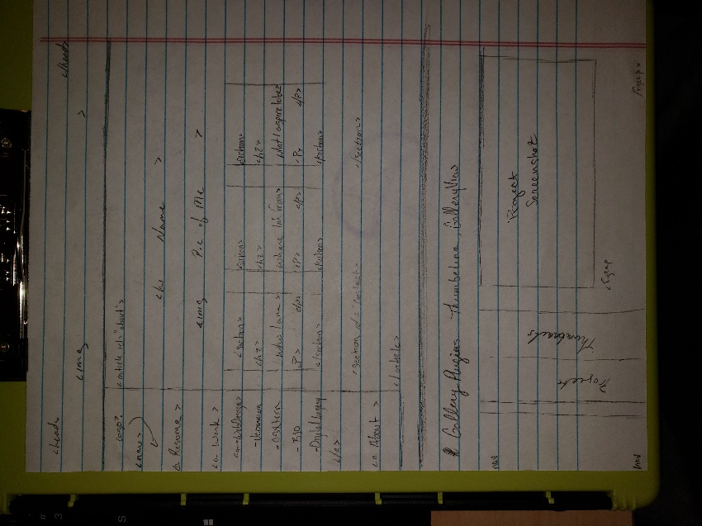
3. **Content**
   1. Create a check list of elements needed for your site - this includes all the text, images, videos, graphics, etc.. You might consider breaking this down by pages / modules.
      1. **Resume**
         1. Resume
         2. References
      2. **Work**
         1. Web Design
         2. Ucommon
         3. OSXtern
         4. BSO
         5. **Digital Imagery**
            1. Wolf Squirrel
            2. Fantasy Video
   2. Describe where you're going to find your resources, especially those that are visual, like photographs and videos.
      1. **All the content that I will use is from past projects. Any content, such as images, that is not from a personal or course project will be from Unsplashed or a similar copyright free source.**
   3. Indicate what content is most important, and what might be less important
      1. **I think the most important content will be information about my most successful and impressive projects and my resume. The less important parts are the about and contact information.**
   4. Indicate as you are able to: interface / interactive elements like a gallery, form, directory, slideshow, timeline, etc.. that you would like to try to implement
      1. **I would like to try and implement a gallery / slideshow where the images would be screenshots of my projects, at least the ones with the ability, and when clicked on or hovered over the gallery would go to a sidebar with thumbnails, the image would take up most of the screen and the figcaption would have an explanation of the project with a link to view more of it if applicable.**
4. **Brand / Look and Feel / 'Style Tiles'**
   1. Describe in a couple of paragraphs the look and feel you'd like to achieve
      1. **I would like my website to be welcoming but reserved, like its there for a reason and it’s not supposed to make any special impact on the visitors. I’ve seen some that try to be funny or include puns, but I’m not that kind of person and I want myself to be reflected as a professional that is trying to jumpstart my career through the site.**
   2. Design and include a logo - or say what you will do instead
      1. **I have a logo that I’ve been using for years, see it on the sketches, but it may look too much like the anarchist symbol.**
   3. Include a 'style tile' or a "Styles Section" in your document showing:
      1. 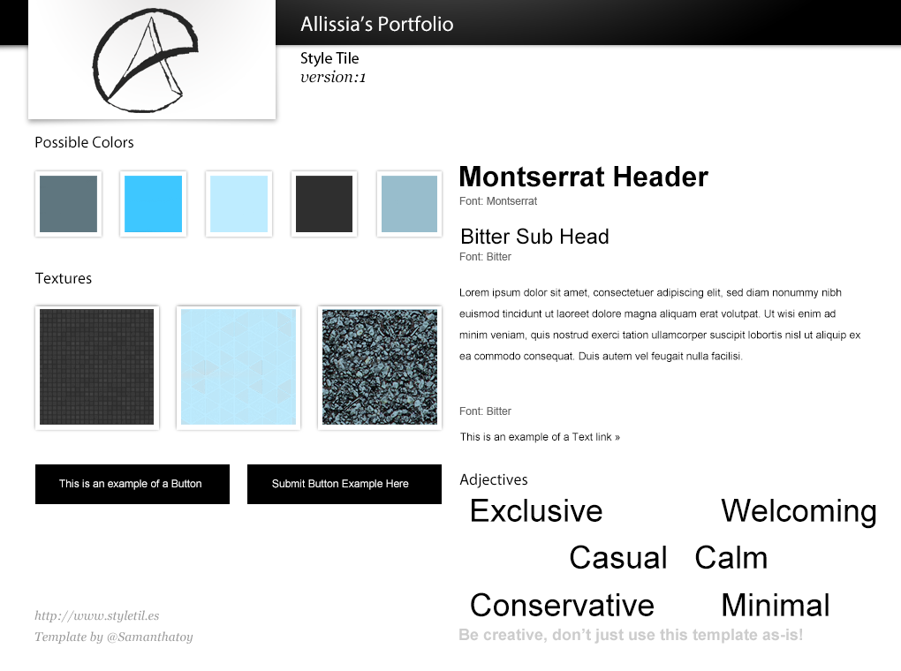
   4. 6 descriptors (SIX or more adjectives describing the personality and character for your site, NOT the functionality this time) -- ESPECIALLY IMPORTANT THAT YOU INCLUDE THESE
      1. **Calm**
      2. **Welcoming**
      3. **Minimal**
      4. **Exclusive**
      5. **Casual**
      6. **Conservative**