## Version History

Business and Enterprise users can view previous versions of files even after changes are made and new versions are uploaded. Set version control to allow multiple edits and multiple parties to collaborate without the fear of remembering which is the latest version or losing information that may become valuable in later versions.

If you have our cloud connect product installed in your pc it installs a dropbox on your desktop and into the ribbon of your MS Office like MS Word or Excel. Any files edited locally by you or your team and saved back to filocity as a version without ever overwriting a team members work.

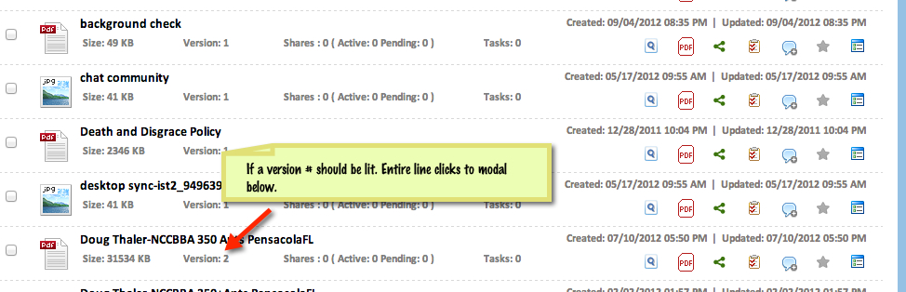

Version List for –File Name

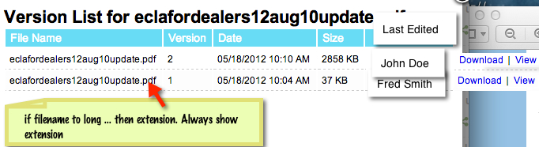

Please be sure all versions held in users account in s3 and all information in database. File id, who edited, etc..