Calling old header

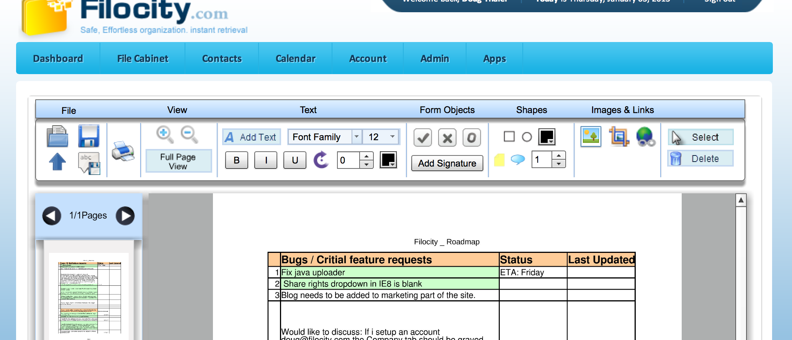

Opening has a funny message. Not sure what it means

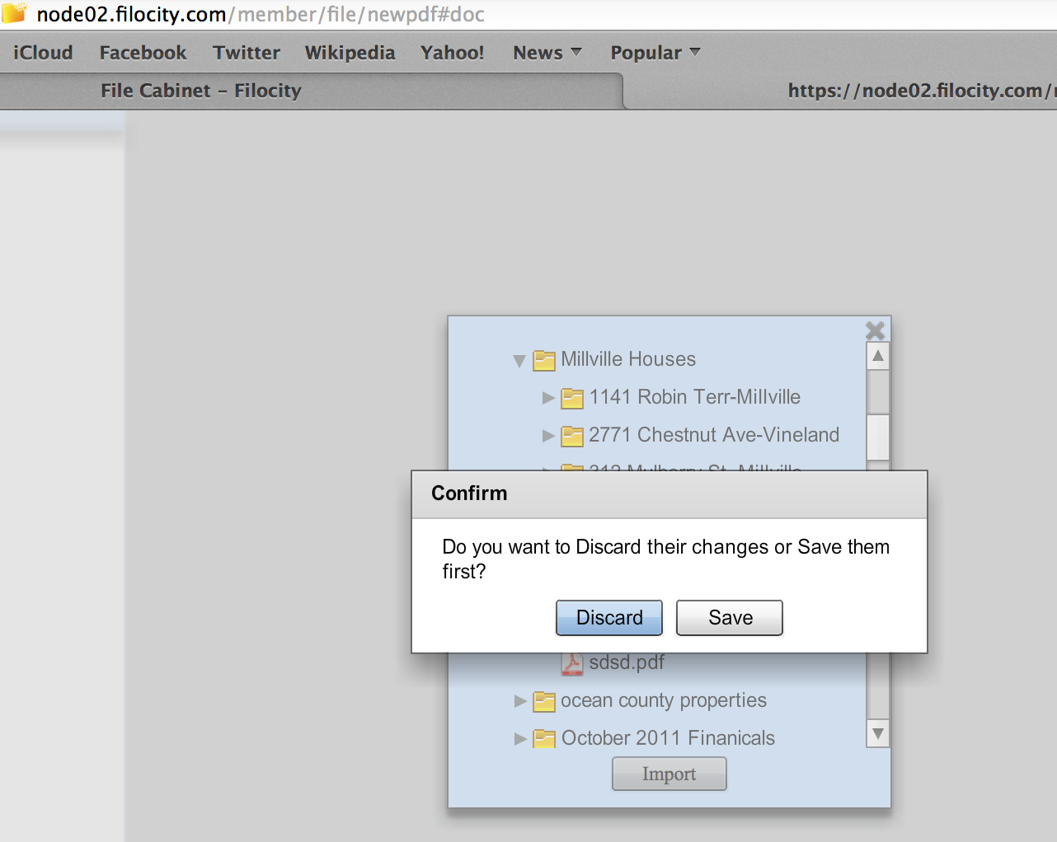

Save and save as logic needs to be fixed . modal is broken and type extends past modal