**Adnetik Product Documentation**

08/24/2011

# 

# 

# Bid Log Fields

Big logs include No Bid, Won Bid, and Lost Bid data returned from the RTB environment.

|  |  |  |
| --- | --- | --- |
| Field Name | Description | Type |
| auction_id | Unique auction ID | string |
| impression_id | Unique impression ID | string |
| advertiser_id | Advertiser ID | integer |
| campaign_id | Campaign ID | integer |
| line_item_id | Line item id | integer |
| creative_id | Creative id | integer |
| url | Publisher URL | string |
| domain | Publisher domain | string |
| exchange_user_id | User ID | string |
| wtp_user_id | User ID | string |

# Bid Log Mapping to Data Intelligence

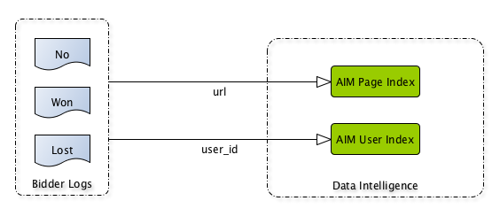

# Bid Log Mapping to Reports

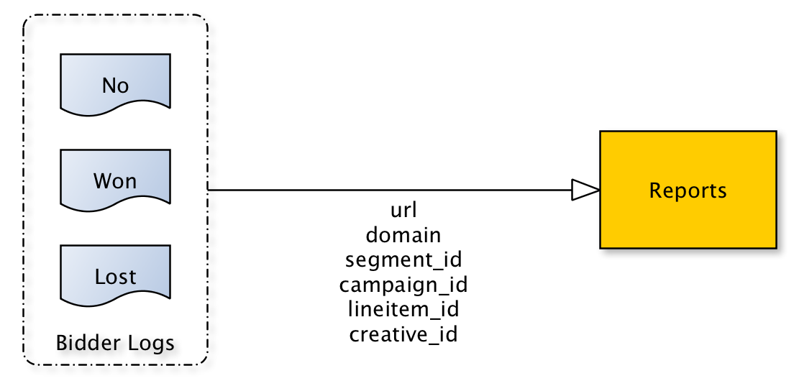

# AdBoard Fields

AdBoard is Adnetik’s internal CRM/ERP for managing campaigns. Its local database contains all campaign setup information, including pixels, ad tags, and targeting lists (users, domains, URLs).

|  |  |  |
| --- | --- | --- |
| Field Name | Description | Type |
| campaign_id | Unique ID | integer |
| lineitem_id | Unique ID | integer |
| creative_id | Unique ID | integer |
| pixel_id | Unique ID | integer |
| list_id | Unique ID | integer |

# Adboard Mapping to Pixel Database

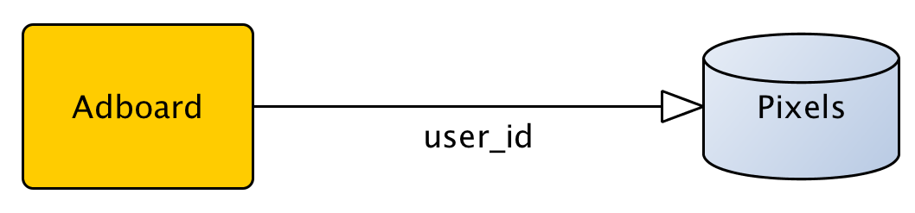

# Adboard Mapping to Lists Database

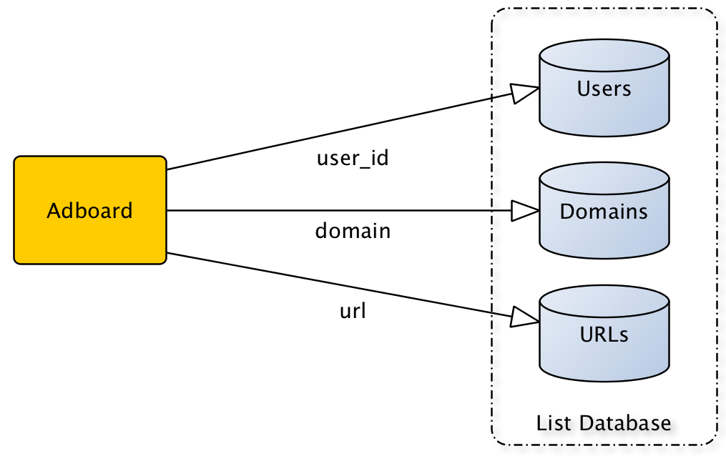

# Pixel Fields

|  |  |  |
| --- | --- | --- |
| Field Name | Description | Type |
| Campaign . campaign_id | Unique ID | Int |
| LineItem . line_item_id | Unique ID | Int |
| Pixel . pixel_id | Unique ID | Int |
| Pixel_type . id | Unique ID | Int |
| Pixel_format . id | Unique ID | Int |

## Pixel, Related Tables Schema

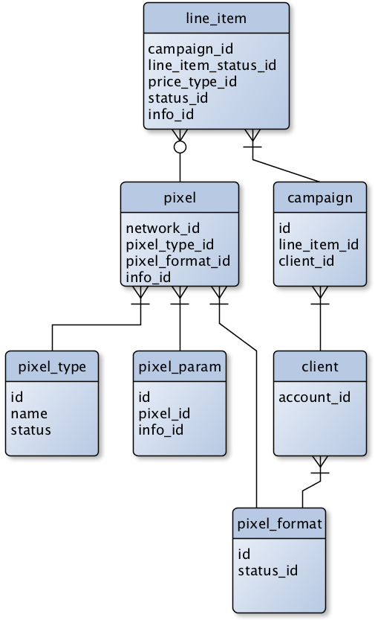

# Bidder Logs Mapping to DFA

|  |  |  |
| --- | --- | --- |
| Adnetik Log Field | DFA Field | Notes |
| Auction_id | Impressions . user_id | ID for unique auction event. |
| Auction_id | Clicks . user_id | ID for unique auction event. |
| Auction_id | ~ | ID for unique auction event. |
| Advertiser_id | Ad . advetiser_id | Advertiser associated with ad |
| Campaign_id | Campaigns . buy_id | Campaign associated with ad |
| Line_item_id | ~ | Adnetik’s proprietary grouping of tactics (eg. *Retargeting*) |
| Creative_id | Ad . ad_id | ID of creative that was imp/clicked |
| ~ | Page . site_id | Closest mapping may be *Adnetik . line_item_id* |
| ~ | Page . placement_id |  |

