## Shares

Any party that a user invites to share a file, folder, calendar, project, photo, etc. The person sharing sends an invite by clicking on the share link at the file, folder, cabinet or project level. The shared party needs to accept the invitation from the user or another share. The shared party will then have access to any features that they were given access to by the person sharing. Users choose parties to share with from their Contact Phonebook that we call Contacts. Each user has their own contact phonebook. The corporate phonebooks are shared among corporate users and personal contacts are kept private from other users. See Phonebook.

If a shared party signs up for their own account they will be able to see all documents and project that have been shared with them as well as all of their own documents and projects which will remain private unless they choose to share them.

When a user invites a person to share a document, file or other their name will appear on the right side of the Files & Folders screen as shared and pending shares. This has changed a number of times but must be visible to the document, folder or project owner, The icon on the file cabinet page must also have the number of shares always visible so an account owner does not inadvertently share documents unintentionally or woth the wrong parties. When the party accepts the share their names will appear under the Share heading on the top right of the Files & Folders portal.

Allow for a notification on upload or share to notify shares when new documents arrive.

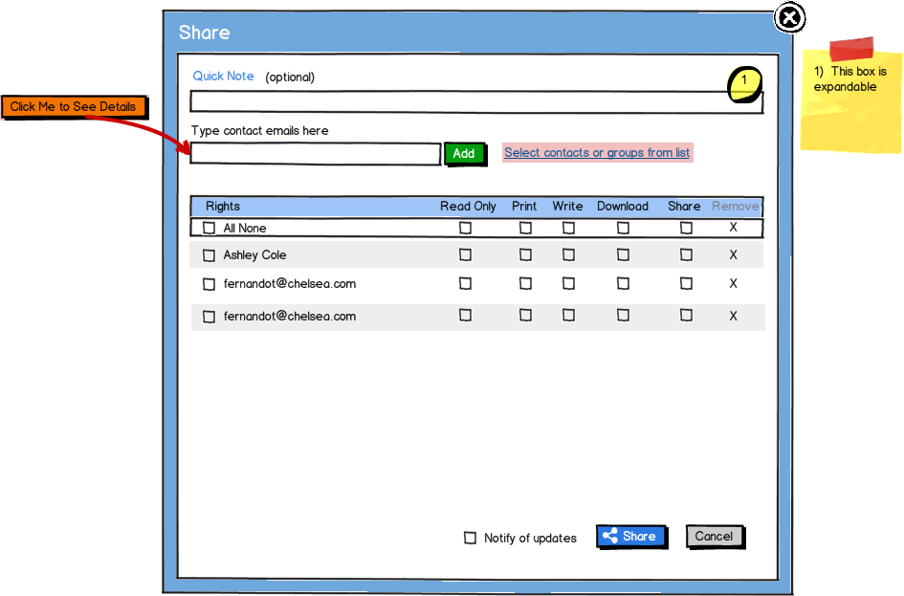

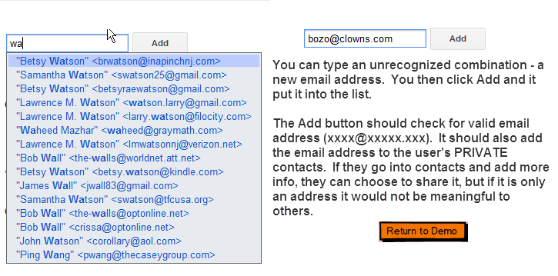

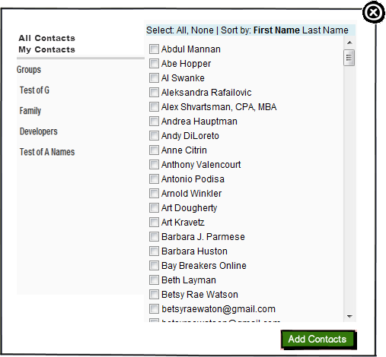

## The Phonebook

Once your initial files are up you will want to easily import your contacts into the phonebook. The phonebook is an important feature in that it allows you to quickly invite users to share your documents, tasks, calanders, files, send chat messages and email links to phonebook members. The Phonebook contacts quickly allow you to mail merge to email contacts or filling forms in our Document template or PDF filler. This is an enterprise level phonebook as well, that can be used as your main phonebook or you can backup your local phonebook to filocity’s for safe keeping

The importer allows you to import your Outlook, Yahoo, Gmail,etc. contacts right into your Filocity account. Contacts by default are saved in the company tab of the phonebook. Once uploaded you can select which contacts you would like to make private. Private contacts will appear in your Personal phonebook and will not be visible to anyone else in your company. If you are a single “user”, that is you are only using 1 email address with your account you do not need to worry about this. Noone including Shares will be able to view your contact list. Please review our Terms of Service and Privacy policy guide regarding your rights. Our terms of service allows us to send email marketing pieces to any contact in the system.

### Phonebook Views

* Master Phone Book form – list view
* Detail view of individual entry
* Compressed list view for selecting multiple entries
* Compressed detail view – for rollovers

-Groups-Allow for grouping and creating a group name. Investors, webmasters, 123 main street, etc.



### Distribution Lists/Groups

Distribution Lists are owned by a user. These groupings let the user quickly select multiple contacts for emails and sharing. Great to quickly setup a chat, project or deal room or to email a marketing or communication piece to clients, employees, teammates or friends. You can setup a group and then share a folder with everyone in the group.

### Custom Label Fields

The phonebook has unlimited custom, user fields. The labels for these fields change dynamically dependent on the ContactType of the selected Contact. These customizable labels can be set from File Drawers. If a File Drawer is checked as linked to the phonebook, the user is given the option to name the custom phonebook label fields. In this manner different types of data can be stored in the same field. For example: the File Drawer for ‘Patients’ might User 1 Field might have a label of “Insurance ID” or a Vendor Field might have a label of “Account number”.