**Online Document Management Features**

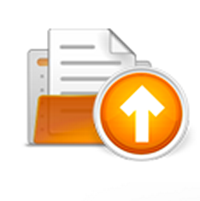

**Familiar File & Folder Structure m**akes using Filocity out of the box a breeze. With a familiar file tree interface and drag and drop functionality your file cabinet space has a familiar feel and functionality.

**Familiar file and folder content**

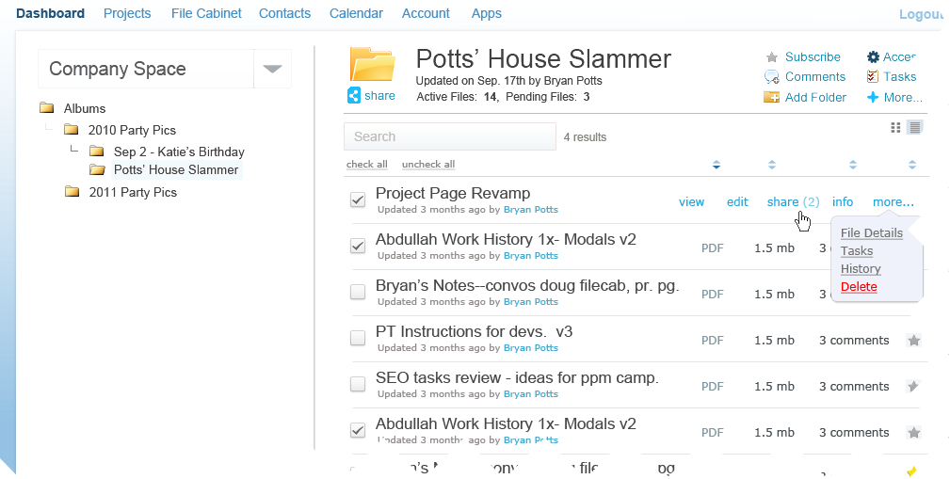All of your electronic and paper documents from across your company or from your partners around the world, organized so you can find them, when you need them.

Filocity.com’s smart filing paradigm allow you to share and organize projects, documents and folders visually so you can access them and view, edit and share them right from your browser. You can see the last time you or someone you gave permission to accessed the folder or documents. New versions that were edited by your team are saved so that you can see them and refer to them when you need to.

Set system notifications to notify you when a file or document is accessed or updated.

Enterprise controls at your fingertips.

[**Signup today and start uploading all of your existing file cabinets and electronic documents to your secure cloud storage space**](javascript:void(0);).

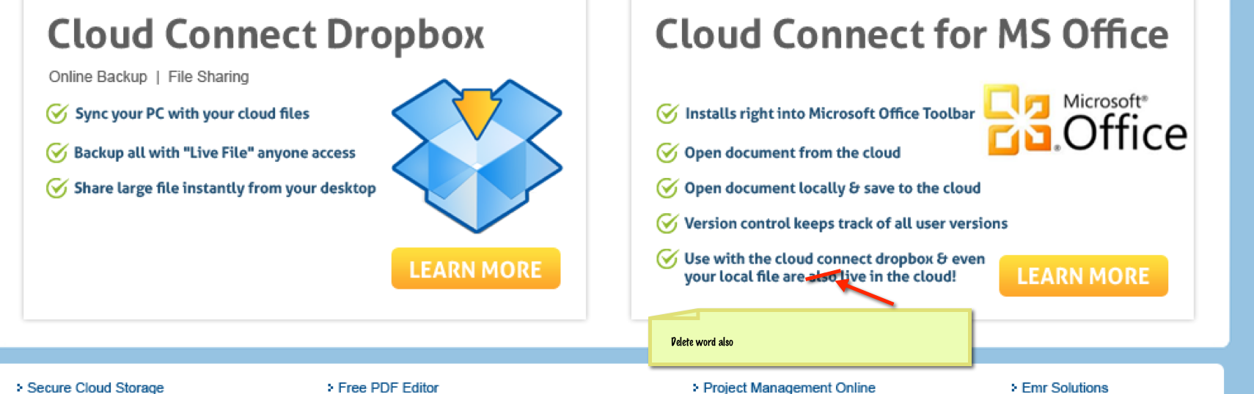

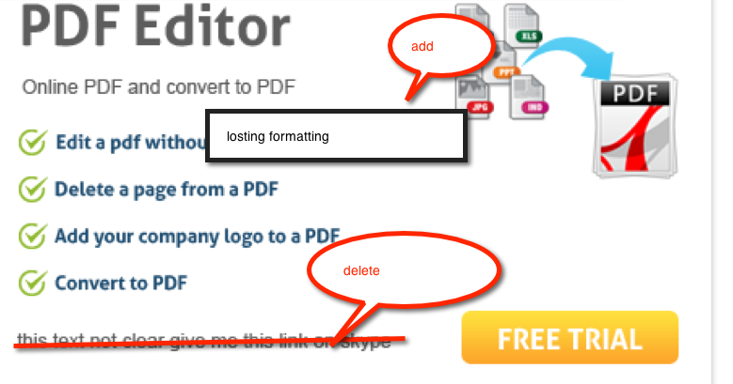

Footer

**Share With Links**

 [Share a file or a folder full of files with direct secure web links. Send them through Filocity or paste links in an email or instant message Keep your files safe in your secure file cabinet. With Filocity.com you can share your files, folders and projects and assign specific permissions to control what your users and and outside resources can do with your files and projects.](http://www.filocity.com/feature/online-file-sharing)

[View who accessed which files and when.](http://www.filocity.com/feature/online-file-sharing)

[.](http://www.filocity.com/feature/online-file-sharing)

Share With Links

User Permissions

Sync for Your desktop

Mobile Access

Send large Files

Online PDF Editing

Create A Webpage

Backup Your Contacts Online

Dropbox

Scan To The Cloud

Office To The Cloud