1. Creating a project creates a project folder in your file cabinet
2. When you add a project \*All Required. An astrik should be next to Name and end time. Delete optional
3. Total Project Budget should read Put Total Project Budget Here and is not a required field.

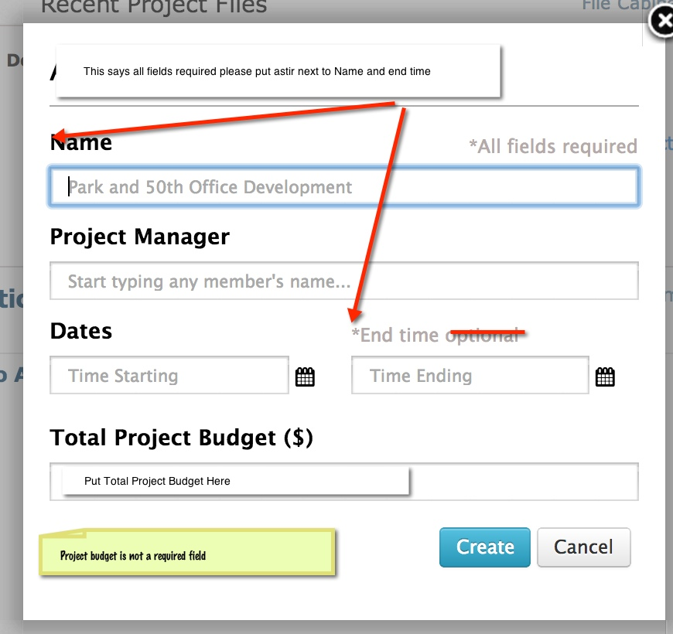

1. When adding project files –Files are added on the projects page and after uploaded stays on the project page. Uploaded files are also saved into the project folder in the file cabinet. The upload modal should just popup on the projects page.
2. Adding Project Members are also added to that project on the resources page. On the resources page change Active Team Members to Project Team Members [+Add] -You need the Ability to add addl project members if you have addl members available in your account or goes to account upgrade.

Projects page

1.Change folder icon to the gold

2. Company logo will appear if added on dashboard. Should also be able to add here and it will show on dashboard. See dashboard page.

3. When you select the name of a project the project name will appear in top center

4. When you have a project selected the calendar is the calendar for that project. The project calendar is also available from the calendar page under projects.

5.Change the add button to hyperlinks bold with + +Add

6. Delete recent project files on left

7. Project members add +Add. You can only add members of your companies account to a project.

8. Budget. If a project is selected and there is no budget the budget should be greyed out. Only members of that project that you added should show under budget. If 1 project has 2 members than only those 2 members can appear to be part of budget.

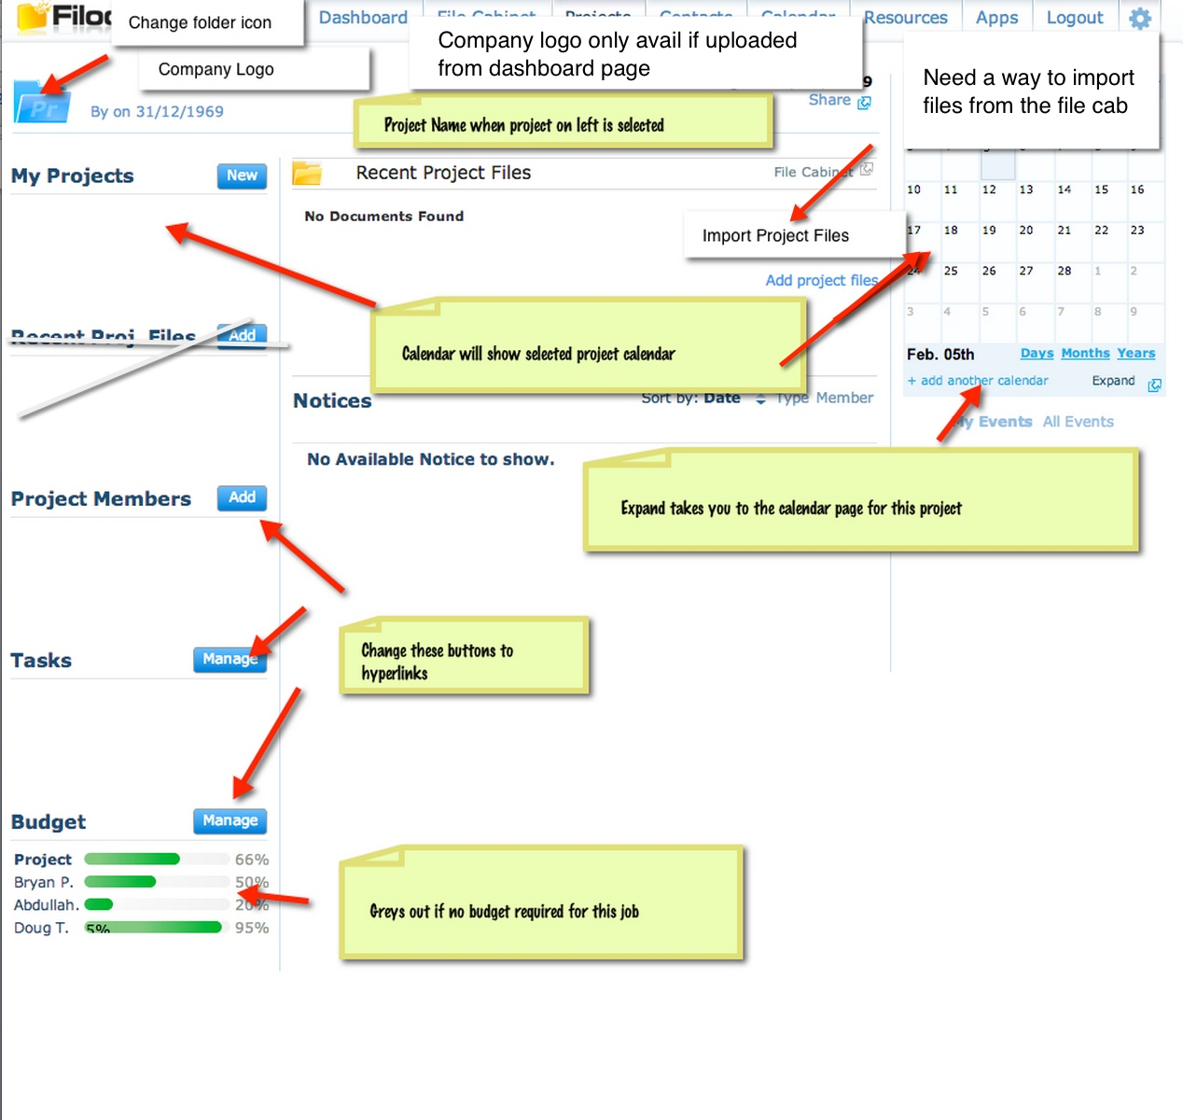

1. Task Management For: Dropdown should be normal size text –Please check on top 3 browsers in pc and mac.
2. Add Team member- if no additional members are left on the account it should go to the upgrade modal (ask Abdullah if any questions). You can only add members for people that are members of your account. Budget can only show for members of this project.
3. Regarding tasks -There needs to be the ability to create custom fields on task types
4. 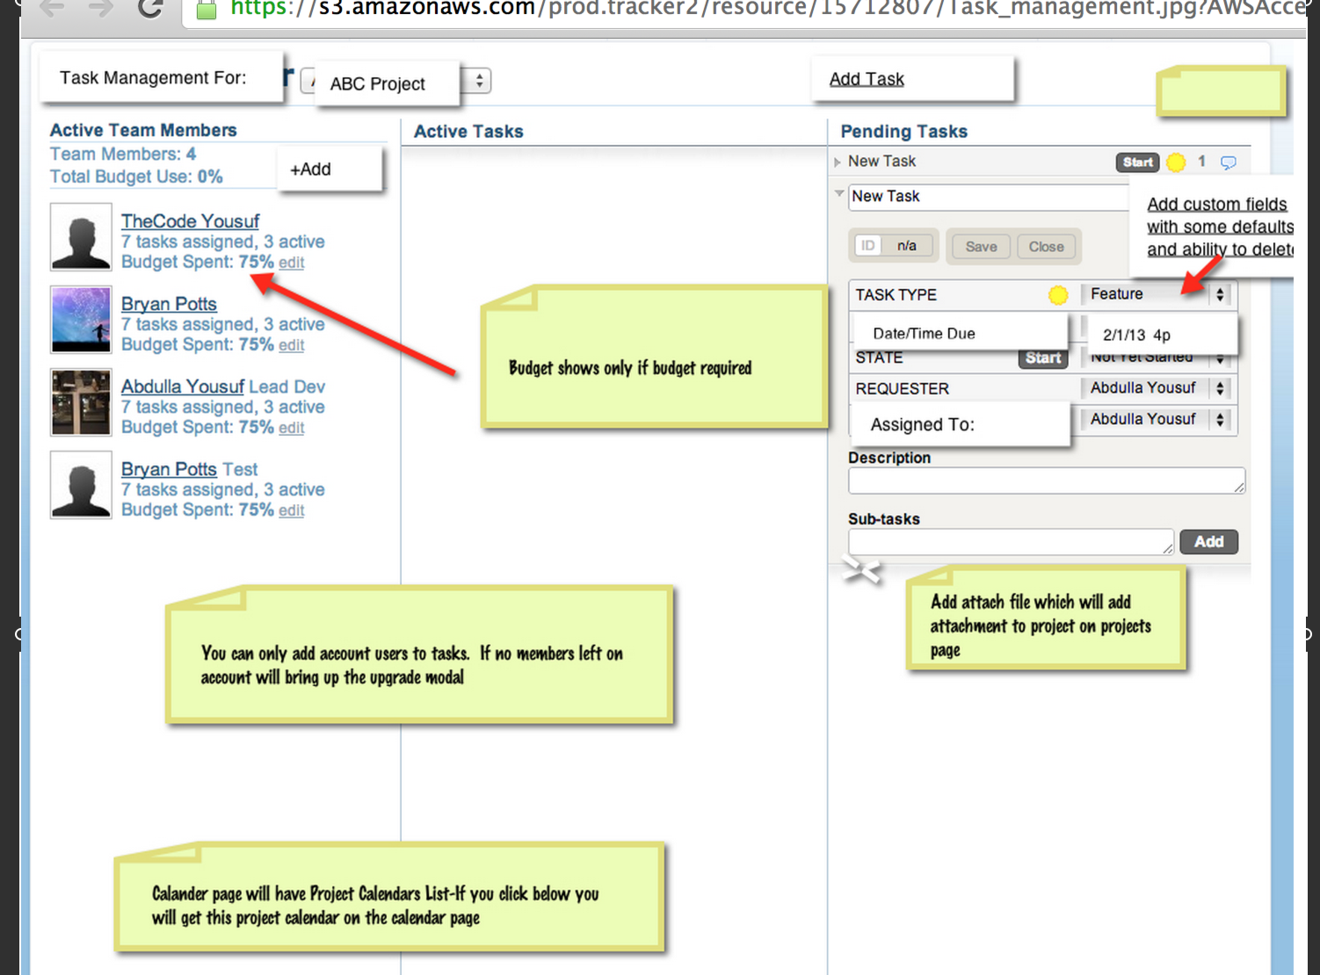

Task summary print view sortable

