1. Creating a project creates a project folder in your file cabinet
2. When you add a project \*All Required. An astrik should be next to Name and end time. Delete optional
3. Total Project Budget should read Put Total Project Budget Here and is not a required field.

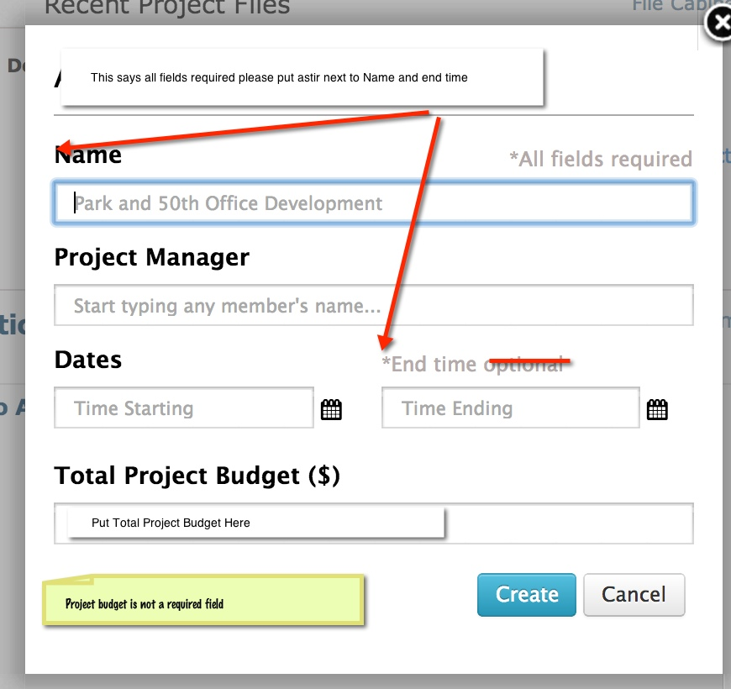

1. When adding project files –Files are added on the projects page and after uploaded stays on the project page. Uploaded files are also saved into the project folder in the file cabinet.
2. Adding Project Members are also added to that project on the resources page. On the resources page change Active Team Members to Project Team Members [+Add] -Ability to add addl project members if you have addl members available or goes to account upgrade.