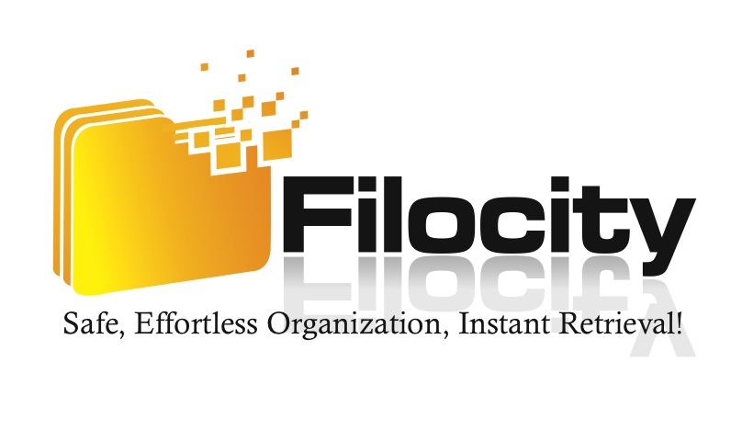

DRAFT

FOR IMMEDIATE RELEASE

“Filocity announces the use of AWS Secure Technology in their Cloud Based Document Management Services”

NEW YORK, NY (March. 5, 2013) – Filocity, a leading cloud based document management firm, announced the usage of AWS (Amazon Web Services) in their online collaboration product suite. In addition, the company is undergoing a website redesign with the new site expected to be unveiled in the last week of October.

Doug Thaler, CEO of Filocity announced in a recent email to the company, “I am proud to announce that Filocity places a significant amount of attention on internal reinvestments including leveraging the same secure technology that government agencies, including NASA, is currently using in their cloud based services.” In addition, Thaler declared “our clients have been the largest benefactors of this highly sophisticated and secured technology as we manage their online collaboration efforts including document management and project management services.”

AWS was introduced by Amazon in 2006 and is commonly known as cloud computing. Cloud computing is changing the way that businesses operate. The technology is heavily advanced and offers a lower variable cost to businesses, which can then be passed on to their consumers. NASA is currently leveraging the same AWS services in their Mars rover project that Filocity uses in their secure cloud based product suite.

“Our usage of AWS technology has enabled Filocity to lower our costs while at the same time dramatically increase the efficiency and security of our services,” said Thaler. “We are now able to pass these cost savings on to our clients which is evidenced by our impressive sales growth and our forward looking 5 year strategic growth plan.”

Cloud computing is expected to create 14 million new jobs by 2015.

“Another strategic focus for us is to continue to leverage our industry leading PDF editor platform,” states Thaler. “The read-only interface of PDF documents has troubled consumers for years and we saw a significant demand from collaborators to have editing capabilities without the dependency on expensive software and costly IT support. We have answered that demand.”

About Filocity.

Filocity, a Manhattan-based online document management firm, is leveraging the world’s most innovative technologies and offers the industry’s best customer support systems to help businesses collaborate online and work more efficiently. The company invests heavily in their technology and is a market leader in collaboration services. Visit http://www.filocity.com/ for more information or if you would like additional information on cloud computing visit [www.filocity.com/thecloud](http://www.filocity.com/thecloud).

Contact:

Doug Thaler

800.790.8095 x225

doug@filocity.com

    