NEA- machine learning speech-to-text
Jack Williamson
S - Jack Williamson
George spencer academy Center:28278

Analysis

  - Introduction

My intention for my NEA is to create a machine learning speech-to-text chatbot in the python programming language. Over the recent years AI has become a particularly useful tool for work, ordinary questions and programming. However, for most AI chatbots you need to type into the computer and send the message to the AI. The problem with this is that if your hands are busy, you cannot use the AI. For example, an electrical engineer is soldering a component to a PCB, and their hands are busy and has a question about where to solder a component he cannot ask this question. However, with a speech recognition-based AI chatbot you can ask this question. This is my intention for my NEA. “Studies from 2021 show that the best speech recognition software is only 61.92% accurate: https://www.dittotranscripts.com/blog/ai-vs-human-transcription-statistics-can-speech-recognition-meet-dittos-gold-standard/ ”

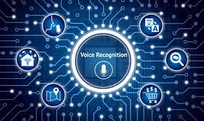

  - The User
My main end user is people who work with their hands in an engineering job for example electrical engineering, network engineering and mechanical engineering as these fields require hands on work with many complex systems therefore they may need

My father is a mechanical engineer he will be a great example of my end user group and i will have him test it

Research

  - Secondary research

Investigation
There are many speech recognition programs and assistants like Siri made by apple. And there are many AI chatbots that use machine learning however there are not many that mix the two in a good way

Firstly i researched some speech recognition programs and found that the speech_recognition python library is the most efficient way of using speech recognition
https://github.com/Uberi/speech_recognition/blob/master/examples/microphone_recognition.py

Also basic machine learning algorithms are popular

