Machine learning speech-to-text note Taking Software
Jack Williamson
S-Jack Williamson
George spencer academy Center:28278

Analysis
Introduction

My intention for my NEA is to create a speech-to-text program in the python programming language. Over recent years speech recognition has become popular however it never really works properly it always cuts in and out at the wrong time due to incorrectly processed transcriptions, and it wrongly interprets what you say because it uses old recognition modules. therefore, it does not work, making daily life harder for those with visual impairments or other disabilities when studying. furthermore, students with visual impairments may find it difficult to take notes and read them so my project can take notes with a microphone and visually and audibly read them through a simple, easy to use and good-looking interface that’s easy and intuitive to use. My program will include machine learning (learns patterns) and natural language processing algorithms (Understanding human behaviour and intent in text) as well as intelligent processing of transcripts. most other speech recognition programs write mathematics like text instead of equations, therefore mine will be special and different as it will write mathematics properly using latex like formatting (Formatting with inline Maths), and algorithms to provide correct transcription and remove all jargon. The end screen will allow a reedbacm feature to ensure users can visually verify their notes.
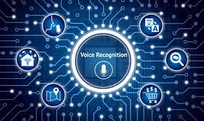

  - The User
My main end users are students, because they take the most notes furthermore it would be useful for them to not have to write notes by hand but instead let the program listen to the professor or video and then turn that into notes this means that they can then spend time reading these notes and making flashcards with them instead of spending the time writing them.
My individual end user is Ethan Slater who is a struggling student at George spencer academy sixth form, he does maths biology and criminology, therefore my maths notation feature would be extremely useful for him, also criminology includes lots of notetaking.

Secondary Research

Investigation
There are many speech recognition programs and assistants like Siri made by apple. And there are many speech recognition tools that take notes e.g. dicatanote however these tools do not have integrated mathematics and show maths equations like this:
which does not help students studying STEM subjects

My intention is to represent mathematics and STEM notations in a LATEX like format which is STEM friendly e.g.:

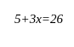

How most other projects work
Firstly, I researched some speech recognition programs and found that the speech_recognition python library is the most efficient way of using initial speech recognition before the NPL. The speech_recognition library uses a web speech API and sends audio as https requests, it then returns JSON this can be used as my initial pre processed transcription
https://github.com/Uberi/speech_recognition/blob/master/examples/microphone_recognition.py

Also machine learning algorithms are popular:

Support Vector machining algorithms are commonly used by many e.g. WordPress who use it to remove unwanted comments from posts.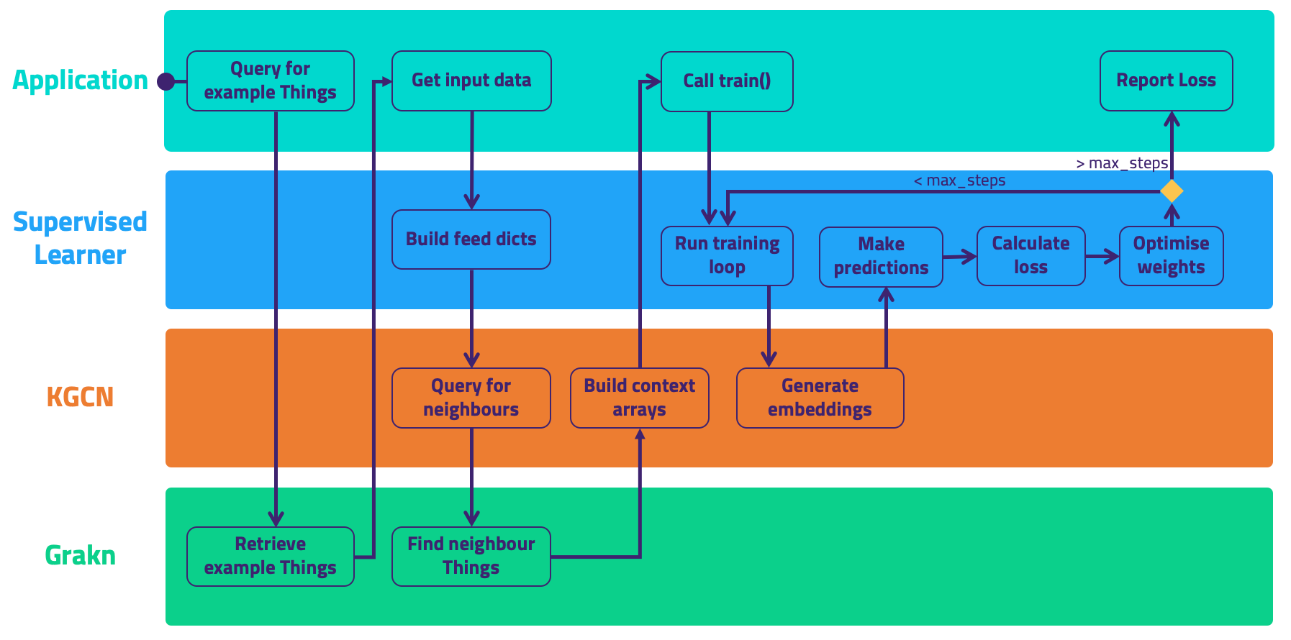
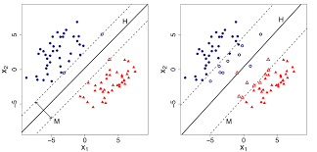For my NLP (natural language processing) and Machine learning algorithms I will use scikit-learn library: https://github.com/scikit-learn/scikit-learn , and documentation: https://scikit-learn.org/0.21/documentation.html to help keep it algorithmic for me I will design the training data and some training algorithms. Along with the intent classifier which tells the AI the user's intent and helps it recognise what the user wants. The intent recognised will be if it is mathematics or text in the transcription.

Other projects:
Dictanote uses JavaScript and is the 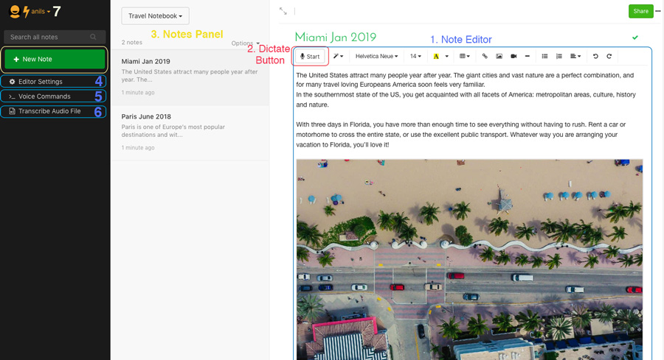 standard for speech to text notetaking. Dictanote uses JavaScript and is the standard for speech to text notetaking however this also does not represent STEM notation properly without manually adding it.

Otter.ai is another popular option which uses AI and llms along with android platforms it integrates itself into zoom to record transcriptions of zoom calls. This is useful but to niche as its limited to zoom and is not its own program furthermore it also has trouble with STEM notation.
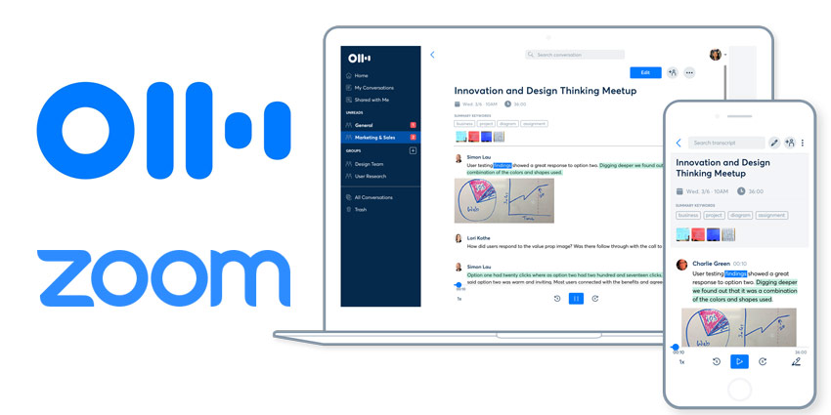
Comparison table
Feature | Siri | Dictanote | Otter.ai | My proposed system
Speech-to-text | yes | yes | yes | yes
Mathematical formatting support | no | no | no | yes
Correct note taking | Sometimes | Not really | Yes (via AI) | Yes (Via basic machine learning and intent classification)

In conclusion, one problem with all these existing solutions is there is no real STEM notation support, poor accuracy on technical vocabulary.

Primary research

I used a google form to collect data from my user group I asked these questions:

- Initial question: which of the following describes you the best?
Student
teacher /professor
Worker
Other_______________

- On a scale of 1-5 how often do you need mathematics symbols in your notes?
Never (1)
Rarely (2)
Sometimes (3)
Often (4)
All the time (5)

- Do you experience problems with current speech recognition software?
Yes
No
- If yes what are these technical problems?
___________________________________________________________

- Do you feel that speech recognition software should provide a way to audibly read to the notes written/recognised (For people who need more accessibility features)?
Yes
No

- Which of the following speech recognition notetaking programs have you use
Siri
Dictanote
Otter.AI
Other____________

- Do you feel current speech recognition notetaking software fails to provide STEM notations?

Yes
No

- How important is this feature?
Not at all
Not really
May use it
Somewhat important
Essential

- Is instant feedback important (where the software confirms it understood your intent?
Yes
No

- What would you define a successful transcript as?

- Do you feel that human intent is important when writing notes?
Yes
No

- Do you think AI is useful in speech recognition
Yes
No

- What features would you like to see the most (try and pick 3)
Clean and polished UI
Incredibly high success rate on transcripts
Futuristic Voice
Audibly reads your notes back to you
Other_______________

- Do you think this Ui design is appropriate?
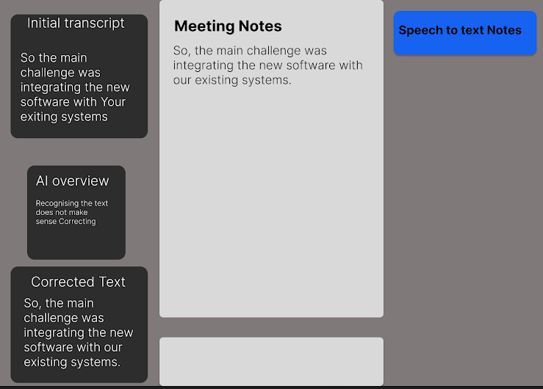Yes
No

- Anything else you would like to add?
_________________________________________________________________________________

Results

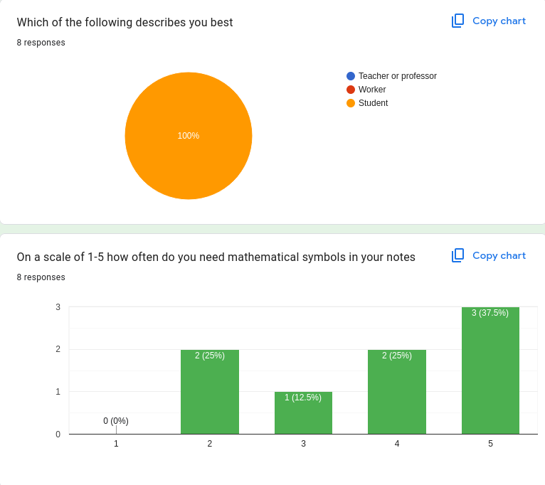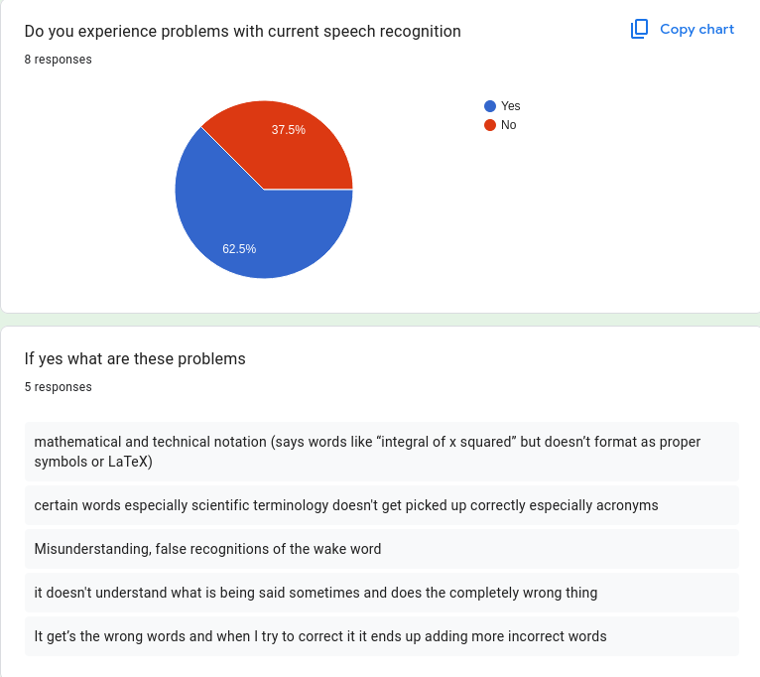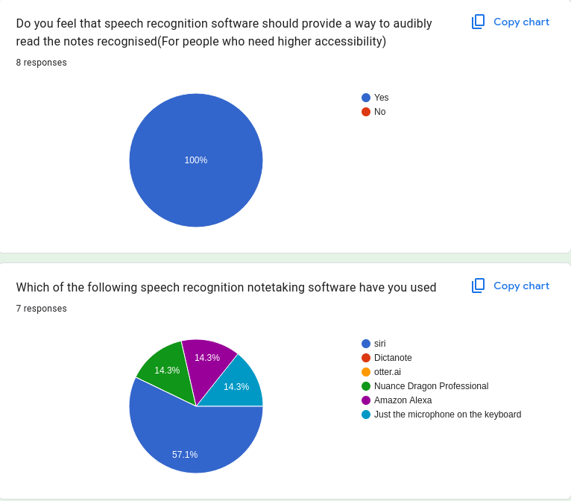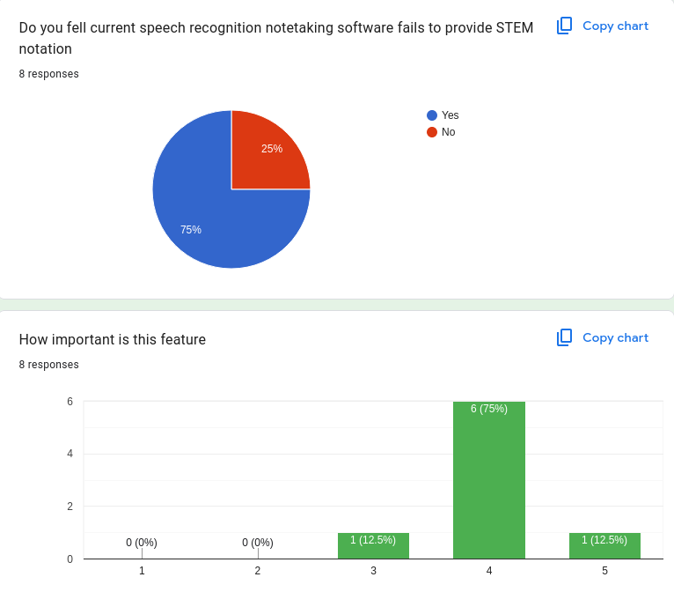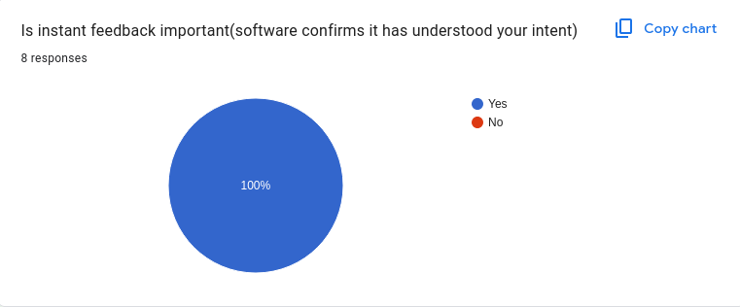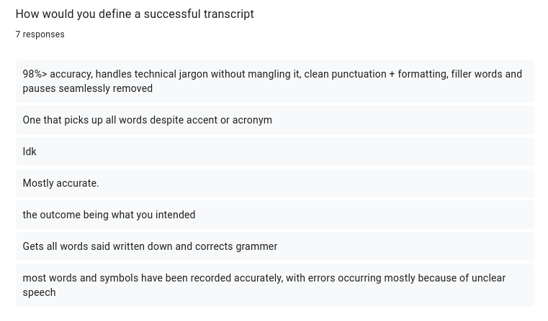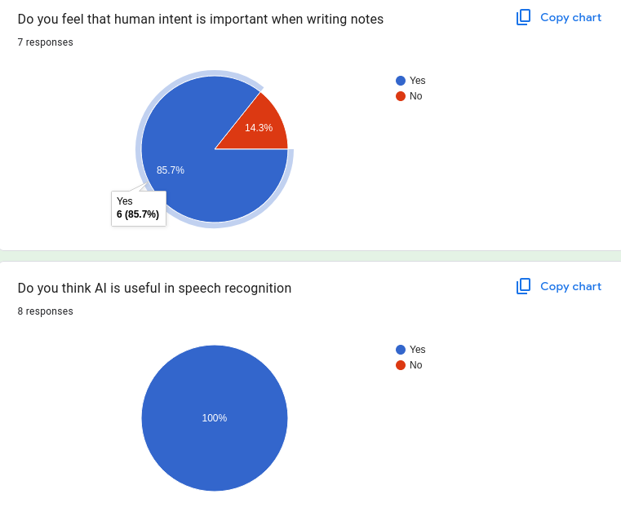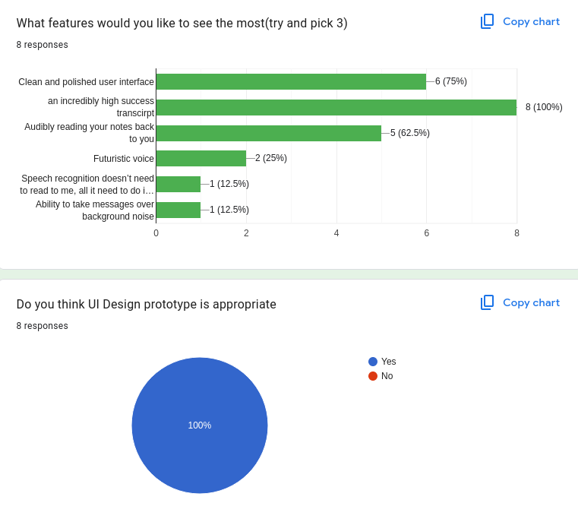
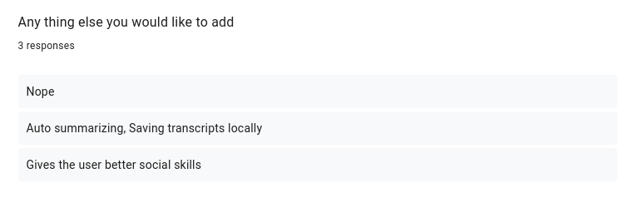

  - What these results tell me about what my user base wants and how I will adapt my software to this:

Firstly, the first question proves that my user base is entirely students. And many of them answered on the second question that mathematical notation is important to them so I will make sure that is a priority feature. Also, from one of my questions I asked about the most important features which are: clean and polished UI, a high success rate on transcription and audibly reading notes back to you. This means that these features will be a top priority and others like voice type. Another important feature to people is instant feedback where the software confirms it has understood your intent.

Algorithms

I need 2 main complex algorithms for my project as well as some others. The First is some kind of natural language processing, which is how computers understand humans’ language e.g. emotions or intent can be recognised from human speech through Natural Language Processing. and the other one is a machine learning algorithm which is an algorithm that can change and adapt constantly where it “Trains” the Algorithm to improve accuracy based on data known as Training Data e.g. an AI(Large ML Algorithm) learning how to speak English properly by looking at a set of conversations between humans in English(Training Data). There are multiple types of both NLP and ML algorithms, so I need to pick more than one of each. Based on research.

The 2 main categories of machine learning algorithms are:
- Supervised: Where algorithms are trained with key structured data effective. or regression(predicting), sorting data and seeing intent
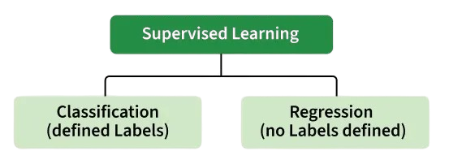
Classification: Where the output is a categorised variable e.g. spam vs non spam emails. Its definitive:
Object | Classification
Table | Furniture
Chandelier | Ornaments
Pen | Stationery
Spaghetti | Consumable

Regression: Where the output is a variable that is continuous e.g. predicting stock prices:
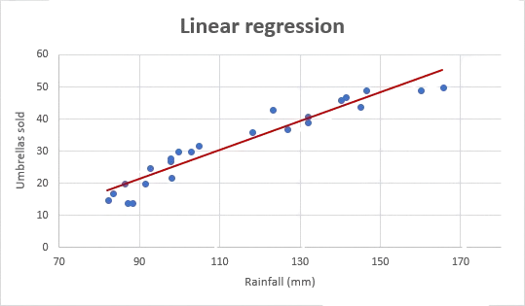

In conclusion Classification is useful for defining key things and lists whereas regression is good for predicting data based on the patterns of data.

Regression would be specifically useful for me for predicting human intent (intent classifier). Where as categorisation would be useful for the training data of my algorithms.
Supervised Machine Learning - GeeksforGeeks
- Unsupervised: Algorithm is trained on unlabelled and unstructured data. It learns patterns on its own by grouping data together or finding hidden meaning without any human intervention.

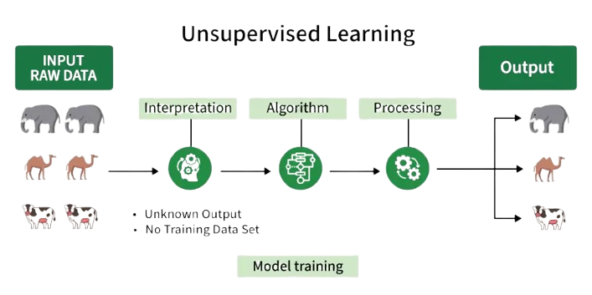
The interpretation stage shows that the algorithm doesn’t have any predefined labels or categories for the data, it groups all the data based on patterns.
The algorithm Stage represents the unsupervised learning process that helps to identify patterns in the data.
The processing stage shows the algorithm working on the data.
How it works:
- Collect unlabelled data e.g. images or animals without any tags
- Select an unsupervised algorithm
- Train the model on raw datasets so it can look for relationships with hidden structures within the data
https://www.geeksforgeeks.org/machine-learning/unsupervised-learning/

Common Machine learning algorithms include:

1. Linear Regression
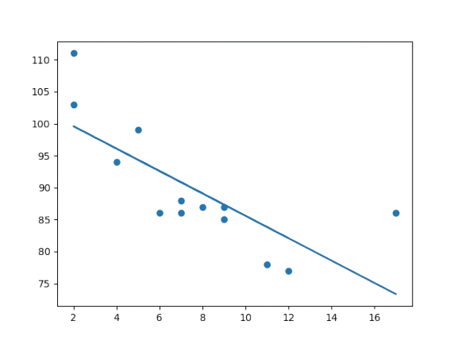
Linear regression predicts a continuous value by fitting a straight line between input and output variables. Example: Predicting house prices based on area or predicting weight from height.
import matplotlib.pyplot as plt
from scipy import stats

x = [5,7,8,7,2,17,2,9,4,11,12,9,6]
y = [99,86,87,88,111,86,103,87,94,78,85]
slope, intercept, r, p, std_err = stats.linregress(x, y)
def myfunc(x):
return slope * x + intercept
mymodel = list(map(myfunc, x))
plt.scatter(x, y)
plt.plot(x, mymodel)
plt.show()

$$y = β^{0}+ β^{1}x$$
Y=dependent variable
X=dependent variable(predictor)
β₁= the slope or weight which represents how much y changes for every one-unit increase in x
β₀ is the intercept or bias, which represents the value of y when x is 0

2. Logistic Regression
Logistic Regression is a supervised machine learning algorithm used for classification problems. Unlike linear regression, which predicts continuous values it predicts the probability that an input belongs to a specific class. (GeeksForGeeks, Last Updated : 1 Jun, 2026)
Binomial Logistic Regression: Used when the dependent variable has only two possible categories, such as Yes/No, Pass/Fail, or 0/1. It is the most common type and is used for binary classification tasks.
Multinomial Logistic Regression: Used when the dependent variable has three or more unordered categories. For example, classifying animals as cat, dog, or sheep. It extends logistic regression to handle multiple classes.
Ordinal Logistic Regression: Used when the dependent variable has three or more categories with a natural order, such as Low, Medium, and High. It considers the ranking of categories during prediction.

Note: Despite the name, logistic regression is a classification algorithm.

3. Decision Trees
Decision trees split data into branches based on feature values.

4. Support Vector Machines (SVM)
SVMs find the best boundary (hyperplane) that separates data points into different classes. Uses support vectors to define decision boundaries. Supports linear and non-linear classification using kernels.

5. k-Nearest Neighbors (k-NN)
k-NN predicts outcomes based on the closest data points in the training set. Uses distance metrics like Euclidean or Manhattan. Works for both classification and regression

6. Naive Bayes
Naive Bayes is based on Bayes’ Theorem and assumes features are independent. Common use case: Text classification, spam filtering

7. Random Forest
Random forest is an ensemble technique that combines multiple decision trees. It uses random sampling and feature selection. Reduces overfitting compared to a single tree.

8. Gradient Boosting
Gradient boosting builds models sequentially, where each model corrects errors made by the previous one. Combines weak learners into a strong model. It works for both classification and regression. Popular Variants:

- XGBoost: faster, regularized boosting
- LightGBM: histogram-based, fast for large datasets
- CatBoost: handles categorical data efficiently

9. Neural Networks (Including Multilayer Perceptron)
Neural Networks learn patterns using layers of connected neurons. It requires labeled data. It trained using backpropagation and used for classification and regression

Reference: https://www.geeksforgeeks.org/machine-learning/machine-learning-algorithms/
21/01/26

Common NLP algorithms include:
Sentiment analysis - determines emotional tone of the speech/text
- Classifies text/speech tone into positive or negative
- Tokenization: Breaking down the text into individual words also known as tokens
- Unnecessary word removal: removing structure words like is, an, the that do not carry meaning
- Extracting important works: extracting key words that indicate sentiment e.g. adjectives like bad or good
- Classification: using machine learning algorithms to classify sentiment which can be rated
- Challenges of this include dealing with sarcasm irony and slang which would need a separate intent recogniser

Keyword Extraction – identifies the most important words or phrases in the speech/text
- Identifies and extracts the important keywords from text and matches it with a database of topics or trends
- This algorithm

Knowledge Graphs – represents relationships between entities e.g. people, place, ideas
- Creates a network of important entities such as people places and things to understand
- This algorithm helps machines grasps the context and semantics of human language
- Makes it possible to understand the nuances of complexities of language

Text Summarization – creates a shorter version of the text/speech by eliminating unimportant words
- Creates condensed versions of long texts
- Retaining the most important
- This can be done using extractive methods
- Or abstractive methods

Reference for this: https://www.geeksforgeeks.org/nlp/nlp-algorithms-1/

What algorithms I'm going to use

- Simple initial speech recognition using the python library speech_recognition
- Complex NLP algorithms: Tokenisation, Keyword extraction
- Complex ML algorithms: Intent classification(scikit learn), SVM

Tokenization:
Tokenization takes an input string then applies a function where each word is a substring without whitespace
τ(S) → {w₁, w₂, w₃, ... wₙ}
Pre tokenization
$$IF inputSTR = \text{Integral\backslash of\backslash X\backslash Squared}$$
Post tokenization
$$T\left(list\right)=\left[\text{integral},\text{of},\text{x},\text{squared}\right]$$

Keyword Extraction:

In short keyword extraction is that for each token it assigns a relevance score to a threshold function
Algorithm removes random/filler noise by iteration through the array/list (T), It cross references words(W) against a static list of jargon and filler words as well as start stop commands:
$$W=\left[\text{um},\text{ah},\text{start},\text{stop}\right]$$
When a word in (T) references a word in (W) it is removed from (T).

Support Vector Machining (SVM) + Intent Classification
The equation for SVM/SVC is:
$$∑i∈SV_{i}^{y}{α_{i}}_{K\left(x_{i},x\right)}+b$$

For a linear SVM the equation can be simplified to:
$$\text{sign}\left(w^{T}x+b\right)$$
X=Input Vector, w=importance/weight,b=Intercept(Shifts decision boundary up or down)
To predict weather the intent was mathematical or pure string notes:
$$Intent prediction=├_{NOTE if f\left(x\right) ≤0}^{MATHS if f\left(x\right)>0}$$

https://scikit-learn.org/stable/modules/svm.html

What this all means is that when the user speaks the system converts words into a number pattern e.g. words “integral” and “history” for integral the phrase gets turned into a list where the maths words get flagged with numbers, the weight vector(w) is a list of score modifiers that the AI learned during training, basically it ranks the importance for each word. A STEM keyword would be assigned a positive value. At the end we multiply the words spoken by their importance scores, the bias(b) is a constant number for the threshold for the decision, ensures the model does not get confused with maths and notes. At the end of the process the program adds the word scores together + the bias threshold. If the final number is positive, the user's intent is Maths, if it is 0 or negative it realises the user's text is Plain text

Objectives

- 70 percent of users find it easy to use
- Of the 30 percent who don’t they should all find the documentation east to follow
- End users should be involved

Output
The user gets a simple but pleasant UI with the initial transcript and then the processed one with true mathematical symbols
Process
Natural language processing algorithms and machine learning algorithms remove unnecessary wording as well as turning mathematical symbols and number from words into proper symbols.
Storage
The program stores what was said and an initial transcript of it

It also stores the output
Input
The user clicks a button on the keyboard and the microphone starts listening, say what they want to say, then they hit the button again and it stops listening.

Intent classifier
Variable name | Datatype | Usage
InitText | String | Initial transcript from speech_recognition library
TrainingData | List | Collection of sentences that show the algorithm what to do with the text e.g. [“X equals Five : x=5”]
intentLabels | List | Number categories for training model(0 transcript 1 for Mathematics
SVMData | Array | Maths representation of words-uses SVM
PredictedIntent | String | Output of SVM – tells program whether to apply STEM formating

STEM Formattung
Variable name | Datatype | Usage
TokenList | List | InitText broken down into separate words
Mapping | Dictionary | Lookup table where keys are words(“plus”=”+”
FormattedStr | String | The final version of the text after mathematical symbols have been swapped in
Output | string | The mathematical string fully formatted

General
Variable name | Datatype | Usage
IsListening | Boolean | If mic button has been clicked and speech recogntion is listening
StoredAudio | .mp3/.wav etc | Audio recording
FinalTranscript | String | Fully processed output to be displayed
User_feedback(maybe) | Integer | 1-5 rating of the program

Smart objectives

- Create a graphical and voice activated hybrid user interface by December 2026
  - Including: a main menu, one screen with the button to start the speech recognition process, one screen with the results displayed
  - Include the colour three way colour format of x,y,z
  - MAYBE: Over 60% of users indicate a positive speech recognition score(especially for the mathematics)

- Create the intent classifier using NLP and ML by December 2026
        - Includes valid training data
        - Includes intent labels and support vector machining
        - Gets an accurate predicted intent(whether to apply stem formatting)
- Create the tokenisation and word removal system with ML and NLP by December 2026
- Uses tokenization to assign numerical data to the transcript words based on how important it is
- Remove unimportant/erroneous words from the transcript
- Remove stop/start words from the transcript
- Provide a cleaned up version of transcript at the end

- Create a basic storage system by December 2026
- Stores the original audio file
- Stores the original transcript
- Stores the final cleaned up version of the transcript
- Stores all of the above in a folder for each recording
- Accessible through the user interface

- Develop a transformation system by December 2026 that will change mathematical tokens into LaTeX like mathematical notation
- Create a rule system that checks for math intent (intent classifier/NLP)
- Successful transcription of complex mathematical strings that would otherwise be jargon

- Optimize the program by December 2026 to ensure processed output is efficient
- Ensure the latency is as low as i can make it for the SVM and NLP
- Ensure there are no unnecessary loops that waste resources
- Measure the latency and document it

- Ensure errors are dealt with properly by December 2026
- Implement error handling with try and except statements to ensure the program runs
- Use iterative and final testing and fix all errors
- Document errors

- Training data will be large and expandable during development by December 2026
- 50+ training data sentences
- Training data is relevant
- Training data will be changed and measured through iterative testing

Flowcharts

SVM+Intent classifier
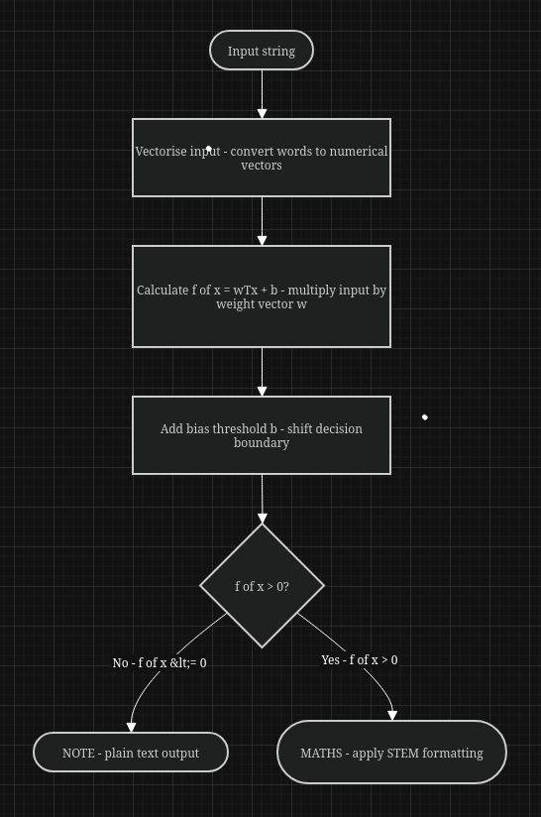

NLP Tokenizer + Stop word removal
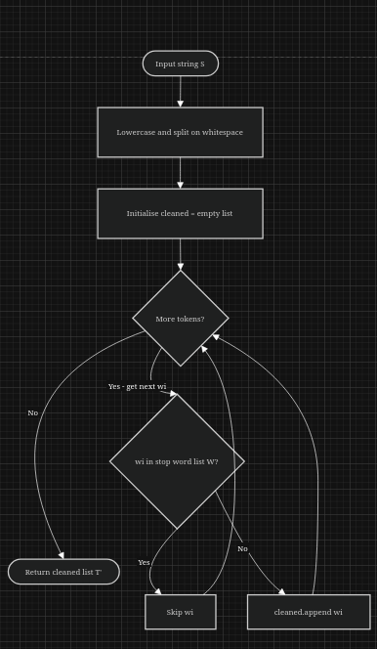

Pseudocode

NLP-tokenization + stop word removal loop
CLASS TranscriptProcessor
STEMKeywordDB = ["integral", "derivative", "coefficient", "vector", "matrix", "sine", "cosine", "tangent", "squared", "cubed", "equals", "pi", "delta", "sigma"]
PRIVATE stopwords ARRAY
PUBLIC PROCEDURE:
stopword= stop_words = ["um", "ah" , "basically", ”start”,”stop]
END
PUBLIC FUNCTION clean STRING
Tokens=LOWER.SPLIT(“ “,clean)
Cleaned=[]
FOR EACH word IN tokens DO
IF word NOT IN stopWords THEN
cleaned.APPEND(word)
END IF
END FOR
RETURN cleaned.JOIN(“”)
END FUNCTION
PUBLIC FUNCTION tokenise(inputSTR) RETURN LIST
Tokens=LOWER(inputSTR).SPLIT(“ “)
RETURN
END FUNCTION
PUBLIC FUNCTION EXTRACT keywords(tokens) RETURN LIST
Keywords=[]
FOR EACH word intokenList then
IF word IN STEMkeywordDB THEN
keywords.APPEND(word)
END IF
END FOR AND RETURN keywords
END FUNCTION
END CLASS

Intent classifier +SVM
CLASS IntentClassifier
PRIVATE SVMModel
PRIVATE trainingData LIST
PRIVATE intentLabels LIST
PUBLIC PROCEDURE initialise()
trainingData = [
"integral of x squared",
"derivative of sine x",
"the battle of hastings",
"causes of world war two",
"x equals five plus three",
"the criminal justice system"
]
intentLabels = [1, 1, 0, 0, 1, 0]
// 1 = MATHS, 0 = PLAIN TEXT
END PROCEDURE

PUBLIC PROCEDURE train()
SVMData = vectorise(trainingData)
// Converts words into numerical vectors
// using term frequency representation
SVMModel = SVC.fit(SVMData, intentLabels)
END PROCEDURE

PUBLIC FUNCTION predictIntent(inputSTR) RETURNS STRING
inputVector = vectorise(inputSTR)
result = SVMModel.predict(inputVector)
IF result > 0 THEN
RETURN "MATHS"
ELSE
RETURN "NOTE"
END IF
END FUNCTION
END CLASS

STEM formatter
CLASS STEMFormatter
PRIVATE mapping DICTIONARY
PUBLIC PROCEDURE initialise()
mapping = {
"plus" : "+",
"minus" : "-",
"times" : "×",
"divided by" : "÷",
"equals" : "=",
"squared" : "²",
"cubed" : "³",
"square root" : "√",
"pi" : "π",
"integral" : "∫",
"delta" : "Δ",
"sum of" : "∑",
"infinity" : "∞"
}
END PROCEDURE
PUBLIC FUNCTION format(inputSTR) RETURNS STRING
formattedStr = inputSTR
FOR EACH key IN mapping DO
IF key IN formattedStr THEN
formattedStr = REPLACE(formattedStr, key, mapping[key])
END IF
END FOR
RETURN formattedStr
END FUNCTION
END CLASS

Speech Recognition

PROCEDURE captureAudio()
TRY
recogniser = Recogniser()
microphone = Microphone()
WITH microphone AS source DO
recogniser.adjustForNoise(source)
audio = recogniser.listen(source)
END WITH
initText = recogniser.recogniseGoogle(audio)
RETURN initText
EXCEPT UnknownValueError
RETURN "Could not recognise audio"
EXCEPT RequestError
RETURN "Service unavailable"
END TRY
END PROCEDURE

Justification of chosen solutions
Language: Python
Advantages | Disadvantages
-Well documented on Machine Learning  -More power in terms of complex algorithms  -Better maintainability due too functions and procedures | -Slower than other languages due to python being  -Less powerful in terms of interface design then languages like HTML,CSS,JS  -

User Interface: Pygame
Advantages | Disadvantages
- offers a simple API for one to draw things on a screen  -comprehensive documentation | -Only semi-portable (as you'll need to distribute a native version of Pygame for each platform)
https://www.reddit.com/r/gamedev/comments/1g1xzd/pygame_proscons/
https://stackoverflow.com/questions/40527057/tkinter-or-pygame-which-should-i-use
https://www.oreilly.com/library/view/python-programming-on/1565926218/ch20s01s02.html

Storage: SQL and .TXT(will definitely use one, try to implement both)
SQL |  | .TXT
Advantages | Disadvantages | Advantages | Disadvantages
-Works incredibly well with python and scikit learn  - SQL databases follow normalization principles | - Limited Scalability for Complex Queries  - Performance Issues with Large Databases | -Better for storing notes in due to it being plaintext  -Exportable and transferrable to pretty much any word processor | -Clunkier to implement in python
https://www.almabetter.com/bytes/articles/advantages-and-disadvantages-of-sql
https://stackoverflow.com/questions/1499239/database-vs-flat-text-file-what-are-some-technical-reasons-for-choosing-one-ove

Python will be used as the main language for the program due to its powerful machine learning and natural language processing documentation. Pygame will be used for the main user interface as it allows for not just strings to be printed (LATEX). Data storage will be both SQL for system data, and .txt for exporting files for that are universial to all platforms(e.g. if a user wants to export notes taken from my program to apps like notepad++ or to store in OneDrive/google drive/Dropbox).

Level 0 DFD(contextual)
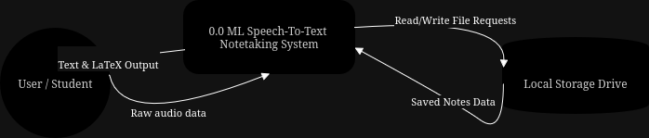

Level 1 DFD: Complex Sub diagram
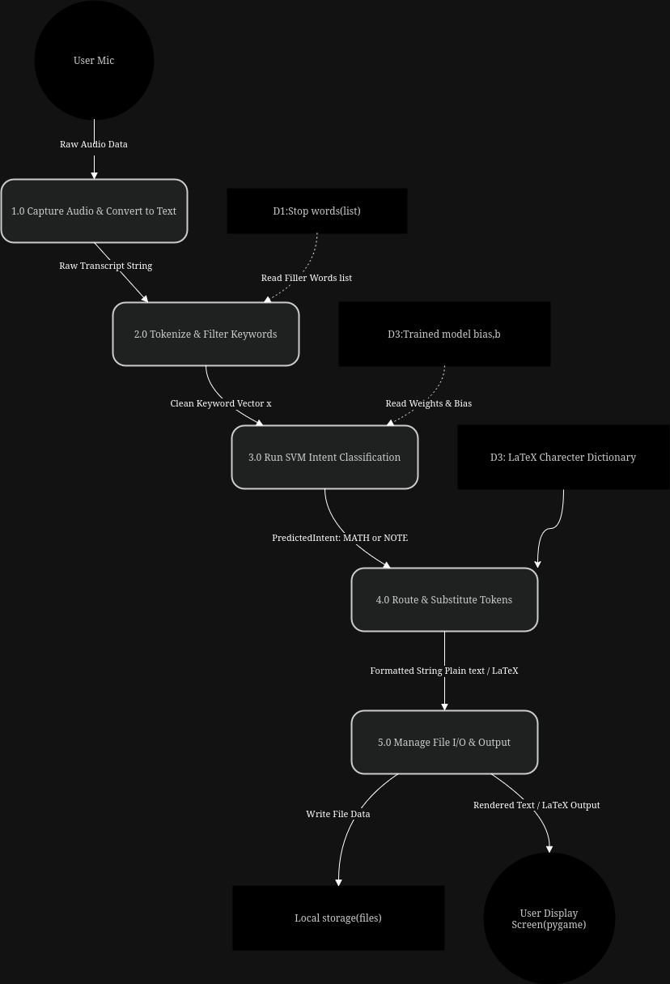

Limitations and constraints of the project

Limitation/Constraint | Solution/Counter argument
Requires internet connection to use the initial speech_recognition library and API | Students typically have internet access in class anyway
The intent classifier can only distinguish between two categories: maths or plain text | Thats really all the intent classifier needs to do and if needed more options can be added
Python is a slower language then c++ | Python is stronger in terms of Natural Language processing and Machine learning algorithms, furthermore to keep it fast i will not bloat the algorithms with unnecessary things keeping it lightweight
The program may incorrectly classify a sentence if user uses mathematical words in non mathematical areas e.g. “the integral role of parents” | The bias threshold (decision threshold) can be tweaked to reduce this by requiring multiple mathematical words in a sentence
Initially the support vector machine algorithm is trained on a small data set, could cause misclassification | WIll add more training data in newer versions

Design

