**Global Space Balloon Challenge Prize Submission for MOST EDUCATIONAL INITIATIVE**

**GSBC TEAM NAME: Blessed Sacrament School Takes Flight (TEAM BSS)**

**ORGANIZATION: Blessed Sacrament School, Burlington, NC**

**LAUNCH DATE: April 25, 2015**

**VENUE: BURLINGTON MINI MAKER FAIRE, Burlington NC**

[**www.bssknights.org**](http://www.bssknights.org)

**INTRODUCTION**

May 5, 1961 Alan Shepard became the first American to fly to space. On July 24, 1969 Neil Armstrong and Buzz Aldrin became the first human beings to set foot on the moon. On Saturday April 25, 2015 Blessed Sacrament School in Burlington, NC became the first citizens of Alamance County to reach the edge of space by successfully launching tandem near space balloons to the edge of space from the 2015 Burlington Mini Maker Faire. This project has been a semester-long community-wide STEM/Maker project by Blessed Sacrament School that shows what is possible when a community comes together! All 165 students, 25 teachers and countless parents and community members were involved in our mission! This was an amazing STEM/Maker project for TEAM BSS at Blessed Sacrament School. It included all students from grades preschool through grade 8, parents, community, STEM education, engineering and so much more!

**WHO ARE WE?**

Blessed Sacrament School is a K-8 school that recently received the title "STEM School of Distinction" from the North Carolina Department of Public Instruction and the Science Math and Technology Center of North Carolina. BSS is one of only 13 schools in the state to receive this honor - and the only private school. This was BEFORE this space mission!   
  
**HOW TEAM BSS CREATIVELY INTEGRATED HAB INTO OUR SCHOOL**

In the Fall of 2014, Blessed Sacrament School introduced our year-long STEM project to the students and the parents of BSS. All 165 students and all teachers had plans to integrate the HAB into their lessons throughout the year.

Middle School Students from Blessed Sacrament School did a vast majority of the work on this project. Teachers and Mentors guided them but students designed and built the payload (to FAA Regulations), put together the balloon system, took part in the launch, participated in Mission Control, Safety Crew, Launch Crew, Communications Crew and the Chase crew. They researched GPS trackers, high definition digital cameras and other integral technology components necessary for a successful flight. Students wrote descriptions and rules for each “crew” involved in our mission. For example Safe Crew students designed signs for working with hydrogen, Mission Control members created check lists and organized display materials, Launch Crew members organized and printed procedures for a safe and properly executed launch. Teachers and students are in the process of analyzing and evaluating the data they collected. The only adult-only portions of the mission were the loading of the hydrogen into the balloon and the drivers for the chase vehicles that tracked and recovered the balloons.

TEAM BSS Middle School students had a large role in this mission. However EVERY student at BSS was involved and learned something from this project. All students had a "flat Knight" which is our school's mascot, in the payload. Students from Kindergarten through Grade 8 attended sessions about what a High Altitude Balloon is and how it works. Grade level appropriate lessons on weather, layers of the atmosphere, etc. were integrated into the curriculum to inspire and ignite excitement for our HAB launch. The students learned about the atmosphere, weather, the space program, GPS, ham radio, engineering, and most importantly team work and community involvement.

All grade levels integrated the HAB launch into their curriculum. For example, Fourth Graders used landing prediction websites to pin and date the different locations throughout the weeks leading up to the launch on a map, integrating North Carolina Social Studies curriculum. Middle School students used the prediction sites as well and downloaded information to Google Maps to take a closer look at the landscape of the landing site and apply longitude and latitude skills, weather implication on launch as well as analyze flight path data. Kindergarten students learned about mass and to-the-gram engineering by comparing the mass of an un-colored knight to one that had been colored by crayons using a high precision balance/scale. 

**EDUCATIONAL EFFECTIVENESS**

One of the most rewarding aspects of the TEAM BSS launch was how much knowledge our students retained for the day of the event. Middle school students were not speaking to each other as children, but rather as scientists. They were using terminology such as payload, gas pressure, buoyancy, grams, mass, tracking system terminology, precision measurement, engineering design process, etc.

Students used the Global Space Balloon Challenge website to see other teams across the country. They also used the site as a resource to help them with the project. Students were able to use the “Forum” section of the site as a resource and our teachers used the “Educators” site for assistance.

Each week BSS middle school students have a designated engineering class, where students worked on their payloads to FAA regulations, researched HAB launches, the technology of GPS systems, programing high definition digital cameras, etc. Students in math class analyzed prediction sites and data retrieved from these sites. After the launch, students analyzed detailed data from the actual flight. Students were truly engaged in making assessments based on actual data. Questions like “Based on the speed change at this height, when do you think the parachute opened and why?” “What might have happened when we lost signal?” “Why are we using hydrogen instead of helium?” etc.

Students also did reflections on the launch experience after the event. The below pictures was used as a prompt for them to write about their experience:

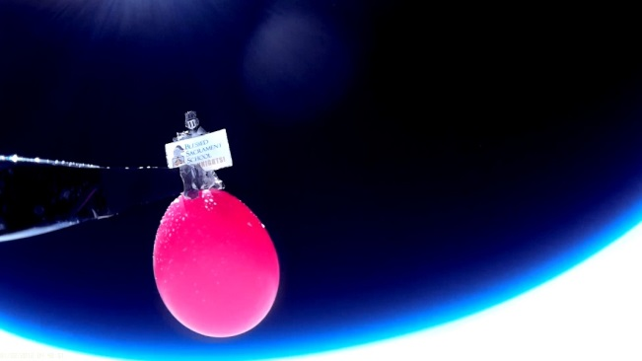

Here is a sample of student reflection: “*When I see that picture, I feel relieved and proud of myself. I had a big role in the making of the payloads. I designed the stringing system on the box which is very important because that is how the payload is attached to the balloon and the parachute. Grant, Lewis, and I had to make a stringing system for the box and we designed a way and it was successful. I also helped make one of the holes for the camera. We had to figure out how to put the camera in the box and I helped cut and design the hole. A lot of people have taken time to work on this project and it was very stressful. I full relieved to see the picture of the arm with the knight on it at near space.” – Stephen, 7th Grade Student*

**HOW DID OUR LAUNCH REACH STUDENTS AND COMMUNITY MEMBERS**

This project has been a semester-long community-wide STEM/Maker project by Blessed Sacrament School that shows what is possible when a community comes together! All 165 students, 25 teachers and countless parents and community members were involved in our mission! Our launch took place at the Burlington Mini Maker Faire which averaged almost 5,000 people in attendance. The Burlington Mini Maker Faire theme for 2015 was "Curiosity Takes Flight" in honor of TEAM BSS’s project!

Community partner Bennett Harris and the Alamance Makers Guild played a huge role in our school/community wide project and Mr. Harris helped make TEAM BSS’s dream a reality. We are proud that the Alamance Makers Guild and leader Bennett Harris supported our school and its teachers and students.  Bennett was our school’s guest speaker at many parent and community events throughout the school year to excite our parents about STEM education, The Maker Movement and the HAB experience. He encouraged school parents and his AMG members to get involved and make this a memorable and special event for the children.   
  
Another hero of this project was Paul Lowell and the team from NC Near Space (A high altitude ballooning club from the Triangle area of NC). Paul took time out of his busy schedule to speak on a number of occasions to our students about High Altitude Balloons, the design process for having our own launch and coached the students and teachers throughout the project for a successful launch. He also donated his equipment, cameras and APRS trackers so that the school could have extra footage and use data for educational purposes. The day of the event, Paul was an integral part of helping TEAM BSS, assuring that our equipment was charged and linked and that our payload was ready to go! Students are currently using Paul’s data charts (see below link for data from NC Near Space) in the classroom for data analysis. Paul provided guidance, advice, mentorship, and direction for the project. Our school community is forever indebted to Paul and the rest of the folks from NC Near Space for helping us with this launch!

Other community members that were engaged in our launch included The Holly Hill Mall and Business Center for provided a public location for the launch site. TEAM BSS connected with Palmer Generator and Kohler for providing our hydrogen source. Multiple parents and community members donated money, time or other helpful resources for our launch.

Parents, community members, students and teachers came together to make this dream a reality! We could not believe the support and involvement of our community members. It is estimated that 5,000 people attended the Burlington Mini Maker Faire and all participants at some point were able to be part of the HAB Launch, whether it was helping countdown the balloon release or tracking the parent chase crew on the screens at mission control educating the public. The excitement was tangible when the balloons burst and when the payloads were found. A truly unforgettable moment for all involved! We currently have parents and community members contacting us and asking us about future launches and offering suggestions on how they can help us take our next launch to new heights.

High Altitude Balloon Launch is a wonderful way that a community can work together embrace, STEM Education and the Maker Movement.

**COULD ANOTHER ORGANIZATION/SCHOOL REPRODUCE OUR LAUNCH?**

Yes! TEAM BSS has been sharing our experience launching a HAB throughout the school year. Literature has been made and reproduced and shared many times with community members, parents, educators from other schools and organizations. Teachers from our school also spoke at the Scaling STEM Conference in Raleigh, NC, The National Catholic Education Association Conference in Orlando Florida and the Diocese of Raleigh School Conference. The picture below is of the exhibit for over 500 attendees at the Scaling STEM Conference to share and learn about our HAB project!

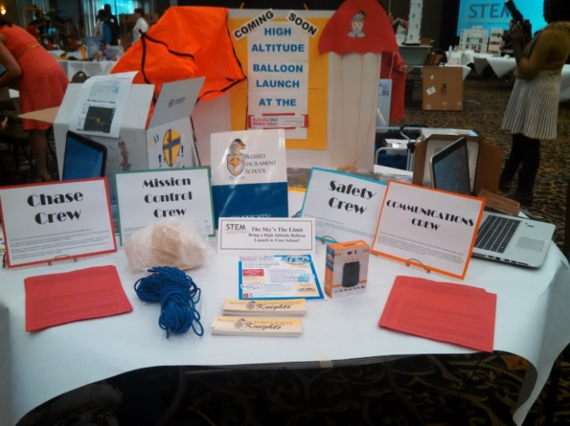

|  |  |  |
| --- | --- | --- |
| Balloon Launch Project Budget |  |  |
|  | 1 Balloon | Cost for 2 Balloons |
| Balloons - $40 each | $40 | $80 |
| Parachute - $60 plus tax/ship | $60 | $120 |
| Rope | $15 | $30 |
| GPS Trackers (1 Unit $99 plus service plan of $99) | $200 | $400 |
| Mobius camera ($85) | $85 | $170 |
| Extended life Battery ($5) for Camera | $5 | $10 |
| SD Card 32 GB for Camera ($20 each) | $20 | $40 |
| Extended Life Ultimate Lithium Batteries | $20 | $20 |
| Materials | $40 | $80 |
| Total Cost | $485 | $970 |

***\*\*Blessed Sacrament School has all rights to the video footage***

***collected in both payloads of our launch***.**

**FLIGHT FOOTAGE CAN BE FOUND HERE:** <https://www.youtube.com/watch?v=apJSouODwik>

This video is footage of the launch, flight, and recovery of Blessed Sacrament School’s amazing Tandem High-Altitude Near-Space Balloon mission to the edge of Space launched from the 2015 Burlington Mini Maker Faire as a year-long community-wide STEM/Maker project by TEAM BSS! TEAM BSS hopes this project can help inspire other schools, communities, maker spaces, and citizen scientists to get involved with their schools and do something BIG in their community to make the statement that STEM education is an important investment in our future!

***\*\*Blessed Sacrament School has all rights to the video footage***

***collected in both payloads of our launch***.**

**EDUCATION DOCUMENTARY VIDEO LINK:** <https://www.youtube.com/watch?v=WBtWPhEk2V8>

This video is a documentary about TEAM BSS’s entire school wide year-long project. It includes interviews with staff, students, parents, footage from educational sessions held for students and parents throughout the school year as well as launch footage.

**Flight Data**

LINK: <http://www.ncnearspace.org/missions/nsl-37-38>

Here is the Flight Data from Blessed Sacrament School’s High Altitude Balloon Launch from the Burlington Mini Maker Faire. One balloon reached 89,247 feet – almost three times the height of commercial jets! So many thanks to NC Near Space for mentoring and assisting us with this project! Students are using data provided by community partner Paul Lowell from NC Near Space in the classrooms in a variety of ways. Flight path, balloon speed, prediction vs actual comparisons and making education conclusions from powerful data!