Using the BallotPath Database Administration Tool

# Introduction

The Ballot Path database is held in a PostgreSQL relational database. Each table represents an entity such as an elected position (the position table), a person holding an office position (the office_holder table), or a geographical district (the district table). Relationships between tables are designed so that information is not stored redundantly. This is unlike a monolithic spreadsheet-type table that will contain duplicated information on many rows. All data maintenance is done by editing the data contained in the individual tables.

All maintenance will normally be done through a web-based application and is described in this document.

# Instructions

1. Access the administrator tools via the public-facing web site and clicking the Developer link at the top.
2. Use the login credentials set up and discussed outside of this document.

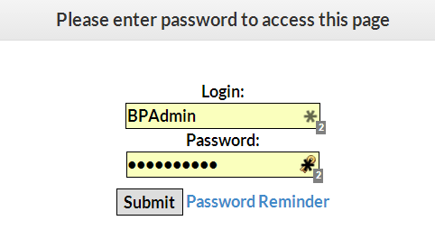

1. After logging in, the main menu will appear where you may perform several administrative functions.

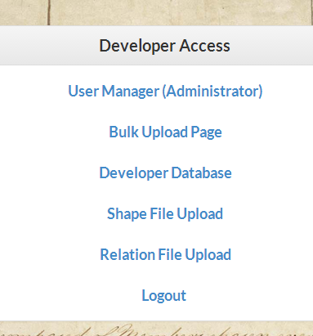

1. After clicking on **Developer Database** and logging in (if necessary), the main data entry screen appears with the Election Divisions table data. On the left navigation pane, you will find links to all of the relevant tables that contain Ballot Path data:

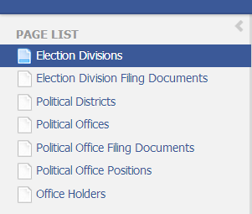

1. In the main body of the page, you will find the election divisions data table. Here you can view, edit, delete, copy, or add rows.

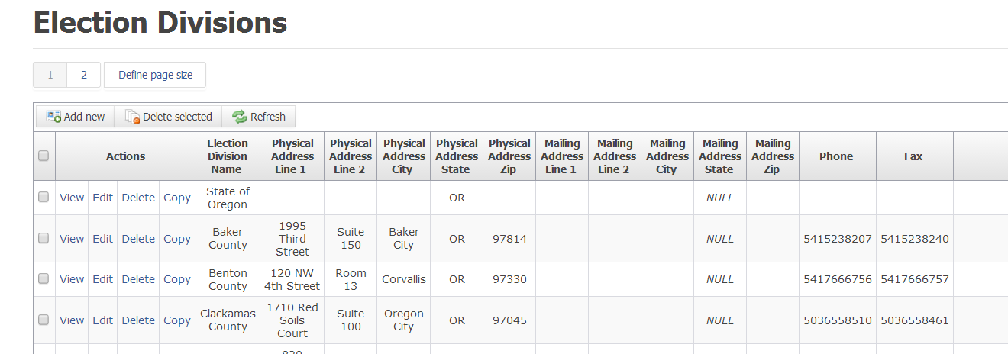

1. By using the navigation pane, you may select the appropriate table to edit. Let’s walk through an example to see how to create a position in the database.

## Example: Creating an elected position in the database

For this example, we will create a fictitious position:

Office Title King of Winterfell

Number of Positions 1

Responsibilities

Filing Fee

Partisan Position No

Age Requirement None

Office Rank 2

Office Holder Brandon Stark

Political District Winterfell Region

Election Division Royal Realm of Winterfell

Additional details will be filled in as we go, but this will give us a start.

We cannot begin by simply entering this data into the offices or positions tables. Since those tables require information found in other tables, we must first make sure the other data is there. For example, we cannot create a position until we are able to assign the position to an office. Offices cannot be created until there is a district in which to create it. Each district must be associated with an election division, and so on. We will start by creating an Election Division.

1. Click on the Election Divisions in the navigation pane.
2. After browsing through the data, we find that there is no election division named “Royal Realm of Winterfell”, so click the **Add new** button.

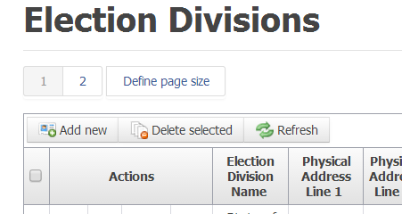

1. In the form that pops up, fill in the information you have about this election division. When you are finished, click the save button at the bottom.

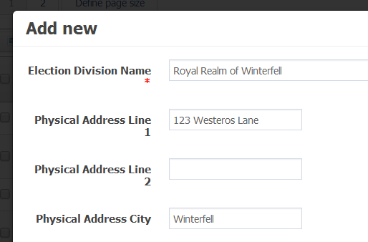

1. Now, let’s add the district. A district is a region in which a candidate can live to qualify for office. Click the Districts table and add a new record. Notice that the **Election Division** dropdown box now contains an entry for the newly created **Royal Realm of Winterfell** election division. Save the change.

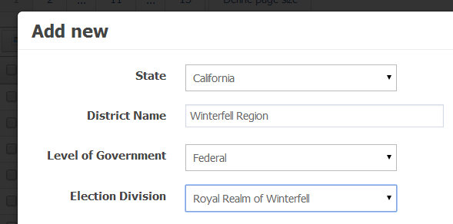

1. Let’s create the office holder. Go to the Office Holders table and add a new record for *Brandon Stark.*

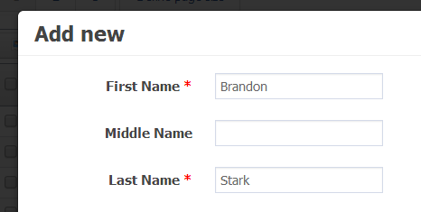

1. Now, create the political office record. Click on **Political Offices** and add a new record for *King of Winterfell*. Note that for this position, there is only 1 position available.

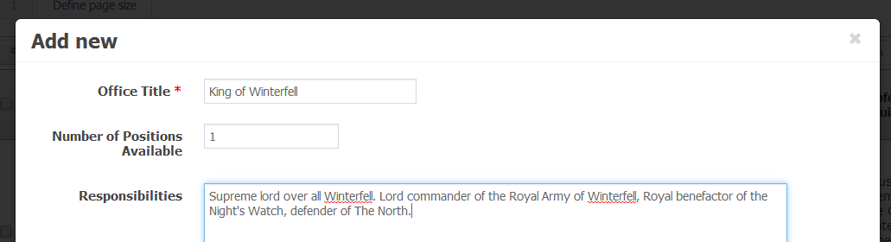

1. Finally, we need a record in the Positions table. This may seem confusing and redundant with the offices table, but it is necessary to represent offices for which there are multiple positions such as City Council, Circuit Court Judge, etc. This table ties many of the other tables together. Click the Add new button and enter the new record.

**Note**: the first few boxes are dropdowns that include information we just created. Also, there is no need (in this case) to fill in the Position Name field. This would only be necessary for offices in which there are multiple positions such as “Position 1”, “Position 2”, etc. When this information is presented to the end user of Ballot Path, the position.name field will be appended to the **office.title** field. If both fields contain the same data, the record would appear as “King of Winterfell King of Winterfell”. In the case of a city council position, the office.title field would contain “City Council” and the **position.name** field would be “Position 1”, resulting in “City Council Position 2” in the user interface.

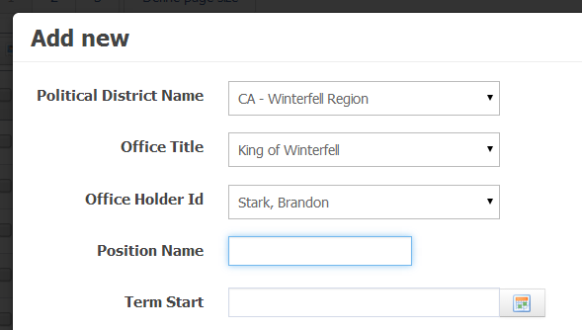

The office rank field is for sorting purposes. For this record, there is no need to change it. For offices that have many positions, this establishes the order in which they are shown on the web page.

1. If there are any documents associated with the election division or with the office, you may create records for them in a similar fashion. Documents in the Election Division Docs table are required for all candidates within that election division. Documents contained in the Office Docs are unique to that particular office and not required for other positions.

# Tables in the Database

**district**

This holds the districts in which a position is electable. It could be the whole state of Oregon, as in the case of US President or US Senator, or it could be a small district such as Multnomah County District 4, or something in-between such as an entire county.

**election_div**

Contains information about the election division that oversees the election of an office. For state-wide positions (US President, US Senators, Governor, Secretary of State, State District Attorney, State Treasurer, State Labor Commissioner, etc.) this is the State of Oregon. For most other positions, it is the county in which the position resides. For some larger cities (Portland, Eugene?, ???) elections are run by the city for city-wide positions. Smaller cities use the county election division.

**election_div_docs**

This holds a list of documents that must be filled out to run for a position in that election_division. These are documents that every candidate must submit, no matter what position it is.

**office**

This is the table holding all the information about a particular office, no matter how many positions it has or who is occupying it. Every office_position record should point to one office record.

**office_docs**

These are documents that a candidate must fill out that are UNIQUE TO THAT POSITION. I don't know if we have any of these, but they might be something that a State Treasurer might fill out to certify that he/she is a CPA or something.

**office_holder**

Information about the current incumbent holding the office.

**office_position**

This is information that contains information about each particular position. If there is one position for a given office (such as Governor), there will be a one-to-one relationship to office. If there are many positions available (such as Circuit Court Judge), then there will be one record in office_position for each available position.