WEEK 3 PROJECT REPORT

Data Cleaning &
Preprocessing Pipeline
Beauty & Wellness Customer Insights
YuvaIntern • Data Science with Python Analyst Internship
Prepared using locally available project dataset files

Project metric | Verified result
Review records processed | 1,094,411 across 5 CSV files
Product records processed | 8,494
Review row-count validation | All 5 files match expected counts
Missing product IDs in cleaned reviews | 0 in every file
Missing / invalid review ratings | 0 in every file; ratings within 1–5
Duplicate product IDs | 0
Quality summary | 117 audit entries generated

1. Executive Summary
This week focused on building a repeatable preprocessing workflow for the Beauty & Wellness Customer Insights project. The pipeline cleans the product catalogue and five large review CSV files while preserving raw inputs. It standardizes field names and text values, handles common missing-value labels, validates numeric fields, removes an exported index column, normalizes recommendation flags, and writes cleaned outputs separately.
The final review validation confirmed that all 1,094,411 records were retained across five cleaned files. Every file matched its expected row count, had no missing product IDs, and had no missing or out-of-range ratings. The product catalogue contains 8,494 records and no duplicate product IDs. A quality summary containing 117 audit entries was generated. Potential duplicate reviews and statistical price outliers were documented as candidates rather than automatically deleted.
Two suspicious zero values in value_price_usd for products P500840 and P501426 were changed to missing in the processed product file after checking their other price fields. The raw source data was not changed.

2. Project Objectives
- Create repeatable cleaning scripts for product and review datasets.
- Preserve raw inputs and write transformed outputs separately.
- Standardize column names and normalize common missing-value markers.
- Validate ratings, product identifiers, numeric price fields and recommendation indicators.
- Measure missingness and identify outliers or possible duplicates without unsupported assumptions.
- Produce quality summaries and validation evidence for later analysis.

3. Dataset Overview
Dataset | Raw records | Columns | Role
reviews_0-250.csv | 602,130 | 19 | Customer reviews and metadata
reviews_250-500.csv | 206,725 | 19 | Customer reviews and metadata
reviews_500-750.csv | 116,262 | 19 | Customer reviews and metadata
reviews_750-1250.csv | 119,317 | 19 | Customer reviews and metadata
reviews_1250-end.csv | 49,977 | 19 | Customer reviews and metadata
product_info.csv | 8,494 | 27 | Product catalogue, prices and attributes
TOTAL review records | 1,094,411 | — | Sum of five review files

Raw files are kept under data/raw/. Processed outputs are stored under data/process/ and data/process/reviews/.

4. Preprocessing Workflow
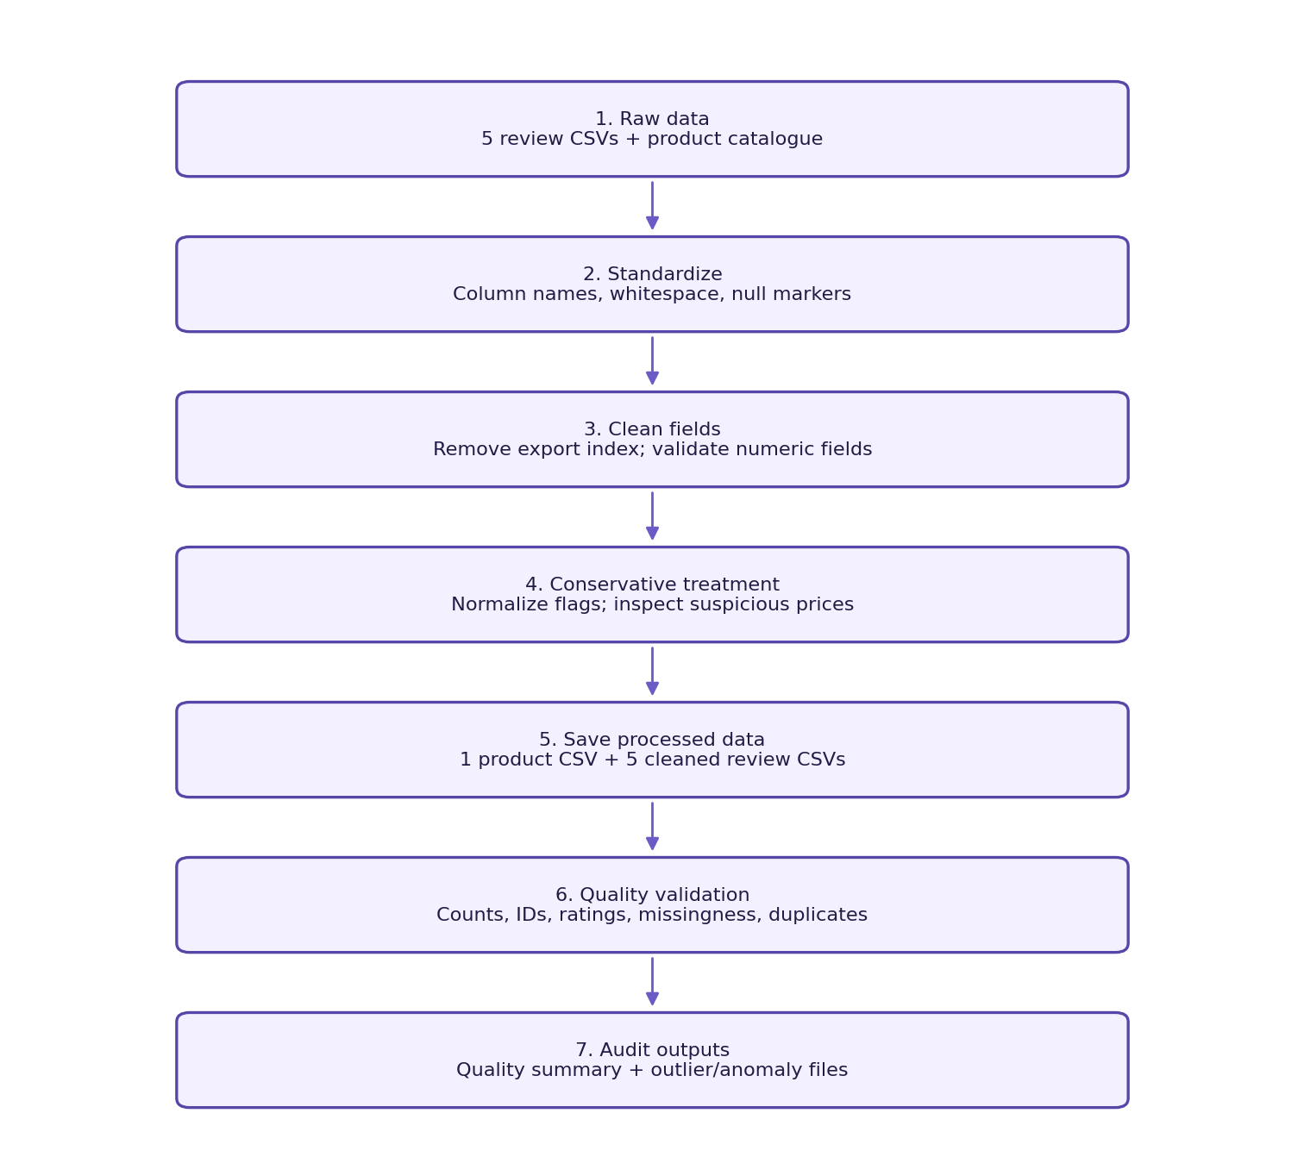
The workflow is repeatable: raw data is read, standardized and validated, then written to separate outputs. Outlier and anomaly files are audit artifacts, not instructions to remove records.

5. Cleaning Rules and Rationale
Area | Rule applied | Reason / treatment
Column names | Standardized to consistent lowercase/underscore names. | Reduces inconsistent field references.
Text fields | Strip surrounding whitespace; blank strings and common null labels become missing. | Avoids treating placeholders as genuine text.
Exported index | Drop Unnamed: 0 / unnamed_0. | It is an export artifact, not a business feature.
Ratings | Convert to numeric; values outside 1–5 become missing. | Enforces expected review scale.
Price fields | Convert to numeric; negative prices become missing. | Supports valid price analysis without inventing replacements.
Review count | Convert to numeric; negative counts become missing. | Counts cannot be negative.
Recommendation flag | Normalize true/false, yes/no and 1/0 into nullable Boolean. | Makes the field consistent for analysis.
Product IDs | Check missing and duplicate identifiers. | Protects catalogue integrity and joins.
Missing values | Measure and retain; no blanket imputation. | Missingness may be structural or not recoverable.
Reference prices | Set two suspicious zero value_price_usd entries to missing after cross-checking other prices. | Conservative anomaly handling.

6. Missing-Value Assessment
Missing values were measured after standardization. High missingness in helpfulness, demographic and product-variation fields was retained and documented. No blanket imputation was applied because a missing demographic response or unavailable product variation cannot safely be inferred from the available data.
Review field | Missing count | Approx. share
helpfulness | 561,592 | 51.31%
review_title | 310,657 | 28.39% (cleaned audit)
hair_color | 226,768 | 20.72%
eye_color | 209,628 | 19.15%
skin_tone | 170,539 | 15.58%
is_recommended | 167,988 | 15.35%
skin_type | 111,557 | 10.19%
review_text | 1,444 | 0.13%

Data reconciliation note: review_title was counted as 310,654 in the earlier raw audit and 310,657 in the cleaned audit. The latest cleaned count is shown here; reconcile this three-record difference before making exact field-level before/after claims. The verified total row count is unaffected.
Product field | Missing count after correction
sale_price_usd | 8,224
value_price_usd | 8,045
variation_desc | 7,244
child_max_price | 5,740
child_min_price | 5,740
highlights | 2,207
size | 1,631
variation_value | 1,598
variation_type | 1,444
tertiary_category | 990
ingredients | 945
rating | 278
reviews | 278
secondary_category | 8

7. Outlier and Anomaly Analysis
The Interquartile Range (IQR) method flags statistical outliers using Q1 − 1.5×IQR and Q3 + 1.5×IQR, where IQR = Q3 − Q1. These are screening flags, not proof of incorrect data. No record was deleted merely for exceeding an IQR bound.
Price field | Valid values | Median | Maximum | Upper bound | Flagged
price_usd | 8,494 | $35 | $1,900 | $107.50 | 845 (9.95%)
sale_price_usd | 270 | $14 | $320 | $50.50 | 11 (4.07%)
value_price_usd | 451 | $67 | $617 | $203.75 | 28 (6.21%)
child_min_price | 2,754 | $28 | $400 | $76.50 | 323 (11.73%)
child_max_price | 2,754 | $32 | $570 | $114.50 | 322 (11.69%)

A separate scan found two zero values in value_price_usd and no zero or negative values in price_usd, sale_price_usd, child_min_price or child_max_price. The two reference-price values were checked against other prices and changed to missing in the cleaned output. Audit files preserve the flagged records for inspection.

8. Duplicate and Relationship Checks
- The product catalogue contains 8,494 unique product IDs and zero duplicate product IDs.
- Review data references 2,351 distinct product IDs. The earlier linkage audit found zero missing review product IDs and zero review product IDs absent from the product catalogue (100% valid links in the audited files).
- A review fingerprint based on author_id, product_id, submission_time, rating, review_text and review_title flagged 465 records matching an earlier fingerprint (about 0.043%). These are candidates, not confirmed errors; no reviews were removed on this basis.

9. Validation Results
Validation | Observed result | Status
reviews_0-250_cleaned.csv | 602,130 rows; 0 missing product IDs; 0 missing/invalid ratings | PASS
reviews_250-500_cleaned.csv | 206,725 rows; 0 missing product IDs; 0 missing/invalid ratings | PASS
reviews_500-750_cleaned.csv | 116,262 rows; 0 missing product IDs; 0 missing/invalid ratings | PASS
reviews_750-1250_cleaned.csv | 119,317 rows; 0 missing product IDs; 0 missing/invalid ratings | PASS
reviews_1250-end_cleaned.csv | 49,977 rows; 0 missing product IDs; 0 missing/invalid ratings | PASS
Total reviews | 1,094,411; all five expected row counts match | PASS
Product catalogue | 8,494 rows; 0 duplicate product IDs | PASS
Quality summary | 117 audit entries generated | PASS

The final validate_preprocessed.py output confirmed all five cleaned review files were found, row counts matched, product IDs were present, and ratings were numeric and within the valid 1–5 range.

10. Tools, Reproducibility and Outputs
Tool / file | Purpose
Python + pandas | Tabular cleaning, numeric conversion, missingness and chunked CSV handling.
src/preprocess.py | Product and review cleaning pipelines.
validate_preprocessed.py | Checks row counts, product IDs and rating validity.
src/quality_audit.py | Summarizes missingness and duplicate candidates.
src/generate_quality_report.py | Creates preprocessing_quality_summary.csv with 117 entries.
src/outlier_analysis.py | Calculates IQR price outlier flags.
src/inspect_price_anomalies.py | Inspects zero/negative price candidates.
src/correct_price_anomalies.py | Applies two documented corrections to the processed product file.

Key outputs:
- data/process/product_info_cleaned.csv
- data/process/reviews/*_cleaned.csv
- data/process/preprocessing_quality_summary.csv
- data/process/product_price_outliers.csv
- data/process/price_anomaly_records.csv
The review pipeline processes files in chunks of 50,000 rows to reduce memory pressure. Raw data is preserved, and processed outputs can be regenerated by rerunning the scripts.

11. Limitations and Next Steps
- High missingness remains in several optional review and product fields; later analyses should report field-specific sample sizes and avoid treating missing values as zero.
- The three-record difference in review_title missingness between raw and cleaned audits should be reconciled before publishing exact before/after comparisons.
- Duplicate review fingerprints and IQR price outliers need contextual review and should not be automatically removed.
- The available dataset does not establish that the records represent all beauty and wellness customers.
- Next: reconcile review_title missingness, inspect highest-price products and duplicate candidates, then proceed to exploratory data analysis and customer-insight features.

12. Conclusion
The Week 3 preprocessing pipeline is operational and the main validation checks pass. It retains all 1,094,411 review records, preserves the 8,494-product catalogue, validates ratings and product IDs, records missingness, and creates audit outputs for price outliers and duplicate candidates. The workflow prioritizes traceability and conservative correction over aggressive row deletion or unsupported imputation.

Appendix A — Simplified Cleaning Pseudocode
FOR each raw dataset:
read the raw file (reviews in chunks)
standardize column names
trim string whitespace
convert blank/common null markers to missing
remove exported index column, if present
convert numeric fields to numeric
mark invalid ratings and negative numeric values as missing
normalize recommendation values to nullable Boolean
validate product identifiers and row counts
write cleaned output to data/process/
record missingness and quality metrics
FOR price analysis:
calculate IQR bounds for each price field
export candidate outliers for inspection
inspect zero/negative price anomalies
correct only the two reviewed zero reference prices
retain raw source files and document changes

Appendix B — Verification Commands
python .\src\preprocess.py
python .\validate_preprocessed.py
python .\src\quality_audit.py
python .\src\generate_quality_report.py
python .\src\outlier_analysis.py
python .\src\inspect_price_anomalies.py

