YUVAINTERN | DATA SCIENCE WITH PYTHON ANALYST INTERNSHIP

Week 4: Exploratory Data Analysis
and Feature Engineering
Beauty & Wellness Customer Insights
Prepared by Sohini Ball
Project stage: EDA workflow and feature engineering plan

Scope note: This report distinguishes validated preprocessing results from proposed Week 4 analyses. Findings from new EDA will be reported only after the analyses are executed.

1. Executive Summary
This report defines a reproducible exploratory data analysis (EDA) and feature engineering workflow for a beauty and wellness customer-insights project. The project combines product catalogue information with customer reviews to investigate rating distributions, category-level differences, price patterns, review engagement, and potential signals of customer satisfaction. The available dataset contains 8,494 product records and 1,094,411 review records across five files. The processed review files have passed row-count, product-ID, and rating-range validation checks. EDA will begin from these processed files rather than changing raw source data.
The planned analysis uses Python, Pandas, NumPy, Matplotlib, Seaborn, and SciPy. It covers dataset profiling, univariate and multivariate analysis, visual exploration, statistical testing where assumptions are reasonable, and creation of interpretable features. Proposed features include review-text length, review-title presence, price bands, product-level average rating, review volume, recommendation rate, and review timing features where dates are available. The report is a workflow plan; it does not claim that all proposed charts, tests, or models have already been run.

2. Project Context and Analytical Objectives
Beauty and wellness purchases can be influenced by product category, price, product claims, customer experience, and the characteristics of the review itself. Public review data is useful but may contain incomplete demographic fields, selection bias, unbalanced ratings, and differences in how products attract reviews. The objective is to describe what the available data can support without treating review ratings as a complete or unbiased measure of customer satisfaction.
- Describe the shape, completeness, types, and distributions of product and review data.
- Identify patterns in ratings, recommendation labels, review volume, price, and product categories.
- Compare groups using appropriate visual and statistical methods, while reporting effect sizes and limitations.
- Create features that are understandable, reproducible, and potentially useful for later analysis or modeling.
- Produce a concise set of evidence-backed business questions, figures, and recommendations.

3. Dataset Overview and Known Baseline
Dataset | Current known size | Purpose
Product catalogue | 8,494 rows; 27 columns | Product attributes such as identifiers, categories, prices, ingredients, and catalogue ratings.
Customer reviews | 1,094,411 rows across 5 files; 19 columns per raw file | Review ratings, text, recommendation label, timestamps, product identifiers, and optional reviewer attributes.
Product–review relationship | 2,351 distinct product IDs in reviews; 8,494 unique product IDs in catalogue | Link review observations to catalogue attributes using validated product identifiers.

Known baseline checks: all five cleaned review files retain their expected row counts; the combined total is 1,094,411. Validation found no missing product IDs, no missing ratings, and no ratings outside 1–5 in the processed review files. Product identifiers were unique in the cleaned product catalogue. These checks confirm selected data-quality properties, not the absence of every possible issue.
The raw review data is rating-imbalanced: 698,951 reviews are rated 5, while 61,223 are rated 1. Five-star reviews represent approximately 63.86% of records, and ratings 4–5 represent approximately 82.08%. This imbalance should be visible in the EDA and considered before training any model. These figures are descriptive baselines and should be rechecked from the processed data during analysis.

4. EDA Workflow

4.1 Load and profile the processed data
Load the cleaned product file and the five cleaned review files with Pandas. Use consistent dtypes, parse date fields deliberately, and retain product identifiers as strings to avoid accidental formatting changes. For large files, read in chunks or use efficient aggregations to control memory. Record file names, row counts, column names, and execution time.
Core checks: shape, dtypes, `head()`, `sample()`, `info()`, `describe(include='all')`, unique counts, duplicated rows, null counts, and valid ranges.

4.2 Univariate analysis
Variable family | Methods and charts | Questions
Ratings | Frequency table, count plot, percentage table | How concentrated are ratings? Are low ratings rare or concentrated in particular groups?
Prices | Histogram, box plot, median and IQR | What is the typical price, spread, skew, and range? Are high values plausible premium products?
Categories and brands | Top-N frequency bars; grouped counts | Which categories and brands have the most catalogue entries and review activity?
Review text | Length distribution, empty-text rate, title presence | How much text is available, and how does completeness vary?
Time fields | Monthly/weekly counts when timestamps parse reliably | Does review activity vary over time? Are there data gaps?

4.3 Bivariate and multivariate analysis
- Category versus rating: compare rating distributions and sample sizes by category; show median/mean with confidence intervals where appropriate.
- Price versus rating: use scatter plots with transparency, price bins, Spearman correlation, and group summaries. Avoid interpreting correlation as causation.
- Recommendation versus rating: use contingency tables and normalized proportions; check how recommendation labels relate to ratings.
- Review volume versus product rating: compare product-level review counts with average ratings, while noting that small review counts produce less stable averages.
- Text length versus rating: compare distributions by rating and use robust summaries because review length is usually skewed.
- Product attributes versus rating: explore category, brand, price, and available product attributes after joining on validated product IDs.

5. Visualization and Statistical Methods
Tool / method | Planned use | Reason / caution
Pandas | Grouping, pivot tables, joins, missingness and summary tables | Efficient tabular analysis and traceable transformations.
NumPy | Vectorized calculations, bins, missing-value handling | Consistent numerical operations on large datasets.
Matplotlib | Custom charts, axes, labels, export of publication-ready figures | Fine-grained control and reproducible figures.
Seaborn | Count plots, box/violin plots, heatmaps, regression plots | Readable statistical graphics with concise code.
SciPy | Spearman correlation; chi-square tests for suitable contingency tables; non-parametric comparisons when justified | Provides established statistical procedures. Check assumptions and report effect sizes, not p-values alone.
Scikit-learn (later, if modeling) | Train/test split, preprocessing pipelines, encoders, scaling and evaluation | Keeps transformations consistent and helps prevent data leakage.

Statistical testing will be hypothesis-driven rather than performed indiscriminately. For example, a chi-square test may assess whether recommendation labels and rating groups are associated, provided expected cell counts are adequate. Spearman correlation may be used for monotonic relationships involving ordinal ratings or skewed prices. For group comparisons, consider non-parametric tests if assumptions for parametric methods are not met. With more than one million reviews, even very small differences can become statistically significant; practical effect size, uncertainty, sample size, and data bias must also be discussed. Where many tests are conducted, multiple-comparison correction should be considered.

6. Feature Engineering Plan
Proposed feature | Example construction | Potential analytical value / caution
review_text_length | Character or token count of normalized review text | Explore whether review detail differs by rating; missing text should not be treated as a zero-length opinion without a separate missingness flag.
has_review_title | 1 when a non-empty title exists; otherwise 0 | Captures title availability; may reflect platform behavior rather than satisfaction.
price_band | Business-defined bins such as budget, mid-range, premium using price_usd | Supports understandable comparisons; define thresholds transparently and check category sizes.
product_review_count | Count reviews per product ID | Captures review volume and helps interpret stability of product-level averages.
product_mean_rating | Mean rating grouped by product ID | Product-level summary; for prediction, calculate from training data only to prevent leakage.
product_recommendation_rate | Mean of valid recommendation values by product | Summarizes recommendation behavior where labels are available; report denominator and missingness.
review_month / review_year | Parse submission timestamp to month/year if reliable | Reveals temporal patterns; inspect timezone, malformed dates, and data coverage.
rating_group | For descriptive plots only: low (1–2), middle (3), high (4–5) | Makes comparisons easier but discards detail; retain original rating for primary analysis.
category_price_interaction | Compare price distributions within product categories | Can reveal category-specific price patterns; use carefully if categories are sparse.
missing_profile_attribute_flags | Indicator for missing optional reviewer attributes | Can expose data-collection patterns; avoid inferring personal traits from missing values.

6.1 Normalization, encoding, and transformation
For descriptive analysis, use original units wherever interpretation benefits from them. If a later model requires scaling, apply StandardScaler or MinMaxScaler to suitable numeric predictors using training data only. Encode nominal categories with one-hot encoding or an appropriate encoder; avoid assigning arbitrary numeric order to categories. Any text features should begin with transparent, simple measures such as length or TF-IDF, depending on the later modeling goal. Log transformations may be considered for heavily right-skewed positive counts or prices, but zero and missing values must be handled explicitly.

6.2 Feature leakage and aggregation safeguards
A feature is not valid for prediction if it contains information that would only be available after the target outcome. For rating prediction, do not include the target rating itself or aggregates calculated using the target row. Use train/test splitting before target-informed aggregations, and calculate product-level statistics within each training fold where needed. Keep review-level and product-level datasets clearly separated and document join cardinality.

7. Example Python Pseudocode
import pandas as pd
import numpy as np
import matplotlib.pyplot as plt
import seaborn as sns
from scipy import stats
# Load only processed data; preserve product IDs as strings.
products = pd.read_csv("data/process/product_info_cleaned.csv",
dtype={"product_id": "string"})
review_files = [
"data/process/reviews/reviews_0-250_cleaned.csv",
"data/process/reviews/reviews_250-500_cleaned.csv",
"data/process/reviews/reviews_500-750_cleaned.csv",
"data/process/reviews/reviews_750-1250_cleaned.csv",
"data/process/reviews/reviews_1250-end_cleaned.csv",
]
reviews = pd.concat(
[pd.read_csv(path, dtype={"product_id": "string"}) for path in review_files],
ignore_index=True
)
# Profile quality and rating distribution.
print(reviews.shape)
print(reviews.isna().sum().sort_values(ascending=False).head(10))
print(reviews["rating"].value_counts(dropna=False).sort_index())
sns.countplot(data=reviews, x="rating")
plt.title("Customer Review Rating Distribution")
plt.tight_layout()
plt.savefig("reports/figures/rating_distribution.png", dpi=160)
plt.close()
# Example features: use actual column names after checking the schema.
reviews["review_text_length"] = (
reviews["review_text"].fillna("").astype(str).str.len()
)
reviews["has_review_title"] = (
reviews["review_title"].notna() &
reviews["review_title"].astype("string").str.strip().ne("")
).astype("int8")
# Use only valid, positive prices to create transparent descriptive bins.
price = pd.to_numeric(products["price_usd"], errors="coerce")
products["price_band"] = pd.cut(
price, bins=[0, 20, 50, 100, np.inf],
labels=["Budget", "Mid-range", "Premium", "Luxury"],
include_lowest=True
)
# Example association: run only after confirming labels and expected counts.
# table = pd.crosstab(reviews["rating"], reviews["is_recommended"])
# chi2, p_value, dof, expected = stats.chi2_contingency(table)
# Report effect size and limitations, not only p_value.
Pseudocode note: Confirm exact column names in the cleaned files before running this example. The example illustrates the workflow; it is not evidence that every proposed analysis has already been executed. The code should be adapted to memory constraints, and large-data plots may use sampled rows or aggregated summaries.

8. Hypothetical Business Scenario
Suppose EDA shows that one product category has a high average rating but very few reviews, while another category has a slightly lower average with a much larger review base. A business should not automatically rank the first category as better. The analysis could present average rating together with review count and uncertainty. Price bands and recommendation rates could then be compared within each category. If review-text length and low-rating frequency are elevated for a subset of products, analysts could inspect those reviews for recurring product-experience themes. These results may guide product-page improvements, customer-support priorities, or further research, but they do not establish causality or guarantee future sales.

9. Reproducibility, Deliverables, and Documentation
- Keep raw files unchanged and perform analysis on the validated processed copies.
- Place reusable analysis code in `src/` and/or a clearly named notebook in `notebooks/`.
- Save figures to a dedicated output directory such as `reports/figures/` or `visualizations/`.
- Record dataset source, file names, run date, library versions, row counts, filters, assumptions, and random seeds for sampling.
- Create a feature dictionary that defines each engineered feature, its formula, data type, missing-value policy, and intended use.
- Keep a clear distinction between descriptive findings, statistical associations, hypotheses, and causal claims.
- Avoid committing raw datasets or sensitive data to a public repository; review `.gitignore` before publishing.
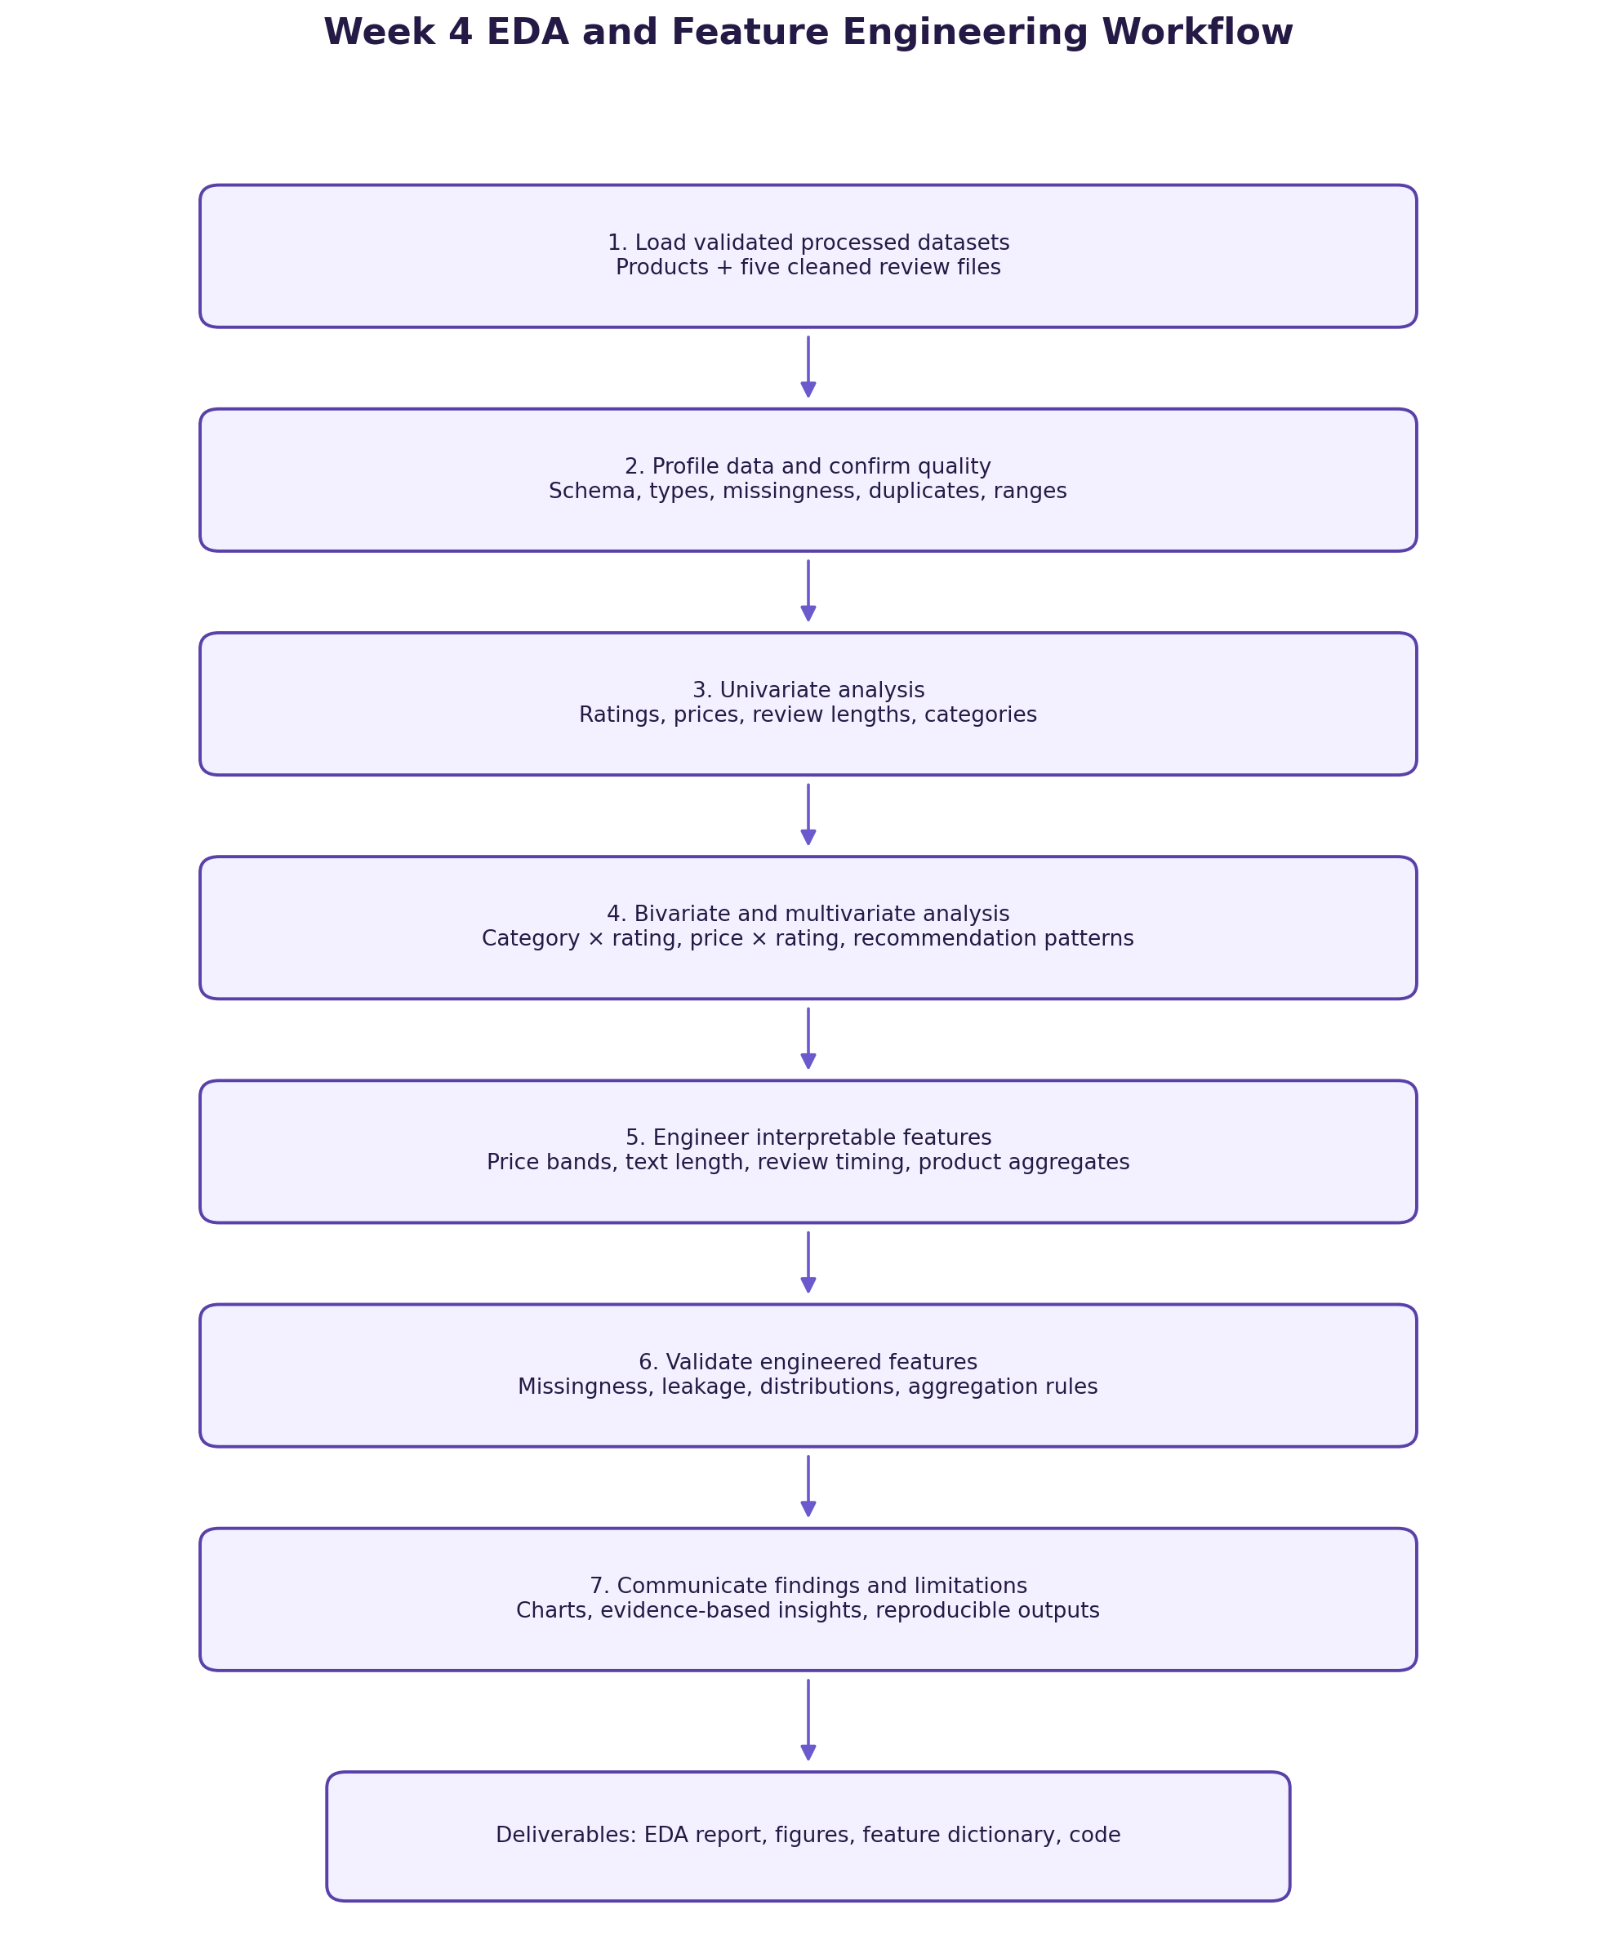
Figure 1. Proposed EDA and feature engineering workflow.

10. Limitations and Responsible Interpretation
- Public review data may be self-selected and may not represent all customers or purchasers.
- Optional demographic/profile attributes contain substantial missingness; comparisons involving them may be biased.
- A large number of reviews can make small differences statistically significant; report practical significance and uncertainty.
- High ratings do not necessarily establish product effectiveness or suitability for every person.
- Potential duplicate reviews and price outliers should be investigated, not automatically removed.
- Product-level summaries can be unstable for products with few reviews and can leak target information if constructed incorrectly.
- No predictive performance claims should be made until a model is trained and evaluated using a leakage-safe design.

11. Proposed Work Plan (30–35 Hours)
Activity | Estimated time | Output
Schema review and data profiling | 4 hours | Data dictionary, quality profile
Univariate analysis and distributions | 5 hours | Rating, price, category, text summaries
Bivariate / multivariate exploration | 7 hours | Group comparisons and association plots
Statistical checks and interpretation | 4 hours | Test notes, effect sizes, limitations
Feature engineering and validation | 6 hours | Feature table and feature dictionary
Figures, documentation, reproducibility review | 5–7 hours | Report, figures, code/notebook, final checks

12. Conclusion
This plan establishes a transparent path from validated datasets to meaningful descriptive insights and carefully engineered features. It prioritizes interpretable summaries, suitable visualizations, explicit assumptions, and leakage prevention. The resulting EDA should help identify where ratings, prices, categories, review characteristics, and product engagement patterns warrant further investigation. The next step is to execute the analyses, save the resulting charts and tables, and update the report with observed findings rather than treating proposed outcomes as established facts.

Appendix: Suggested output checklist
- Rating distribution chart and percentage table
- Product price distribution and IQR summary
- Top product categories/brands by count and review volume
- Category-wise rating summaries with sample sizes
- Price-band and recommendation comparisons
- Review length and title-availability summaries
- Timestamp coverage and trend chart, if dates are usable
- Feature dictionary and leakage-prevention notes
- Reproducible scripts/notebook and final written report

