
Alameda Naval Air Museum 2151 Ferry Pt. Road, Building 77, Alameda, California (510) 522-4262 |  | $1.00 off regular admission  with this coupon  Good for one entry only  Expires on June 6th, 2009  Free Parking
The Alameda Naval Air Museum is your portal to the past. Come experience the rich history of Alameda Point and the Alameda Naval Air Station, once one of the largest naval air bases in the world.  Known as the Gateway to the Pacific, NAS Alameda was the starting point for the men, women and machines that served in the Pacific Theater during World War II. From WWII, Korea and VietNam, to Desert Storm, Alameda was homeport for aircraft carriers such as the USS Ranger, USS Enterprise, and USS Coral Sea.  Visitors to the Alameda Naval Air Museum can immerse themselves in the images, stories and living history of Alameda Point's proud aviation legacy that began in 1930 with the San Francisco Bay Airdrome, followed by Pan Am's China Clipper base in 1935, and continued through 1997 with NAS Alameda.  The museum's collection includes rare artifacts, archival material, aircraft models and dioramas, uniforms and much more chronicling over 75 years of local history. | Open Saturday and Sunday from 10:00am until 4:00pm  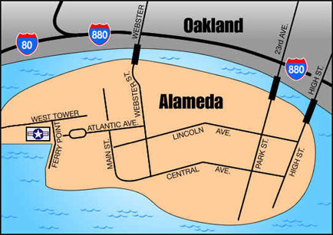  http://www.alamedanavalairmuseum.org

Alameda Naval Air Museum 2151 Ferry Pt. Road, Building 77, Alameda, California (510) 522-4262
$1.00 off regular admission
with this coupon
Good for one entry only
Expires on June 6th, 2009
Free Parking

The Alameda Naval Air Museum is your portal to the past. Come experience the rich history of Alameda Point and the Alameda Naval Air Station, once one of the largest naval air bases in the world.  Known as the Gateway to the Pacific, NAS Alameda was the starting point for the men, women and machines that served in the Pacific Theater during World War II. From WWII, Korea and VietNam, to Desert Storm, Alameda was homeport for aircraft carriers such as the USS Ranger, USS Enterprise, and USS Coral Sea.  Visitors to the Alameda Naval Air Museum can immerse themselves in the images, stories and living history of Alameda Point's proud aviation legacy that began in 1930 with the San Francisco Bay Airdrome, followed by Pan Am's China Clipper base in 1935, and continued through 1997 with NAS Alameda.  The museum's collection includes rare artifacts, archival material, aircraft models and dioramas, uniforms and much more chronicling over 75 years of local history. | Open Saturday and Sunday from 10:00am until 4:00pm  http://www.alamedanavalairmuseum.org

Alameda Naval Air Museum 2151 Ferry Pt. Road, Building 77, Alameda, California (510) 522-4262
$1.00 off regular admission
with this coupon
Good for one entry only
Expires on June 6th, 2009
Free Parking

The Alameda Naval Air Museum is your portal to the past. Come experience the rich history of Alameda Point and the Alameda Naval Air Station, once one of the largest naval air bases in the world.  Known as the Gateway to the Pacific, NAS Alameda was the starting point for the men, women and machines that served in the Pacific Theater during World War II. From WWII, Korea and VietNam, to Desert Storm, Alameda was homeport for aircraft carriers such as the USS Ranger, USS Enterprise, and USS Coral Sea.  Visitors to the Alameda Naval Air Museum can immerse themselves in the images, stories and living history of Alameda Point's proud aviation legacy that began in 1930 with the San Francisco Bay Airdrome, followed by Pan Am's China Clipper base in 1935, and continued through 1997 with NAS Alameda.  The museum's collection includes rare artifacts, archival material, aircraft models and dioramas, uniforms and much more chronicling over 75 years of local history. | Open Saturday and Sunday from 10:00am until 4:00pm  http://www.alamedanavalairmuseum.org

