Membership information for the museum  Alameda Naval Air Museum is a non-profit organization and is not sponsored by or affiliated with the US Navy. It is staffed by volunteers, many of whom are former civilian employees and veterans.  Memberships and donations pay for utilities, collecting and preserving artifacts, building exhibits, and community outreach programs.  As bases continue to close, many artifacts, papers, photographs, and collections may disappear. The chance to preserve the naval aviation history of  the San Francisco Bay Area is NOW.  Enclosed is my 501(c)3 tax deductible membership check payable to ANAM for:  - Annual Membership $25  - Annual Family Membership $45  - Lifetime Membership $500  - Sponsor/Corporate $1000  - Patron $2500  You can help by including ANAM in your estate planning.  Name  Address  City  State Zip  Phone  Please make check payable to ANAM.  alameda naval air museum  po box 1769, alameda, ca 94501  (510) 522-4262 | OUR MISSION  - To provide the opportunity to learn, share and experience the history of the naval air station.  - To collect, document and preserve those items that made aviation history and those associated with NAS Alameda.  - To provide students of all ages the ability and chance to understand and explore the world of aviation.  - To provide people with information and research on naval aviation in the Pacific.  “History is the ship carrying living memories  to the future.” – Stephen Spender | ALAMEDA  NAVAL  AIR  MUSEUM  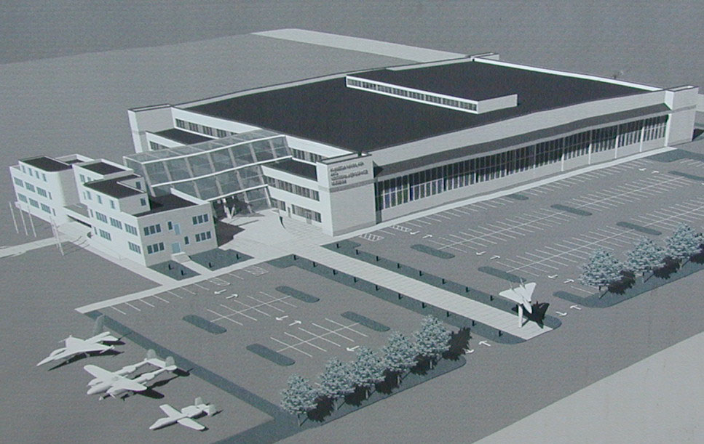  Building 77 and Hangar 41  Open Saturday & Sunday  Hours 10 am – 4 pm  http://www.alamedanavalairmuseum.org
  Board of Directors
  Marilyn York | President
  Barbara Baack | Vice President
  Carol Trotter | Secretary
  Billie Sites | Treasurer
  Frank Musso | Event Coordinator
  Sieg Wroebel | Acquisitions
  Larry Pirack | Curator
  Kin Robles | Public Relations
  Chief Bronson Perry | Community Outreach
  Staff
  Wayne Shannon | Maintenance
  Ray Gillardo | Logistics
  Betty Gayley | Gift Shop
  David Balmer | Web Master
  Advisory Board
  RAdm Edwin Wilson, USNR (Ret)
  RAdm Ray Hemmings, USN (Ret)
  Capt. Duncan Campbell, USN (Ret)
  Capt. Jim Dodge, USN (Ret)
  Building 77
  2151 Ferry Point Rd.
  Alameda, CA 94501
  510.522.4262
The museum has a unique collection of artifacts and exhibits emphasizing the US Navy’s role in the defense of our nation. It presents an overview of the development of flight and especially that of Naval aviation. The flight of Eugene Ely on San Francisco Bay in 1911 is depicted. This flight made a landing and takeoff from the U.S.S. Pennsylvania, the beginning of carrier aviation.  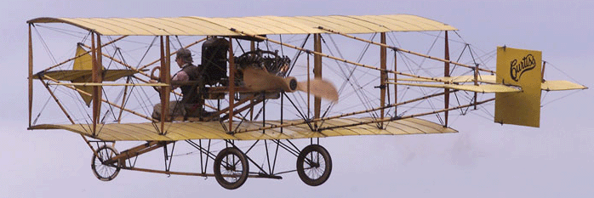  Style of Aircraft similar to Eugene Ely’s Curtis Pusher  The development of aircraft propulsion systems and delivery systems are illustrated with photos from 1911 to the present time. On display are numerous models of these planes.  - In our theatre, films will be shown that cover everything from aircraft maintenance and training films to actual combat footage.  - Slides showing the behind-the-scenes look at aircraft repair.  - Currently being developed is the opportunity to provide computerized flight simulations.  - Plans are underway to have a weather station, for hands-on work, on the 3rd floor.  - As we acquire aircraft, the chance to have your photo taken in the cockpit may become a reality.  From NAS Alameda in 1942, the carrier “USS Hornet” sailed with B-25’s that would launch the famous “Doolittle Raid on Tokyo”.  By the end of WW II, there were over 110 aircraft carriers and throughout the next 50 years, many of these would be homeported at Alameda. | In the repair shops at NAS Alameda, “Rosie the Riveter” came to work and stayed until the base closed. She occupied all trades and rose to high levels of management.  President’s Kennedy, Bush and Clinton stopped here. Robert Stack, the actor, once worked at the Naval Aviation Depot Alameda.  - The collections and artifacts from Naval Medical Center – Oakland, Naval Air Rework Facility, NAS Alameda, HM-15, Seabees, and a few others have already been saved by the museum.  - Donations from veterans have active duty elements of both the US Navy and US Marine Corps have already founded places in our current exhibits.  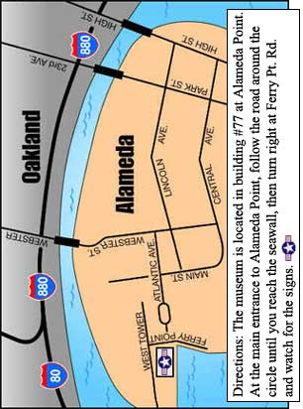 | Given the time and resources, these dreams will become reality. The museum plans for the following:  - A display/restoration area for aircraft in the hangar behind the museum.  - A snack bar on the 2nd floor with a commanding view of the Bay Area.  - A workshop for model makers interested in aviation.  Yes! I would like to volunteer.  Name  Phone  My Interest  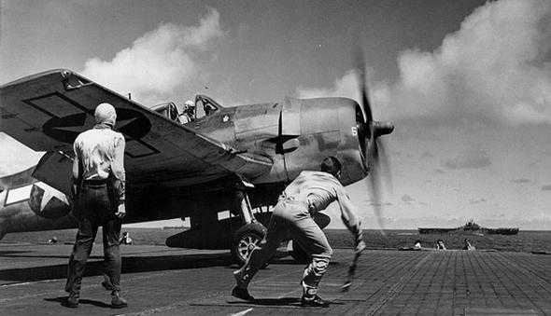  - Come join us for a fun-filled day, where you can see history come to life.  - See our panoramic view of the Bay Area from our viewers area.  - See the ships of the Maritime Force.  - Come and relive the past with someone special.
  ANAM (Alameda Naval Air Museum)
  A view to the Future of ANAM

