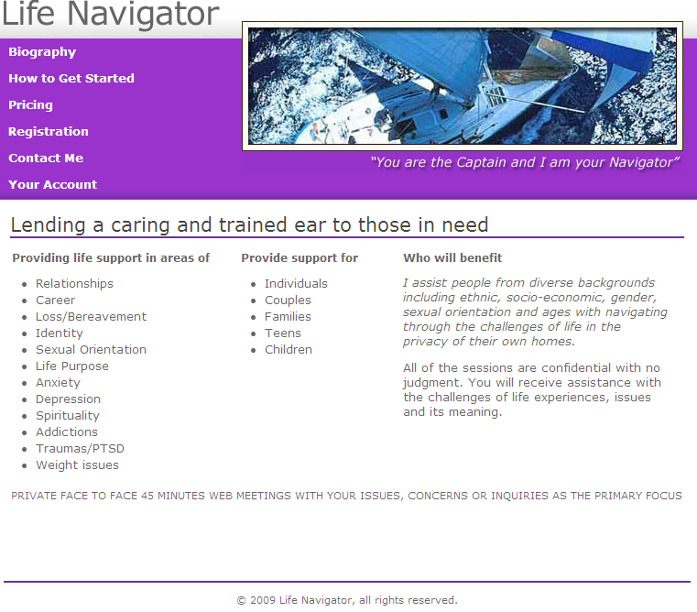

TESTING

Is done using the PayPal Sandbox which works the same way as the real PayPal site,
except there isn’t any real money or bank account info being used ☺

You will need two browser windows open, one for the PayPal Sandbox, and another for the LifeNavigator website…this is required only when testing, not for the finished website.

Login to the PayPal test site

https://developer.paypal.com/

Email Address: evadremlab@gmail.com
Password: W0rri3sPal (that’s a zero after the ‘W’)

select the “Log me in automatically” checkbox

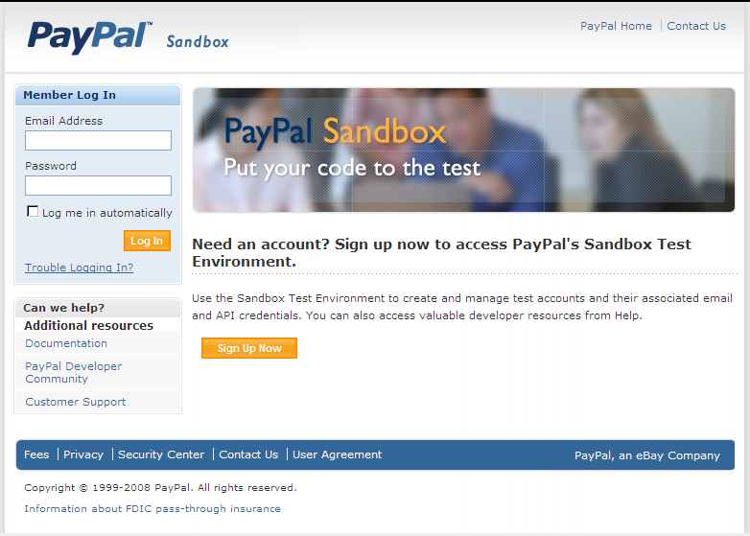

There are two PayPal test accounts

Buyer -- for logging into PayPal when scheduling an appointment

Email Address: dave.b_1236107322_per@gmail.com
Password : 236107250

Seller -- to check your transactions

Email Address: dave.s_1236107383_biz@gmail.com
Password : 236107359

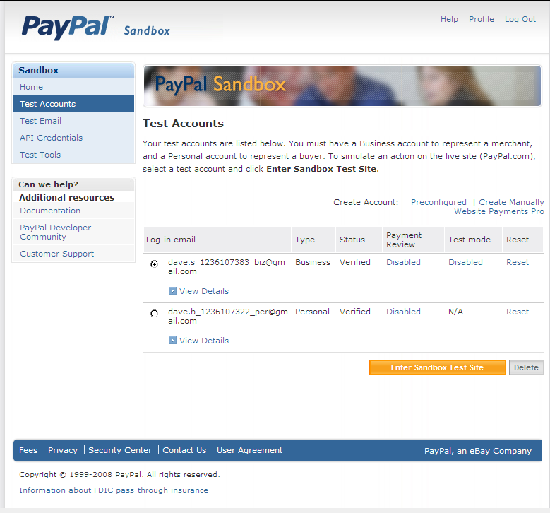

Register with LifeNavigator and Schedule an Appointment

http://lifenavigator.dbalmer.net

Click on Registration on the main menu to go to the Registration/Agreement page

Registration/Agreement page

Click on the “I Accept this Agreement” button (only required for first-time clients).

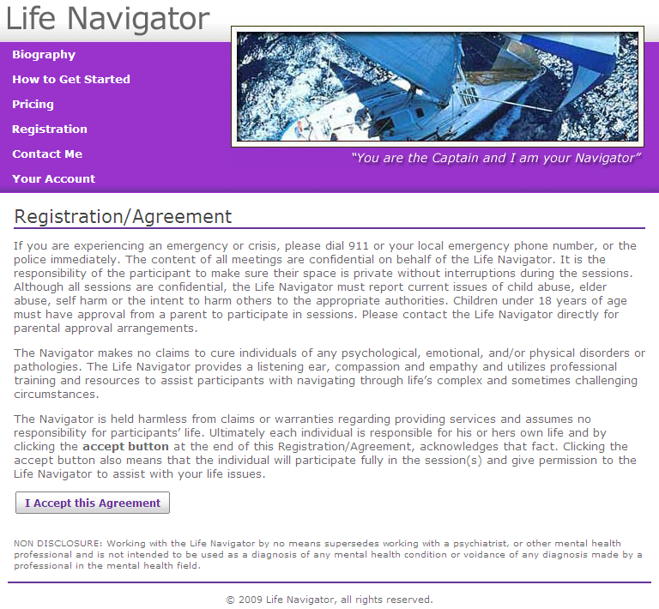

Registration form

Fill out the registration form and click on the “Continue” button.

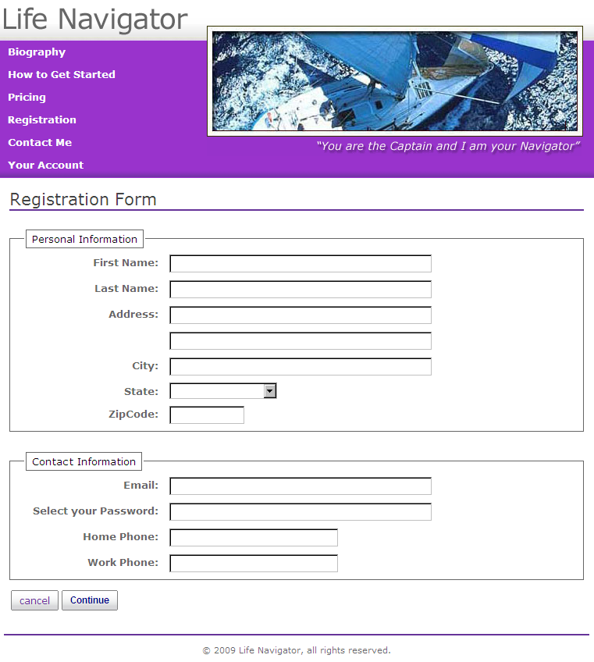

The registration information will be saved into the Client database, and you will be redirected to the Appointment Schedule page. A welcome email is sent out to the email address entered on the registration form (see Appendix A for an example).

Appointment Schedule page

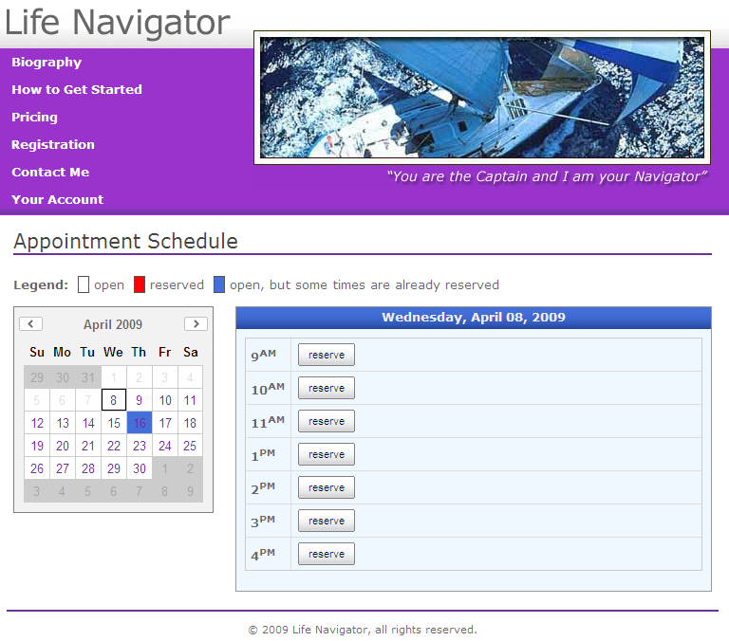

Select a date from the calendar, and a time from the appointment schedule. Clicking on a “reserve” button will take you to the Confirmation page.

Confirmation page

Select an appointment type, and click on the “Buy Now” button. You will be redirected to the PayPal login page.

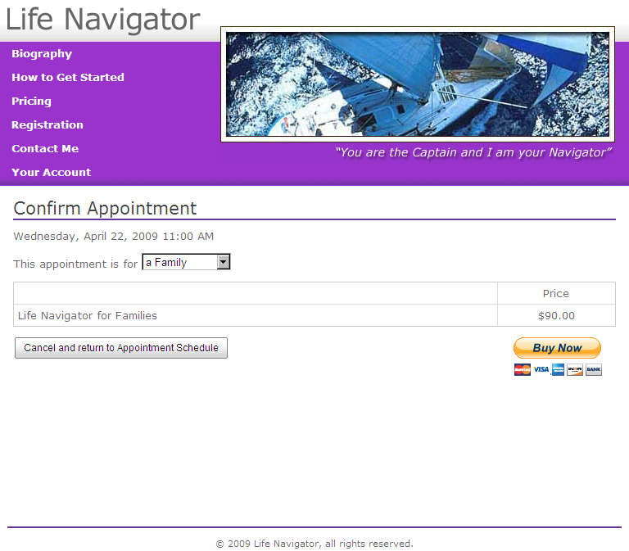

PayPal login page

Use the Seller email and password here. Click on the “Login” button and you will be redirected to the PayPal Confirmation page.

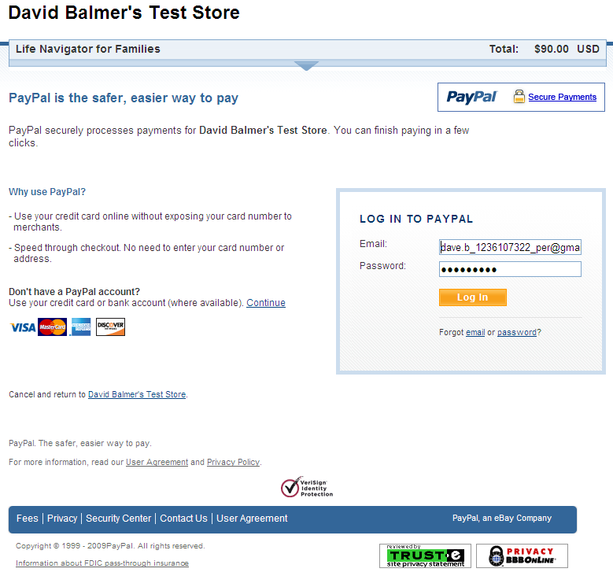

PayPal Confirmation page

Click the “Pay Now” button and you will be redirected to the PayPal Receipt page.

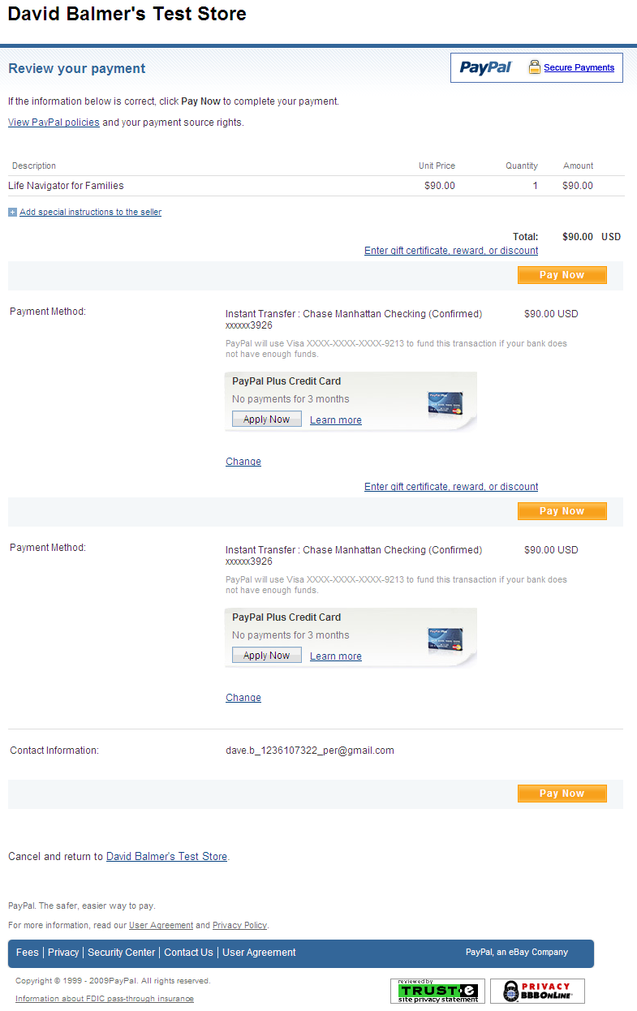

PayPal Receipt page

Clicking on the “Return to David Balmer’s Test Store” button will to return you to the LifeNavigator Appointment Schedule page.

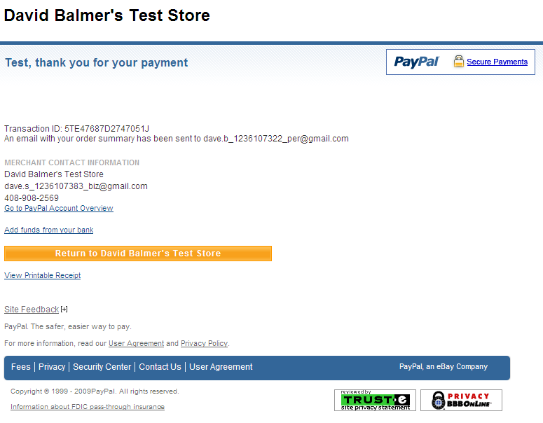

Appointment Schedule page

The appointment will be saved in the Client database, an email will be sent to the client (see Appendix B for an example), and your new appointment will be displayed in the calendar.

Clicking on “Your Account” from the main menu will display the Account page with your upcoming appointments listed.

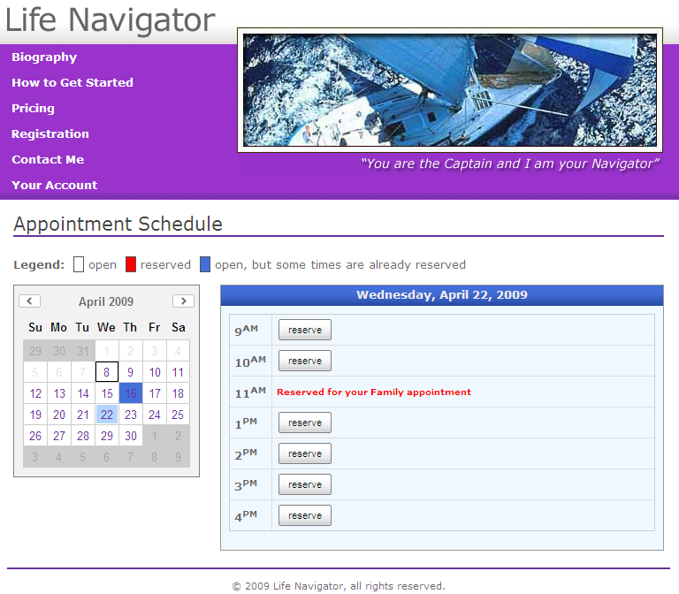

Account page

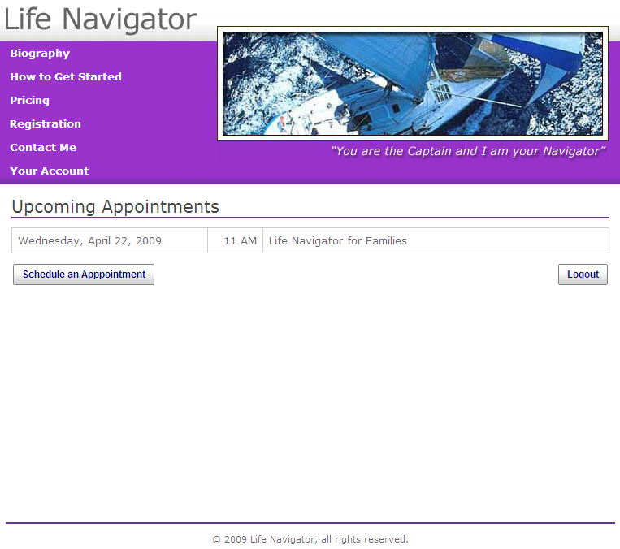

Click on the “Logout” button and you’re done!

Check your transactions on the PayPal test website

From the PayPal Sandbox window, click on the “Enter Sandbox Test Site” button, and login with your Seller information.

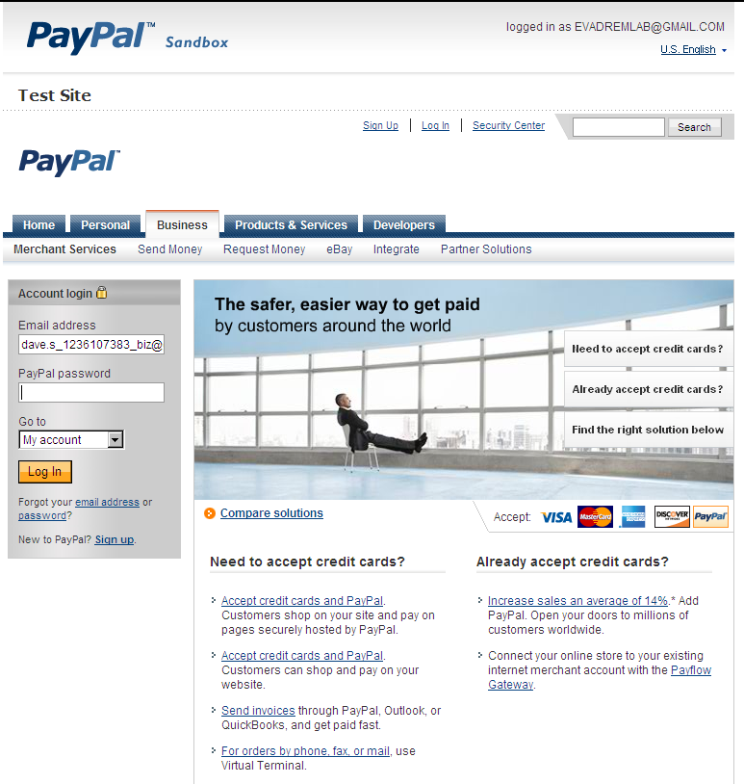

You can see your payments received and the fee deducted by PayPal.

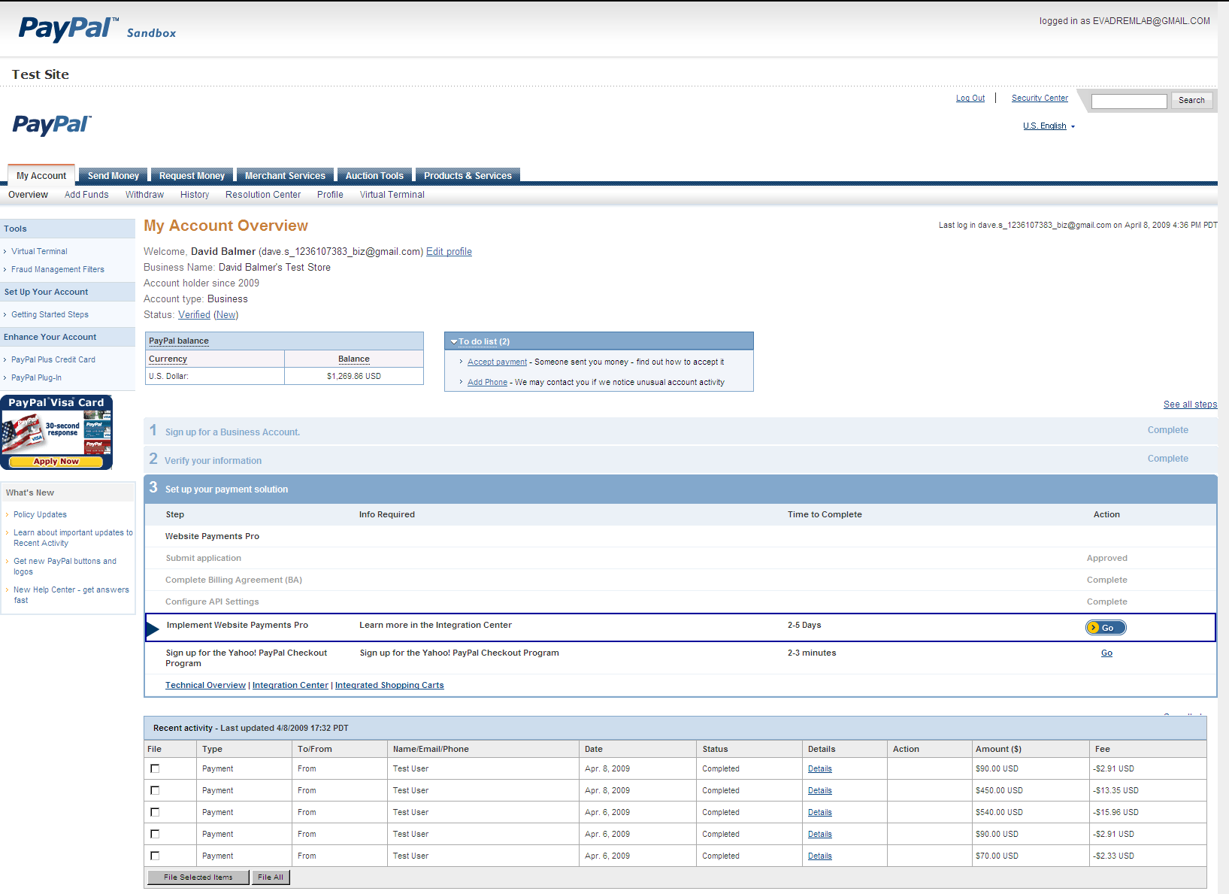

Appendix A – Sample Welcome Email

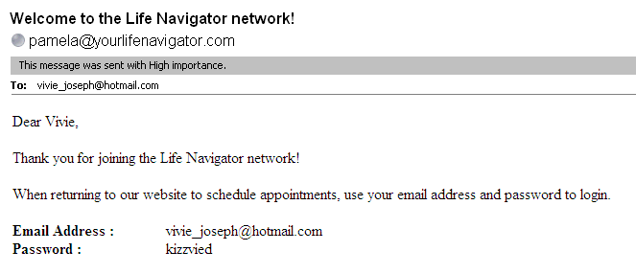

Appendix B – Sample Appointment Email

