Meruyert Balgabek

MET AD 571 Assignment 6

Optimization Using Solver

This optimization model aims to maximize the Net Present Value (NPV) of a real estate company’s operations over the next eight quarters. Using a 6% IRR with quarterly compounding, the model incorporates factors like market penetration, commission rate, rent, employee costs, and operating budgets. The goal was to determine the optimal rent, employee count, and commission rate for a new office in Bay Ridge, NYC.

**Key Assumptions and Inputs**

Quarterly sales were estimated at **$25,540,716**, compounding at **1.5%** per quarter.

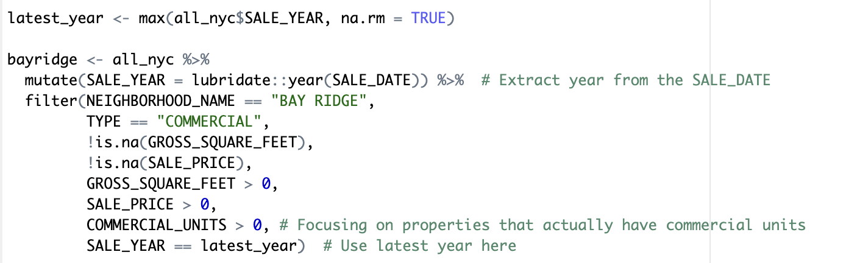

The average cost per square foot was calculated to be $731.60.

We assume cost of $65,000 annually per employee, or $5,416.67 per month. Monthly costs are constrained to $15,000, or $45,000 quarterly. Total monthly cost consists of rent and employee costs.

**Decision Variables and Constraints**

The model considers the following decision variables:

* Rent (R)
* Employees (E)
* Commission Rate (C)

The Rent (R) is constrained by: R = 250 + 125 × E, where E (the number of employees) is an integer ranging from 0 to 3.

The Maximum Market Penetration (MP) is modeled by the equation:

MP = 0.055 + 0.005 × E + (0.05 - C) × 1.5,

where the adjustment factor of 1.5 was chosen to account for the sensitivity of market penetration to changes in employee count and commission rate.

Commission rate varies from minimum of 4% to maximum of 5%.

**Outputs and Interpretation**

Given these assumptions, the Net Present Value **(NPV)**of the project was estimated to be **$505,399.77**, with expected profit and revenue remaining constant across all periods.

To maximize the NPV, we identified the optimal quarterly **operating cost of** **$8230.447**. This result suggests hiring **0 employees** and setting the **commission rate at 4.33%.** With this configuration, we achieved a **market penetration rate of 6.5%,** which is higher than the baseline due to the lower commission rate by 0.7%.

The optimal rent area was calculated to be **exactly 250 square feet**.

**Insights for Decision-Making**

We can infer that keeping employee and rent costs low while optimizing the commission rate can lead to higher profitability. Lowering the commission rate slightly enhanced market penetration, showing flexibility in pricing can lead to better financial outcomes. The model also demonstrates that it’s possible to meet budget constraints while still achieving a strong market presence, offering a cost-effective strategy for new office openings.

**Conclusion**

The analysis reveals that minimizing fixed costs (rent and employees) and adjusting the commission rate can significantly enhance NPV. By focusing on cost efficiency and optimizing the commission structure, the company can improve profitability while maintaining competitive market penetration in Bay Ridge.