Abstract
ENEL 417 GROUP PROJECT RC CAR

Matthew Selin 200339312, Ali Baloch 200332615, Mohammed Benhammou 200281262
A remote controlled car that is operated with alternative controls and assisted driving systems for users that are unable to use conventional controls. The user can drive the car using a gesture or voice based control system that is wirelessly connected to the car. The car is equipped with assisted driving features that are able to avoid collisions and regulate speed.

Keywords: Alternative Controls, Assisted Driving, RC Car, Wireless communication.

1. Introduction

The purpose of this project is to create alternative controls and assisted driving systems to allow people, who are unable to use conventional controls, to operate a small remote controlled car. Conventional controls that are to be avoided are steering wheels, foot pedals, levers, buttons switches and knobs. These conventional controls may not be able to be implemented in an application for any practical reason however, this project focuses on users with a disability preventing them from effectively using conventional controls. A specific application that this project would relate to is providing controls for someone who is unable to grip a steering wheel. There are five sub systems that were investigated to create alternative controls and assisted driving during the execution of this project.
Gesture based directional control is another alternative system that was investigated. The goal is to provide the user with a means of controlling the direction that the vehicle moves by performing one of multiple gestures with their hand. The gestures should be easy for a user to perform. There should be enough gestures that the user has adequate directional control of the vehicle.
Voice recognition control is another alternative system that was investigated. The goal is to provide the users with a means of controlling additional aspects of the vehicle by speaking specific commands into their controller.
Collision avoidance is an assisted driving system that was investigated. The goal is to develop a system on the vehicle that is able to automatically avoid collisions to assist the user in driving the vehicle. This system should detect obstacles in the vehicles path and stop the vehicle before making contact on its own without the help of the user.
Speed regulation is an assisted driving system that was investigated. The goal is to develop a system on the vehicle that is able to control the vehicles speed to assist the user. This system should interface the motors for the wheels to turn them the correct direction and the correct speed based on the user's directional input.
Wireless communication is a system that was investigated. The goal is to develop a system that is capable of transferring inputs from the user controller the vehicle. This system should be able to transfer enough data to identify all user inputs. This system should be able to communicate wirelessly and over an appropriate range. This system should not be obstructed by obstacles such as tables or walls.

2. Methods and Material

The gesture base directional control system is designed using an accelerometer ADXL362 as shown in figure1 to capture the user input. The accelerometer is attached to the user’s hand.
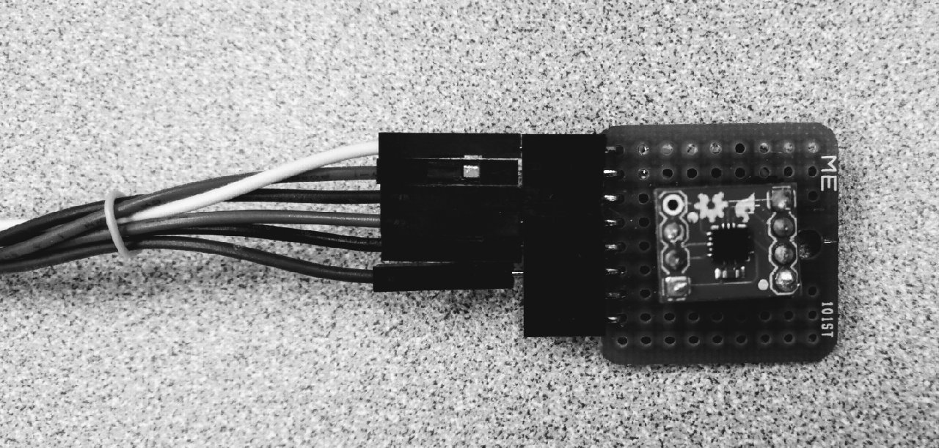

Figure1: ADXL362 accelerometer.

The user will rotate his/her hand in a combination of forward/backward and left/right directions. The accelerometer will measure the user's input in these two directions to determine what direction the vehicle should move.
The voice based control system is designed using a voice recognition module V3 that is shown in figure 2. The component is trained to recognize specific commands from the user. These commands are then programmed to control aspects of the vehicle.

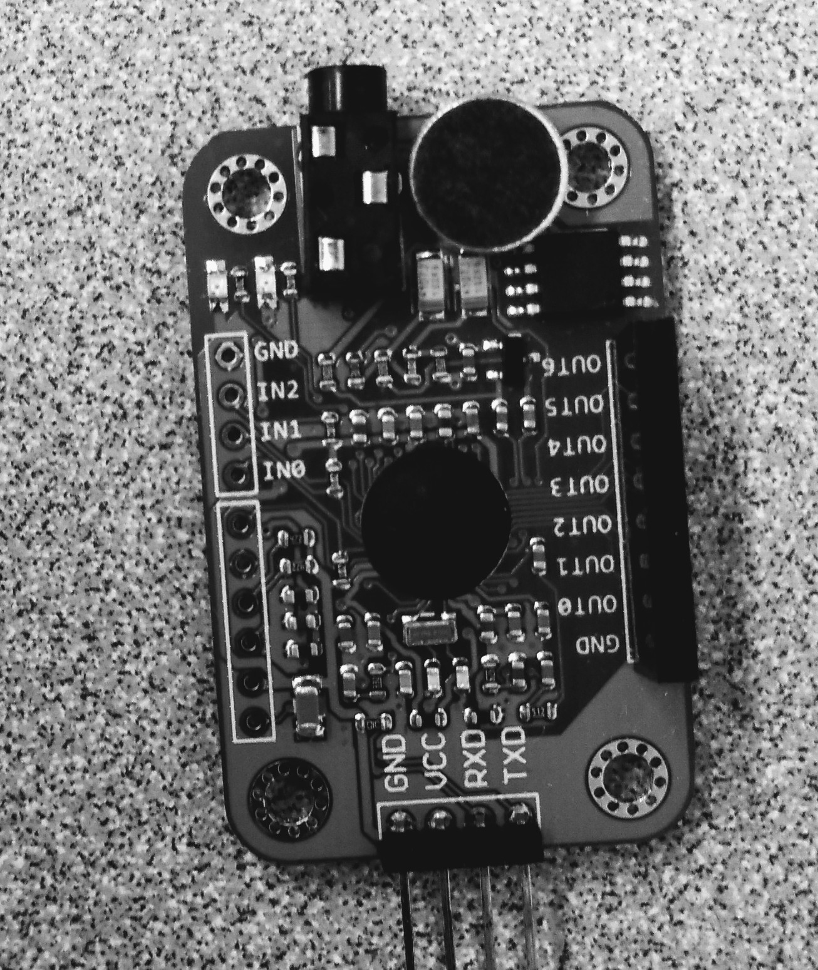

Figure2: Voice Recognition Module V3

The collision avoidance system is designed using ultrasonic sensors to detect objects in the vehicles path. Sensors are mounted on the front and back of the vehicle. If
an object is detected close to the vehicle, the vehicle will not drive any closer to the object. The vehicle will still be able to
pivot on the spot so that user can navigate around the object.

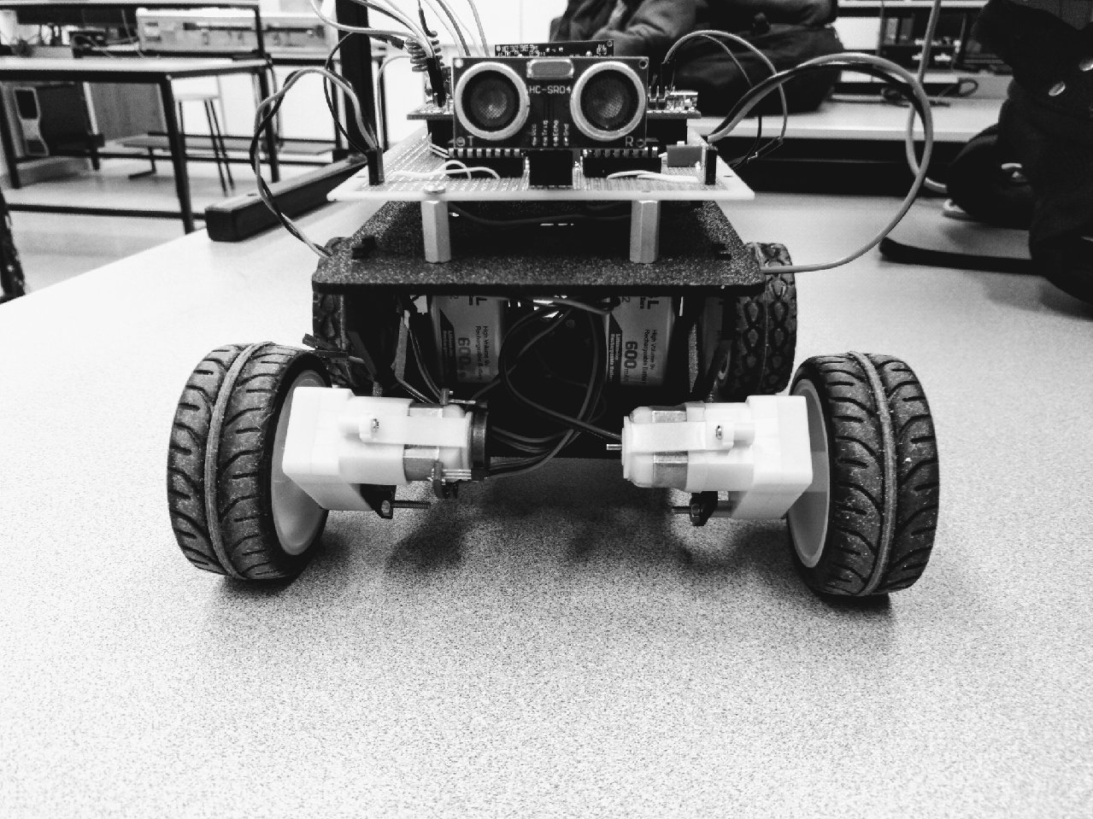

Figure3: HC SR04 Ultra Sonic Sensor

The speed regulation system is designed using logic. The
vehicle is programmed to drive the motors at specific voltages in either forward or backwards rotation to execute the directional commands received from the user. The vehicle was also designed to use a wheel encoder to provide feedback on how fast the vehicle is moving to provide greater control over speed however, due to time constraints it was never built or fully implemented into this project.
The wireless communication system is designed using ASK (Amplitude Shift Keying). ASK is the most basic and simplest technology used to transmit digital data wirelessly. Digital data is transmitted from the user controller to the car using low power on a 433 MHz frequency.
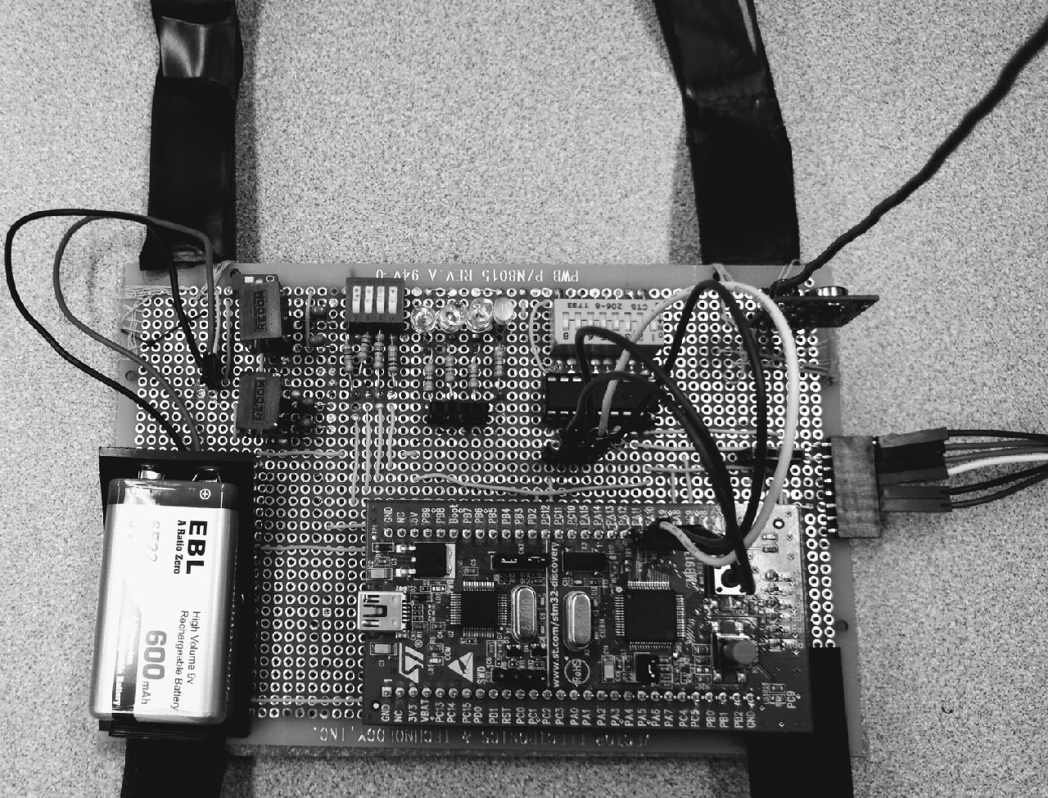

Figure4: The car transmitter device.

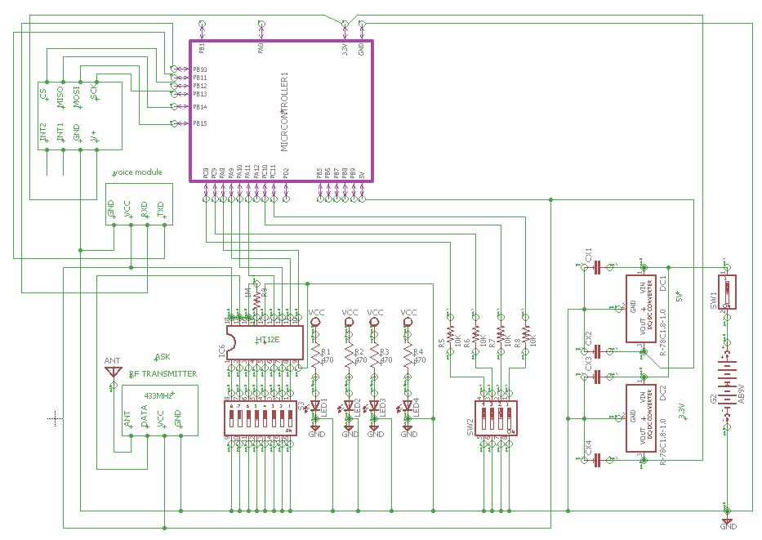

Figure5: The car transmitter circuit.

3. Results
The gesture based directional control system worked according to the specifications described. Users are able to execute all directional gestures. The accelerometer measures the change in acceleration in three different direction (x,y,z). The user is assumed to not wave their hand. The user is gesturing in two dimensions, due to which we are able to measure change in rotation in each axis separately. The orientation of the accelerometer is defined by three regions in the two dimensions that the user gestures. There are 9 different gestures that the user can perform. These regions were defined while considering the user dexterity. These gestures correlate to directional control for the cars movement. This system has good response time of 1 mg allowing the user to have responsive control over the vehicle.
The voice based control was accomplished by using a voice recognition module V3 that is speaker-dependent. It supports up to 80 voice signatures however, only seven signatures are effective at one time. The voice module V3 needs to be trained first before it can be used. Depending on how well the device is trained, it will recognize better. The voice module works well but it is not an effective means of providing directional control over the vehicle. The response time for voice recognition is too long giving the user poor control over the vehicle while operating.
The obstacle avoidance system is able to detect objects within its range. Its range is 2cm -4m directly in front of and behind the car. The ultrasonic sensors will not detect small or narrow obstacles. The sensors are not able to detect objects that redirect the ultrasonic sound waves away from the sensor. Therefore the system was not able to detect all obstacles. The system operates well at an adequate 100ms response time.
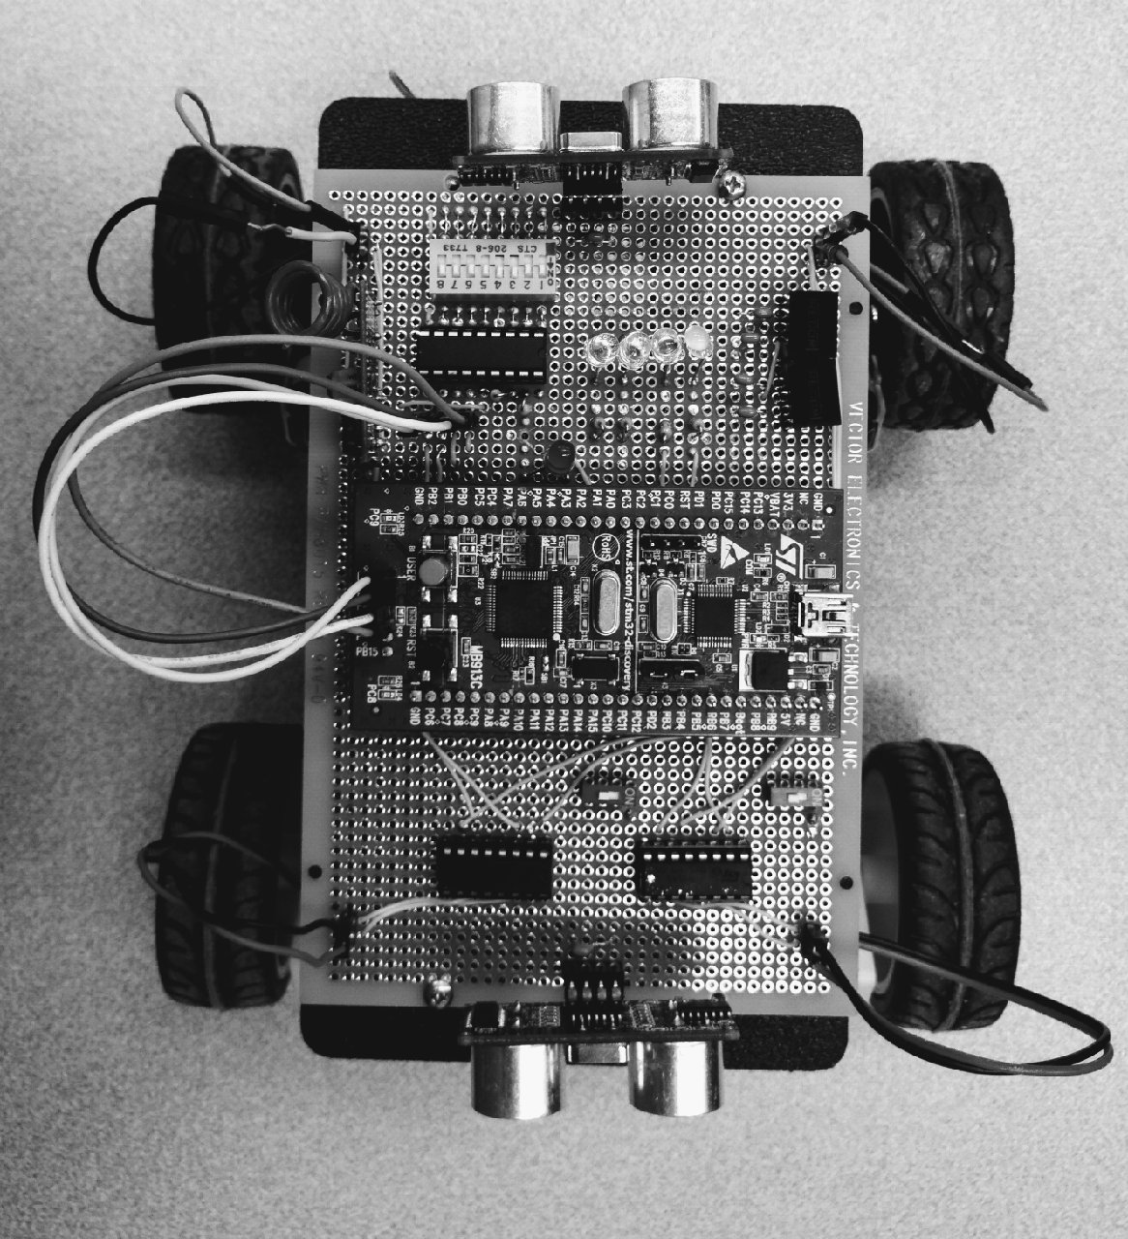

Figure6: The car receiver device.

The speed regulation system was not fully developed. The vehicle has nine functions for interfacing the motor drivers. Each function is designed specifically for one directional input. These functions interface the motor drivers with hard coded PWM (Pulse Width Modulated) signals. Speed regulation is not a priority for this project. Therefore development time was spent elsewhere. However, the car is equipped with a wheel encoder that is capable of sensing its speed. The input from the encoder can be used as feedback to adjust the PWM signals to the motors.
The wireless communication works well. It is able to transmit data to the car using an RF transmitter and an encoder. An RF receiver and decoder are used on the car. The wireless communication was successfully tested at approximately 100 meters range and could transmit through obstacles such as tables and walls. The communication is one way by design. As a result, it is required that the user have visual feedback on car while operating.

4. Discussion

The gesture based directional control worked system worked well. Users were able to execute all directional gestures. The system had a good response time when the user changed their gestures. All the gestures made by the users were according to the user dexterity. It was most successful part as we measure the success by the usability of the system.
The voice based control was challenging to successfully recognize speech during the training process of the voice module. Our issue was to figure out why the module was not performing properly. After investigation and persistent trouble shooting we were able to figure out that the microphone was causing disturbance that prevented the recognition. After installing a different kind of microphone directly onto the voice module, the component was recognizing much better and was partially implemented into the project. The voice based control was not an effective way of controlling the motion of the vehicle due to its slow response time. The voice based control would be better suited to control other aspects of the vehicle such as changing speed or invoking preset maneuvers that the car would execute autonomously. Through the use of carefully developed preset maneuvers, the user could have adequate control over the vehicles motion. These are systems that were investigated however, we did not have time to implement.
The obstacle avoidance system was integrated to the system and it has some limitations. The obstacle avoidance was dependent on the direction that the ultrasonic sensor was facing. It would not detect all obstacles when testing. Perhaps adding more sensors on the vehicle to give the system the ability to detect objects in more directions would improve system.
The car was equipped with the speed regulation system that could be used to allow the vehicle to gently transition between different speeds and execute preset maneuvers autonomously. These features were intended to work with the voice based controller to give the user greater control over the vehicle however, we did not have time to complete everything that we initially set out to achieve.
The wireless communication system was able to meet all requirements and worked better than we needed it to for our project.
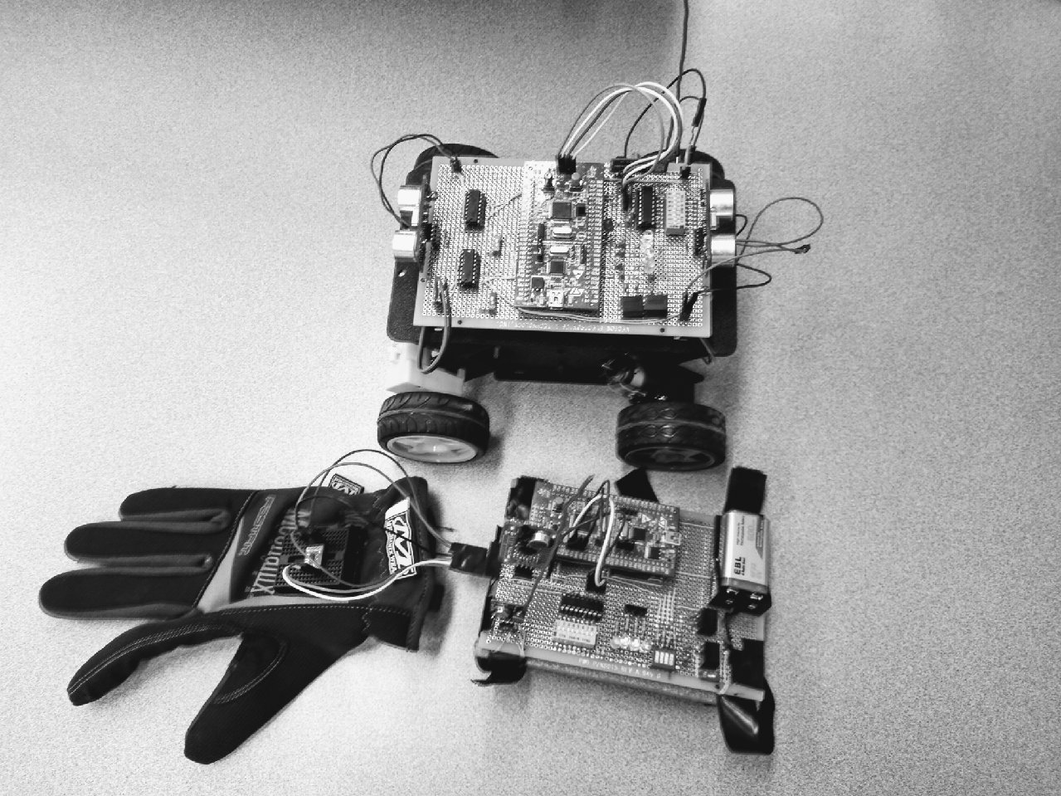

Figure7: The car transmitter and receiver devices.

5. Conclusions

In this project we learned the real time controls implemented system, we learned, how to define the problem and step it down the task into smaller sub task, we learned the team coordination, we also learned how to work as a supervise individually, and also learned how the group work is implemented. In this project the main thing we learned was that how to design our project in such a way that even if something happened to any of the group partner, your part does not get effected by it. And we also learned how to deal the system if one of the components doesn’t work properly, we had our code and system designed in such a way that, it can produced the same results even if it was running by itself.
If we were to continue this project we would want to have a specific application to design for. Everything that we accomplished is as a proof of concept in the form of a prototype build. The current system would need to be further analyzed to identify areas that need to be improved to meet new specifications.
6. Design Diagrams
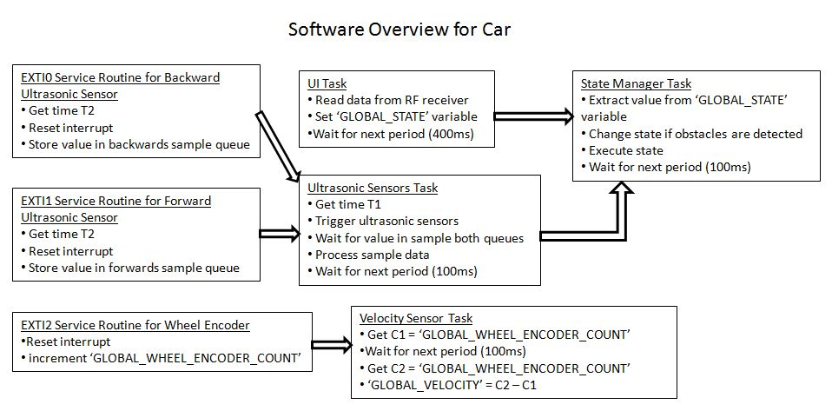
The micro controller on the car is running Free RTOS (Real Time Operating System). This design allows for modular programming of individual tasks. Each task performs the processing for a single subsystem that is running on the car. These tasks run independently from each other at different intervals. This is advantageous because the timing of each sub system is different. The ultrasonic sensor and UI (User Interface) tasks update variables that are in the scope of the state manager task. The state manager task then uses these variables to determine what state the vehicle should execute. The vehicle is programmed to be in one of nine possible states. These states relate to the nine gestures that the user is able to perform. The state manager task will put the vehicle in the state that the user has input unless the ultrasonic sensor task detects obstacles. If an obstacle is detected, the state manger will work with the user’s input to put the car into one of three appropriate states. The vehicle will always be able to be in the pivot left, right or idle states.
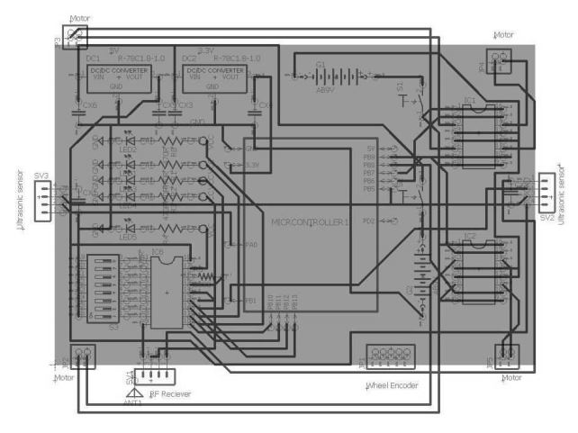
Physical connections of the circuit on the car is shown in the above schematic diagram.

