USC NEWS

USER’S MANUAL

Submitted by:

Remedio, Mark

Bucaloy, Renato

Revisions

|  |  |
| --- | --- |
| Date | Changes |
| March 4, 2014 | Added Table of Contents, List of Tables and Pictures |

Table of Contents

I. Splash Screen 4

II.Homepage 5

A. Search Page 6

B. Academics Page 6

C. Extra Curricular Page 7

D.SVD Community Page 7

E. Specific Date Page 8

III. News Details Page 8

A.Comments Page 9

List of Figures

1.0 Splash Screen 4

2.0 Homepage 5

1.1 Homepage>>Search Page View 6

1.2 Homepage>>Academics Page View 6

1.3 Homepage>>Extracurricular Page View 7

1.4 Homepage>>SVD Community Page View 7

1.5 Homepage>>Specific Date Page 8

3.0 News Details Page 8

2.1 News Details Page>>Comments View 9

List of Tables

1.0 Homepage 5

USC News is an application where the user can read the latest happening inside the University of San Carlos straight into your Android Phones.

I. Splash Screen

 Fig 1.0

When the user enters the application, this screen will appear for 3 seconds and it will be redirected to the hompage.

I.Homepage

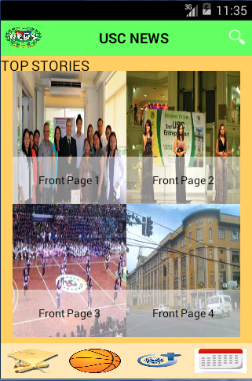

Table 1.0

|  |  |
| --- | --- |
| Button | Description |
|  | Academic Page Button; Clicking this image redirects the user to the Academic Page |
|  | Extra Curricular Button; Clicking this image redirects the user to the Extra Curricular Page |
|  | SVD Community Button; Clicking this image redirects the user to the SVD Community Page |
|  | Recent Date Button; Clicking this image redirects the user to the Recent Date Pages |
|  | Search Button; Clicking this image redirects the user to the Search Page |

A.Search

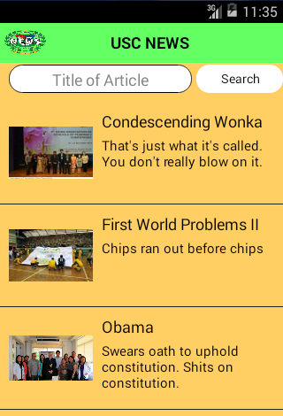Fig. 2.1

This page lets the user search for the news he/she wanted to read via keywords of the article. To click the news the user wanted to read, just click the news on the list.

B. Academics Page

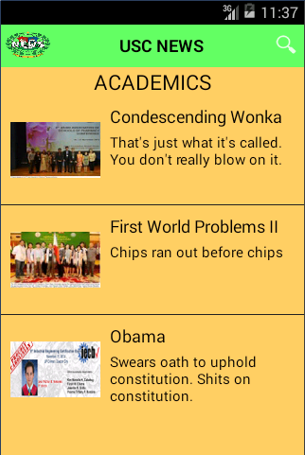Fig. 2.2

Academics page lets the user read news regarding the academic activities inside the University of San Carlos and also the notable person in the field of academic studies.

C. Extra Curricular Page

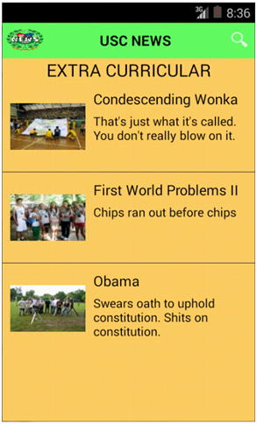

Fig. 2.3

Extra Curricular Page lets the user read news about the latest happening about University Of San Carlos Extra Curricular activities. Click one of the news in the list to read the details.

D. SVD Community Page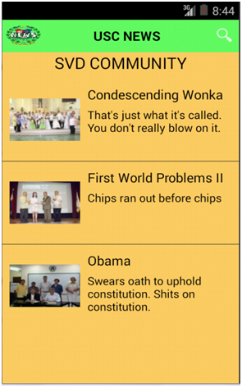

fig. 2.4

SVD Community page lets the user read the news about the SVD community and the activities of the SVD priest inside the University Of San Carlos. Click one of the news in the list to read the details.

E. Specific Date Page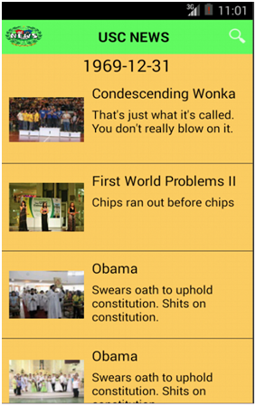

Fig. 2.5

Specific Date Page lets the user read news that happened on a specific date.

II. News Details Page

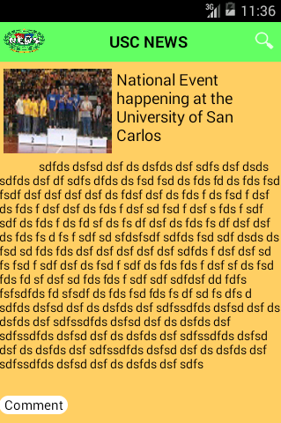

This page allows the user to view the details of the news selected in either Extra Curricular Page, Academic Page and other pages defined above.

A. Comments Page

Fig. 3.1

This page allows the user to comment on the news that he/she viewed earlier. To comment, just click the screen and a cursor will appear. Type what you want to type and just click comment to finish writing.