New Website Overview

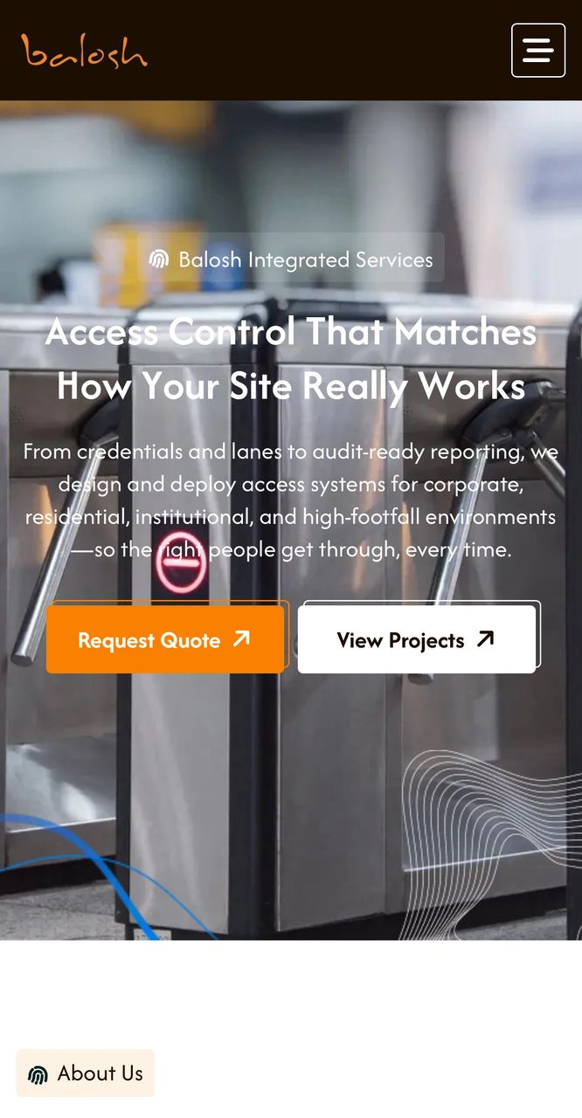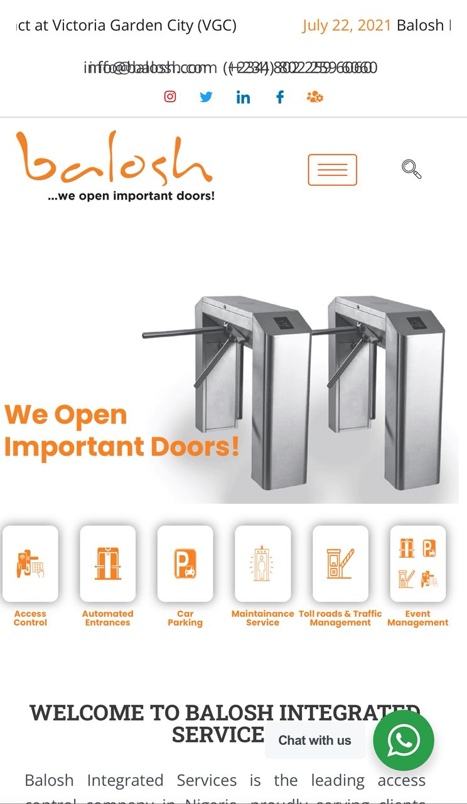
Home Page
The image on the left shows the proposed homepage for the new website, while the image on the right represents the current website for comparison.
The tagline “We open important doors” will be incorporated into the logo, and social media icons will be added to the website header.
To guide your review:
- Text in black represents new or updated content
- Text in grey reflects content from the current website
- Text highlighted in red indicates information or materials required from your team
The About Us page will be expanded to include the following sections:
  - Who We Are
  - What We Stand For
  - The Balosh Journey
  - Balosh Allstars
  - The Balosh Difference
  - Balosh Leadership

- Who We Are;
Since 2005, Balosh Integrated Services Limited has built its reputation on three uncompromising pillars: reliability, credibility, and consistent industry leadership. For two decades, we have delivered trusted security and access control solutions across Nigeria’s most critical environments.
We provide fully integrated, end-to-end services, from design and development to installation and ongoing support, all managed in-house. This approach ensures seamless execution, accountability, and the highest standards of quality at every stage.
From major transport terminals handling millions of people to government institutions, corporate campuses, and leading retail destinations, Balosh has become a trusted name in securing and managing high-value spaces. Our solutions are built to perform in demanding environments, supporting efficiency, safety, and operational excellence.
The trust placed in us by Nigeria’s most important institutions has been earned through consistency, expertise, and results. It is a responsibility we take seriously, and one that continues to drive our commitment to delivering reliable, future-focused solutions.

- What We Stand For
Page Header: Built on Principles That Deliver
At Balosh, our work is guided by principles that shape how we design, deliver, and support every system.
Our Focus
We create secure, efficient environments that give organisations and communities confidence, control, and operational clarity.
Our Commitment
At Balosh Integrated Services, our mission is to be the leading provider of access control solutions, driven by a commitment to integrity, customer satisfaction, and innovation. Our foundational beliefs guide every aspect of our operations.

What Drives Us
Built on Trust
We operate with transparency and take full responsibility for every system we deliver. Our clients rely on us because we stand behind our work—consistently and without compromise.
Client-First Thinking
We build long-term partnerships, not one-off projects—delivering solutions tailored to each client’s environment and real operational needs, with performance and durability designed for long-term value.
People Who Deliver
Our strength lies in our team. We invest in continuous development and empower our people to take ownership, solve problems, and deliver results in complex, high-demand environments.
Innovation with Agility
We don’t just adopt new technologies—we respond quickly to changing needs. Our agile approach allows us to adapt systems, integrate new solutions, and continuously improve performance in dynamic environments.
Committed to the Communities We Serve
Our work extends beyond installations. By enabling safer access, reducing operational risks, and improving how people and vehicles move through critical spaces, we contribute directly to safer, more efficient communities.
We also support local economies by developing local expertise, creating employment opportunities, and delivering solutions that strengthen the environments in which our clients operate.
Excellence Without Compromise
In the environments we operate in, failure is not an option. We are committed to delivering systems that perform consistently, reliably, and at scale.
Visual Direction
The goal is to clearly communicate the values of Balosh and what the company stands for. See sample; Corporate Values

- The Balosh Journey
Page Header: Our Journey
Founded in 2005, Balosh Integrated Services began with a clear focus: to bring structure, reliability, and control to environments where it matters most.
Over the past two decades, that focus has driven our growth into a trusted leader in access control and infrastructure systems—delivering solutions across Nigeria’s most critical and high-traffic environments.
Today, our systems support over 200,000 daily check-ins, reflecting the scale, reliability, and operational confidence our clients depend on every day. Backed by a team of over 100 skilled professionals nationwide, we continue to deliver consistent performance across sectors.
Our evolution has been shaped by a commitment to building systems that work in real conditions. By leveraging OEM hardware tailored for the Nigerian environment, we ensure durability, efficiency, and long-term value across every deployment.
As Balosh continues to grow, one thing remains constant: a commitment to delivering solutions that perform—consistently, reliably, and at scale.
Visual Direction (Balosh Input Required)
To effectively communicate Balosh’s growth and leadership over time, we recommend curating a set of images or captions that tell a clear story of progression, scale, and capability.
Rather than static “before and after” visuals, the goal is to create a timeline-driven narrative that reflects how Balosh has evolved from early projects to a trusted operator in Nigeria’s most critical environments.
See below some samples;
https://www.icmif.org/icmif-timeline/
https://www.oandoplc.com/our-history
https://skymitmotorsltd.com/our-legacy/

- Balosh Allstars
Behind every door we open is a team we call the Balosh Allstars—engineers, technicians, software developers, and support specialists who take full ownership of every outcome.
Because at Balosh, “we open important doors”—and the people behind those doors matter just as much as the systems themselves.
Our team is built to deliver in environments where performance is critical. Their expertise, responsiveness, and commitment to excellence ensure that every system we design, install, and support works—consistently and at scale.
We have built a culture where:
      - Ownership is expected — every team member is accountable for results
      - Collaboration drives execution — complex challenges are solved as one team
      - Continuous growth is a priority — through training, mentorship, and real-world experience

We also recognize that opening doors goes beyond access—it’s about opportunity, trust, and impact. By bringing together people from diverse backgrounds, we foster a culture that encourages new thinking, adaptability, and stronger outcomes.
Beyond delivery, we invest in our people—supporting their development, well-being, and long- term growth—because a motivated, supported team delivers better results for our clients.
At Balosh, we don’t just open important doors.
We have the team that ensures what’s behind them works.
Visual Direction
The goal is to make the brand feel more human, premium, and trustworthy. To achieve this, we’ll need a group photograph of the team, which may require a mini photoshoot. One set of images should convey professionalism and seriousness, reinforcing the company’s ability to handle complex, high-stakes projects—ideally featuring engineers in branded work attire. The remaining visuals can highlight a more approachable side, showcasing team spirit and a sense of connection.
See sample here; https://www.oandoplc.com/our-people

- The Balosh Difference (Newly added)
Page Header: Why Leaders Choose Balosh:
There are many vendors, but there is only one Balosh.
  - Built for Nigeria’s Realities: Our systems are engineered to perform in demanding conditions, from power variability to large-scale, complex environments.
  - End-to-End Accountability: We manage every stage in-house, from hardware and software to installation and ongoing support, ensuring seamless delivery and full responsibility.
  - Propriety OEM Hardware: Our solutions are powered by hardware designed for Nigerian conditions, offering durability, faster parts access, and flexible customization.
  - Global Technology, Local Expertise: We combine world-class technology with deep local insight to deliver solutions that truly work where it matters most.
  - A Reputation Earned Through Results: For over 20 years, our clients have become our strongest advocates, driven by consistent performance and trust.
  - Built for the Long Term; We don’t just deliver projects, we build lasting partnerships. Your uptime, reliability, and success remain our priority.

  - Why Balosh? (We will maintain the same diagram but with updated content)

- Balosh Leadership: (Newly added)
Our management team brings together experience, strategic insight, and a shared commitment to excellence. With a clear vision and deep industry expertise, they drive Balosh’s growth while ensuring the consistent delivery of reliable, high-quality solutions across every project.
Visual Direction
This isn’t just to show the management team but to tell a story about leadership, credibility and culture. This section should be short, sharp and impactful.
Below are the important information we require from your team;
- Name and position of key management.
- A professional, yet warm picture from them
- Their corporate profile which should highlight their experience, personality and credibility markers (awards, past roles and achievements)
See samples here;
https://www.dangote.com/about-us#leadership

https://www.oandoplc.com/our-people#team

- Our Solutions:
Page Header: Integrated Access, Mobility & Security Solutions
At Balosh Integrated Services, we deliver tailor-made solutions built around the unique needs of every client. With expertise across multiple sectors, we combine innovation with the latest technology to provide services that are not only effective but also future-ready and reliable.
- Access Control: provides secure, scalable access management solutions that integrate hardware and software systems. It includes advanced biometric options such as fingerprint, facial recognition, iris scanning, and multi-modal authentication. These systems also integrate time and attendance tracking, visitor management, and workforce security features. The service is delivered end-to-end, covering design, installation, system integration, and ongoing support.

- Automated Entrances: focus on intelligent entry and exit systems, including automatic doors and gates, barriers, bollards, turnstiles, and roller shutters. These solutions are built to handle high-traffic environments while maintaining strong security integration. They can be seamlessly connected with access control systems, ANPR technology, and centralized dashboard monitoring for efficient oversight and control.

- Car Park Management: delivers complete, end-to-end parking ecosystems that include design, supply, installation, operation, and maintenance. The system features automated barriers with ticketing, ANPR integration, and cashless payment options. They also provide real-time occupancy monitoring through digital dashboards, with flexible operational models, including leasing options where required.

- Toll Road Management: covers fully integrated toll-plaza solutions, including hardware and software systems. These support multi-lane toll processing with multiple payment methods, including cash, cards, and RFID. The system provides real-time revenue reporting, detailed audit trails, and nationwide maintenance support, ensuring reliability across large-scale road infrastructure.

- Security Systems: offers comprehensive screening and threat-detection solutions for high-security environments. These include walk-through metal detectors, baggage scanners, and under-vehicle inspection systems. The solutions are fully integrated with access control, CCTV surveillance, and incident management platforms, supported by end-to-end implementation and 24/7 operational assistance.

- Cross-cutting Capabilities: includes custom software development tailored to specific business needs, flexible equipment rental solutions to support varying project demands, and seamless system integration with API access, enabling different platforms and technologies to work together efficiently.
(We need images for each solution – preferably Balosh images and not stock photos. If it has to be stock, we will work on including the logo on each item.)
Looking at the demo website, there will be a drop down page that shows information of the various services when the image icon is clicked; https://balosh.netlify.app/#service
Confirm what solution section the following equipment falls under. A comprehensive list of equipment in each category will help your audience see what is available to them.
    - Tripod Bridge Turnstiles
    - Linear Tripod Turnstiles
    - Automated Ticketing Terminals
    - Structured Parking Arrangement
    - Digital Door Access
    - Entrance Controls
    - Rentals
    - Maintenance Service
    - Toll Roads & Traffic Management

- Our Market: (Only the industries were listed without write-ups)
Page Header: Industries We Serve
Balosh provides tailored solutions across residential, commercial, education, public services, transportation, access control, traffic management, and event operations.
Our expertise allows us to adapt to the unique needs of each segment, delivering efficient, reliable, and high-quality services that support seamless operations and enhance everyday experiences.
- Commercial; We deliver integrated solutions that optimize operational efficiency, enhance security infrastructure, and support seamless facility management across commercial environments.
- Residential; Our residential offerings focus on access control, safety systems, an environment management, ensuring secure, efficient, and well-regulated living spaces.
- Education; We provide structured solutions for educational institutions, including access management, safety protocols, and operational support to maintain secure and conducive learning environments.
- Events; We offer end-to-end event operational support, including crowd management, access control systems, traffic coordination, and on-ground logistics for seamless execution.
- Leisure; Our services in leisure environments are designed to support operational flow, safety compliance, and visitor management across recreational and hospitality spaces.
- Public Sector; We work with government and public institutions to implement scalable solutions that enhance service delivery, improve infrastructure management, and ensure regulatory compliance.
- Transport; We provide advanced traffic and mobility management solutions, including access systems, flow optimization, and operational coordination to improve transport efficiency and safety. Our expertise also extends to delivering comprehensive security solutions for airports, ensuring secure, efficient, and well-managed aviation environments.

Creative Direction
(The aim is to create awareness on the different sectors the company’s product/services can be used. Kindly provide images of the kind of products used on the different sectors. If unavailable, stock images can also be used). Below is a sample on the demo account;
Balosh Integrated Services | Access Control & Security Solutions

- Projects: (Input Required)
Page Header: Access & Mobility Project (Newly added)
Portfolio:
Explore selected Balosh projects across events, healthcare, residential estates, ports, hospitality, and education environments.
- MMA2 Airport Car Park, Lagos
The Challenge
MMA2 is one of Nigeria's busiest airports, and its multi-story car park wasn't keeping up. Outdated equipment cost more than twice as much as modern alternatives, spare parts had to be imported (causing costly delays), and system failures forced manual processing, leaving passengers stuck in queues — still being charged while they waited. On top of this, there was no vehicle classification system and no ANPR technology, creating revenue leakage and bottlenecks at every turn.

The Solution
We replaced the ageing infrastructure with modern, cost-effective equipment at less than half the previous price. Paper tickets gave way to reusable plastic cards, eliminating the need for imported consumables entirely. A vehicle classification system was introduced to enable accurate, differentiated tariffs, and ANPR cameras were deployed to handle lost tickets swiftly and without dispute. Trained staff and locally stocked spare parts ensured a rapid response to any issues.

The Results
- Major cost savings on both equipment and consumables
- Near-zero downtime- 24/7 reliability in a 24/7 environment
- Increased revenue- through accurate vehicle classification and tariffing
- Faster throughput- queues eliminated, passengers moving freely
- Lost tickets resolved instantly via number plate lookup
The MMA2 transformation proves what the right technology and the right support can deliver, even in the most demanding environments.
- Ikoyi Club Access Control
The Challenge
For one of Lagos' most prestigious members-only institutions, access control is about far more than security; it's about prestige and member trust. Yet frequent turnstile breakdowns were creating dangerous gaps in security, and unreliable access cards made controlling entry nearly impossible. Behind the scenes, a complete disconnect between the accounts department and access control software meant staff had to manually activate and deactivate member access, an error-prone process that left lapsed and unauthorized memberships slipping through undetected.
The Solution
We moved quickly — immediately repairing existing turnstiles and replacing the access control software to restore security without delay. From there, we delivered a full upgrade:
- Proprietary turnstiles engineered specifically for the Nigerian environment
- Facial recognition & QR code readers introduced alongside card access for seamless, flexible entry
- Full integration between accounting and access control software — member access now activates or deactivates automatically based on subscription status
- A formal SLA guaranteeing proactive maintenance and rapid response times
The Results
- Zero unauthorised access — entry is strictly controlled, guests included
- Zero downtime — a complete reversal from constant failures
- Hundreds of staff hours saved through automated account management
- Measurable increase in membership dues payment and revenue
- Full entry records for members, staff and guests — anytime, anywhere
- Adopted by HR for staff time and attendance tracking
The Ikoyi Club project is proof that the right access control system doesn't just secure a building — it protects an institution's identity.
- Ikeja City Mall Car Park
The Challenge
Ikeja City Mall's car park had been poorly managed for years. Frequent system failures — some lasting up to three months were caused by a lack of spare parts and undertrained engineers. Fixing problems meant flying in specialists from South Africa, leaving the facility crippled in the meantime. A chronic shortage of imported ticket consumables led to a heavy reliance on manual ticketing, opening the door to revenue leakage and fraud while frustrating shoppers and damaging the mall's reputation.
The Solution
Taking over operations on 1st July 2024, we delivered a complete reset:
- Paper ticketing replaced with reusable plastic cards — eliminating imported consumables, reducing mechanical failures and cutting paper waste
- Full staffing overhaul — trained personnel and on-site standby engineers replaced, ending the need for costly overseas specialists
- Comprehensive spare parts stock maintained locally at all times — keeping resolution times minimal and emergency imports firmly in the past
The Results
- Near-zero downtime — compared to failures lasting months under the previous operator
- Up to 60% revenue increase in some months — with manual processing and fraud eliminated
- Faster throughput — reusable cards process vehicles more quickly, reducing congestion at peak times
- Improved shopper experience — faster, smoother and frustration-free parking
The Ikeja City Mall turnaround shows exactly what the right technology, the right people and the right preparation can deliver.

- Davido Timeless Concert Access Control
- Dangote Refinery Commissioning Event Security
- LASUTH Car Park Management System
- Victoria Garden City Estate Access Control
- Nigerian Ports Authority Electronic Call-Up System (ETO)
- Federal Palace Hotel and Casino Car Park and Entry System
- Osborne Foreshore Estate Security Upgrade
- Landmark Access Control and Entry Management
- Greensprings School Secure Access Control System
(We currently have detailed information for only the first three projects listed above. The other case studies can be left out for now, but including them would help enrich the section with more content for potential clients to explore. While not urgent, adding images to the projects without full details would still enhance the overall presentation. Kindly provide images to support the projects).
Here is a sample for reference; Our Turnstar Projects | Read Here
- Clients We Serve
Carousel- Logos of companies Balosh has served on the homepage

5. Frequently Asked Questions (Input Required)
To improve the overall user experience and reduce the need for routine enquiries, we recommend including a Frequently Asked Questions (FAQ) section on the website.
Kindly provide a list of common questions your clients typically ask, along with clear and concise responses. These may include enquiries related to:
    - System capabilities and customisation
    - Integration with existing systems
    - Installation and maintenance processes
    - Project timelines
    - Coverage and locations of operation
    - Support and after-sales services

This will help ensure that prospective clients can quickly find the information they need, while allowing your team to focus on more complex or high-value engagement.

- Media
- Balosh In Asaba
- Balosh brings sanity to the LASUTH Car Park.
- Balosh At TTP Lagos
- Balosh wins access control contract at Victoria Garden City (VGC) – Check the website to confirm the image's accuracy.
- Osborne Foreshore Estate: Balosh rises to the challenge
- Nigerian Ports Authority (NPA) rolls out the Electronic Call-up system (ETO) to address the perennial traffic gridlock around the seaports.
- Federal Palace Hotel & Casino to install a car-park ticketing and entrance control system
- Airport Contract Award
(To bring this section to life, we will need high-quality images to accompany each news post. We also encourage your team to share recent updates, key achievements, project highlights, and any corporate social responsibility (CSR) initiatives you would like featured.
Kindly click on the link for reference Turnstar Blog Articles | See What We Have Done

Additional Questions
- Do you have a Google Analytics account?
- Do you have a Search Console account?

