NAME: SHARIFAH NUR IMAN BALQIS BINTI SYED KHAIR AZMAN JAMALULIL
MATRIC NO: B032610168
SESSION: S2G2

QUESTION 1:
a) 1. Function prototype
2. Function call
3. Function definition

b)1. Function prototype is for announces the function to the compiler so it can be safely used anywhere.
2. Function call is to call the function to executes during program runtime
3. Function definition is contains the actual code and logic that the function runs.

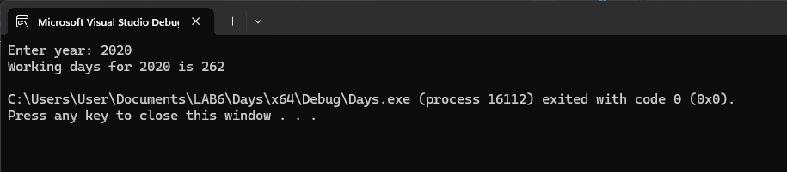

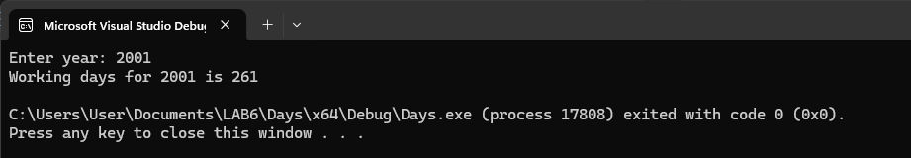

QUESTION 2:



