**Package.json => root location**

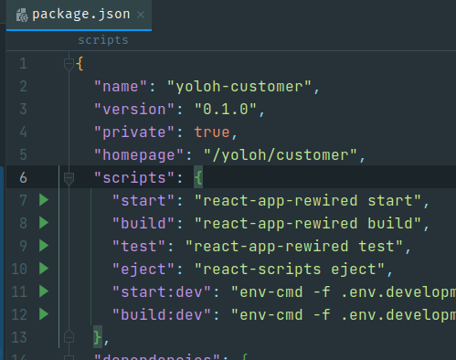

1] For root folder specify “./” value

"homepage":"./",

2] For sub folder folder specify “/xyz/customer” value same as you can see in screenshot above  
---------------------------------------------------------

**App.js => src/App.js location**

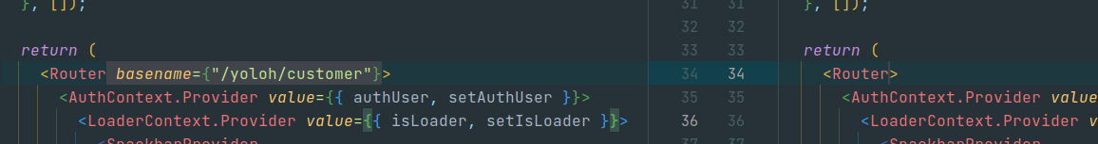  
1] For root folder you don’t need to sepcify anything any Router basename

2] For sub folder whatevr value you have defined in the package.json same value you need to

specify in Router’s basename field

---------------------------------------------------------

**.htaccess => public/.htaccess location** [ .htaccess is not relevant in all server for example nginx is not supporting nginx so make changes accordingly ]

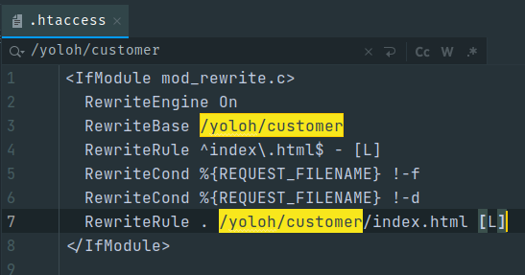1] sub folder specify /*yoloh*customer [ your folder location ] at 2 places in the .htaccess location

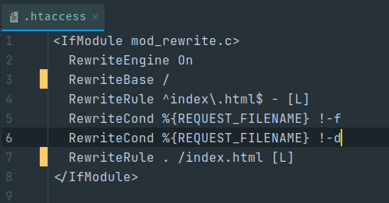2] For root folder set value same as below screenshot