Assignment 5 - Arrays

1. To reverse an array of int/float
2. To insert an element at a given location of an array
3. Delete a given element in an array
4. Linear search for element
5. Binary search for an element (which one among linear or binary search is better and why)

Binary search assumes that the data is sorted (ascending or descending). In every phase, one of the halves is rejected which does not contain the required element. Thus it is exponentially faster than linear search.

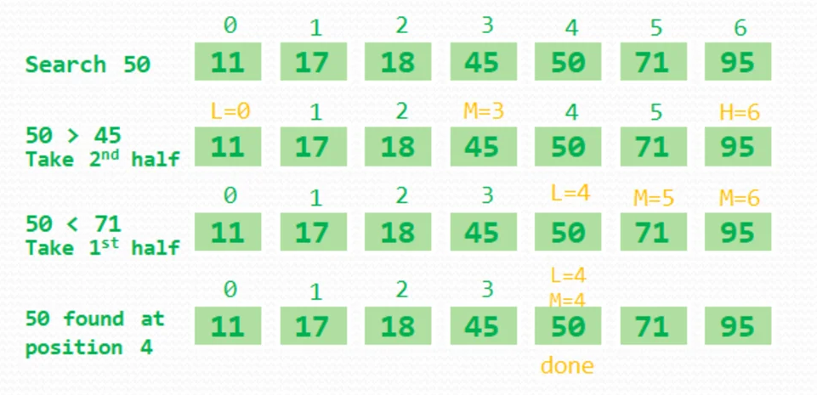

1. Sum and average of array elements
2. Merge two arrays
3. Find largest and smallest in array
4. Union and intersection of elements of two arrays
5. Remove duplicates in an array
6. **To add, multiply and transpose of a matrix**
7. Sort the array elements in ascending order
8. Rotate array elements (123,231,312) or (abcd, bcda, cdab, dabc)
9. Find mean, median, mode of an array
10. Use functions, loops and arrays to convert a decimal number into (a) binary (b) octal (c) hexadecimal.