LIBRARY MANAGEMENT SYSTEM
Software Development Life Cycle (SDLC) Documentation

Project Details

Project Name | Library Management System (LMS)
Language | C++ (Console Application)
Project Type | Academic / Educational Software
Version | 1.0
Date | 22 June 2026
Documentation Type | Full SDLC Documentation

Prepared By: Muhammad Mubashir | Institution: [UOBS]

PHASE 1: PROBLEM DEFINITION
Traditional library management in educational institutions relies heavily on manual processes — paper registers for book records, handwritten issue/return logs, and physical searches to locate books. These methods are slow, error-prone, and inefficient, especially in libraries with large collections. The core problem is the absence of a centralized, automated system to manage book inventory, track availability, and handle student interactions in real time.

PHASE 2: FEASIBILITY STUDY
The project uses C++ — a widely available, mature programming language — and standard input/output streams (iostream). No external libraries or database engines are required. The system runs as a console application on any machine with a C++ compiler (GCC, MSVC, Clang), making it technically feasible in virtually any academic environment.

Criterion | Requirement | Assessment
Programming Language | C++11 or higher | Feasible — widely supported
Compiler | GCC / MSVC / Clang | Feasible — freely available
Hardware | Any PC/Laptop | Feasible — minimal resources needed
Storage | None (in-memory) | Feasible — no DB required

PHASE 3: SYSTEM REQUIREMENTS

Functional Requirements

Administrator

Student

PHASE 4: SYSTEM DESIGN

Data Design

Global Data Structures
Variable | Type | Size | Purpose
bookId[] | int | 50 | Stores unique integer ID for each book
bookName[] | string | 50 | Stores title/name of each book
totalBook[] | int | 50 | Stores total number of copies added
availableBook[] | int | 50 | Tracks currently available copies
bookCount | int | 1 | Counter tracking number of books entered

Module Design

Function Descriptions
Function | Input | Output | Description
addBook() | User keyboard input | Updated global arrays | Prompts for Book ID, name, and quantity; stores in arrays; initializes availableBook = totalBook.
displayBooks() | None | Console output | Iterates all bookCount entries and prints a formatted table of all books.
searchBook() | Book ID (int) | Console output | Linear search through bookId[] array; prints book details if found, error if not.
issueBook() | Book ID (int) | Updated availableBook[] | Finds the book; decrements availableBook[i] if > 0; shows appropriate message.
returnBook() | Book ID (int) | Updated availableBook[] | Finds the book; increments availableBook[i]; confirms return to user.

PHASE 5: IMPLEMENTATION

Development Environment
Tool / Technology | Details
Programming Language | C++
Compiler | GCC (g++)
IDE | Dev-C++,
Standard Library | #include <iostream>, using namespace std
Data Storage | In-memory global arrays (no database)

PHASE 6: TESTING
The system is tested using Black-Box Testing (testing based on expected behavior without looking at code) and White-Box Testing (code-level review). Test cases cover normal flows, edge cases, and invalid inputs.

I have tested both Black – box and White – box

6.2 Screenshots of Program

1 Administration Module

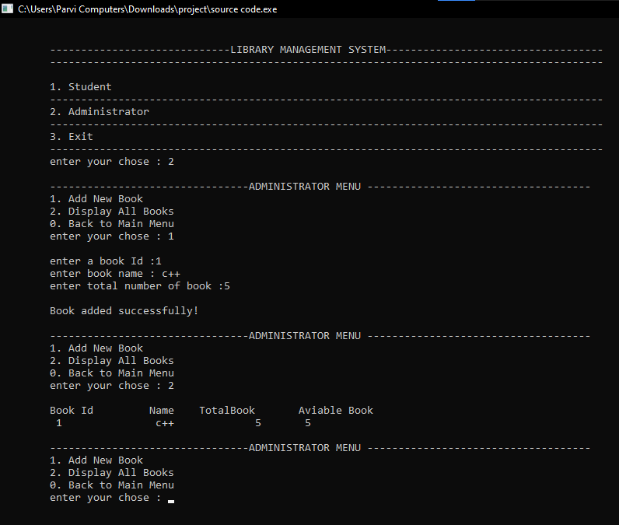

2 Student Module

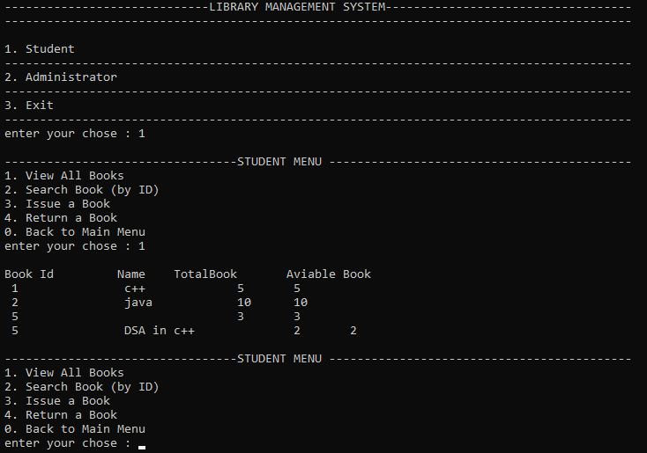

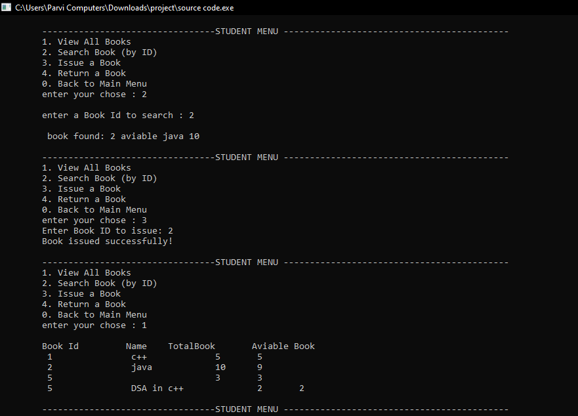

PHASE 7: MAINTENANCE & FUTURE ENHANCEMENTS
There are many bugs and limitations found in this program.
I will improve it in future.

PHASE 8: CONCLUSION
The Library Management System successfully demonstrates the core principles of software engineering: problem identification, requirement gathering, modular design, implementation, and testing — all within the context of a simple C++ console application. While the current version has limitations around persistence and security, it provides a solid foundation that can be extended into a full-featured library system in future development cycles. The system meets its primary academic objectives and serves as an effective learning project for understanding fundamental programming and SDLC concepts.

— End of SDLC Documentation —

