Cesar Santiago

ID: 970403634

COP4710 Database Systems

Pf. J. Teichert

## **Checkpoint 4.1:**

1) Entities are objects that hold different types of attributes, therefore an automobile, a college class, and a student are all entities because they hold attributes. However a name of student, book title, and number of dependents are attributes of entities themselves.

4) ER Diagrams help visualize the way that a database will be organized. This makes it easier for the designer to catch mistakes between different types of relations. It also helps with transfering the concept to the code of the database.

5) Attributes are defining features that a certain object has that are relevant to the information in a database. Automobiles have brands, make, models, whether they are gas or electric; A college class ahs teachers, students, subjects, classrooms; And students have names, IDs, majors, grades.

6) A relationship is the way two entities interact. For example, a teacher teaches many students.

## **Checkpoint 4.2:**

1) Describe the basic types of data representation schemas used in ER

modeling.

There are multiple ways to represent an attribute: The Simple / Atomic attributes are attributes that cannot be simplified into any other attributes; The Composite attributes are those that come from combining other related attributes; The Multivalued Attribute is one which can take multiple values for any one occurrence in a database; the Derived Attribute is one which comes to be through interpretation of data in other attributes; Keys are those attributes that are unique in data between all entities inside of a database, mostly used to find a certain datapoint.

2) entities are enclosed inside of boxes and are linked with attributes nearby, which are put in circles or otherwise listed next to the entity box.

3) In a Chen-like model unique attributes are underlined, composite attributes are listed with its component parts, and multivalued attributes are enclosed in parenthesis.

4) Composite attributes are put into circles like any other attribute but are linked to the sub-attributes as well as to the entity itself.

5) 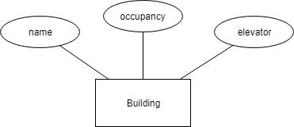

6) 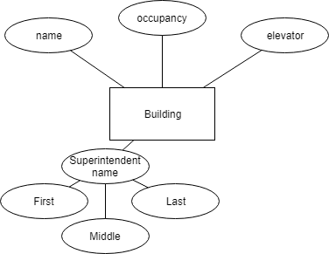

7) 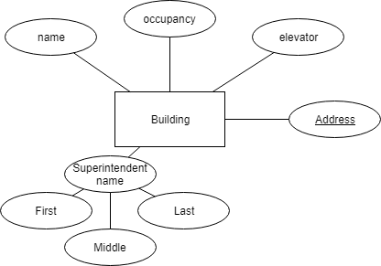

8) 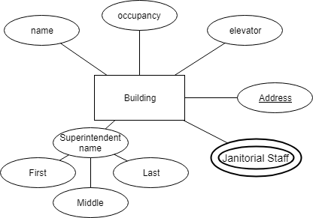

9) The Janitor Staff attribute is a multivariable attribute that may contain multiple names of the janitorial staff.

10)an entity can have as many attributes as are necessary for the database that we are building.

## **Checkpoint 4.3:**

1) To map multivalued attributes you have to create a separate table that connects the identifier attribute from the main table to the identifier attribute from the multi value table.

2) Every attribute in a database table is atomic therefore to map composite attributes we must denote the sub-attributes into the table. If the attribute is name and has two sub-attributes first and last then the attributes mapped into the table would be similar to name.first and name.last.

3) A unique identifier is the only attribute in a table/entity that is forced to be exclusive to a single row of a table to be identifiable from any other row. A candidate key is that which belongs to a table that forces all attributes to be unique therefore any attribute can be used as a key. A candidate key can be any attribute in a table of unique attributes therefore no candidate key is the primary key.

**Chapter 4 Exercises**

Book(Author, Title, Publisher, Courses)

A book was written by an author, has a unique title, a publisher, many courses study it. I don’t believe any attribute needs to be composite, unless the Author attribute requires the first, middle or last names. Since there are multiple courses that might study from the same book it should be a multivalued attribute. If a certain title is only published by one publisher then it could be a derived attribute, but that is not true for all books. I think the title is a good key but maybe an ID would be a better key attribute.

