Cesar Santiago

ID: 970403634

COP4710 Database Systems

Pf. J. Teichert

**Checkpoint 5.1**

1) The nature of an entity is valued through its attributes. The user of the database can determine the use or application of the attributes of an entity and could make them more complex than at first originated. Therefore an attribute can become over time an entity itself if more information about that attribute is needed, and will then connect to the starting entity via a relationship.

2) A relationship in an ER diagram is a connection between two or more

entities or between one entity and itself. Relationships have names which describe the type of connection the two entities have. The relationship between one entity and itself is known as a recursive relationship.

3) An entity itself represents an object from which we can derive information, whereas the relationship between entities represent the actions that objects take to interact with one another or with themselves.

4) It is preferable to consider an attribute an entity when the information needed from it transcends a simple description and becomes in itself an object that contains multiple types of information.

5) An entity with only one attribute should only exist if it represents an object and not a description of the object, however in most cases if an entity only has one attribute it can be represented as an attribute of another entity with which it has a relationship.

**Checkpoint 5.2**

Do All

1) Depending on the necessity of the user at any given time during an evaluation of the database, the idea that defines the entities involved in a relationship can change. The database can become either simpler, with fewer relationships or more complex with more relationships.

2) The attributes of an entity are not permanent and can be changed within the user’s request. However, it should be done with careful consideration because the change of multiple attributes carelessly can end in a cluttered and untraversable database.

3) In a database with multiple entities, it is not necessary for each entity to have some relation to any other depending on what the use of the database will be. Although it is preferable for all entities to be interconnected in a way that helps achieve the objective of the database.

4) a relationship which only involves two entities connected to each other is called a binary relationship. The relationship should have a name indicating the action that ties the two entities together. For example, A Student drives an Automobile.

**Chapter 5 Exercises**

Do Exercises 5.2 and 5.4

5.2)

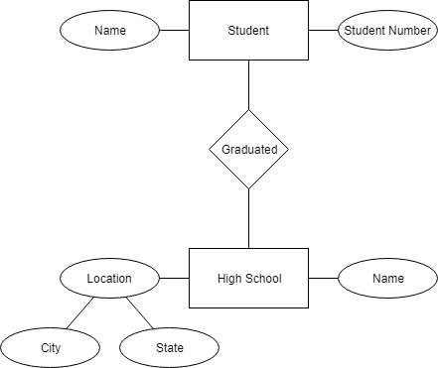

The name of the relationship I thought would be appropriate is “Graduated.” The description could be written as “A Student graduated from a High School” or as “A High School graduated a Student.”

5.4) The relationship from the plane’s perspective can be described as:

“A PLANE is flown by a PILOT.”