Cesar Santiago

ID: 970403634

COP4710 Database Systems

Pf. J. Teichert

**Checkpoint 6.1:**

1) Structural constraints are those restrictions we place upon entities; such as a key restriction which creates a unique attribute for an entity to be identified for, or an atomic attribute which is represented in their respective objects as only one data point.

2) the cardinality ratio tells us how many objects can occur in a relationship. Whether they can be multiple, single or a specific amount, as well as whether there has to be at least one.

4) The participation constraint tells us whether the relationships are required to have at least one object connecting to it.

**Checkpoint 6.2:**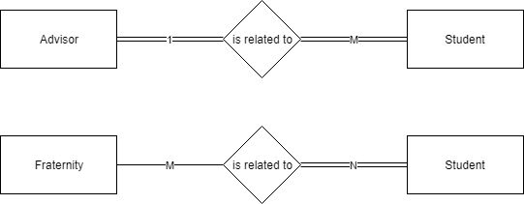

1)

**Checkpoint 6.3:**

1) The User and only one user can use a Computer. The computer may be used by one User.

3) The Students must be tutored by many Tutors, but not necessarily all tutors. The Tutors may tutor many, (one or more) Students.

**Checkpoint 6.4:**

2)Figure 6.17 relationship can be described as Passenger::Flight::M(full)::1.

Mapping rule 5 can be used passenger will use a concatenated flight_no to identify the relation.

PASSENGER(name.first, name.middle, name.last, frequent_flier_no, luggage_pieces, flight_no)

FLIGHT(flight_no, arrive_time, destination, depart_time)

**Chapter 6 Exercises:**

For exercise 6.5, for the methodology and English descriptions, follow pages 148-150 of the ER book.

6.5) For each RESTAURANT there will be only one name. The value for a name will not be subdivided.

For each RESTAURANT we will have the following primary key: location.

For each RESTAURANT there will be only one hours_open. The value for hours_open will not be subdivided.

For each RESTAURANT there will only be one capacity. The value for capacity will not be subdivided.

For each EMPLOYEE there will be only one name. The value for a name will not be subdivided.

For each EMPLOYEE we will have the following primary key: ID.

For each EMPLOYEE there will only be one salary. The value for salary will not be subdivided.

For each EMPLOYEE there will only be one title. The value for the title will not be subdivided.

For each EMPLOYEE there will only be one restaurant_location, The value for restaurant_location will not be subdivided.

RESTAURANT(name, location, hours_open, capacity)

EMPLOYEE(name, ID, salary, title, restaurant_location)

RESTAURANT

**name location hours_open capacity**

McDonalds 9 Mile Rd. 5am - 12pm 20

Whataburger Davis Hwy.. 9am - 10pm 35

SteakShake Airport Blv 9am - 10pm 25

EMPLOYEE

**name ID salary title restaurant_location**

David 1 20,000 Janitor 9 Mile Rd.

Lucas 2 50,000 A.Manager 9 Mile Rd.

Sharry 3 35,000 Hostess Airport Blv.

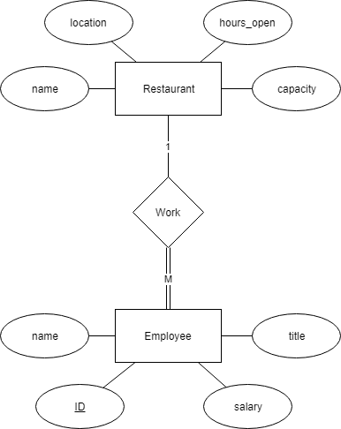

6.9)

1. Student::Car::1(full)::1
2. Student::Car::M(partial)::1
3. Student::Car::M(partial)::N

**Extra Exercise 1 :**

An employee ***may***work at a restaurant and can work for many restaurants, but a restaurant ***must*** have at least one employee working for it, and can have many employees working for it.

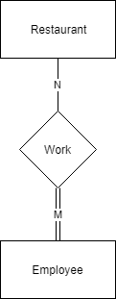

**Extra Exercise 2:**

An employee ***must*** work for at least one restaurant and can only work for one restaurant. A restaurant ***may*** have employees working for it.

