Cesar Santiago

ID: 970403634

COP4710 Database Systems

Pf. J. Teichert

**Checkpoint 9.1:**

1) A ternary relationship is that relationship which is held by three entities at a time. It withholds to the same standards that binary relationships stand to, such as attribute holding and participation. Ternary relationships must hold the same logic within any two connected entities.

2) An n-ary relationship is that relationship whose logic holds for n number of entities. The rules to the relationship are the same as for a binary or ternary relationship.

4) 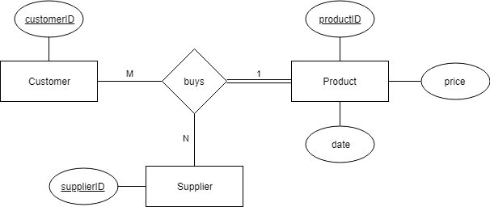

**Checkpoint 9.2:**

2) 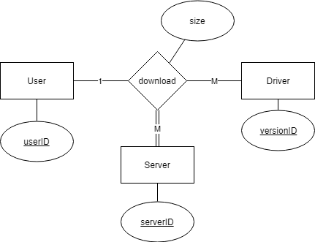

USER:DRIVER:SERVER::1:M:M.

A user may download many [one or more] drivers with many [one or more] servers.

I believe that the server entity could be a relationship itself so user and driver can be in a binary relationship.

**Checkpoint 9.3:**

1) The state entity could be an attribute stateName in the supplier entity. The supplier entity can have a binary relationship with product called supplies and the relationship buys would only deal with the supplier and the customer and the attribute price would be moved to the product entity. I think this shortening of the relationship negatively affects the use of this database because it makes it more specialized to the circumstance. For example, the state entity could be referring to the state of the customer or the current location of the product.

2) Making a table for buys with all of the key attributes as its primary keys and the price attribute. A table for the other entities separately with their attributes.

3) CUSTOMER (customerID)

SUPPLIER(supplierID)

STATE(name)

PRODUCT(productID)

BUYS(customerID, supplierID, stateName, productID, price)

**Chapter 9 Exercises: (at the end of the chapter)**

9.3)

