INVENTION DISCLOSURE FORM
To be filled in by the Inventors
1) Describe the invention.
Title: QubitChat: A Controlled Evaluation of Grover-Inspired Reranking for Document Retrieval
1a. Describe the invention in your own words. Is the invention a new process, composition of matter, device or product, system, software, or a combination of these elements?
QubitChat is a web software prototype for asking questions about uploaded documents. It accepts PDFs and images, extracts text page by page, and uses OCR for scanned pages. The extracted text is divided into page-aware overlapping chunks, encoded as normalized 384-dimensional MiniLM vectors, and stored in Chroma. For a question, the system retrieves candidate passages and can rank them with cosine similarity, a Grover-style classical simulation, analytical amplification, or a matched classical-sampling control. The selected passages and their source information are sent to optional answer generation so a user can inspect supporting evidence.
At a high level, QubitChat has three stages (Fig. 1):
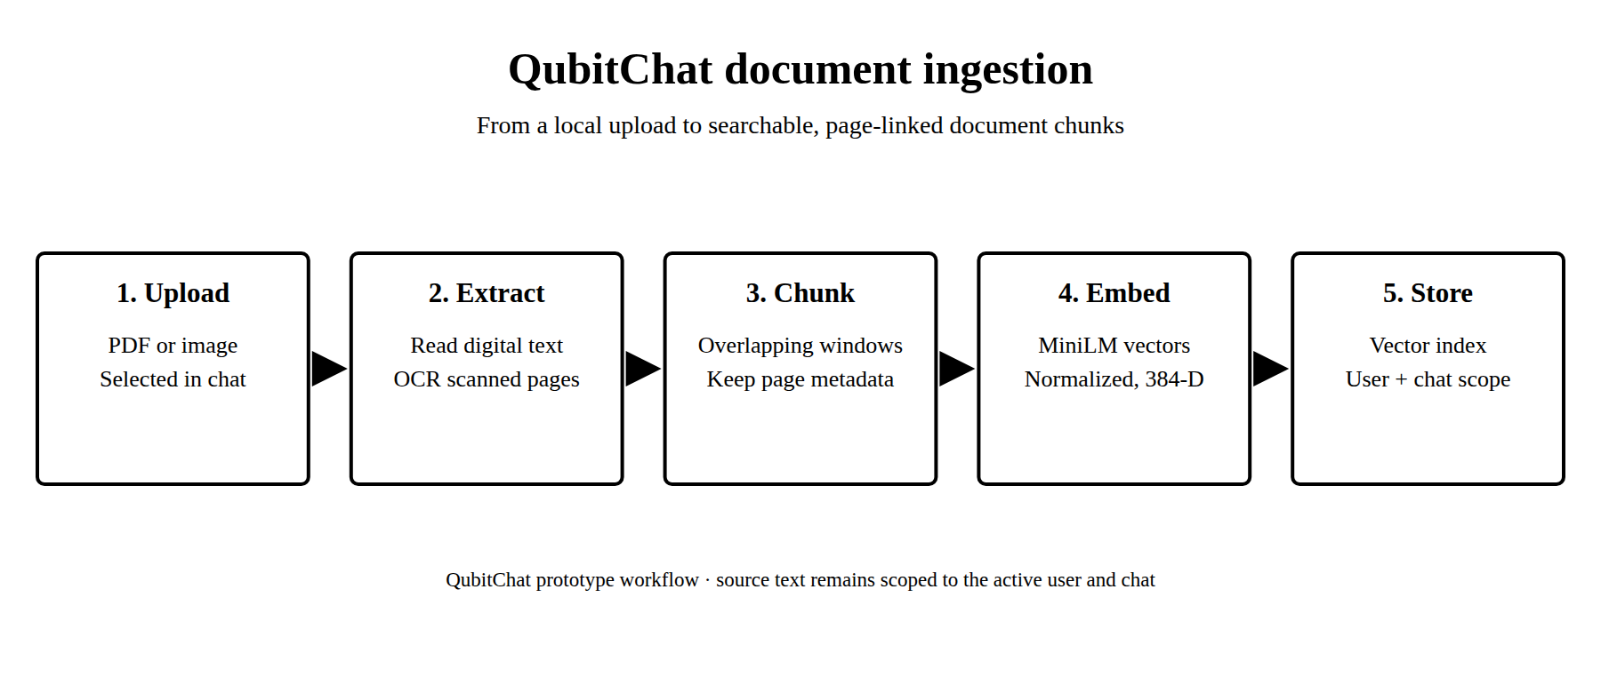
Fig. 1: QubitChat document ingestion and indexing flow.
- Ingest. A user uploads a PDF or image. The system extracts page text and uses an OCR path for scanned pages.
- Index. Extracted text is divided into page-aware overlapping chunks, embedded with MiniLM, and stored in the vector database.
- Retrieve and answer. A question selects a candidate shortlist, applies a retrieval policy, and returns top passages with source context for an optional generated answer.
1b. Does the invention provide a new use of or an improvement to, an existing product or process?
The prototype applies established document retrieval and retrieval-augmented generation techniques in an interactive document-chat workflow and exposes multiple retrieval policies for controlled study. Its research component compares reranking policies on the same classically selected candidates, with explicit cosine fallback and recorded seeds and timings. Text embeddings, OCR, vector databases, retrieval-augmented generation, and Grover search are established techniques; this disclosure describes the project implementation and evaluation rather than claiming those underlying methods as new.
QubitChat processing and retrieval workflow
The prototype processes each document and question through the stages below. Figures 1 and 2 show the ingestion and question-to-answer flows.
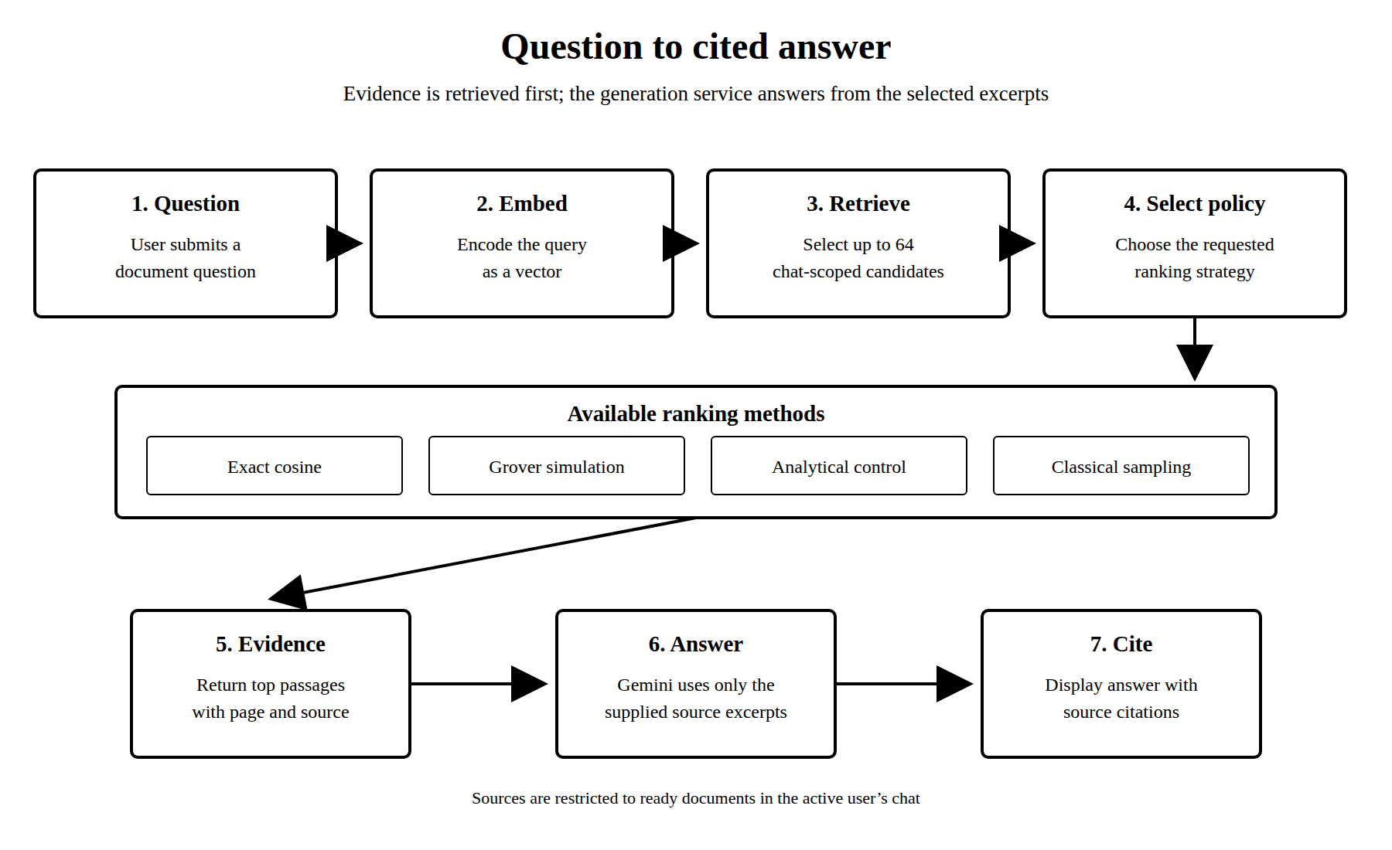
Fig. 2: Question retrieval and cited-answer flow.
- Extract text. PDF and image pages are parsed; scanned pages use the OCR path. Page information is retained with the extracted text.
- Chunk and embed. The study uses 192-token windows with a 32-token overlap and normalized 384-dimensional vectors from a pinned MiniLM encoder.
Stage | Current implementation | Output
Document input | PDF/image extraction; OCR path for scanned pages | Page text and document metadata
Chunking and vectors | 192-token windows, 32-token overlap; pinned MiniLM encoder; 384-dimensional normalized vectors | Page-linked chunks in the vector store
Candidate retrieval | Classical cosine search; experimental HNSW baseline; up to 64 candidates in the study | Ranked candidate shortlist
Reranking and answer | Cosine, Grover simulation, analytical control, or sampling control; optional Gemini generation | Top passages and a response with source context

- Retrieve candidates. Classical cosine search selects candidate passages; HNSW is an experimental baseline. The study uses a candidate budget of up to 64.
- Apply a reranking policy. The prototype compares exact cosine, Grover-style simulation, analytical amplification, and matched classical sampling over the selected candidates.
- Use explicit fallback and fixed settings. The research configuration records the encoder revision, chunking, candidate budget, threshold, shot count, seeds, metrics, and statistical procedure. If the threshold yields no marked candidate, the policy uses the declared exact-cosine fallback.
- Return source context. Top passages and page-linked source details are passed to optional Gemini answer generation. The answer can be checked against the retrieved passages.
2) From the description, identify and provide a detailed description of specific novel and unusual features.
- Controlled comparison. The analytical, sampling, and Grover policies receive the same exact-cosine candidate shortlist and raw scores, so the reranking stage is compared without changing candidate discovery.
- Explicit fallback. When no candidates meet the threshold, the policy returns the exact-cosine ranking and records the fallback rather than presenting a circuit run as successful.
- Reproducible configuration. The encoder revision, chunk size and overlap, candidate budget, threshold, shot count, seeds, metrics, and statistical procedure are fixed in the research configuration.
- Auditable run traces. Candidate passages, scores, seeds, timing, circuit resources, and fallback reasons are retained for analysis.
- Application integration. Document parsing, OCR paths, page-linked chunks, authentication-scoped sessions, retrieval, and source-aware answers are combined in a working web prototype.
3) (How does the invention differ from present technology? What problems does it solve, or what advantages does it possess?)
Aspect | Established approaches | QubitChat project
Document question answering | Retrieval-augmented generation combines retrieval with language generation. | A web prototype accepts documents and returns answers with source context.
Candidate retrieval | Dense or lexical retrieval and approximate-neighbor indexes are common baselines. | The study uses a classically selected shortlist and includes cosine and HNSW baselines.
Reranking | Candidate ranking is performed with classical scoring or learned methods. | Grover-style simulation, analytical amplification, and matched sampling are compared on the same candidates.
Evaluation | Retrieval systems use relevance judgments and ranking metrics. | The manuscript evaluates SciFact and NFCorpus with frozen settings and paired statistical tests.
Observed result | Improvement should be claimed only when supported by evidence. | Grover did not improve nDCG@10 over exact cosine; differences were not statistically significant.
Quantum claim | A quantum speedup requires evidence from an appropriate quantum implementation. | The Grover step is a classical simulation; no quantum advantage is claimed.

The practical purpose is to help a user locate relevant passages in uploaded material and to provide a platform for reproducible retrieval experiments. The project has not demonstrated a quantum speedup, lower end-to-end cost, or improved answer quality over competing systems.
4) Describe uses, applications and benefits of the invention. What are the possible uses for the invention, particularly the major application(s)?
The major application is question answering over uploaded PDFs and images, with source context linked to the relevant passages. Potential uses include academic papers, reports, manuals, policies, course materials, research demonstrations, and—after security, privacy, and deployment work—internal knowledge search. Potential benefits include quicker access to relevant passages and visible evidence alongside generated answers. OCR quality, user productivity, customer demand, and commercial readiness have not been measured.
Potential applications and users are summarized below; these are prospective uses, not validated customer demand:
Potential application | Potential user group | Possible value
Search across papers, reports, manuals, policies, and course materials | Universities and research groups | Locate relevant passages and inspect source context.
Internal search over manuals, procedures, and technical records | Enterprise knowledge teams | Support document discovery after privacy and deployment review.
Evidence-linked document discovery features | Software and document-platform providers | Explore a prototype feature or research component.
Research and classroom demonstrations | Students and educators | Compare document processing and retrieval policies.

5) Characterize the disadvantages and limitations of the invention.
- Prototype status. Production deployment would require security, privacy, reliability, and operational review.
- External services. Account authentication and database operations depend on configured Supabase services; answer generation depends on a configured Gemini service.
- Retrieval limits. Relevant content can be missed when extraction, chunking, or candidate retrieval fails; generated responses can still be incomplete or incorrect.
- Unmeasured quality. OCR quality and answer quality were not quantitatively evaluated in the reported retrieval study.
- Classical simulation. The Grover step is simulated on a classical computer over a classically generated shortlist. It does not demonstrate physical quantum computing or quantum advantage.
- Benchmark scope. The benchmark covers two public datasets, not every private document collection, language, scan quality, or real user workflow.
- Reproducibility assets. The repository does not include downloaded benchmark archives or sealed run directories needed to regenerate all reported tables from scratch.
6) Enclose sketches, drawings, photographs and other materials that help illustrate the invention.
Figures 1–3 show document ingestion, question answering, and controlled retrieval evaluation. Screenshots 1–5 show the locally running prototype in its warm-brown dark theme: home, sign-in, account creation, a cited answer in a resume chat, and the document upload dialog before file selection.
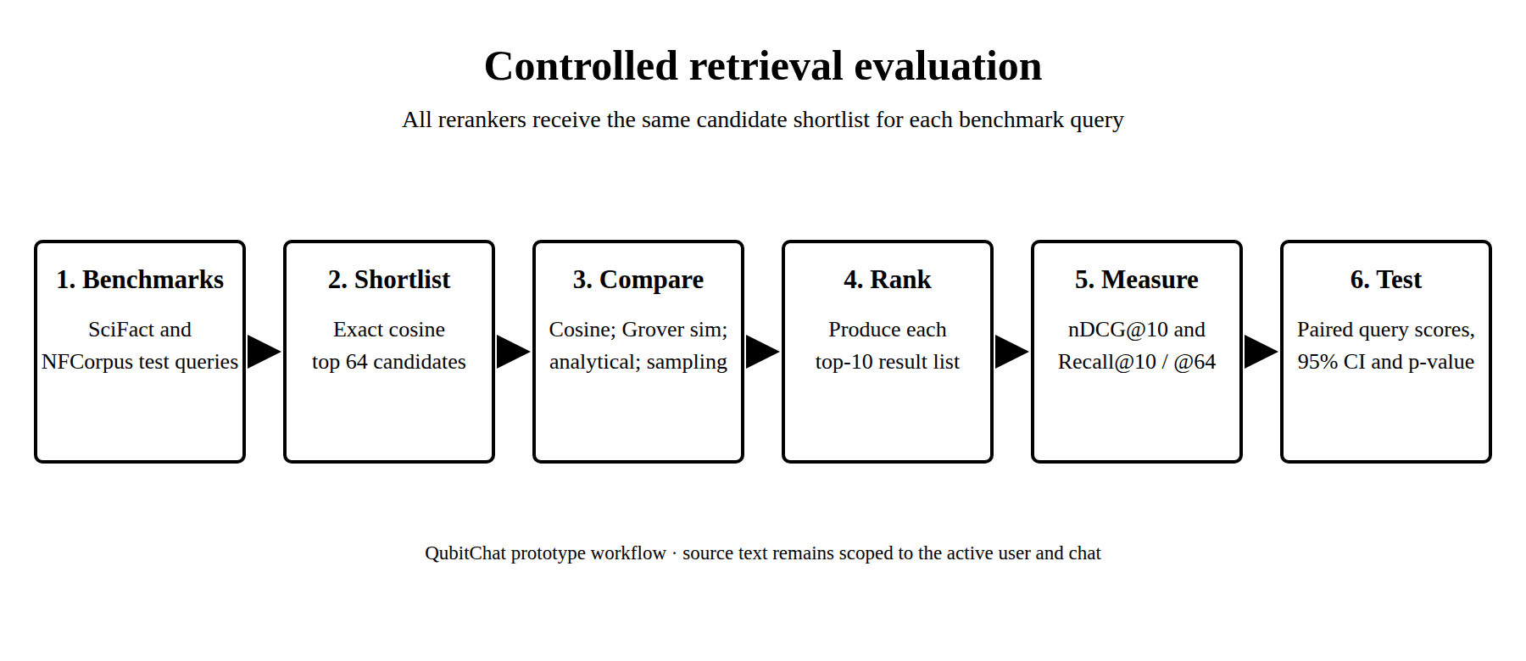
Fig. 3: Controlled retrieval evaluation flow.

Screenshots of the working prototype

Screenshot 1: QubitChat home page.

Screenshot 2: QubitChat sign-in page; no account details are entered or displayed.
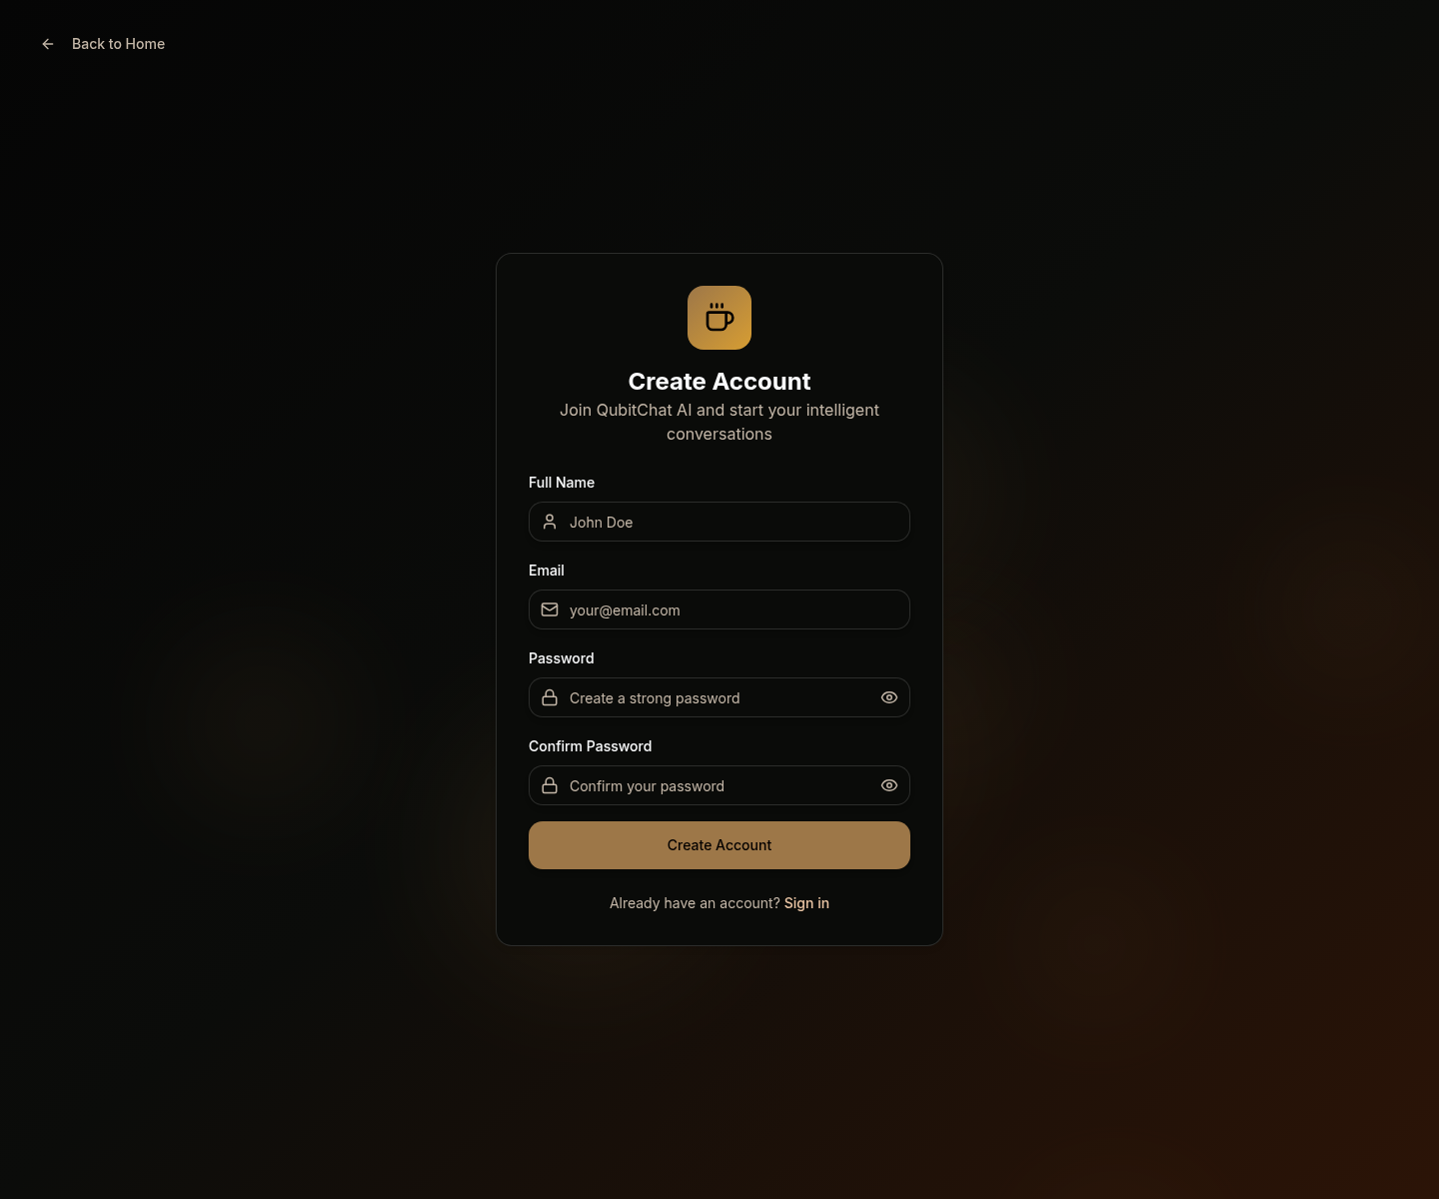
Screenshot 3: QubitChat account-creation page; the field text is placeholder text.
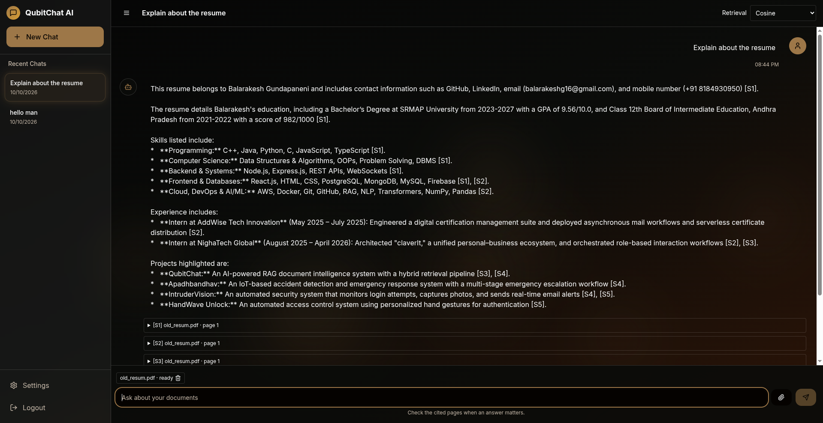
Screenshot 4: Answer to a question about an uploaded resume, with source citations visible.
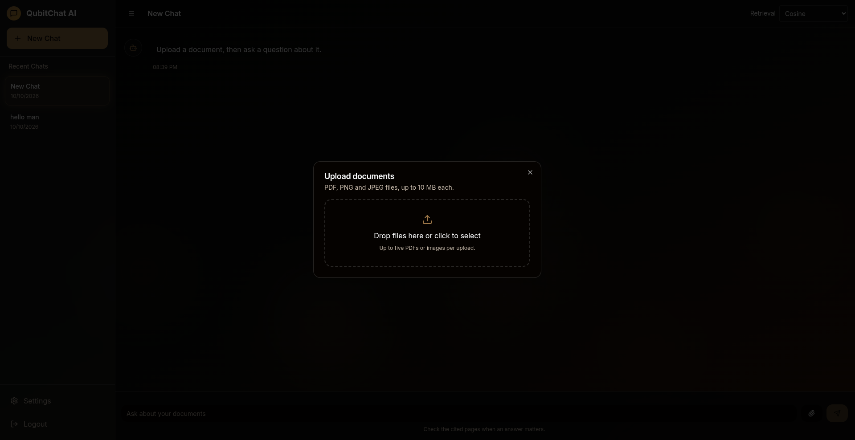
Screenshot 5: PDF and image upload dialog, before a file is selected.
7) Provide details concerning experimental data. (Complete experimental procedure including list of experiments or trials conducted)
The manuscript evaluates retrieval separately from OCR and answer generation. It uses official BEIR relevance judgments for SciFact and NFCorpus. Test-query membership follows the benchmark test files; threshold tuning uses a held-out portion of SciFact training queries and the official NFCorpus development split.
The frozen study configuration uses sentence-transformers/all-MiniLM-L6-v2 at a pinned revision; 192-token chunks with 32-token overlap; 384-dimensional normalized embeddings; a 64-candidate budget; top-10 output; cosine threshold 0.7; 1,024 shots; and five fixed seeds for stochastic reranking. Methods compared include BM25, exact cosine, HNSW, analytical amplification, matched classical sampling, and Grover simulation.
Dataset | Corpus documents | Test queries | Chunks evaluated
SciFact | 5,183 | 300 | 13,503
NFCorpus | 3,633 | 323 | 9,968

The primary metric is nDCG@10. Recall@10 and Recall@64 are also reported. Paired inference uses 10,000 query-bootstrap resamples, sign-randomization tests, and Holm correction.
Dataset | Method | nDCG@10 | Recall@10 | Recall@64
SciFact | BM25 | 0.661 | 0.778 | 0.874
SciFact | Exact cosine | 0.662 | 0.817 | 0.924
SciFact | Grover policy | 0.662 | 0.817 | 0.924
NFCorpus | BM25 | 0.305 | 0.146 | 0.217
NFCorpus | Exact cosine | 0.295 | 0.143 | 0.267
NFCorpus | Grover policy | 0.295 | 0.143 | 0.267

Result: the Grover policy’s reported nDCG@10 matches exact cosine at three decimal places on both datasets. Paired differences are slightly negative, both confidence intervals include zero, and neither comparison is statistically significant. Grover circuits ran for 101 of 300 SciFact queries and 52 of 323 NFCorpus queries; other queries used the declared exact-cosine fallback because no candidate met the threshold. The study therefore reports no retrieval improvement or quantum advantage.

Dataset | Grover minus exact cosine | 95% paired CI | p-value | Holm result
SciFact | −0.279 × 10⁻³ | [−5.412, 5.096] × 10⁻³ | 0.918 | Not significant
NFCorpus | −0.149 × 10⁻³ | [−0.706, 0.356] × 10⁻³ | 0.600 | Not significant

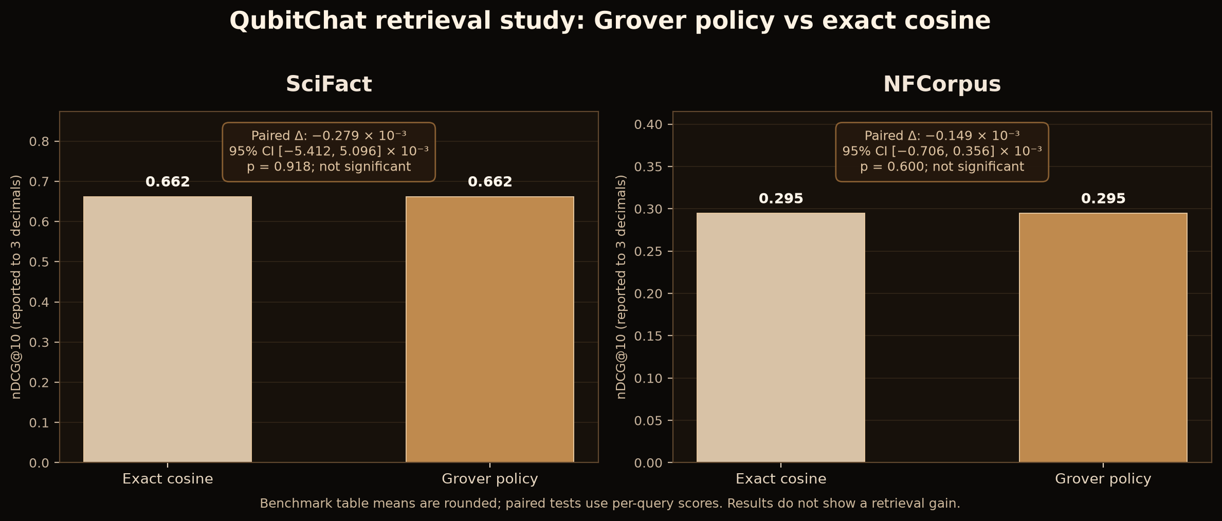
Fig. 4: Retrieval result summary from the manuscript’s generated result tables. Displayed means are rounded; paired tests use per-query scores.
Timing excludes query embedding, corpus encoding, index construction, and Gemini generation. Grover timing combines five seeded reranks and should not be read as single-query production latency. Raw benchmark data and sealed run directories are required to regenerate the tables.
8) Please list any of your publications (including abstracts, posters, news releases, etc.) in print or anticipated. Please state the date, place and circumstances of such disclosures.
Per team confirmation, no publication, presentation, poster, public repository posting, or other public disclosure of this project has occurred, and no patent application has been filed. A manuscript draft, “QubitChat: A Controlled Evaluation of Grover-Inspired Reranking for Document Retrieval,” is maintained in the internal project repository and has not been publicly shared.
Item | Current status
Public disclosure | None reported by the team as of 10 October 2026.
Patent application | No patent application has been filed, per team confirmation.
Internal manuscript | Draft is maintained in the project repository and has not been publicly shared, per team confirmation.
9) Provide detail of potential market of your invention (key problems the invention solves, potential applications, commercial potential, companies most likely to be interested in the technology)
QubitChat addresses the time and effort involved in locating useful information in long documents and checking answers against source passages. Possible applications include research, education, and internal knowledge search after appropriate security, privacy, and deployment review.
Commercial potential has not been validated: the repository contains no customer interviews, paying users, deployment evidence, pricing study, or market-size estimate. No revenue or market-size figure is claimed.
Possible user groups and applications are listed in the table below; no company-specific interest has been established.
Potential application | Potential user group | Possible value
Search across papers, reports, manuals, policies, and course materials | Universities and research groups | Locate relevant passages and inspect source context.
Internal search over manuals, procedures, and technical records | Enterprise knowledge teams | Support document discovery after privacy and deployment review.
Evidence-linked document discovery features | Software and document-platform providers | Explore a prototype feature or research component.
Research and classroom demonstrations | Students and educators | Compare document processing and retrieval policies.
10) Provide Prior Art Search details of the invention
Search date: 10 October 2026. Search terms included “document chat retrieval augmented generation”, “vector retrieval question answering”, “Grover document retrieval”, “quantum semantic search”, and “Grover image retrieval”. Web search results and Google Patents listings were reviewed for representative prior work on the project’s building blocks and related search ideas:
• Lewis et al., “Retrieval-Augmented Generation for Knowledge-Intensive NLP Tasks,” NeurIPS 2020 — prior work combining a neural retriever, dense index, and language generation. Paper
• Thakur et al., “BEIR: A Heterogeneous Benchmark for Zero-shot Evaluation of Information Retrieval Models,” NeurIPS 2021 — benchmark and retrieval evaluation framework used by this study. Paper
• “Quantum Computing for Semantic Search and Information Retrieval,” QuantumNLP 2025 — review of quantum methods for information retrieval, including Grover-based document retrieval. ACL Anthology PDF
• CN113434723A, “Image retrieval method, device and medium based on quantum Grover algorithm” (2021) — adjacent patent literature on Grover-style feature-vector image retrieval. Google Patents
• US12524416B1, “Query response system implementing a retrieval-augment generation architecture” (2025) — patent literature concerning RAG query-response systems. Google Patents
• US7028275B1, “Quantum circuit design for Grover’s algorithm” — earlier patent literature on Grover search circuits and information retrieval. Google Patents
This is a preliminary web search, not an exhaustive patent search, claim chart, novelty opinion, or freedom-to-operate analysis. These references are not all identical to QubitChat, but show prior art around RAG, document retrieval, quantum search, and Grover-based retrieval. A patent professional should review specific claims and official records before filing.
11) Provide Prior Art Search details of the invention
The three student team members and their identifiers are listed below; the project guide appears in a separate row. Student contribution wording is a suggested draft allocation and must be confirmed by the named contributors before signing or filing.
S. No. | Name | Roll No. / ID | Department | Suggested contribution — confirm
1 | Balarakesh | AP23110010003 | CSE | System architecture, backend API, and document retrieval integration.
2 | Jagadesh | AP23110010058 | CSE | Frontend workflow, chat interface, and authentication integration.
3 | Basith | AP23110011061 | CSE | Dataset preparation, benchmark experiments, and results analysis.
4 | Dr. Naga Sravanthi Puppala |  | CSE (Guide) | Project guidance and supervision.

12) Signature of inventor(s) and date
Balarakesh | Jagadesh | Basith | Dr. Naga Sravanthi Puppala (Guide)
Signature:  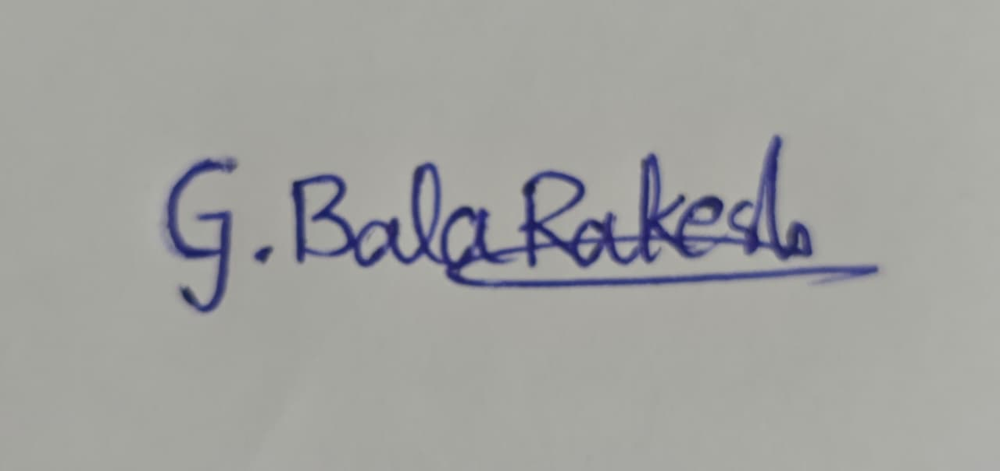 | Signature:  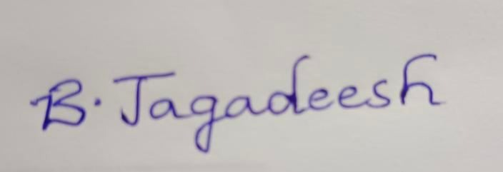 | Signature:  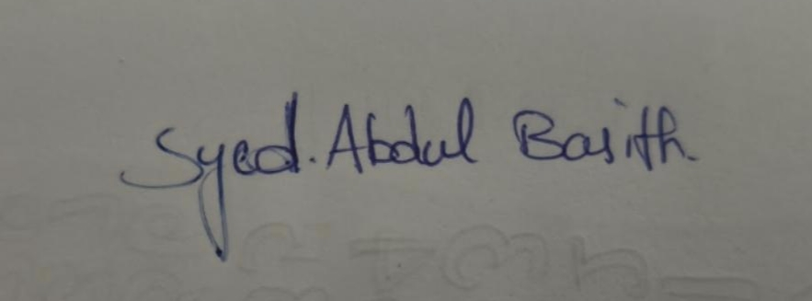 | Signature:  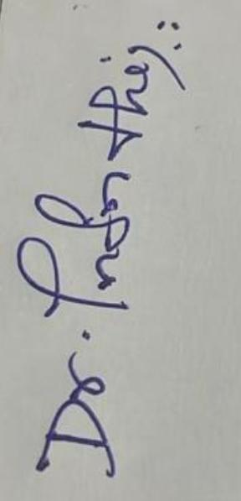
Date: 10.10.2026 | Date: 10.10.2026 | Date: 10.10.2026 | Date: 10.10.2026

