**New European Driving Cycle (NEDC)**

New European Driving Cycle (NEDC) is a [driving cycle](https://en.wikipedia.org/wiki/Driving_cycle" \o "Driving cycle), last updated in 1997, designed to assess the emission levels of car engines and [fuel economy](https://en.wikipedia.org/wiki/Fuel_economy_in_automobiles" \l "Europe" \o "Fuel economy in automobiles) in [passenger cars](https://en.wikipedia.org/wiki/Automobile" \o "Automobile) (exclude [light trucks](https://en.wikipedia.org/wiki/Light_truck" \o "Light truck) and commercial vehicles).

Although originally designed for petrol-based road vehicles, the driving cycle is now also used for diesel vehicles and to estimate the electric power consumption and driving range of [hybrid](https://en.wikipedia.org/wiki/Hybrid_electric_vehicle) and [battery electric vehicles](https://en.wikipedia.org/wiki/Battery_electric_vehicles).

Measurement

UN Regulation 101

Several measurements are usually performed along the cycle. The figures made available to the general public are:

* Urban fuel economy (first 780 seconds)
* Extra-Urban fuel economy (780 to 1180 s)
* Overall fuel economy (complete cycle)
* CO2 emission (complete cycle)

UN Regulation 8

Some or all of the following parameters are measured depending upon the requirements of the region implementing the test:

* Mass of carbon monoxide (CO)
* Mass of total hydrocarbons (THC)
* Mass of nonmethane hydrocarbons (NMHC)
* Mass of oxides of nitrogen (NOx)
* Combined mass of hydrocarbons and oxides of nitrogen (THC + NOx)
* Mass of particulate matter (PM)
* Number of particulates (PN)

Test procedure

The cycle must be performed on a cold vehicle at 20–30 °C (typically run at 25 °C). The cycles may be performed on a flat road, in the absence of wind. However, to improve [repeatability](https://en.wikipedia.org/wiki/Repeatability" \o "Repeatability), they are generally performed on a roller test bench.

For each vehicle configuration, a look-up table is applied: each speed corresponds to a certain value of resistance (reverse [torque](https://en.wikipedia.org/wiki/Torque" \o "Torque) applied to the drive wheels). This arrangement enables the use of a single physical vehicle to test all vehicle body styles (Sedan, hatchback, MPV etc.) by simply changing the look-up table.

Urban driving Cycle

The cycle has been designed to represent typical driving conditions of busy European cities, and is characterized by low engine load, low exhaust gas temperature, and a maximum speed of 50 km/h. When the engine starts, the car pauses for 11 s - if equipped with a [manual gearbox](https://en.wikipedia.org/wiki/Manual_gearbox), 6 s in neutral (with clutch engaged) and 5 s in the 1st gear (with clutch disengaged) - then slowly accelerates to 15 km/h in 4 s, cruises at constant speed for 8 s, brakes to a full stop in 5 s (manual: last 3 s with [clutch](https://en.wikipedia.org/wiki/Clutch) disengaged), then stops for 21 s (manual: 16 s in neutral, then 5 s in the 1st gear).

At 49 s, the car slowly accelerates to 32 km/h in 12 s (manual: 5 s in 1st gear, 2 s gear change, then 5 s in the 2nd gear), cruises for 24 s, slowly brakes to a full stop in 11 s (manual: last 3 s with clutch disengaged), then pauses for another 21 s (manual: 16 s in neutral, 5 s in the 1st gear).

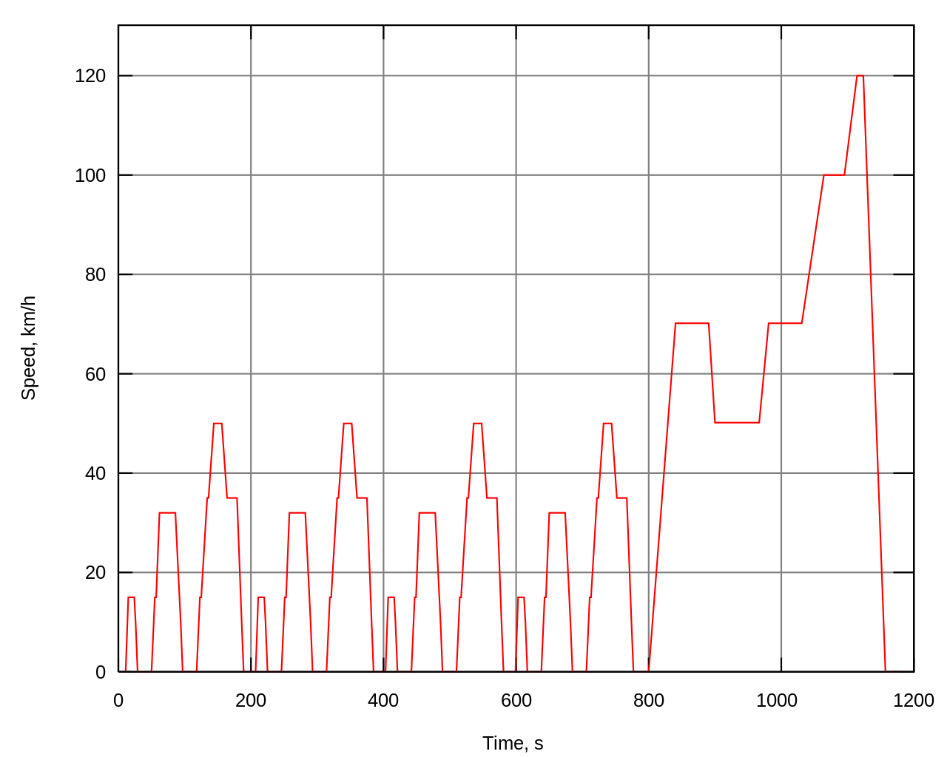

Extra-urban driving Cycle

The Extra-Urban Driving Cycle EUDC, introduced by ECE R101 in 1990,[[1]](https://en.wikipedia.org/wiki/New_European_Driving_Cycle#cite_note-UNECE_R101-1) has been designed to represent more aggressive, high speed driving modes. The maximum speed of the EUDC cycle is 120 km/h; low-powered vehicles are limited to 90 km/h.[[6]](https://en.wikipedia.org/wiki/New_European_Driving_Cycle#cite_note-NEDC_DieselNet-6)

After a 20 s stop - if equipped with manual gearbox, in the 1st gear with clutch disengaged - the car slowly accelerates to 70 km/h in 41 s (manual: 5 s, 9 s, 8 s and 13 s in the 1st, 2nd, 3rd and 4th gears, with additional 3 × 2 s for gear changes), cruises for 50 s (manual: in the 5th gear [sic]), decelerates to 50 km/h in 8 s (manual: 4 s in the 5th and 4 s in the 4th gear [sic]) and cruises for 69 s, then slowly accelerates to 70 km/h in 13 s .

At 201 s, the car cruises at 70 km/h for 50 s (manual: in the 5th gear), then slowly accelerates to 100 km/h in 35 s and cruises for 30 s (manual: in the 5th or 6th gear).

Finally, at 316 s the car slowly accelerates to 120 km/h in 20 s, cruises for 10 s, then slowly brakes to a full stop in 34 s (manual: in the 5th or 6th gear, last 10 s with clutch disengaged), and idles for another 20 s (manual: in neutral).

Total duration is 400 s (6 minutes 40 s econds) and theoretical distance is 6956 meters, with an average speed of 62.6 km/h.

Combined

The combined fuel economy is calculated by a total consumption of urban and extra-urban cycles over the total distance (theoretical 10932 meters). The total test time amounts to 1180 s with an average speed of 33.35 km/h. Sometimes the NEDC is also quoted at 1220 s, which includes the initial 40 s with the vehicle at standstill and combustion engine off.