**Docker Compose**

**Pre-requisites:** (Here I taken Amazon Linux-2)

* Install Git
* Install Docker
* Install Docker-Compose

**Install Git:**

yum install git -y

**Install Docker:**

yum install docker -y

service docker start

usermod -aG docker ec2-user

**Install Docker-Compose:**

sudo curl -L "https://github.com/docker/compose/releases/download/1.25.4/docker-compose-$(uname -s)-$(uname -m)" -o /usr/local/bin/docker-compose

sudo chmod +x /usr/local/bin/docker-compose

sudo ln -s /usr/local/bin/docker-compose /usr/bin/docker-compose

docker-compose -version

**Clone SCM from github:**

git clone <https://github.com/Naresh240/docker-compose.git>

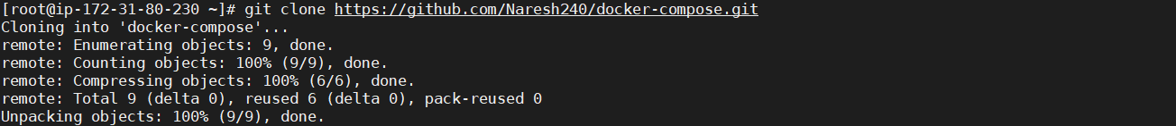

**Build Docker image using docker-compose:**

docker-compose build

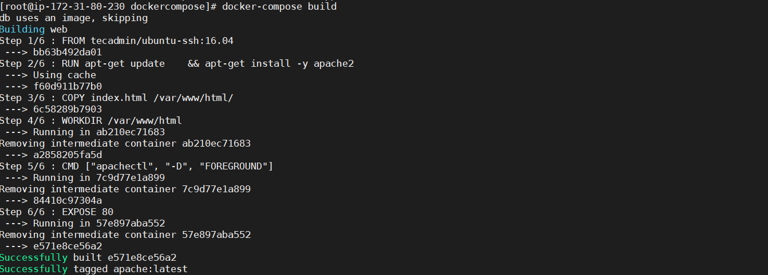

**Launch Docker Containers:**

Finally launch your containers using docker-compose up command. Use -d switch to run them in daemon mode.

docker-compose up –d

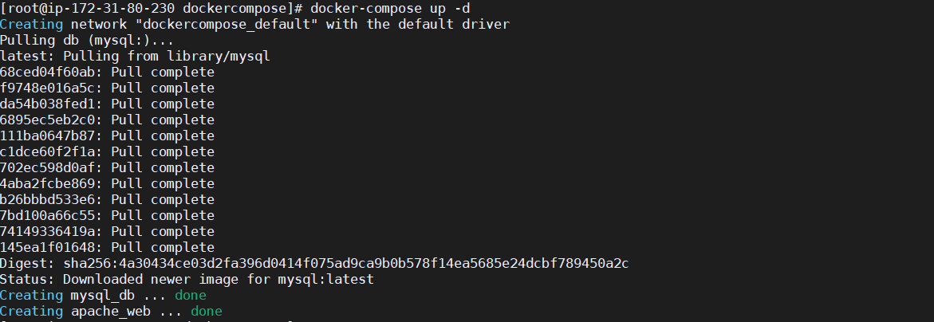

**Check Running Container:**

docker ps -a



Allow Port number 8080 for EC2 instance and check output in Web-UI:

<IP-address>:8080



**Clean UP:**

docker-compose down

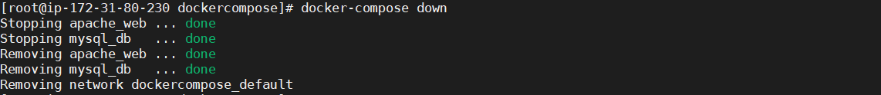

**Again check running containers:**

docker ps -a

