**Docker Swarm**

**Pre-requisites:**

* Install Git
* Take two EC2 Instances
* Install docker

**Install Docker:**

yum install docker -y

service docker start

usermod -aG docker ec2-user

Here I taken Two EC2 Server: (Allow port number: **2377** in both servers)

One server is for Leader and other for Node

Goto master server and give below command:

docker swarm init

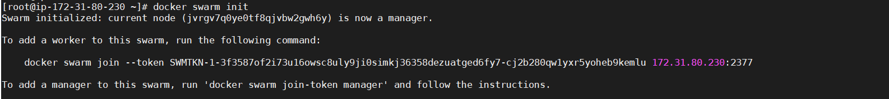

Here we get **token.** This token we need to give in node servers

Goto node server and give token which we get in master:

docker swarm join --token SWMTKN-1-3f3587of2i73u16owsc8uly9ji0simkj36358dezuatged6fy7-cj2b280qw1yxr5yoheb9kemlu 172.31.80.230:2377



Check nodes in Master server:

docker node ls



**Create a service using an image**

docker service create --name nginxtest --replicas 3 --publish published=8080,target=80 nginx

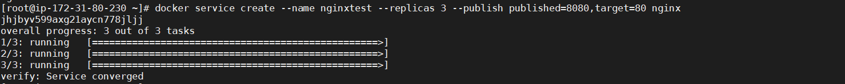

Check Services:

Goto Master Server:

docker service ls



Check how many containers running on Master and Nodes:

In the above example we taken 3 replicas. In these 3 replicas 2 will run in one server and other will run in other server

Goto Master Server:

docker ps -a



Goto Node Server:

docker ps -a



Update number of Replicas:

docker service update --replicas=5 nginxtest

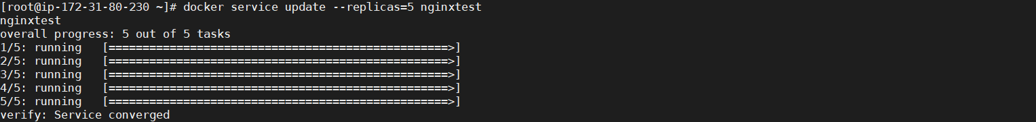

Again Check Services:

Goto Master Server:

docker service ls



Again Check how many containers running on Master and Nodes:

In the above example we taken 3 replicas. In these 3 replicas 2 will run in one server and other will run in other server

Goto Master Server:

docker ps -a



Goto Node Server:

docker ps -a



Remove Service:

docker service rm nginxtest



Docker Swarm Stack Deploy:

Clone SCM from github:

git clone <https://github.com/Naresh240/example-voting-app.git>

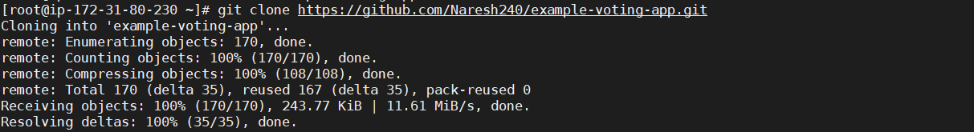

cd example-voting-app/

Stack deploy command:

docker stack deploy --compose-file docker-stack.yml vote

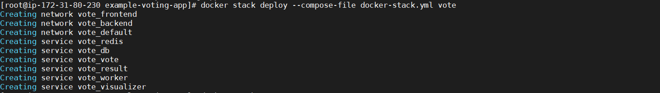

Check output in web-UI:

<IP-address of Master/Node>:5001

Master Server output:

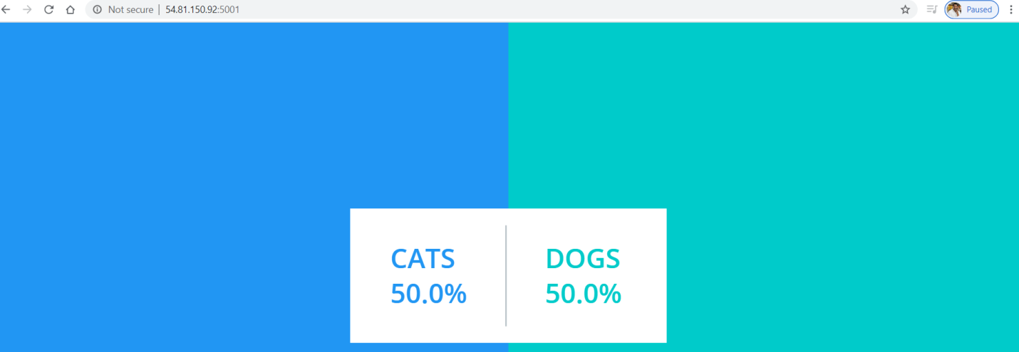

Node Server Output:



Cleanup Stack:

docker stack rm vote

