Page Object model: -
In this project we have followed Page Object Model pattern, so all page objects classes are stored in the page objects
package as shown below
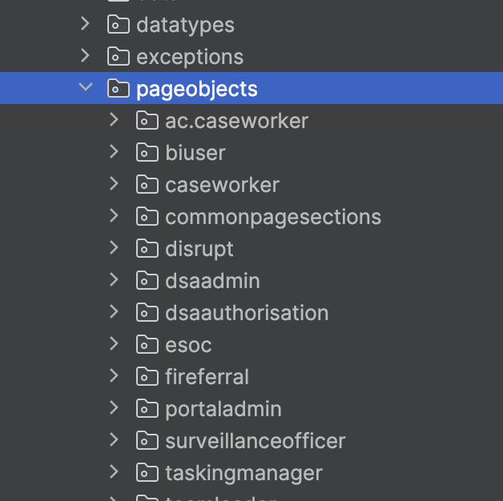

Based on the Functions and user role packages has been created separated the page objects
Example: -
Page object for Ask for some advice page: -
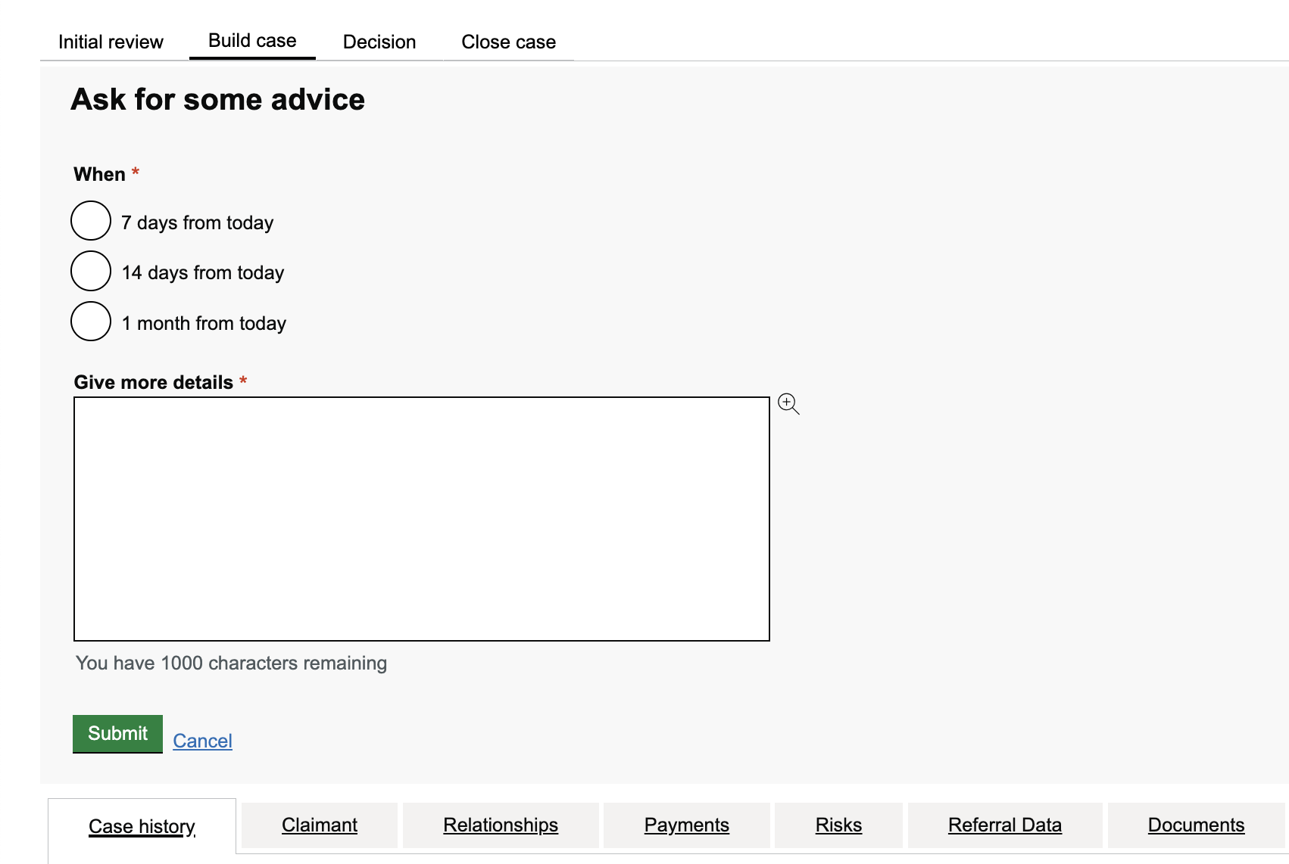

Define each field as a private WebElement and create each action as public methods as can call those methods while writing the test cases
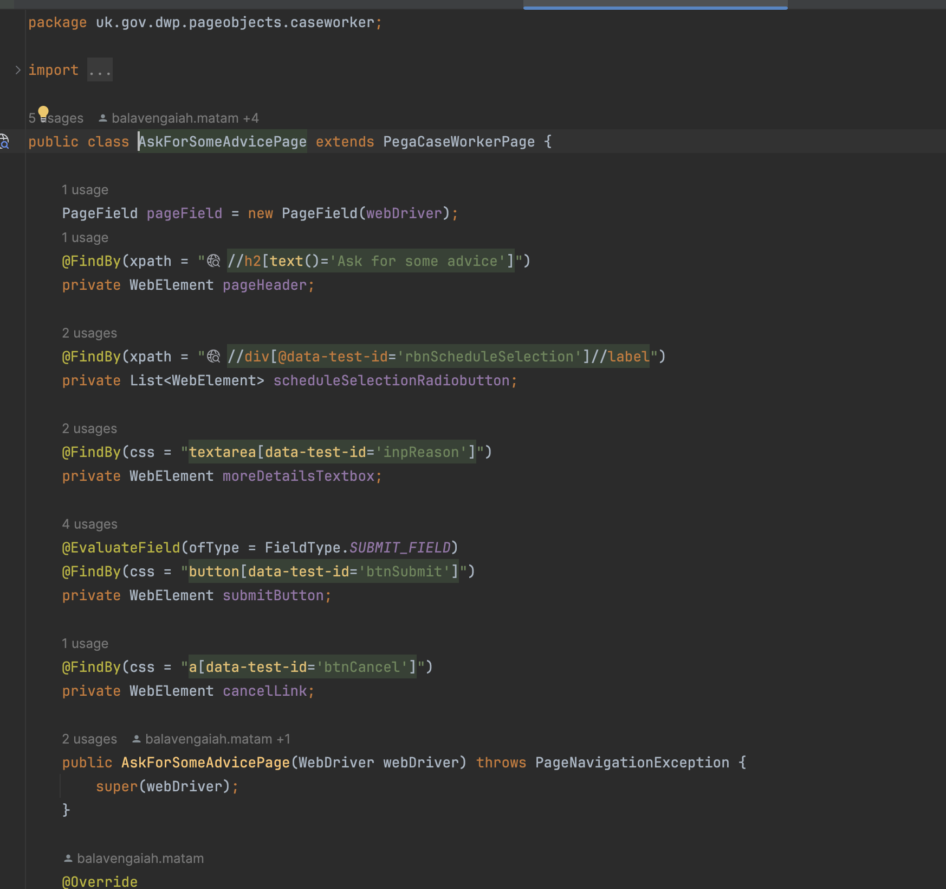

Page specific Methods as actions that can perform on the page: -
