Test data Generation: -
Example: -
Below example is providing how to create and generate Test data for Ask for the benefit suspended functionality.
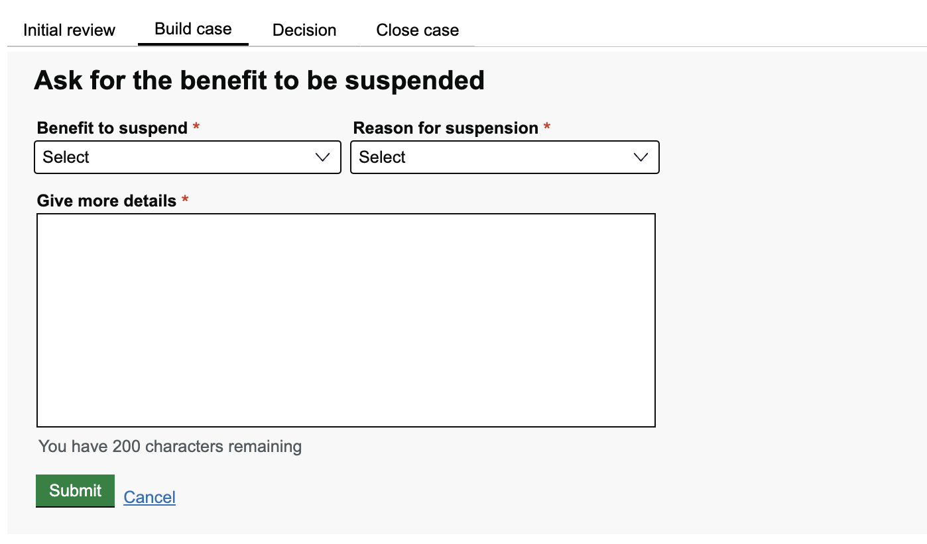

To test ask benefit to be suspended functionality we need Benefit to suspend, Reason for suspension and More details
So, we need to create the data model as shown below for each field in BenefitSuspendedDetails class in data/datamodel package

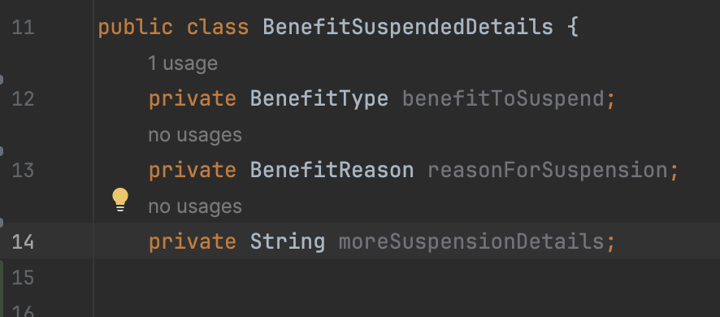

Then add @Data annotation above the class to get the setters and getters methods for the data model as shown below
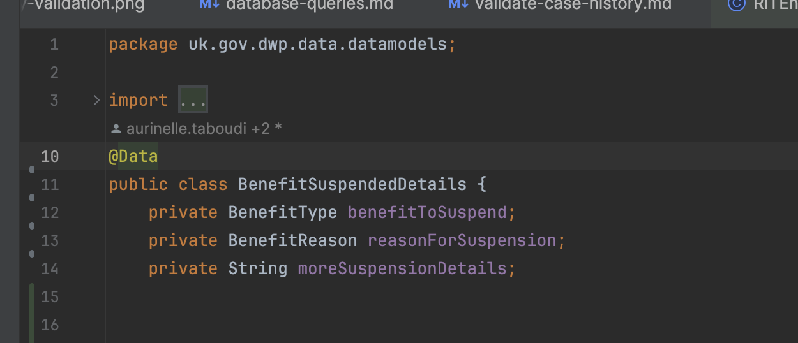
Add @Accessor(chain=true) so the setters’ method will return same class object, so it is easy to reuse and continue the object chain as shown below
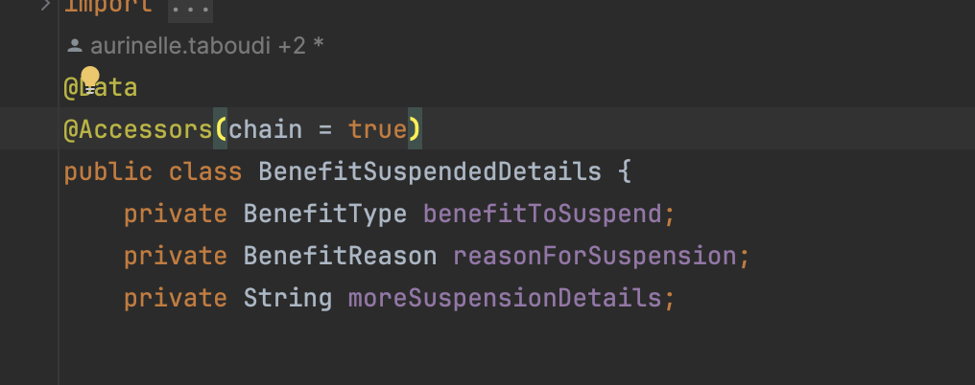
Example: -
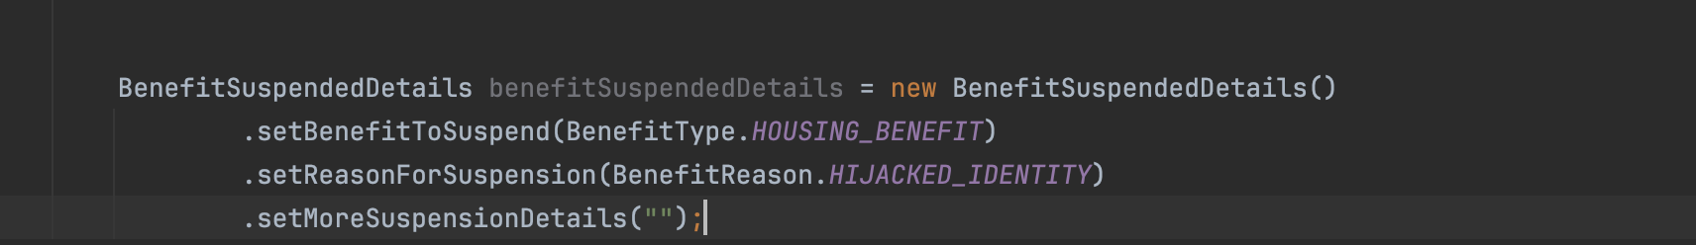
Now, create BenefitSuspendData class in datagenerator package and define suspend de
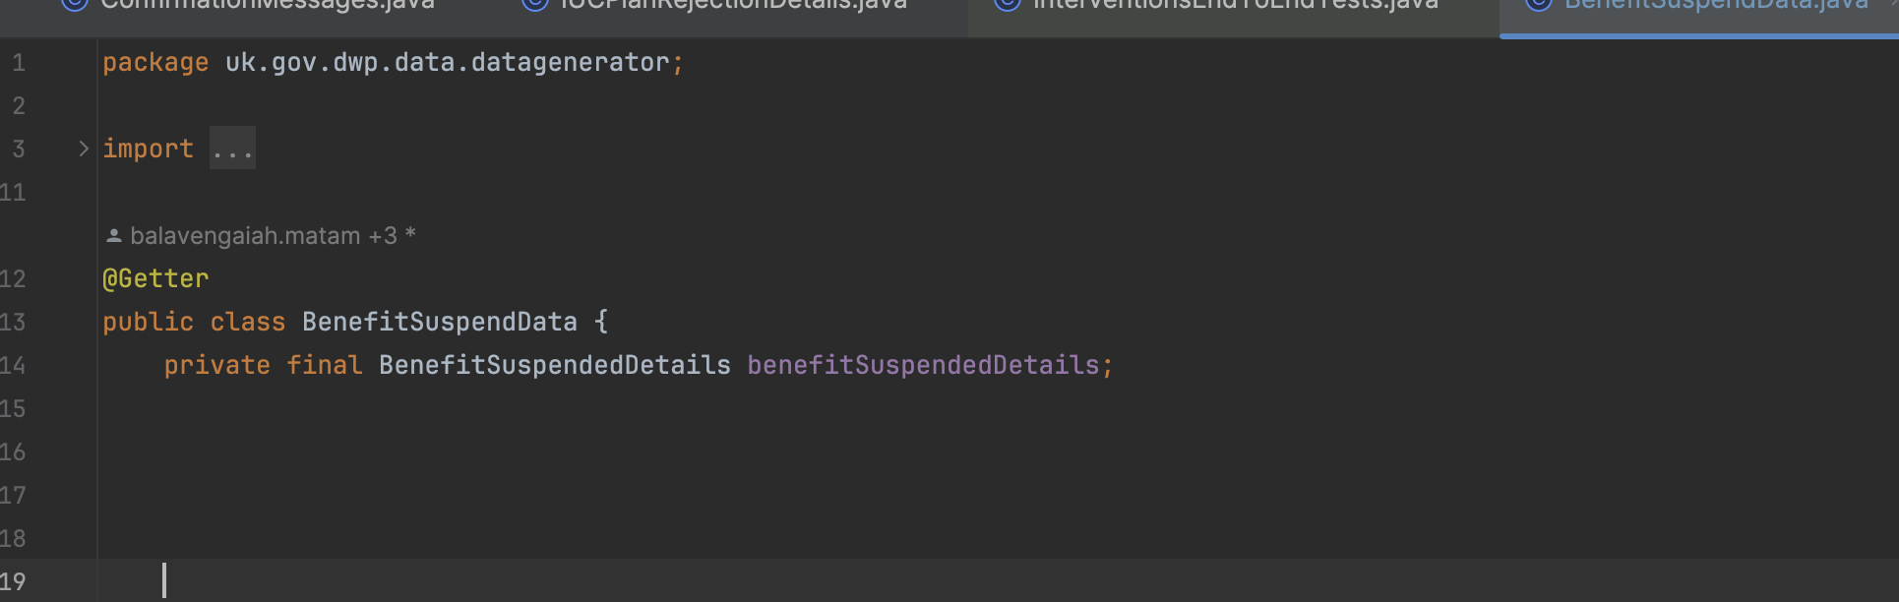
Now add the constructor as shown below and create the method to set the dynamic values using “filler” method
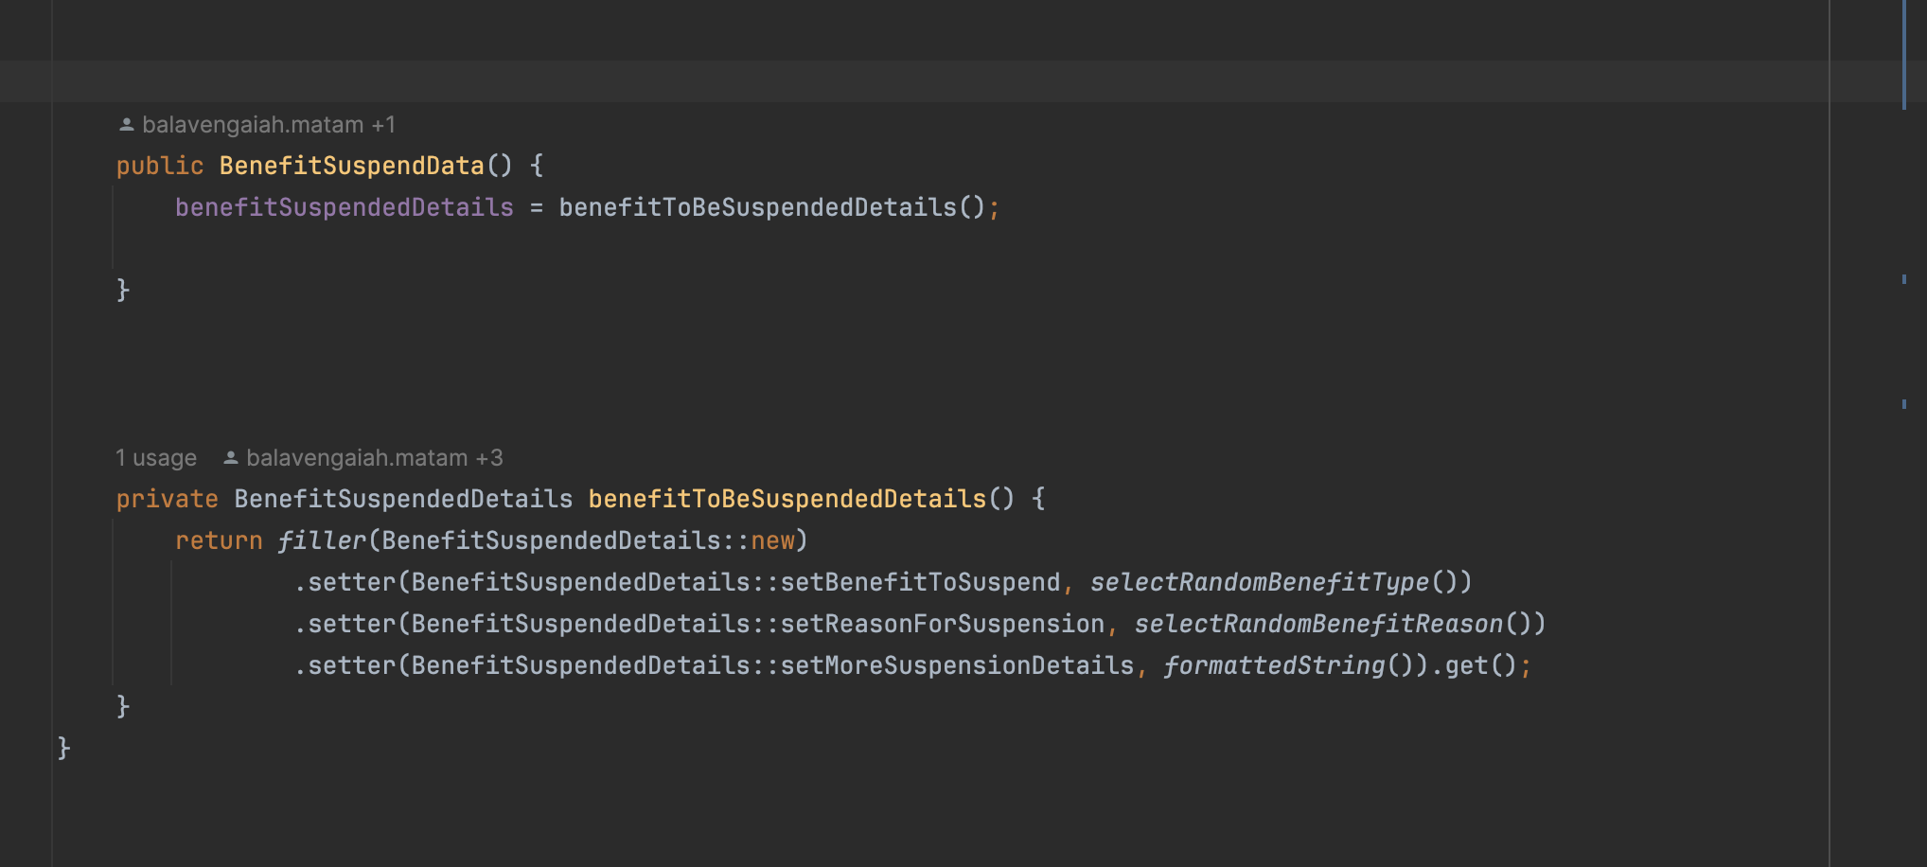
In Page object create a method to submit these details as shown below: -
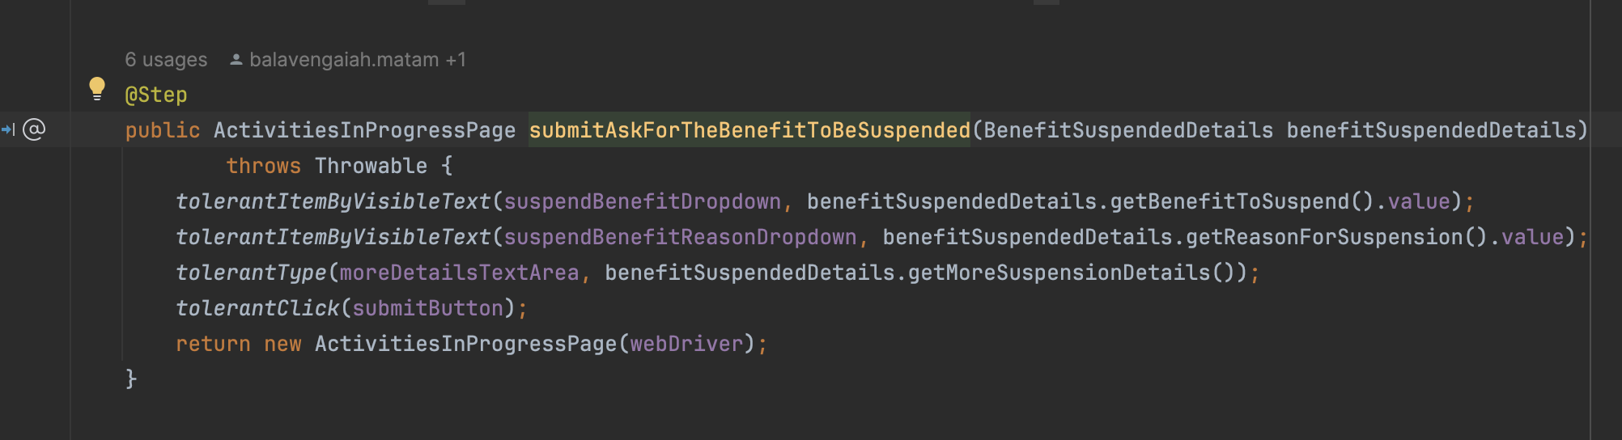
Now go to the Tests class and create Benefit decision details using “BenefitSuspendData” class as shown below
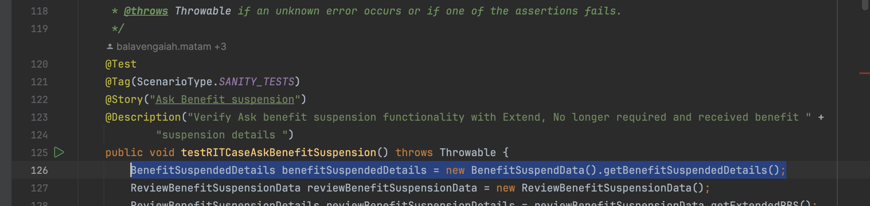

Pass the details to the method where you call in the test
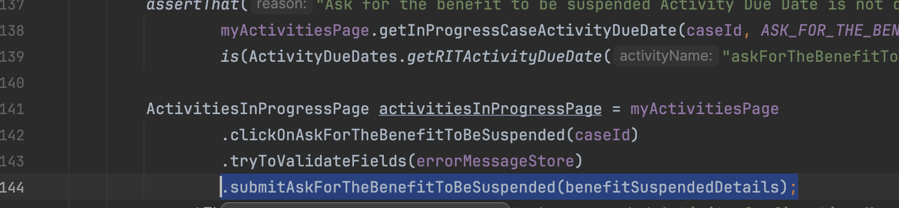

The actual values what submitted
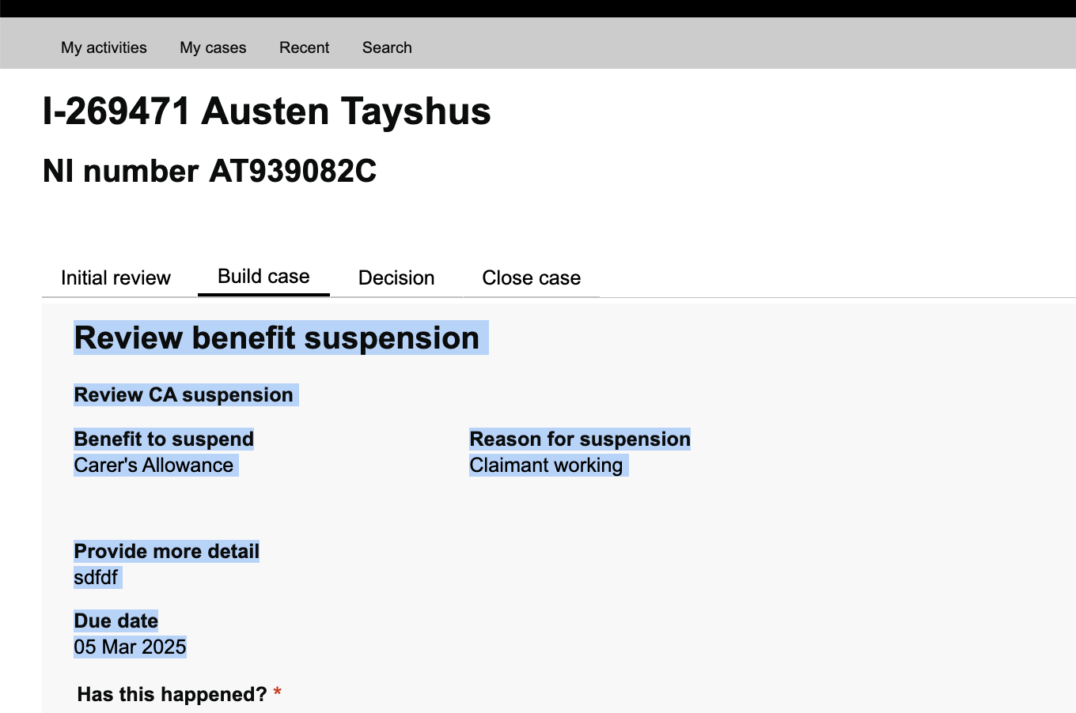
Use the same class to set the actual values for asserting details as shown below
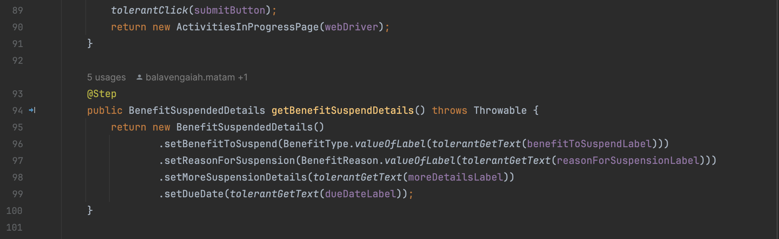
Assert the expected and actual values in the test
