# Analysis Report

**Purpose**:

This is to provide a writeup about the DNA methylation data analysis lecture’s homework for the course “*Setting Bioinformatics Pipelines*”. The report summarizes the group work doing the analysis of described in the following paper (<https://www.ncbi.nlm.nih.gov/pmc/articles/PMC9706884/> ) and using the <https://www.ncbi.nlm.nih.gov/geo/query/acc.cgi?acc=GSE188573> dataset.

**Pre-implementation thoughts:**

The paper conducted analysis on COVID19 individuals (48) and used another 11 participants as “healthy” or reference controls. The research team done multiple analysis using different original and public monocytes datasets. DNA methylation was done using the EPIC arrays.

**Implementation**:

1. Dataset
   1. The Methylation array dataset ([GSE188573](https://www.ncbi.nlm.nih.gov/geo/query/acc.cgi?acc=GSE188573)) was downloaded using GEOquery.
   2. The Data sample was created to accommodate the analysis tools requirements.
2. ShinyÉPICo– differentially methylated positions (DMPs).

2.1. CpH and SNP removed by the Noob method.

2.2. Sex chromosomes (X and Y) were removed.

2.3. Quantile normalization.

2.4. Group & gender was used as variable for the model.

2.5 DMPs analysis.

1. ChAMP– differentially methylation regions (DMRs).
   1. The dataset was filtered and normalized using the Beta MIxture Quantile dilation (BMIQ).
   2. The DMRs was detected using the Bumphunter method.
   3. GSEA analysis was done based on the DMRs and normalized results.
2. ChAMP – DMRS.

**Results:**

*ShinyÉPICo pre-analysis and QC plots*

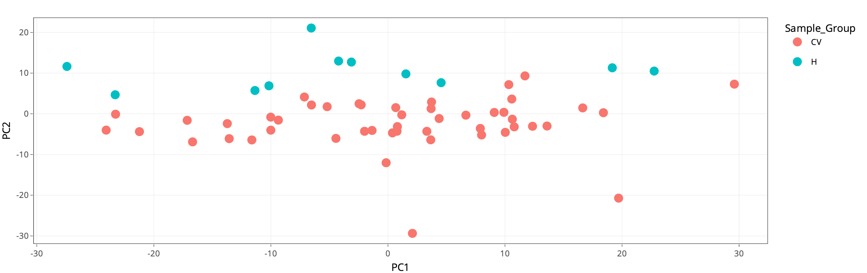

Figure 1: PCA plot.

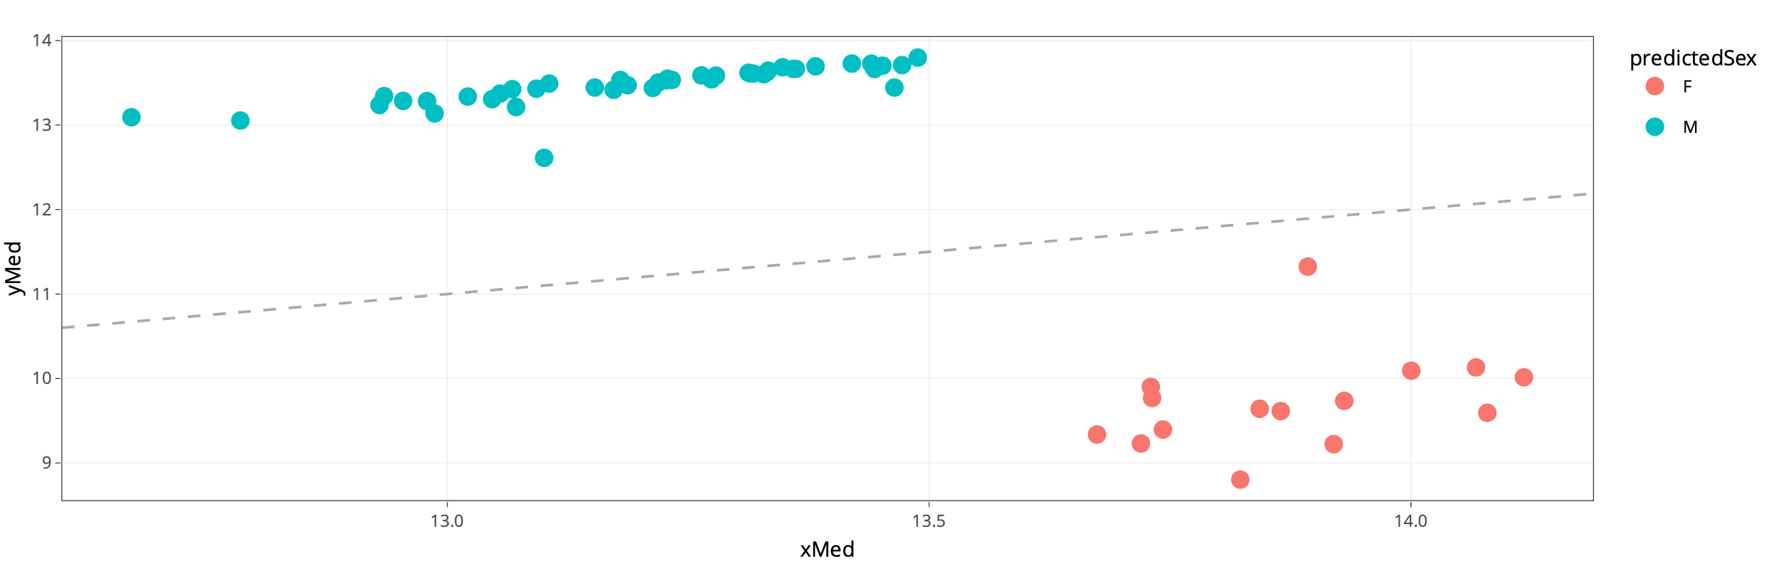

Figure 2: Gender prediction.

*ShinyÉPICo DMPs*

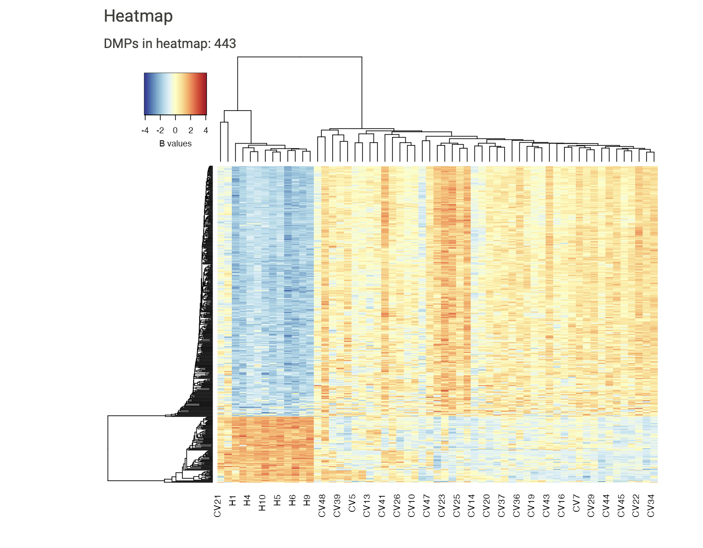

Figure 3: Heatmap based of significantly DMPs using group and gender as variables.

*ChAMP DMPs*

|  |  |  |  |  |  |
| --- | --- | --- | --- | --- | --- |
|  | seqnames | start | end | value | p.valueAre |
| DMR_1 | chr22 | 45608345 | 45608713 | -1.5409019 | 0.00096504 |
| DMR_2 | chr2 | 128458240 | 128458556 | -1.5268398 | 0.00135365 |
| DMR_3 | chr1 | 1182418 | 1182424 | 2.0601044 | 0.03302525 |
| DMR_4 | chr12 | 6657744 | 6657972 | -1.3327601 | 0.01802496 |
| DMR_5 | chr3 | 189348936 | 189349323 | -1.2350003 | 0.00481875 |
| DMR_6 | chr13 | 26796956 | 26797529 | -1.2351084 | 0.02153539 |
| DMR_7 | chr19 | 827576 | 827843 | 1.1663558 | 0.00571255 |
| DMR_8 | chr6 | 31543169 | 31543686 | -0.9304682 | 0.00194952 |
| DMR_9 | chr1 | 25291385 | 25292274 | -0.9912104 | 0.00203372 |
| DMR_10 | chr12 | 86229804 | 86230557 | 1.1000454 | 0.01025279 |
| DMR_11 | chr20 | 19866974 | 19867423 | -1.0698765 | 0.01110125 |
| DMR_12 | chr6 | 30624395 | 30624769 | -1.0228192 | 0.00566073 |
| DMR_13 | chr8 | 41522721 | 41523480 | -0.9772544 | 0.00639909 |
| DMR_14 | chr12 | 6745057 | 6745707 | -0.8319037 | 0.00323193 |
| DMR_15 | chr17 | 58499679 | 58499911 | -0.9648038 | 0.00950796 |
| DMR_16 | chr10 | 135202522 | 135203102 | -0.9445639 | 0.01020745 |
| DMR_17 | chr17 | 27044685 | 27045548 | 0.4372582 | 0.00729936 |
| DMR_18 | chr1 | 10509906 | 10510054 | -0.9294847 | 0.04093991 |
| DMR_19 | chr17 | 79004850 | 79005662 | -0.8435962 | 0.00691076 |
| DMR_20 | chr19 | 41882368 | 41882741 | 0.9243764 | 0.02537614 |
| DMR_21 | chr1 | 27961680 | 27961868 | 0.8960641 | 0.01765578 |
| DMR_22 | chr12 | 14996143 | 14996272 | -0.9090594 | 0.04273399 |
| DMR_23 | chr6 | 31539973 | 31540750 | -0.4545614 | 0.00776569 |
| DMR_24 | chr16 | 1494876 | 1495363 | -0.8722121 | 0.01886047 |
| DMR_25 | chr19 | 9785295 | 9786077 | 0.7712042 | 0.00509725 |
| DMR_26 | chr6 | 30619137 | 30619242 | -0.848729 | 0.02007811 |
| DMR_27 | chr9 | 125795488 | 125795935 | 0.8099939 | 0.01533709 |
| DMR_28 | chr5 | 102898463 | 102898733 | 0.7975814 | 0.0112826 |
| DMR_29 | chr20 | 20036632 | 20037346 | -0.7928162 | 0.01147043 |
| DMR_30 | chr4 | 1294783 | 1295078 | 0.8214114 | 0.02168436 |
| DMR_31 | chr16 | 89043510 | 89043707 | 0.783408 | 0.01663245 |
| DMR_32 | chr6 | 28543508 | 28543693 | -0.825323 | 0.03291515 |
| DMR_33 | chr20 | 62367108 | 62368256 | -0.5464008 | 0.00829679 |
| DMR_34 | chr5 | 135415693 | 135416613 | -0.5364433 | 0.00875017 |
| DMR_35 | chr18 | 77623199 | 77623598 | -0.7454313 | 0.01348472 |
| DMR_36 | chr17 | 72620022 | 72620274 | 0.7592764 | 0.02626994 |
| DMR_37 | chr3 | 196065318 | 196065569 | 0.7573929 | 0.02640595 |
| DMR_38 | chr15 | 91427184 | 91428203 | 0.5302502 | 0.01137328 |
| DMR_39 | chr6 | 32904074 | 32904889 | -0.7510639 | 0.02695648 |
| DMR_40 | chr11 | 47399813 | 47400199 | 0.6906055 | 0.01218936 |
| DMR_41 | chr16 | 85935556 | 85936480 | -0.7212985 | 0.0146635 |
| DMR_42 | chr6 | 149805995 | 149806502 | -0.7036971 | 0.01561559 |
| DMR_43 | chr21 | 36259067 | 36259797 | 0.6019892 | 0.01319974 |
| DMR_44 | chr16 | 1538347 | 1538826 | -0.690266 | 0.01634747 |
| DMR_45 | chr2 | 239008705 | 239009246 | -0.6826667 | 0.016898 |
| DMR_46 | chr3 | 195489708 | 195490309 | 0.6806052 | 0.01696276 |
| DMR_47 | chr12 | 54446019 | 54446576 | 0.5803319 | 0.01448862 |
| DMR_48 | chr8 | 1900353 | 1901041 | -0.5773261 | 0.01465054 |
| DMR_49 | chr17 | 79792777 | 79793208 | -0.5690778 | 0.01516869 |
| DMR_50 | chr8 | 19539991 | 19540479 | 0.6759086 | 0.01738376 |
| DMR_51 | chr17 | 79201972 | 79202947 | -0.6754752 | 0.01740319 |
| DMR_52 | chr5 | 35230549 | 35230935 | -0.6713844 | 0.01770112 |
| DMR_53 | chr6 | 10555682 | 10556326 | -0.6701891 | 0.01777884 |
| DMR_54 | chr10 | 77542302 | 77542585 | -0.5871206 | 0.01832289 |
| DMR_55 | chr19 | 7766717 | 7767566 | -0.6760159 | 0.02400953 |
| DMR_56 | chr1 | 153599479 | 153599831 | -0.4515244 | 0.01722831 |
| DMR_57 | chr5 | 157079404 | 157079668 | 0.6363438 | 0.02770779 |
| DMR_58 | chr20 | 57582706 | 57583091 | 0.5171205 | 0.01938509 |
| DMR_59 | chr12 | 123752628 | 123753272 | 0.5553626 | 0.02096543 |
| DMR_60 | chr7 | 100881007 | 100881367 | 0.627343 | 0.02858216 |
| DMR_61 | chr1 | 230415185 | 230415668 | -0.6599501 | 0.03593982 |
| DMR_62 | chr17 | 33775779 | 33776683 | 0.4920248 | 0.01733842 |
| DMR_63 | chr16 | 57701317 | 57702239 | 0.6083725 | 0.02246805 |
| DMR_64 | chr15 | 91473059 | 91473569 | 0.4801285 | 0.02316107 |
| DMR_65 | chr12 | 122356033 | 122356852 | 0.4698499 | 0.02444348 |
| DMR_66 | chr15 | 22833149 | 22833400 | 0.5723277 | 0.02595258 |
| DMR_67 | chr8 | 22132874 | 22133356 | -0.5711024 | 0.02610154 |
| DMR_68 | chr10 | 128994297 | 128994702 | 0.5447375 | 0.02906145 |
| DMR_69 | chr20 | 13976093 | 13976218 | 0.544179 | 0.02913917 |
| DMR_70 | chr12 | 322587 | 322920 | -0.4826983 | 0.02928166 |
| DMR_71 | chr21 | 34774627 | 34775045 | 0.6159099 | 0.02970913 |
| DMR_72 | chr16 | 53407328 | 53407808 | -0.471984 | 0.03073894 |
| DMR_73 | chr17 | 7461260 | 7461678 | 0.577743 | 0.0344372 |
| DMR_74 | chr7 | 27197614 | 27198429 | 0.5722298 | 0.03513669 |
| DMR_75 | chr19 | 57019005 | 57019373 | 0.5601902 | 0.03667817 |
| DMR_76 | chr5 | 162864268 | 162864496 | 0.3813276 | 0.03881552 |
| DMR_77 | chr20 | 3051954 | 3052274 | 0.4179171 | 0.03998782 |
| DMR_78 | chr2 | 183943388 | 183943938 | 0.4684796 | 0.04029871 |
| DMR_79 | chr17 | 80196719 | 80197538 | -0.614964 | 0.04158112 |
| DMR_80 | chr12 | 4488749 | 4489155 | -0.5229343 | 0.04221585 |
| DMR_81 | chr12 | 122711988 | 122712381 | -0.4372889 | 0.04566799 |
| DMR_82 | chr6 | 33091567 | 33092097 | 0.5802296 | 0.04606307 |
| DMR_83 | chr8 | 27468981 | 27469338 | 0.5798805 | 0.04609546 |
| DMR_84 | chr3 | 182817338 | 182817626 | -0.3833791 | 0.04682086 |
| DMR_85 | chr8 | 87521177 | 87521456 | -0.5730733 | 0.04700869 |
| DMR_86 | chr8 | 17433625 | 17433926 | 0.5683734 | 0.04786362 |
| DMR_87 | chr11 | 112034801 | 112035175 | 0.5676912 | 0.04797373 |
| DMR_88 | chr9 | 130524679 | 130524915 | 0.4793449 | 0.04922375 |
| DMR_89 | chr3 | 155421735 | 155422159 | 0.4767273 | 0.04965122 |

Table 1: DMRs with significant FDR (< 0.05).