Open cmd from zookeeper \bin folder

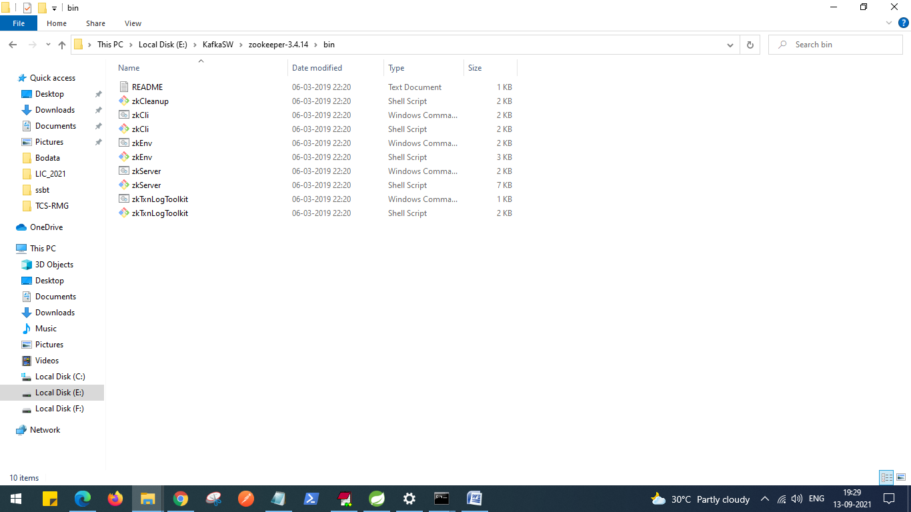

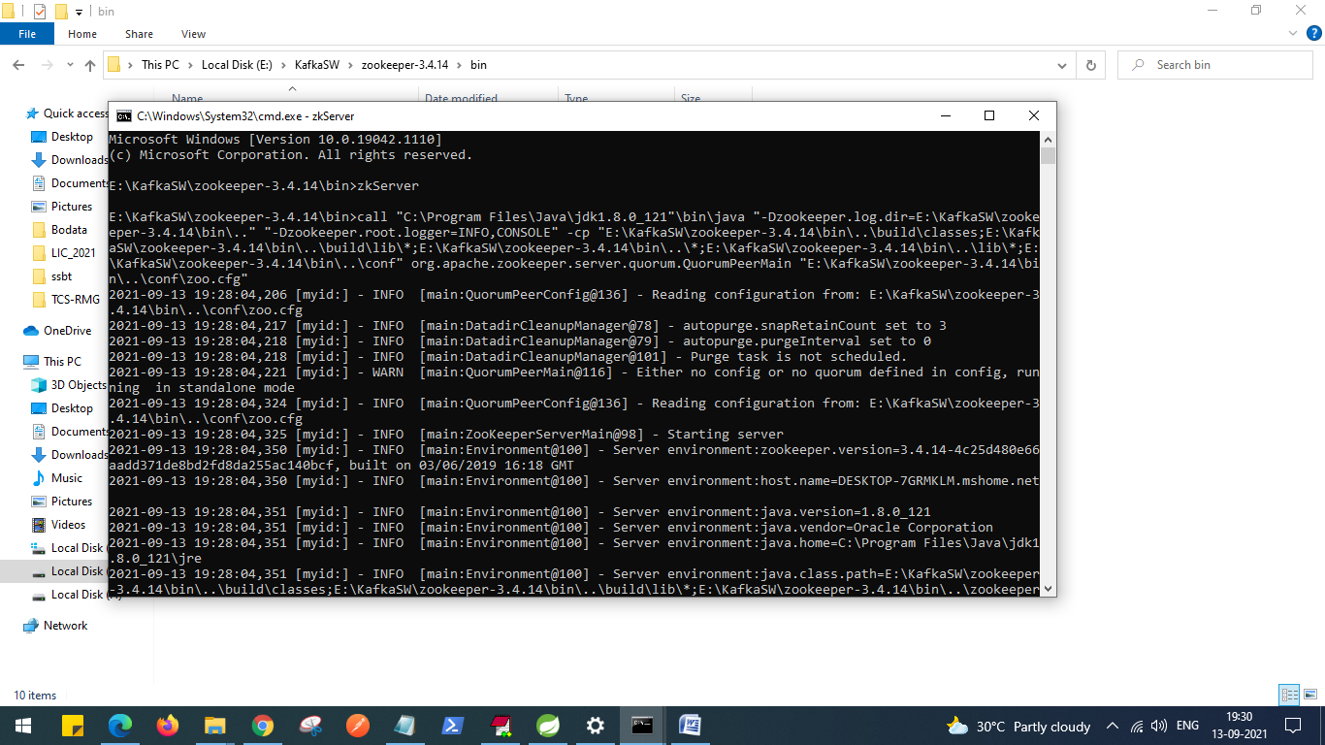

Run below command to run

>zkServer

Change name of zoo.cfg folder name from actual name

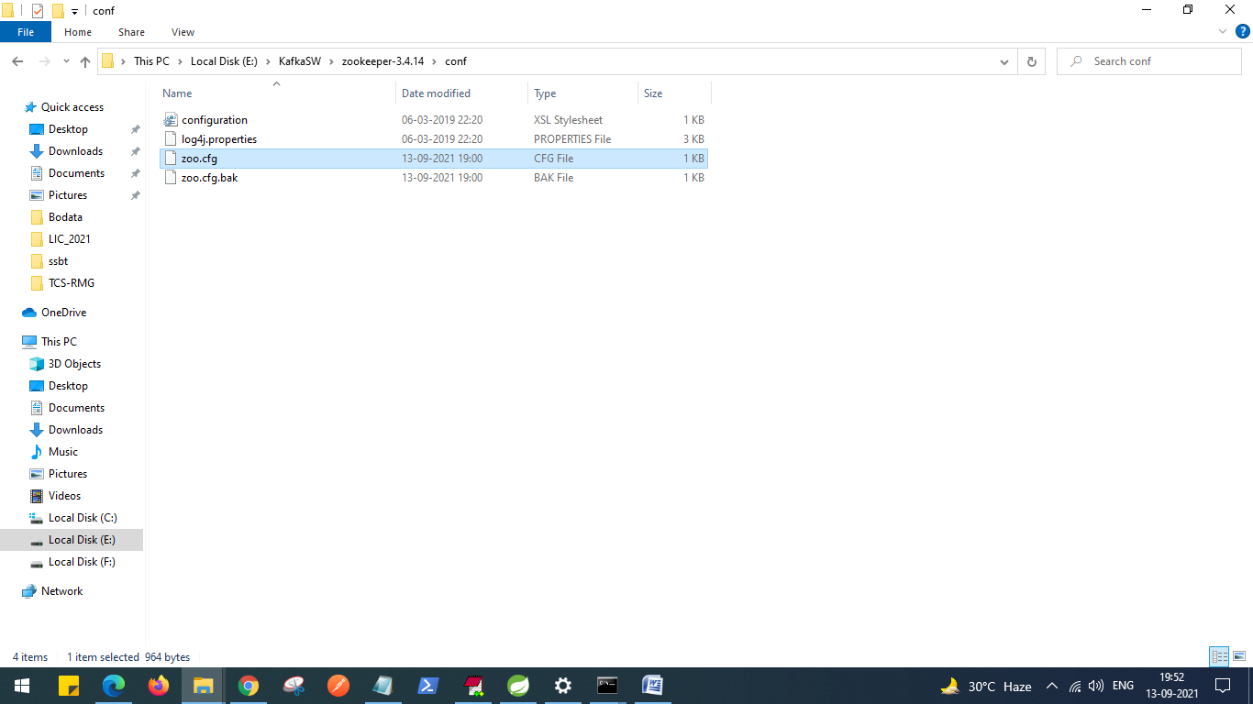

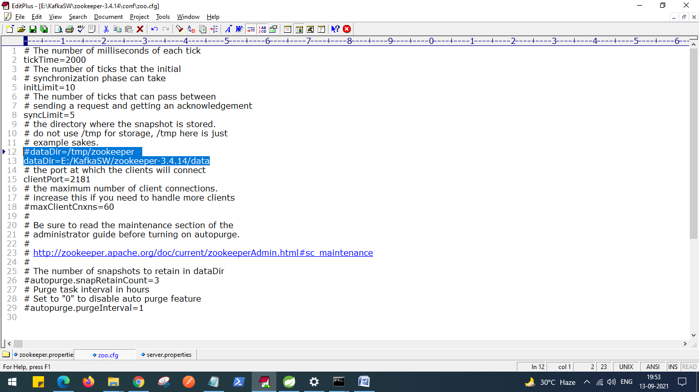

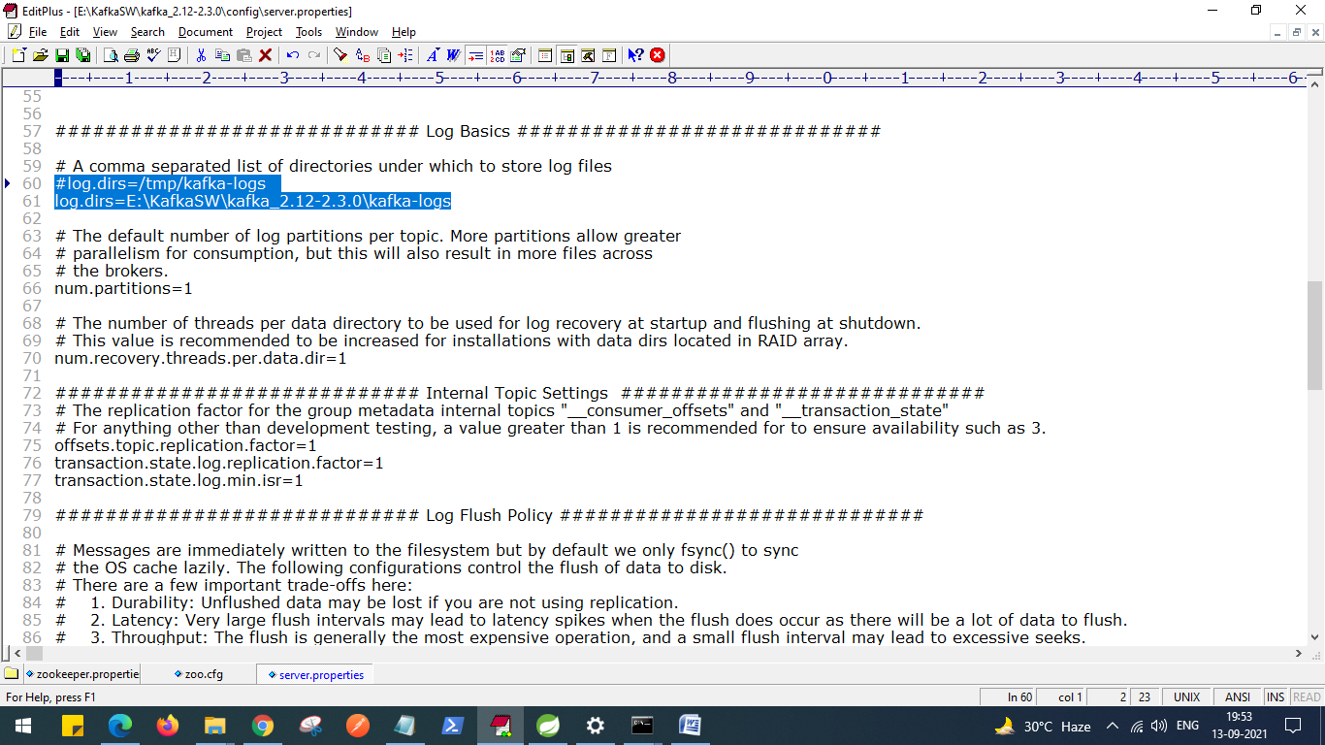

Topic creation: **kolluTopic**

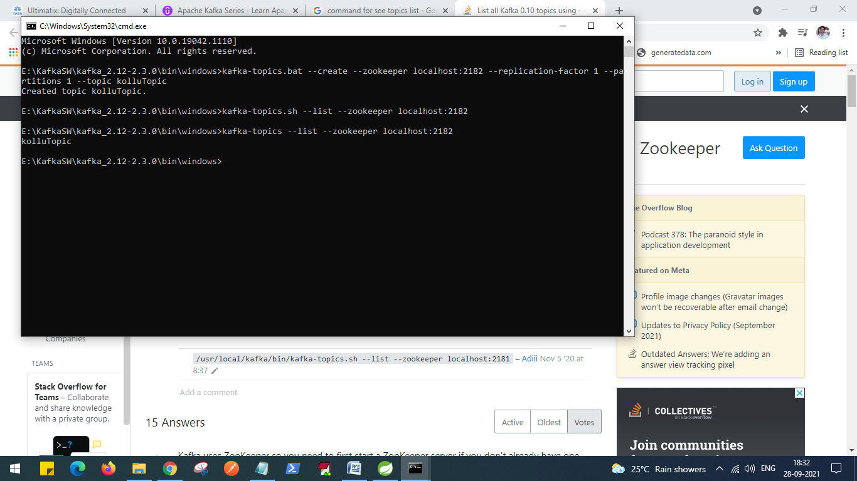

To see list of topics created.

> kafka-topics --list --zookeeper localhost:2182

>kafka-topics.bat --create --zookeeper localhost:2181 --replication-factor 1 --partitions 1 --topic kolluTopic

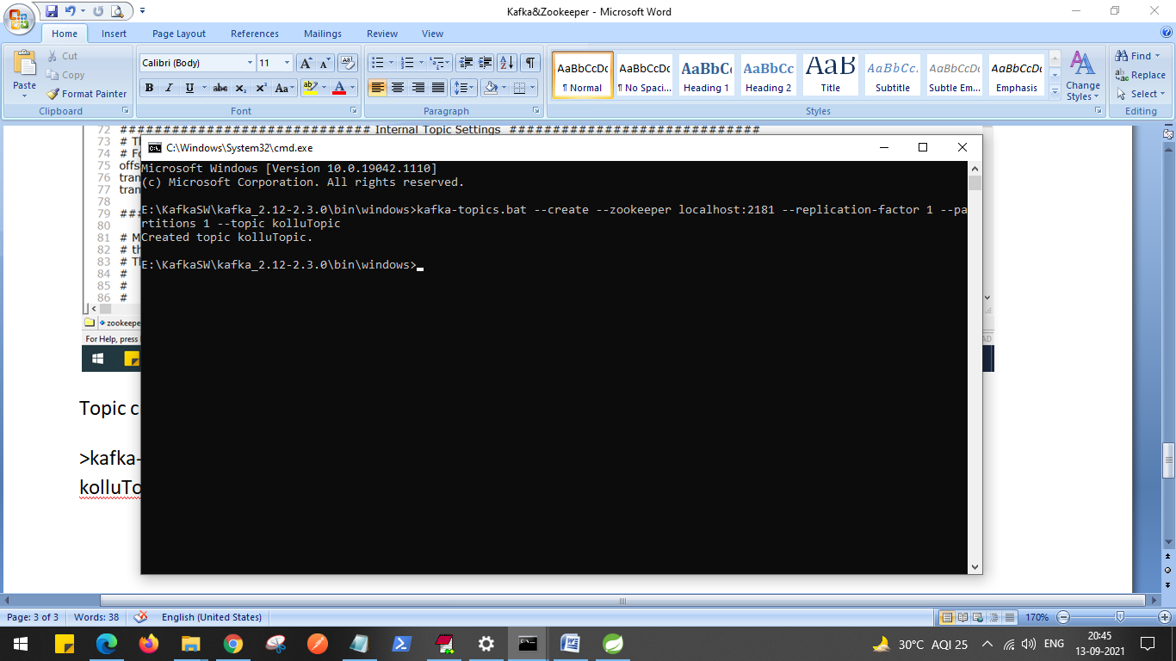

http://localhost:9091/publish/kollu1

2021-09-13 20:53:32.020 INFO 10520 --- [nio-9091-exec-5] o.a.k.clients.producer.ProducerConfig : ProducerConfig values:

acks = 1

batch.size = 16384

bootstrap.servers = [localhost:9092]

buffer.memory = 33554432

client.dns.lookup = use_all_dns_ips

client.id = producer-1

compression.type = none

connections.max.idle.ms = 540000

delivery.timeout.ms = 120000

enable.idempotence = false

interceptor.classes = []

internal.auto.downgrade.txn.commit = true

key.serializer = class org.apache.kafka.common.serialization.StringSerializer

linger.ms = 0

max.block.ms = 60000

max.in.flight.requests.per.connection = 5

max.request.size = 1048576

metadata.max.age.ms = 300000

metadata.max.idle.ms = 300000

metric.reporters = []

metrics.num.samples = 2

metrics.recording.level = INFO

metrics.sample.window.ms = 30000

partitioner.class = class org.apache.kafka.clients.producer.internals.DefaultPartitioner

receive.buffer.bytes = 32768

reconnect.backoff.max.ms = 1000

reconnect.backoff.ms = 50

request.timeout.ms = 30000

retries = 2147483647

retry.backoff.ms = 100

sasl.client.callback.handler.class = null

sasl.jaas.config = null

sasl.kerberos.kinit.cmd = /usr/bin/kinit

sasl.kerberos.min.time.before.relogin = 60000

sasl.kerberos.service.name = null

sasl.kerberos.ticket.renew.jitter = 0.05

sasl.kerberos.ticket.renew.window.factor = 0.8

sasl.login.callback.handler.class = null

sasl.login.class = null

sasl.login.refresh.buffer.seconds = 300

sasl.login.refresh.min.period.seconds = 60

sasl.login.refresh.window.factor = 0.8

sasl.login.refresh.window.jitter = 0.05

sasl.mechanism = GSSAPI

security.protocol = PLAINTEXT

security.providers = null

send.buffer.bytes = 131072

socket.connection.setup.timeout.max.ms = 127000

socket.connection.setup.timeout.ms = 10000

ssl.cipher.suites = null

ssl.enabled.protocols = [TLSv1.2]

ssl.endpoint.identification.algorithm = https

ssl.engine.factory.class = null

ssl.key.password = null

ssl.keymanager.algorithm = SunX509

ssl.keystore.certificate.chain = null

ssl.keystore.key = null

ssl.keystore.location = null

ssl.keystore.password = null

ssl.keystore.type = JKS

ssl.protocol = TLSv1.2

ssl.provider = null

ssl.secure.random.implementation = null

ssl.trustmanager.algorithm = PKIX

ssl.truststore.certificates = null

ssl.truststore.location = null

ssl.truststore.password = null

ssl.truststore.type = JKS

transaction.timeout.ms = 60000

transactional.id = null

value.serializer = class org.apache.kafka.common.serialization.StringSerializer

2021-09-13 20:53:37.550 INFO 10520 --- [nio-9091-exec-5] o.a.kafka.common.utils.AppInfoParser : Kafka version: 2.7.1

2021-09-13 20:53:37.573 INFO 10520 --- [nio-9091-exec-5] o.a.kafka.common.utils.AppInfoParser : Kafka commitId: 61dbce85d0d41457

2021-09-13 20:53:37.573 INFO 10520 --- [nio-9091-exec-5] o.a.kafka.common.utils.AppInfoParser : Kafka startTimeMs: 1631546617546

2021-09-13 20:53:47.419 INFO 10520 --- [ad | producer-1] org.apache.kafka.clients.Metadata : [Producer clientId=producer-1] Cluster ID: QXGp7QwnSOitYIyhQBc1Aw

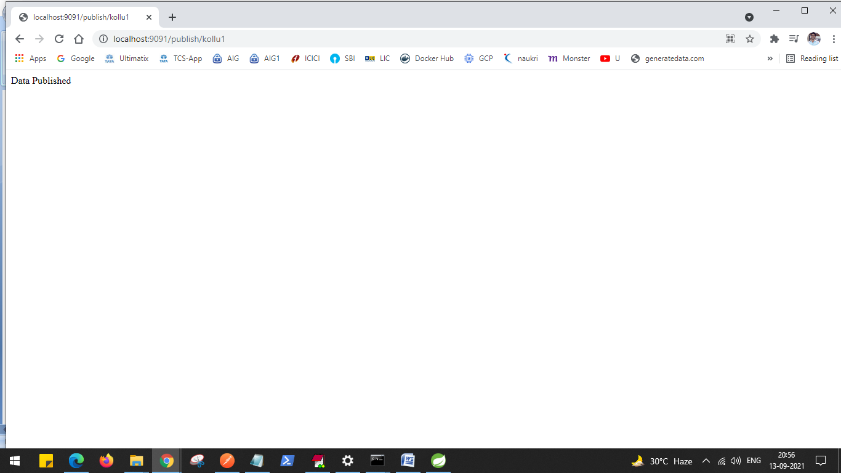

Test:

Consumer:

>kafka-console-consumer.bat --bootstrap-server localhost:9092 --topic kolluTopic

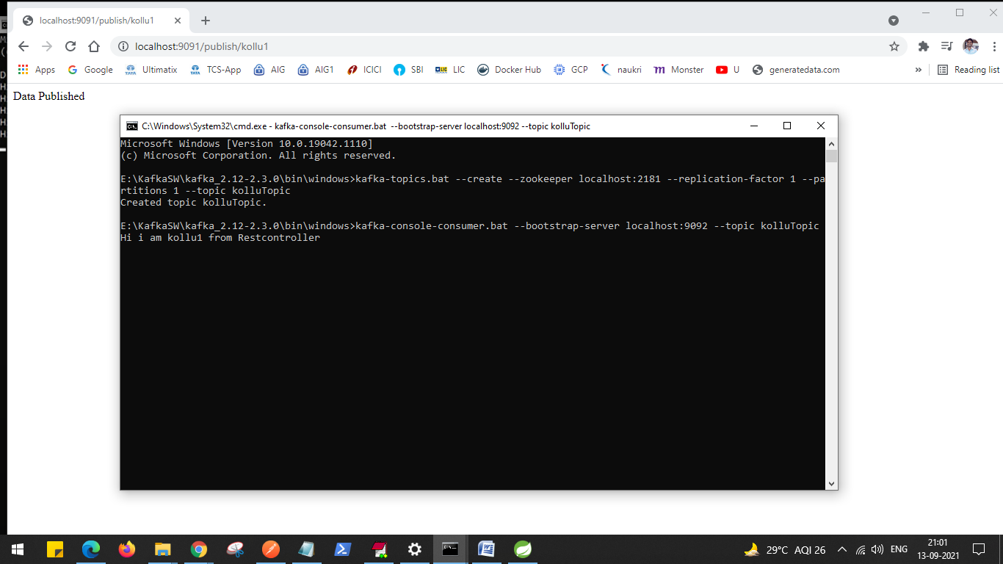

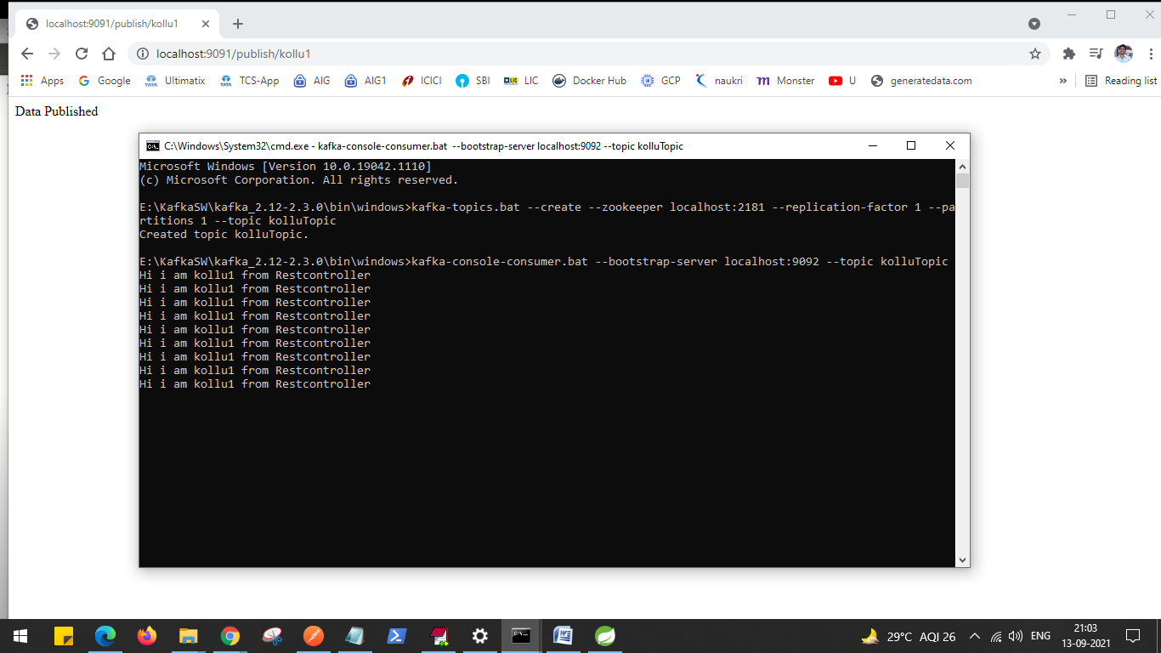

Exception:

**Please refer to this lecture first if you have setup problems.**

=====================

**> Zookeeper - java.net.BindException: Address already in use**

Something is already occupying your port 2181. Figure out which application it is and stop it

**> Kafka - org.apache.kafka.common.KafkaException: Socket server failed to bind to 0.0.0.0:9092: Address already in use.**

Something is already occupying your port 9092. Figure out what it is and stop it.  
Otherwise, if you really insist, you can change the Kafka port by adding the following line to server.properties

1. # example for port 9093
2. listeners=PLAINTEXT://:9093

**> My topics are losing their data after a while**

This is how Kafka works. Data is only retained for 7 days.

**> The topics list is disappearing**

Make sure you have changed the Zookeeper dataDir=/path/to/data/zookeeper , and Kafka log.dirs=/path/to/data/kafka

**> I have launched Kafka in a VM or in the Cloud, and I can't produce to Kafka**

If you can't produce to Kafka, it's possible you are using a VM and this can break the Kafka behaviour. Please look at the annex lectures for solutions of how to deal with that. I strongly recommend doing this tutorial using the Kafka binaries and localhost

zookeeper:

>zkserver

Start kafka server:

>zookeeper-server-start E:\KafkaSW\kafka_2.12-2.3.0\config\server.properties

topic creation:

/bin/windows>kafka-topics.bat --create --zookeeper localhost:2182 --replication-factor 1 --partitions 1 --topic kolluTopic

Test:

Consumer API:

kafka/windows>kafka-console-consumer.bat --bootstrap-server localhost:9092 --topic kolluTopic

Zookeeper view:

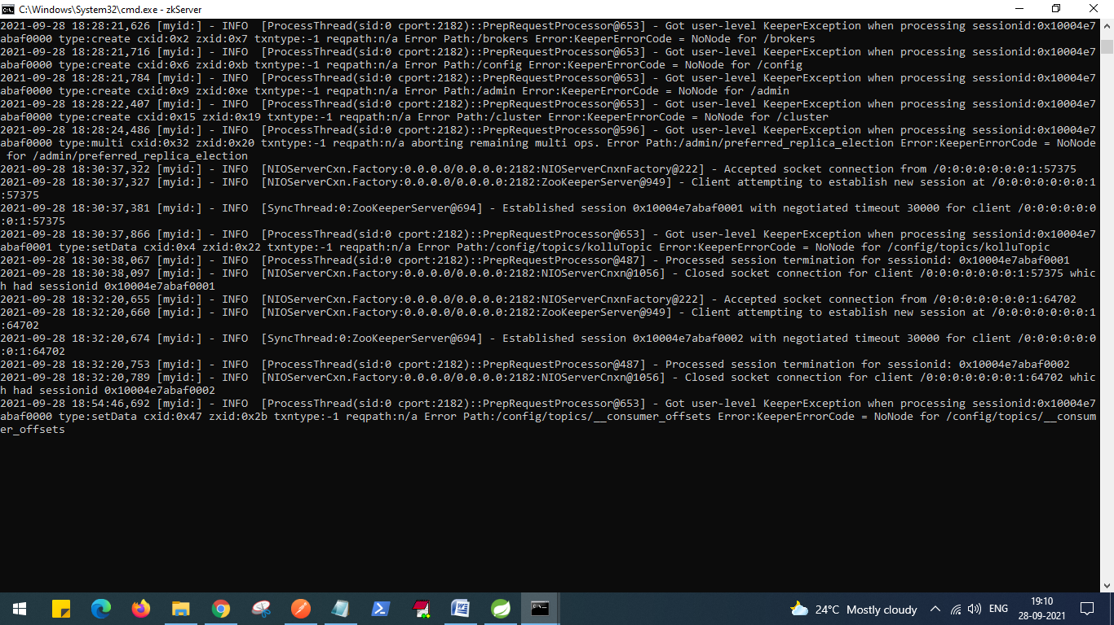

Kafka view:

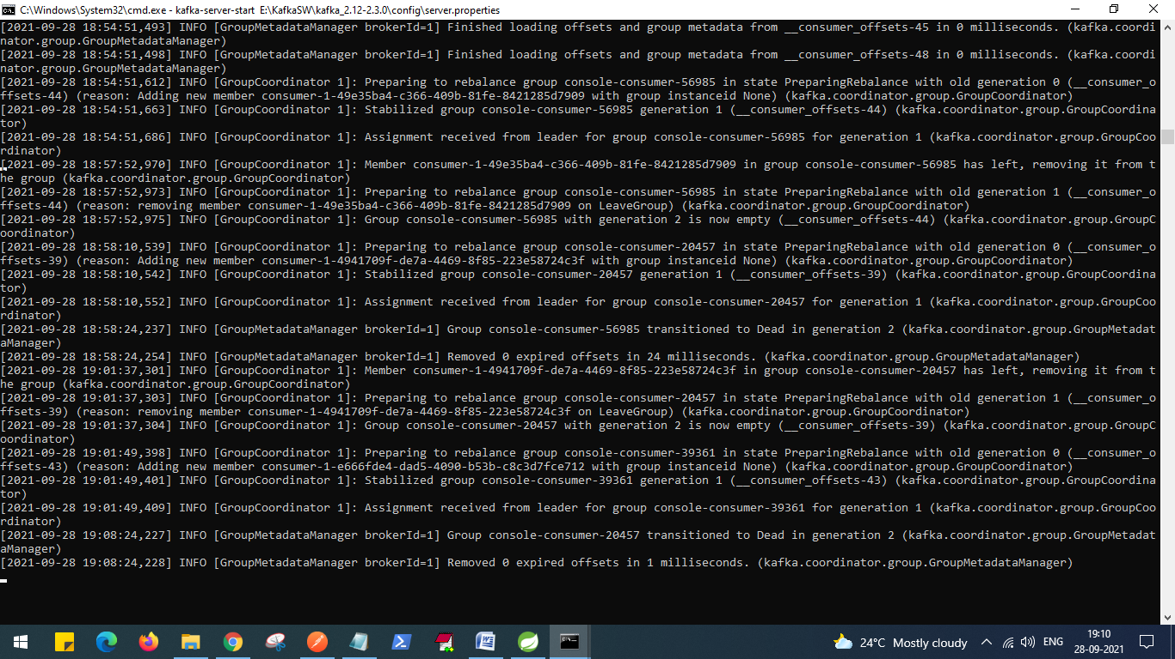

Consumer view:

