**Assignment 3: Configuring Monitoring to Enable Health Check**

STUDENT NAME: BABAJIDE ALUKULUKA

DATE: 25TH SEPTEMBER, 2024

Configuration Guide

Follow the instructions to enable health checks on a new host using Nagios:

(The name Test Host in these instructions can be replaced by any other valid name for the host)

OPEN YOUR VIRTUAL MACHINE HOSTING THE NAGIOS CORE

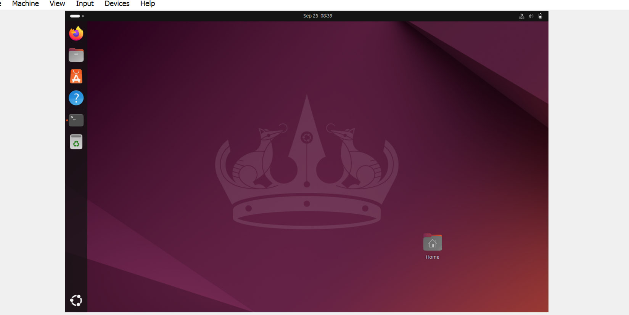

1. Open the Terminal on the Linux machine on which Nagios is setup by pressing **Ctrl+Alt+T** and give the following commands:
   1. *cd /usr/local/nagios/etc*
   2. *mkdir servers*
   3. *cd servers*
   4. *sudo nano TestHost.cfg*

After entering your password, TestHost.cfg will be opened in the Nano text editor. Here we will define the host we want to monitor and the health checks that need to be performed.

After this you will get a new window (check the screenshot added below and continue to number 2)

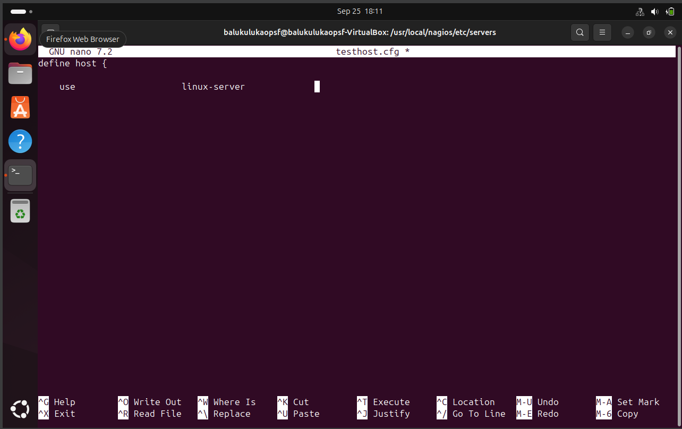

1. Type the following in the text editor:

*define host {*

*use linux-server ; Name of host template to use*

*host_name TestHost*

*alias TestHost*

*address 127.0.0.1*

*}*

*define service {*

*use local-service ; Name of service template to use*

*host_name TestHost*

*service_description Disk Space Usage*

*check_command check_local_disk!15%!10%/*

*}*

*define service {*

*use local-service ; Name of service template to use*

*host_name TestHost*

*service_description Memory Usage*

*check_command check_local_swap!15%!10%/*

*}*

*define service {*

*use local-service ; Name of service template to use*

*host_name TestHost*

*service_description Nagios GUI Accessible*

*check_command check_http!10.0.2.200*

*}*

*define service {*

*use local-service ; Name of service template to use*

*host_name TestHost*

*service_description PING*

*check_command check_ping!100.0,20%!500,60%*

*}*

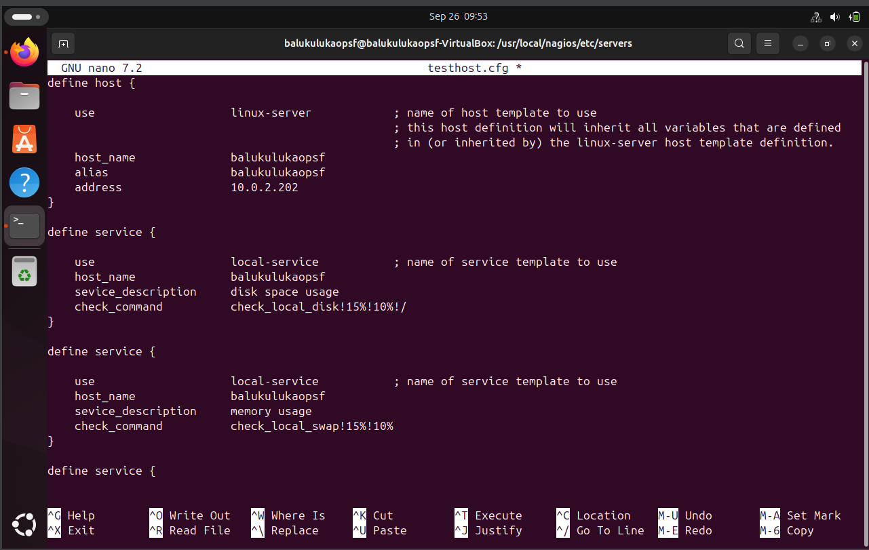

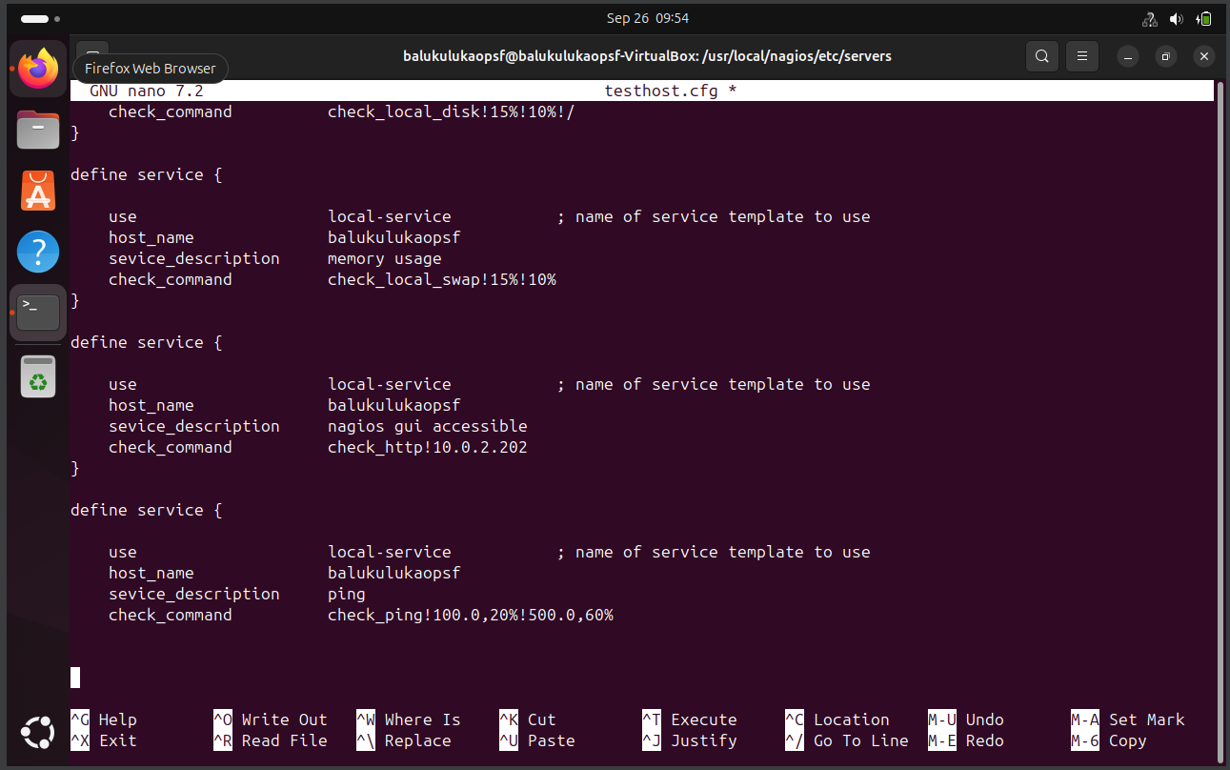

1. Use Ctrl + X key combination, then press ‘Y’ followed by Enter to save the file and exit the editor.

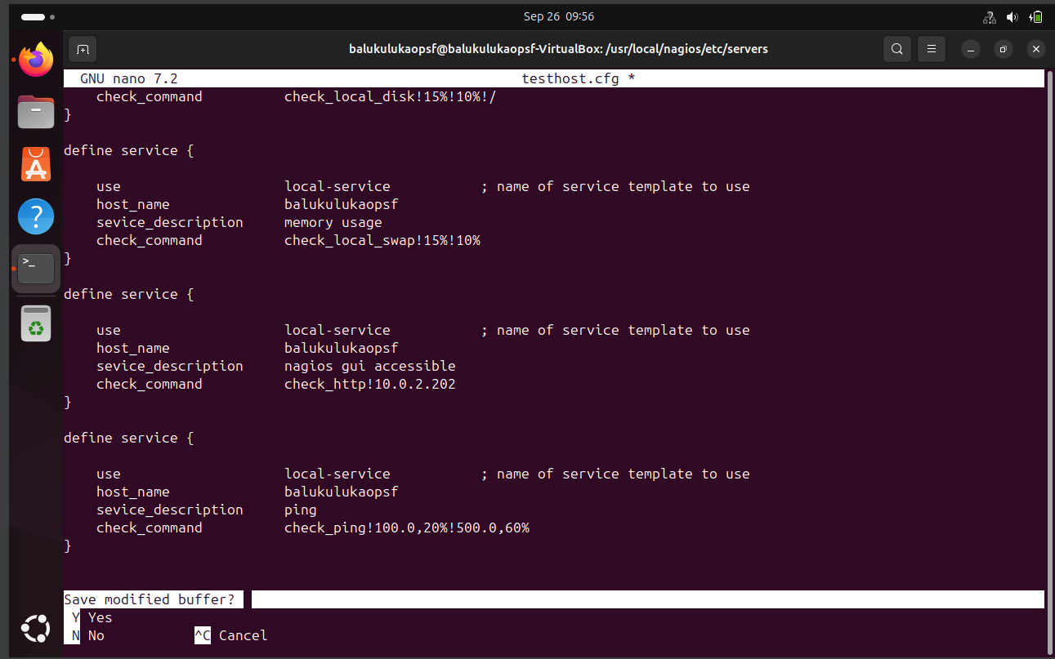

1. In the terminal, give the following commands:
   1. *cd /usr/local/nagios/etc*
   2. *sudo nano nagios.cfg*

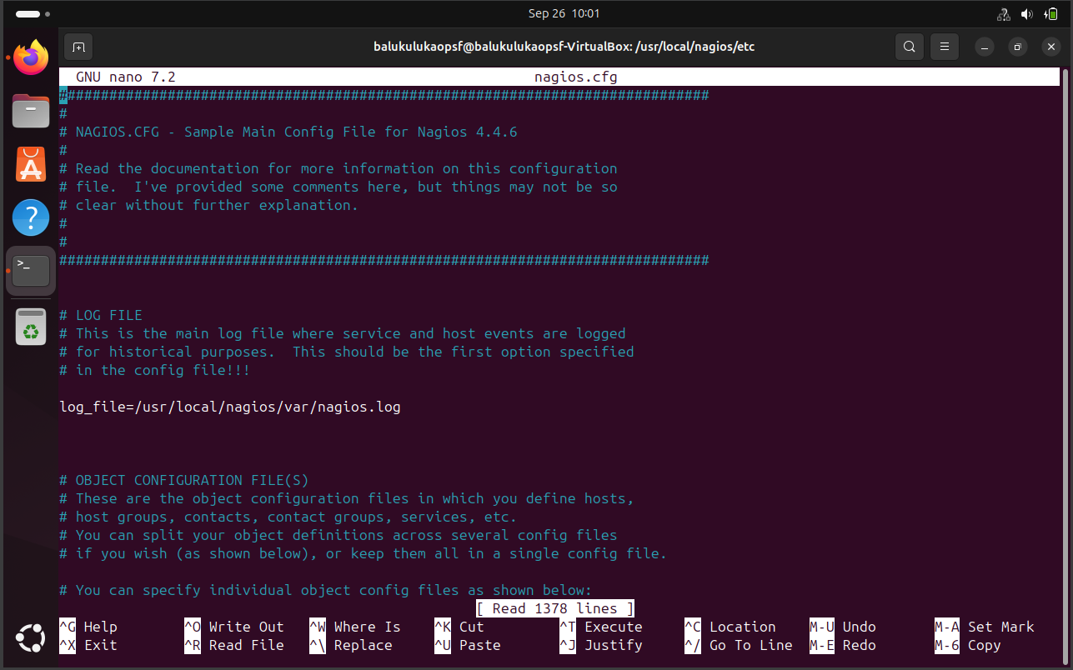

1. Here, scroll down and find “*#cfg_dir=/usr/local/nagios/etc/servers”* and remove the # in front of the line.

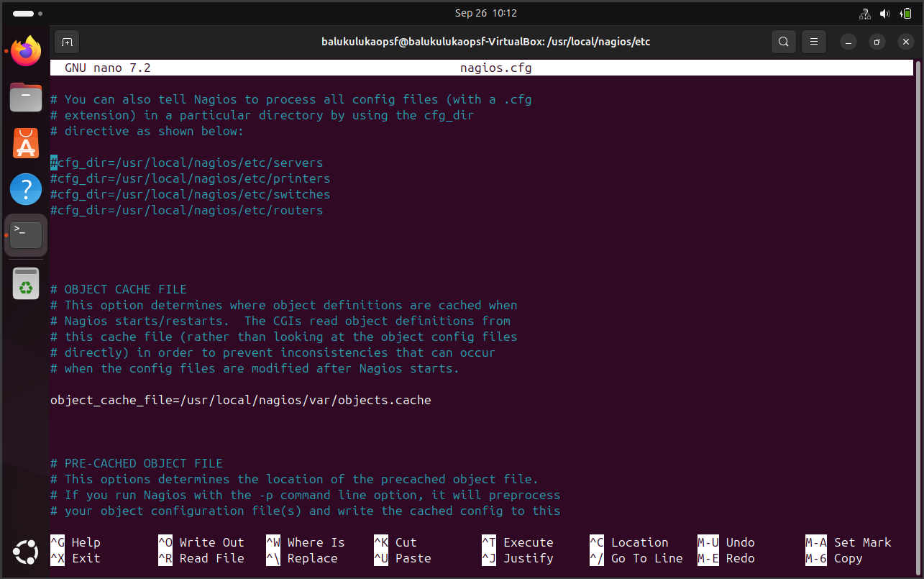

1. Use Ctrl + X key combination, then press ‘Y’ followed by Enter to save the file and exit the editor.
2. In the terminal give the following commands:
   1. *cd /usr/local/nagios/etc/objects*
   2. *sudo nano localhost.cfg*
3. Scroll down and find the *“define hostgroup” piece of code and against the “members” attribute, change the text from “localhost” to “localhost, TestHost”.*
4. Use Ctrl + X key combination, then press ‘Y’ followed by Enter to save the file and exit the editor.
5. In the terminal, give the following command:

*sudo systemctl restart nagios.service*

1. The required checks are now configured and can be checked on the Nagios Web GUI:
   1. Open your web browser and go to <http://localhost/nagios>.
   2. Open Tactical Overview by clicking the text on column. You should see a value of 2 in the UP column in Host section.
   3. Click on this number 2. You will find the TestHost along with the localhost in a list.
   4. Click on the magnifying glass next TestHost label. Service Status Details will be opened for TestHost. Here, you can observe the status of the 3 health checks.

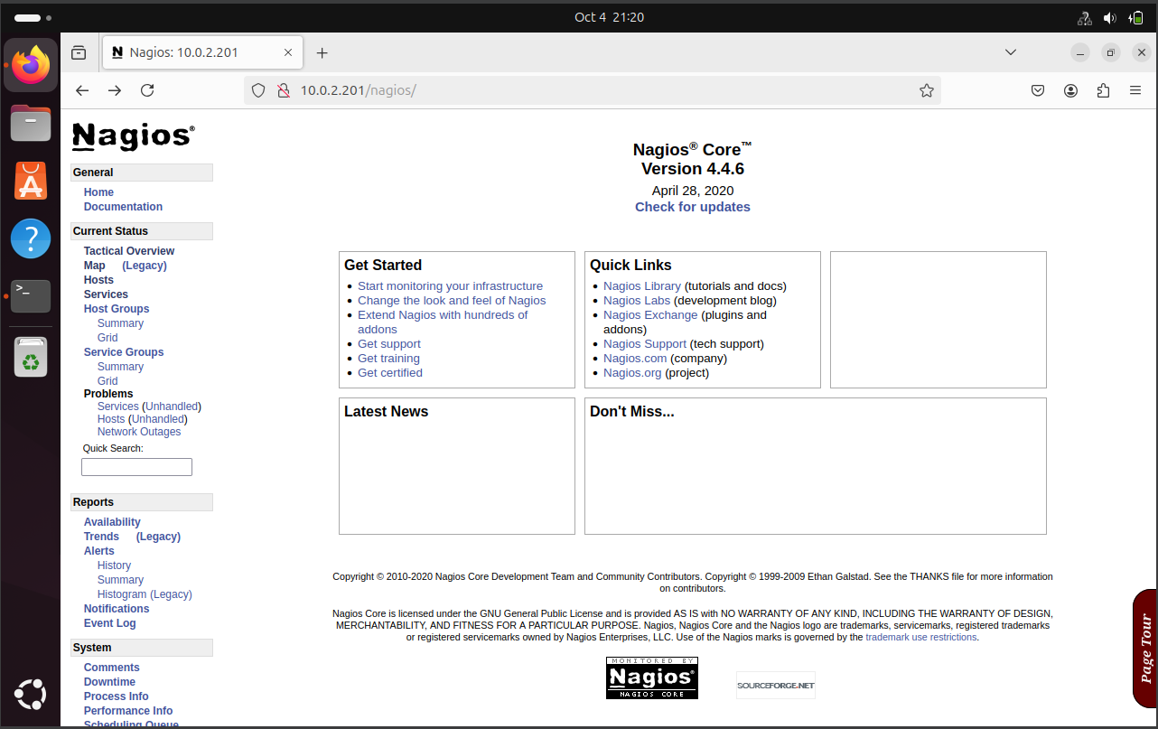

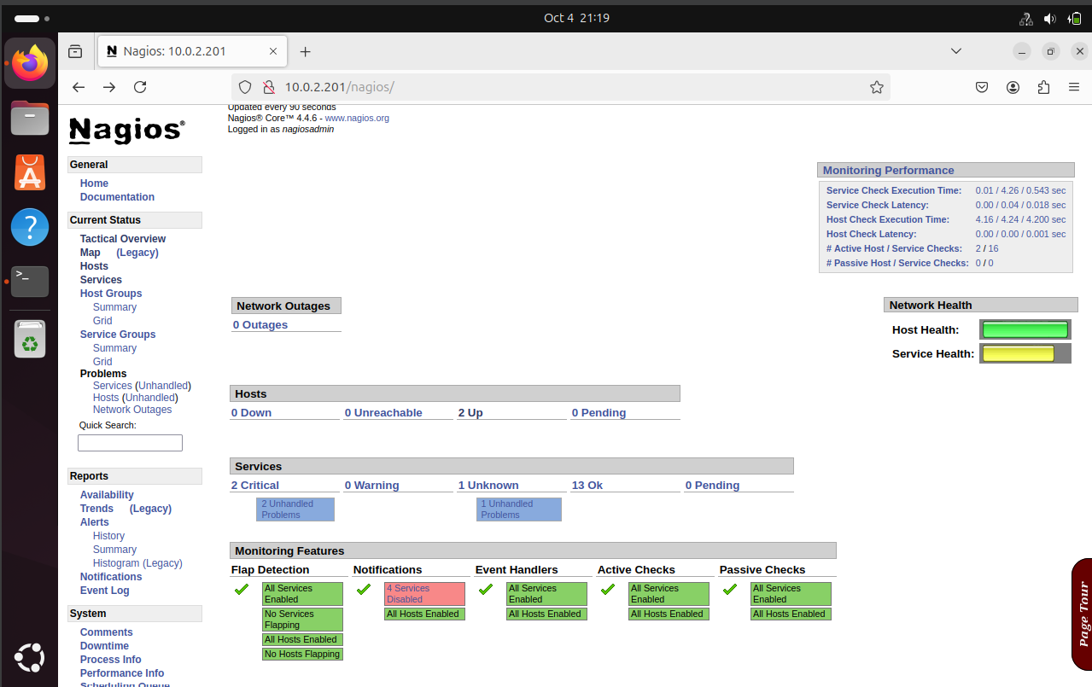

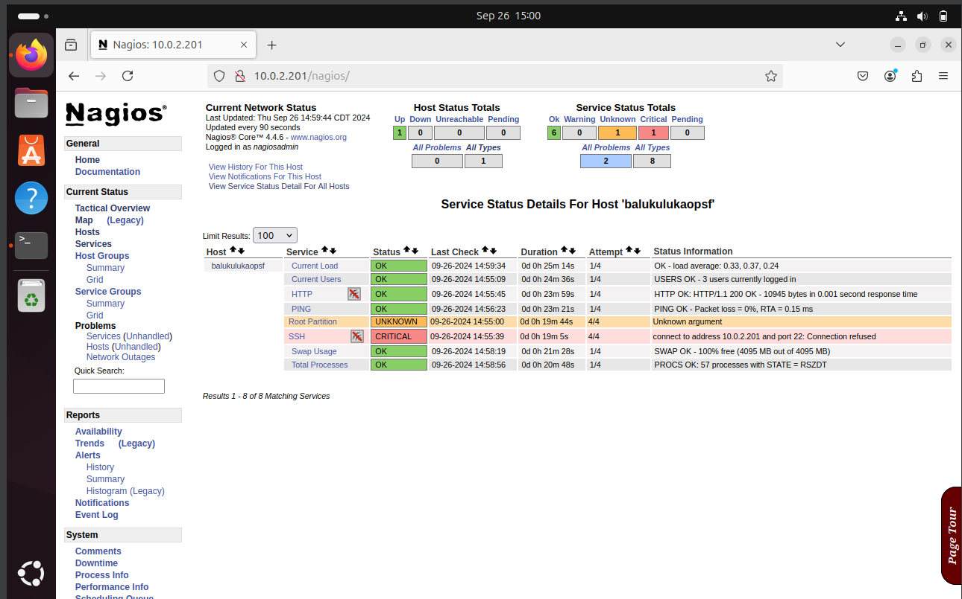

# Resource

chindemax. (2019, February 9). *Nagios Server/Client setup & configuration (On Ubuntu) - Part 1/Server* [Video]. YouTube. https://www.youtube.com/watch?v=VNm6J-U3cuU

chindemax. (2019b, February 10). *Nagios Server/Client setup & configuration (On Ubuntu) - Part 2/Client & Config* [Video]. YouTube. https://www.youtube.com/watch?v=Civw7iKulFg